Flame-Retardancy Finishing of Cotton Fabric by Surface-Initiated Photochemically Induced Atom Transfer Radical Polymerization

Gamal Zain [a,b], Igor Jordanov [c], Sandra Bischof [d] , Alena Opálková Šišková [a], Angela Kleinová [a], Matej Mičušík [a], Katarína Mosnáčková [a] , Jana Doháňošová [e] and Jaroslav Mosnáček*[a,f]
ª Polymer Institute, Slovak Academy of Sciences, Dúbravská cesta 9, 84541 Bratislava, Slovakia
^{b} Pretreatment and Finishing of Cellulose Based Textiles Dept., Textile Research Division, National Research Centre, Dokki, Giza, Egypt
^{c} Department of Textile Engineering, Faculty of Technology and Metallurgy, Ss. Cyril and Methodius University, Ruger Boskovic 16, 1000, Skopje, North Macedonia
Department of Textile Chemistry and Ecology, Faculty of Textile Technology, University of Zagreb, Prilaza baruna Filipovica 28a, Zagreb, Croatia
^{e} Central Laboratories, Faculty of Chemical and Food Technology STU, Radlinského 9, 812 37 Bratislava, Slovakia
^{f} Centre for Advanced Material Applications, Slovak Academy of Sciences, Dúbravská cesta 9, 84511 Bratislava, Slovakia

* Corresponding author: jaroslav.mosnacek@savba.sk, +421 2 3229 4388

Supporting Information

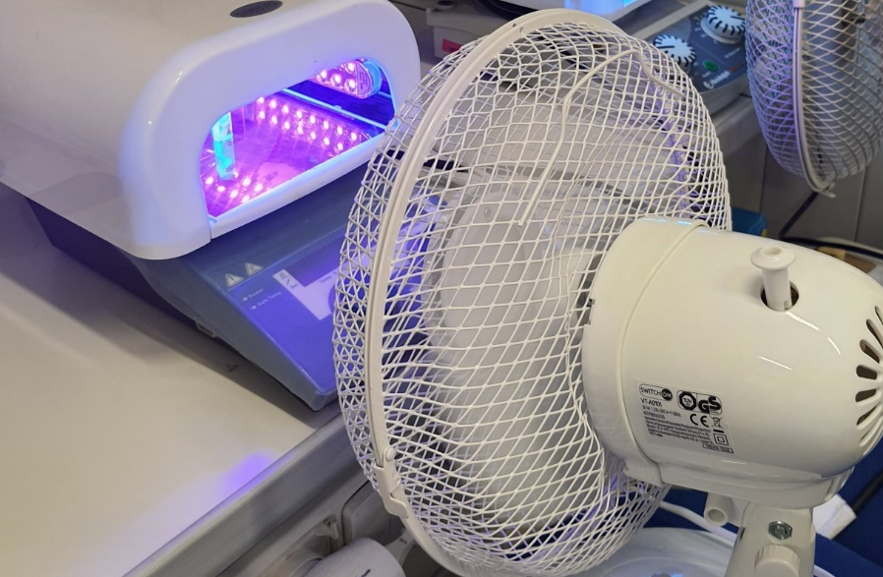
Figure S1. PhotoATRP setup for small cotton fabric pieces.

Figure. S2. C1S Spectra of modified cotton fabric Cg65.

Table S1. Weight % of elemental contribution determined from EDS analysis.
Spectrum Label | Neat Cotton | Fabric-Si | Fabric-Br | Cg15 | Cg65
C | 51.33 | 70.67 | 70.50 | 67.29 | 65.68
O | 45.27 | 22.80 | 23.02 | 24.82 | 24.98
Si | 0 | 3.82 | 3.88 | 2.99 | 4.52
N | 0 | 2.71 | 1.42 | 1.68 | 1.63
Br | 0 | 0 | 1.18 | 1.17 | 1.00
P | 0 | 0 | 0 | 2.04 | 2.18

Figure S3. EDS results for neat cotton fabric (A), fabric-Si (B), fabric-Br (C), Cg15 (d) and Cg65 (E).
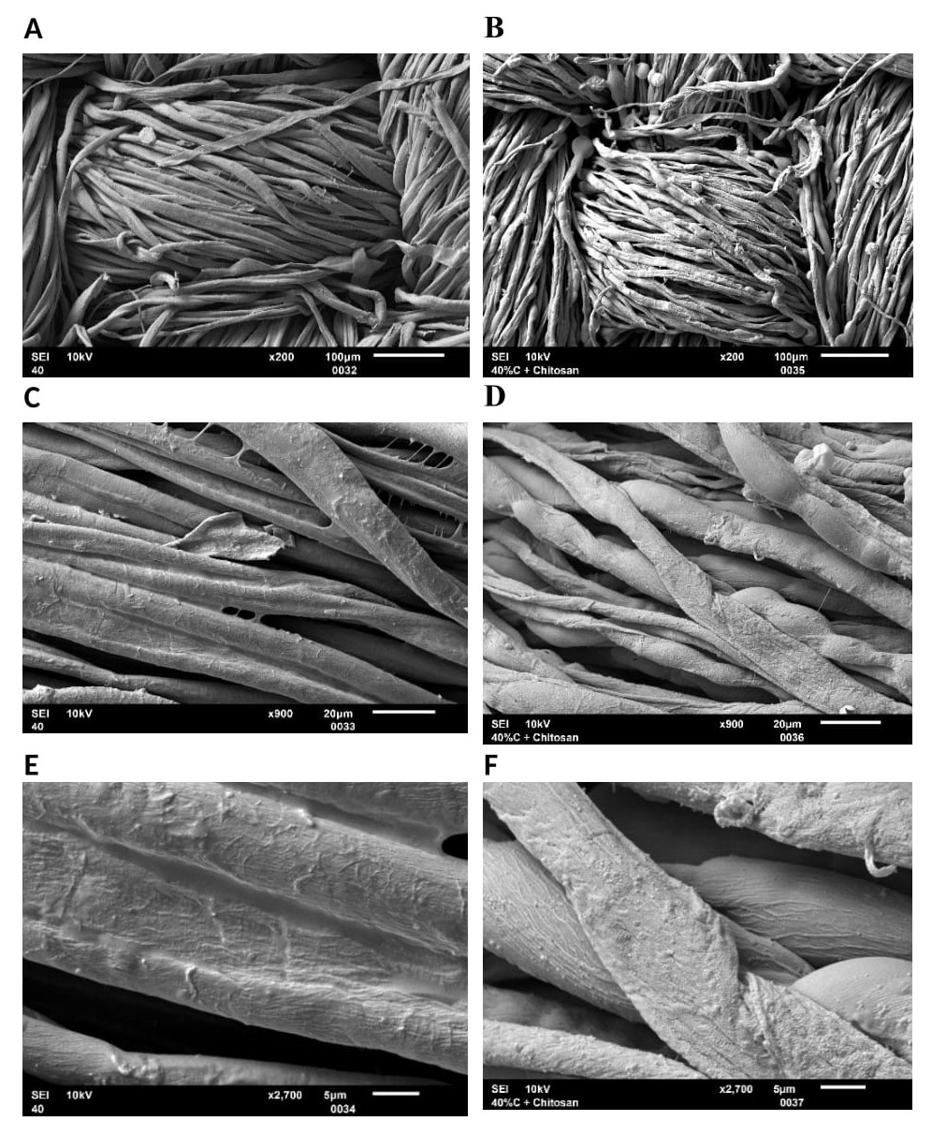
Figure S4. SEM photographs of char residue of grafted cotton fabric a,c,e) Cg41 after HFT and b,d,f) Cg41 treated with hydrolyzed chitosan after VFT at magnifications a,b) 200x, c,d) 900x and e,f) 2700x.

