Supplementary Material

Table S1. Definitions of clinical target volumes (CTVs) and planning target volumes (PTVs)

Organ | Target | Definition
Prostate | CTV_{prostate} | Included the entire prostate gland for all patients with the addition of proximal two-thirds of seminal vesicles for patients with intermediate- or high-risk PC.
 | PTV_{prostate} | An anisotropic expansion of CTVprostate with a 6-mm margin posteriorly and 1-cm margin in all other directions.
Lymph nodes | CTV_{LN} | Included the distal common iliac lymphatics, external iliac lymphatics, internal iliac lymphatics, presacral lymphatics and obturator lymphatics
 | PTV_{LN} | An isotropic expansion of CTVLN with a 5-mm margin.

Table S2. Acceptance criteria and organ-at-risk (OAR) constraints.

Volume | Acceptance criteria or constraints
PTV | Dose_{mininum} ≥ 95% of prescribed dose  ≤ 3% received > 107% of prescribed dose  ≤ 3% received < 93% of prescribed dose
Rectum | Volume_{75Gy} ≤ 15%  Volume_{70Gy} ≤ 20%  Volume_{65Gy} ≤ 25%  Volume_{60Gy} ≤ 35%  Volume_{50Gy} ≤ 50%
Bladder | Volume_{80Gy} ≤ 15%  Volume_{75Gy} ≤ 25%  Volume_{70Gy} ≤ 35%  Volume_{65Gy} ≤ 50%
Femoral head | Volume_{50Gy} ≤ 50%
Bowel space | Volume_{45Gy} ≤ 200 cc
Penile bulb | Dose_{70%} ≤ 70 Gy  Dose_{90%} ≤ 50 Gy
Normal tissue | Dose_{maximum} ≤110% of prescribed dose

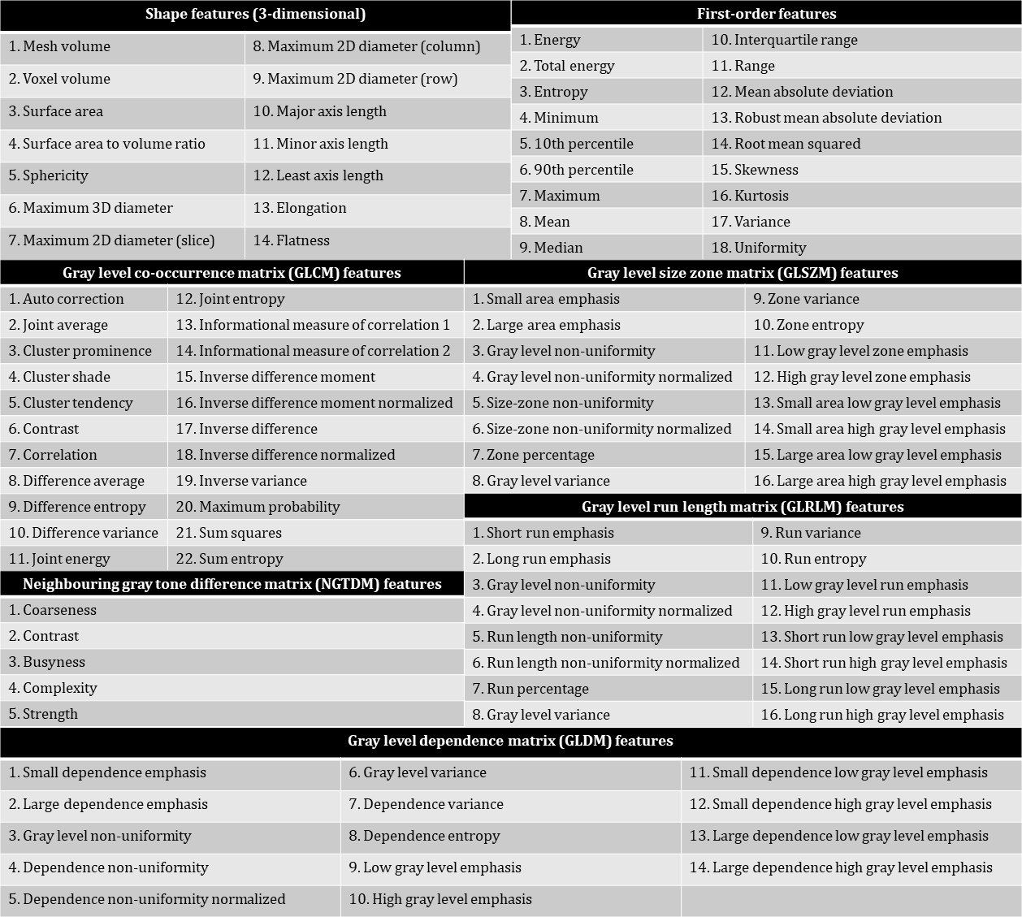

Figure S1. Shape features, first-order features and texture features extracted from the CTV_{prostate}. Texture features include gray level co-occurrence matrix (GLCM) features, gray level size zone matrix (GLSZM) features, neighbouring gray tone difference matrix (NGTDM) features, gray level run length matrix (GLRLM) features and gray level dependence matrix (GLDM) features.

Table S3. Count of extracted radiomic features.

 | Extracted radiomic features (n=651)
 | Shape | First-order | Texture
 | Shape | First-order | GLCM | GLSZM | NGTDM | GLRLM | GLDM
Original | 14 | 18 | 0 | 0 | 0 | 0 | 0
Discretized | 0 | 0 | 22 | 16 | 5 | 16 | 14
LoG_{0.5mm} | 0 | 18 | 0 | 0 | 0 | 0 | 0
LoG_{2mm} | 0 | 18 | 0 | 0 | 0 | 0 | 0
LoG_{3mm} | 0 | 18 | 0 | 0 | 0 | 0 | 0
LoG_{4mm} | 0 | 18 | 0 | 0 | 0 | 0 | 0
LoG_{4.5mm} | 0 | 18 | 0 | 0 | 0 | 0 | 0
LoG_{5mm} | 0 | 18 | 0 | 0 | 0 | 0 | 0
LoG_{0.5mm} + Discretized | 0 | 0 | 22 | 16 | 5 | 16 | 14
LoG_{2mm} + Discretized | 0 | 0 | 22 | 16 | 5 | 16 | 14
LoG_{3mm} + Discretized | 0 | 0 | 22 | 16 | 5 | 16 | 14
LoG_{4mm} + Discretized | 0 | 0 | 22 | 16 | 5 | 16 | 14
LoG_{4.5mm} + Discretized | 0 | 0 | 22 | 16 | 5 | 16 | 14
LoG_{5mm} + Discretized | 0 | 0 | 22 | 16 | 5 | 16 | 14
Sub-total | 14 | 126 | 154 | 112 | 35 | 112 | 98

