The development of an optimized and reliable iron overload HepG2 cell model
Usama Abbasi,^{1,2,#} Srinivas Abbina,^{1,2,#} Jayachandran N. Kizhakkedathu^{1,2,3,4,*}

¹Department of Pathology and Laboratory Medicine, The University of British Columbia, Vancouver, BC, Canada.
²Centre for Blood Research, Life Sciences Institute, The University of British Columbia, Vancouver, BC, Canada.
³Department of Chemistry, The University of British Columbia, Vancouver, BC, Canada.
⁴The School of Biomedical Engineering, The University of British Columbia, Vancouver, BC, Canada.

#Equally contributed
*Address to which correspondence to be addressed.

Supplementary Table and Figures:

Supplementary Table S1. Literature reported iron overload models with different treatment regimes.

Iron source | Iron concentration | Time of incubation | Cell lines | Outcome
Ferric ammonium  citrate (FAC) | 100 or 200 μg/mL | 24 hr | HepG2 | No statistical difference in ferritin-L levels from 100 to 200 μg/mL²⁶
Fe-NTA | 5, 20, and 50 μM | 5 days | HepG2 | A slight difference in intra cellular iron was observed among the tested concentrations; however, it is not in linear relationship with iron loading²⁷
Fe-NTA | 30, 100, 300, 500, and 1000 μM | 6 days | HepG2 | 300 μM was chosen for mitochondrial ROS production considering the cytotoxicity²⁸
FAC | 720 μg/mL | 3-7 days | HepG2 | Consistent iron loading was observed and was chosen for lipid peroxidation assays³¹
Ferrous sulfate | 1000 μM | 72 hr | HepG2 | Desired iron overload was achieved ³²
Ferrous sulfate | 10, 100, and 1000 μM | 3 days | HepG 2.2.15 | No statical difference was found among the treatments³³
Fe-NTA | 100 μM | 24 hr | HepG2  /HFE | Intracellular iron loading was observed³⁵
FAC or diferric transferrin | 66 μM | 7 or 10 days | HepG2, Hep3B | Maximum iron content was observed after 10 days³⁶
Ferrous sulfate heptahydrate or ferric sulfate.5H₂O | 0.5 mM | 24 h | HepG2 | Intracellular iron was observed and used for chelating studies³⁸
Ferric citrate | 10 mM | 20 h | HepG2 | Iron chelator L1 was used in these studies to prevent DNA damage³⁹
Ferric saccharate, ferric gluconate, and ferric dextran | 25, 75, and 150 μM | 24 h | HepG2 | Determination of cellular iron levels⁴⁹
Iron citrate (Fe³⁺), iron sulfate (Fe²⁺), and iron chloride (Fe³⁺) | 10 mM | 4 h | HepG2 | Proliferation, toxicity, and hepcidin expression were measured⁵¹
FAC | 5 mM | 12–72 h | HH4 | Intracellular ROS studies were performed⁷¹
FAC | 200 or 300 µM | 24 or 48 h | Chondro-cytes | ROS studies were performed⁷²

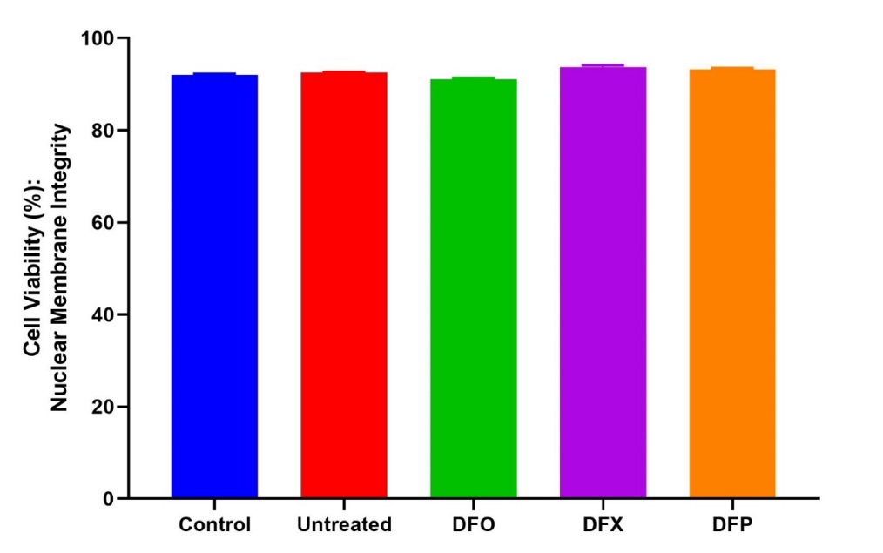
Supplementary Figure S1. Cell viability was assessed by MTT assay after iron overloaded HepG2 cells treated with small molecular iron chelators. Cells were seeded in a 48 well plate at a density of 50,000 cells per well. The MTT (3-(4,5-dimethylthiazolyl-2)-2,5-diphenyltetrazolium bromide) assay (ATCC 20-1010K) was performed according to manufacturer’s protocol to investigate changes in metabolic activity. Absorbance was measured at 570 nm on SpectraMax 190 Microplate Reader from Molecular Devices. Cell viability was determined; (mean_{570 nm} treated cells / mean_{570 nm} untreated cells) x 100%. Error bars show standard deviations for N = 3 independent replicates.
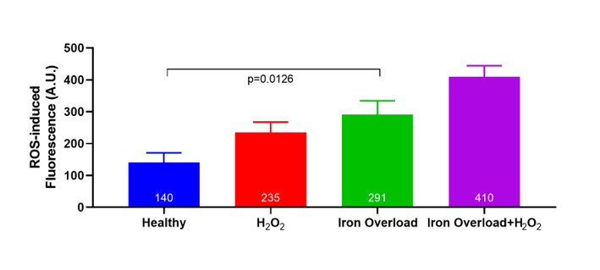

Supplementary Figure S2. Cellular ROS generation measured using a DCFDA / H2DCFDA kit (Abcam 113851) on Beckman Coulters CytoFLEX Flow Cytometer. One-way ANOVA with Dunnett’s correction method was used to compare among the treatments. Error bars show standard deviations for N = 3 independent replicates. Statistical analysis were performed using GraphPad Prism. **** represent p < 0.0001, *** represents p < 0.0010, ** represents p < 0.0100 and * represents p < 0.05.

