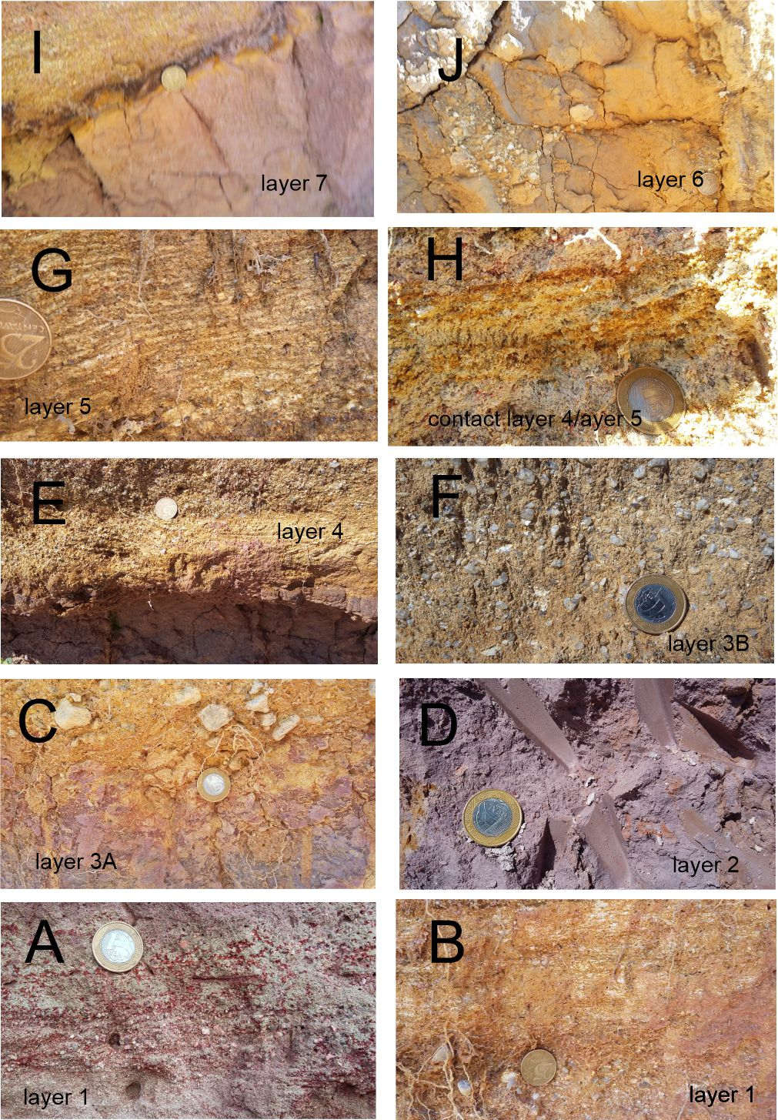
Figure 1. Supplementary material. Layer observed in the studied outcrop. Layers sampled for zircon separation: Layer 1 (CAM 01); Layer 3A (CAM 03A); Layer 3B (CAM 03B); Layer 5 (CAM 05); Layer 7 (CAM 07).

