Studies of the Symmetric Binding Mode of Daclatasvir and Analogs Using a New Homology Model of HCV NS5A GT-4a
Kholoud A. Saad^{a,*}, Mohammed A. Eldawyª, Khaled M. Elokely^{a,b,*}
ªDepartment of Pharmaceutical Chemistry, Tanta University, Tanta 31527, Egypt
^{b}Institute for Computational Molecular Science, and Department of Chemistry, Temple University, Philadelphia, Pennsylvania 19122, United States
*Corresponding Authors Emails:
kholoud.saad@pharm.tanta.edu.eg, kelokely@temple.edu

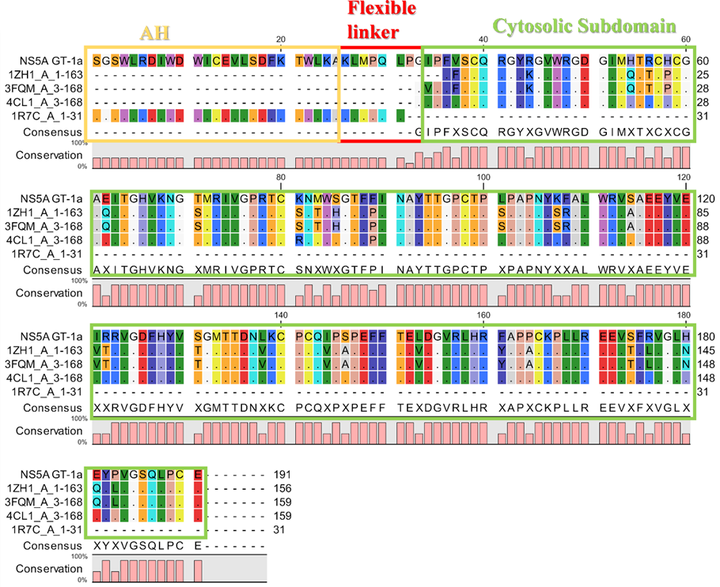
Fig. S1 The sequence alignment of HCV NS5a GT-1a and the three available crystal structures 1ZH1, 3FQQ, and 4CL1. These sequences are aligned using the T-coffee server [33] and demonstrated using CLC sequence viewer [34]

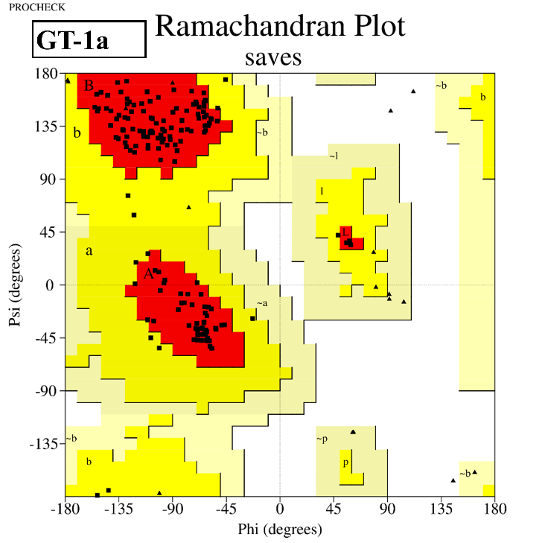
Fig. S2 Ramachandran plot of the modeled HCV NS5A GT-1a

Fig. S3 (A) HCV NS5A GT-4a model using Robetta server [19]. (B) alignment of GT-1a (green) and GT-4a (cyan)

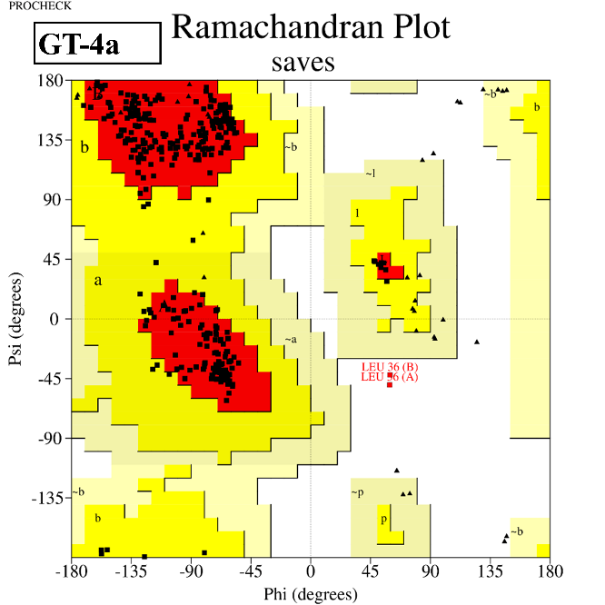
Fig. S4 Ramachandran plot of the modeled HCV NS5A GT-4a

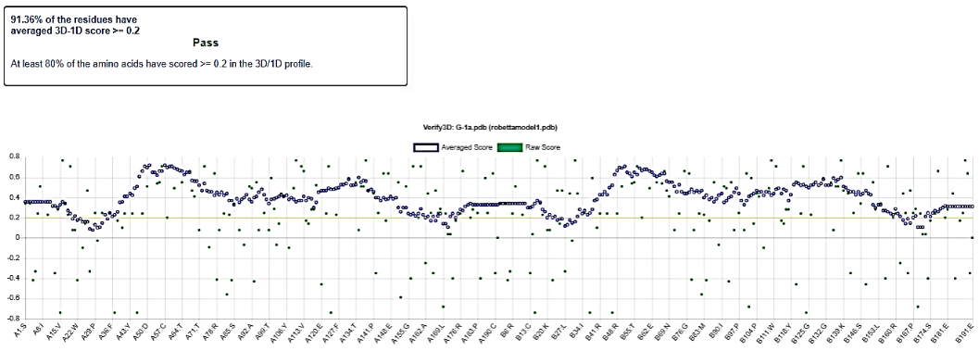
Fig. S5 Verify3D plot of the modeled HCV NS5A GT-1a

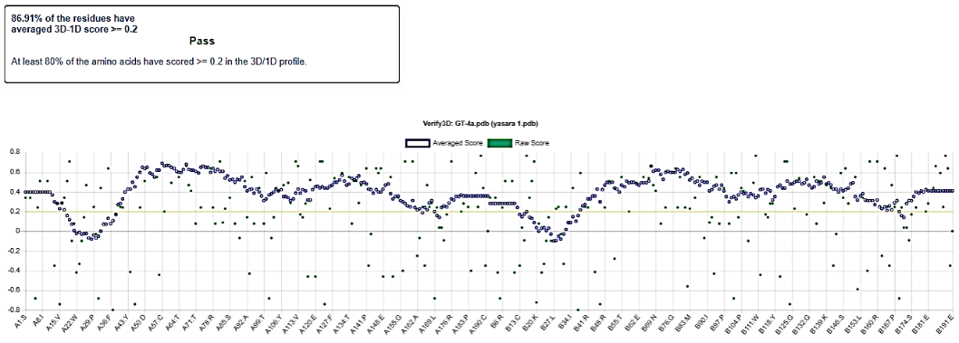
Fig. S6 Verify3D plot of the modeled HCV NS5A GT-4a

Fig. S7 Three major segments of daclatasvir

Fig. S8 Symmetrical binding mode of daclatasvir and analogs to HCV NS5A GT-4a. The figure was generated using PyMOL
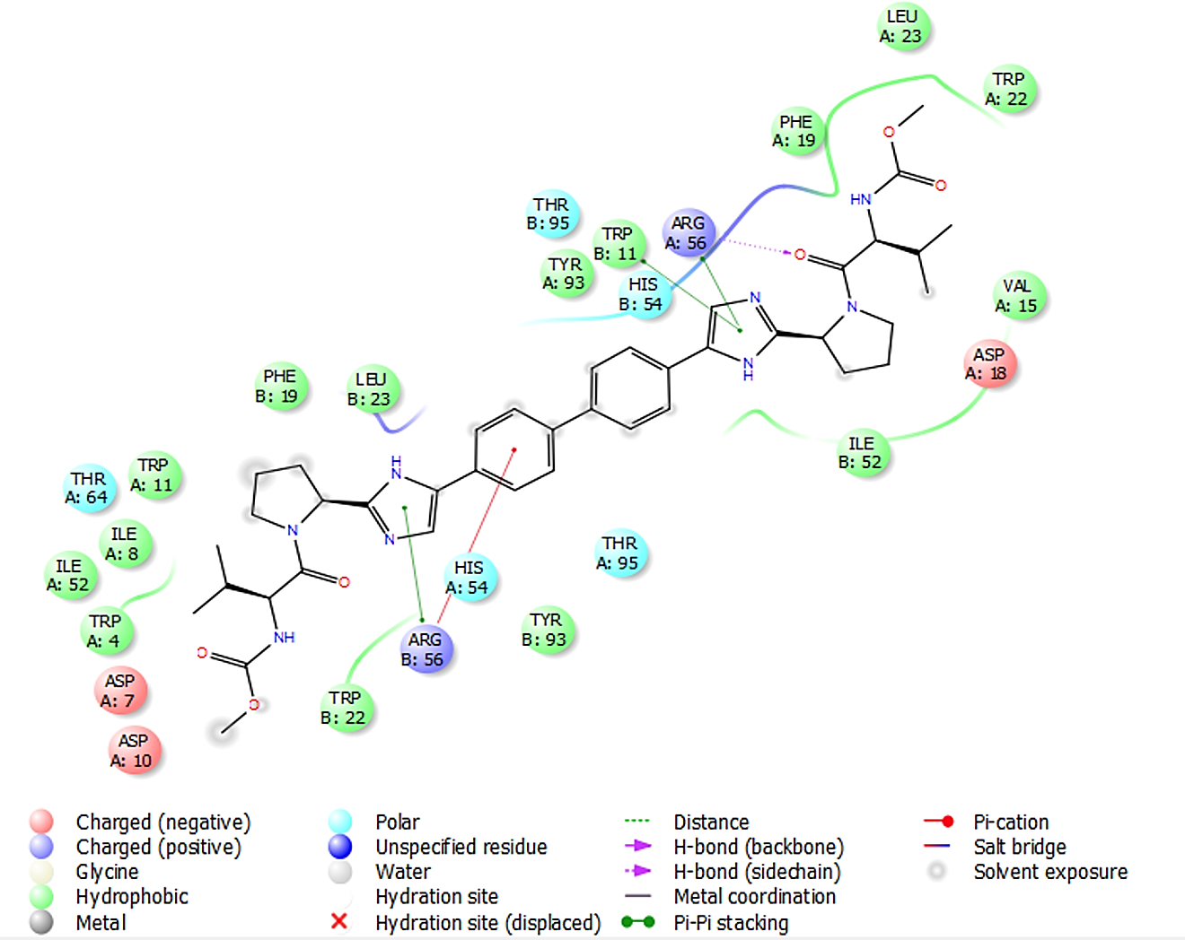
Fig. S9 The 2D interaction diagram of daclatasvir binding to HCV NS5A GT-1a
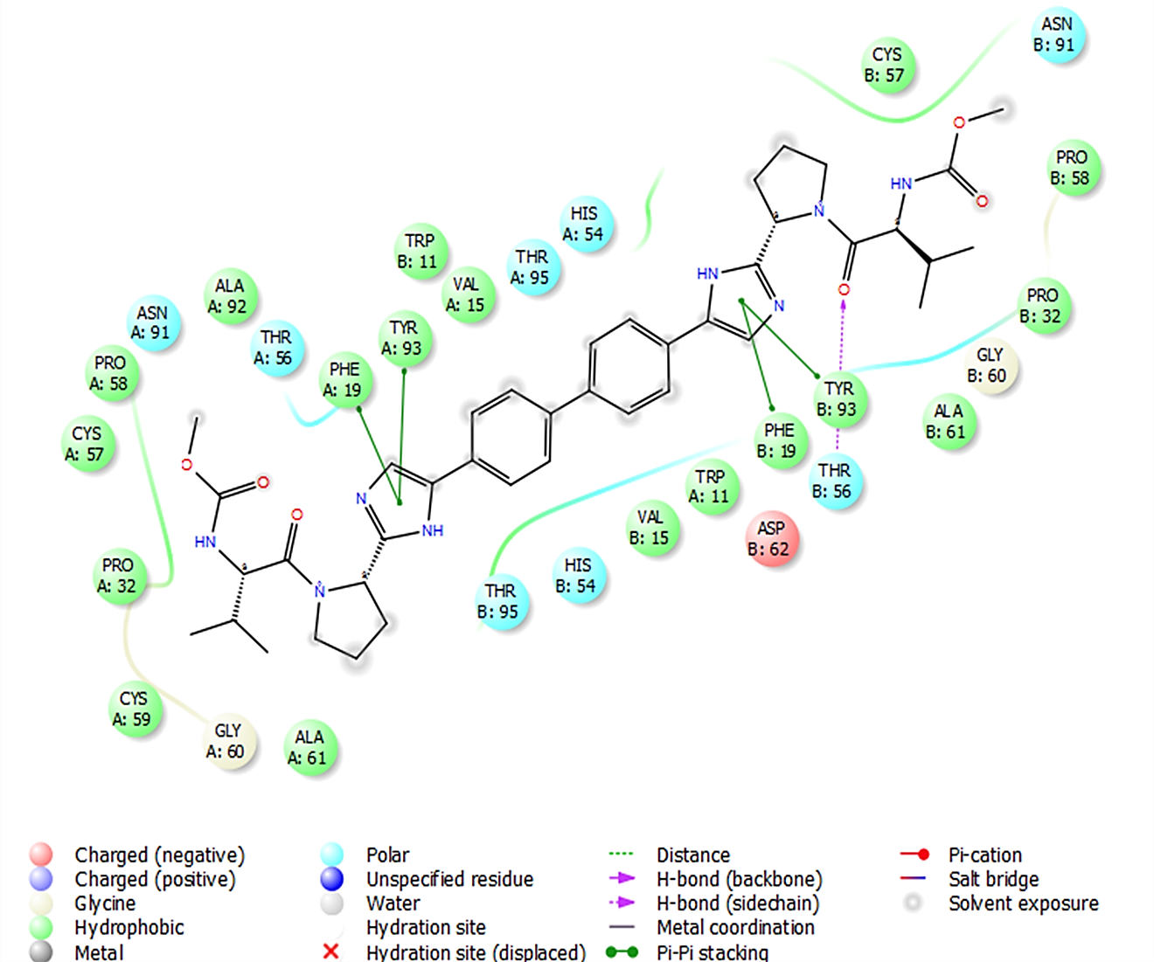
Fig. S10 The 2D interaction diagram of daclatasvir binding to HCV NS5A GT-4a

Fig. S11 Effect of amino acid change in position 56 on daclatasvir binding to HCV NS5A GT-1a and GT-4a. The figure was generated using PyMOL

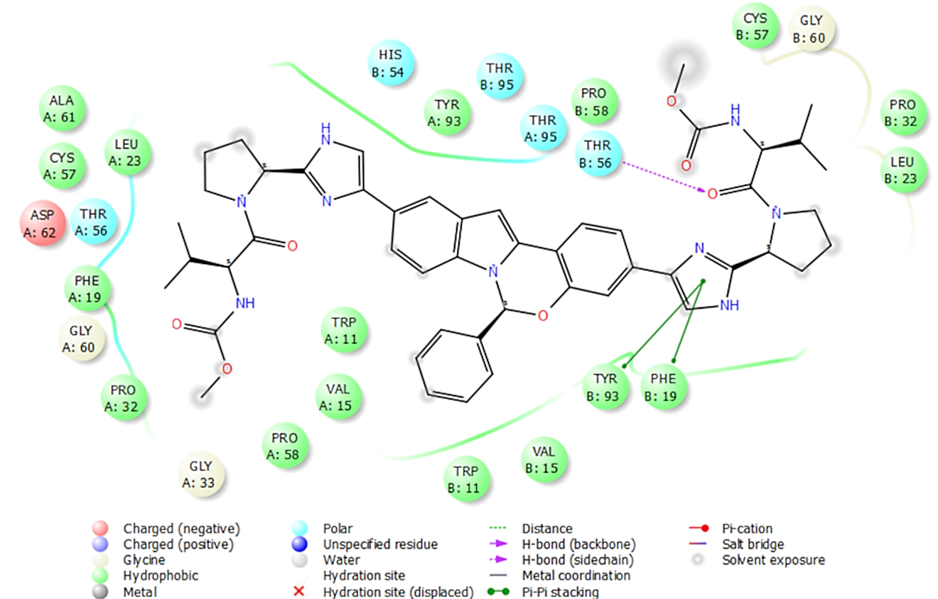
Fig. S12 The 2D interaction diagram of elbasvir binding to HCV NS5A GT-4a

Fig. S13 NS5A dimer complexed with elbasvir and shows the orientation of the phenyl ring toward the membrane to provide contact with the helix

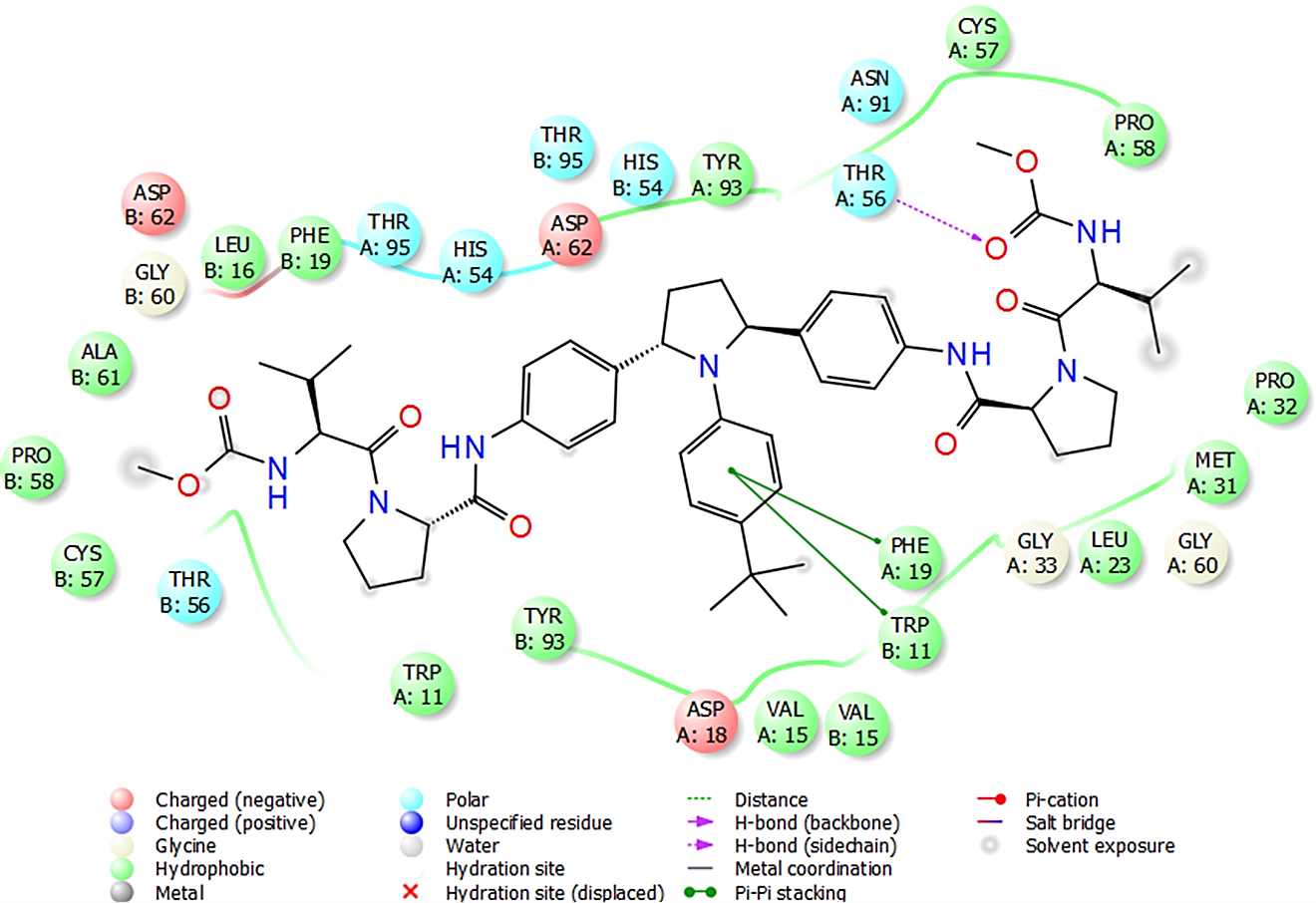
Fig. S14 The 2D interaction diagram of ombitasvir binding to HCV NS5A GT-4a

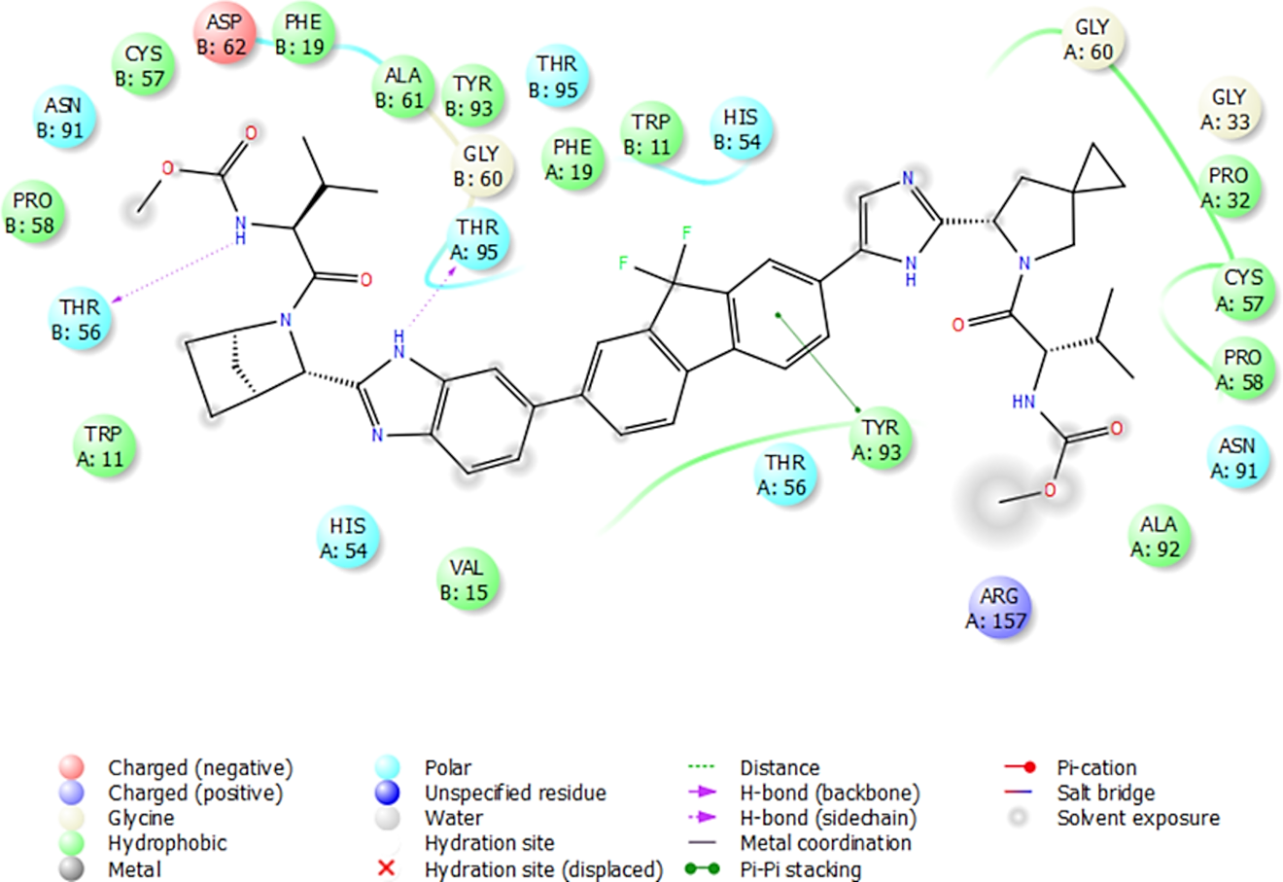
Fig. S15 The 2D interaction diagram of ledipasvir binding to HCV NS5A GT-4a

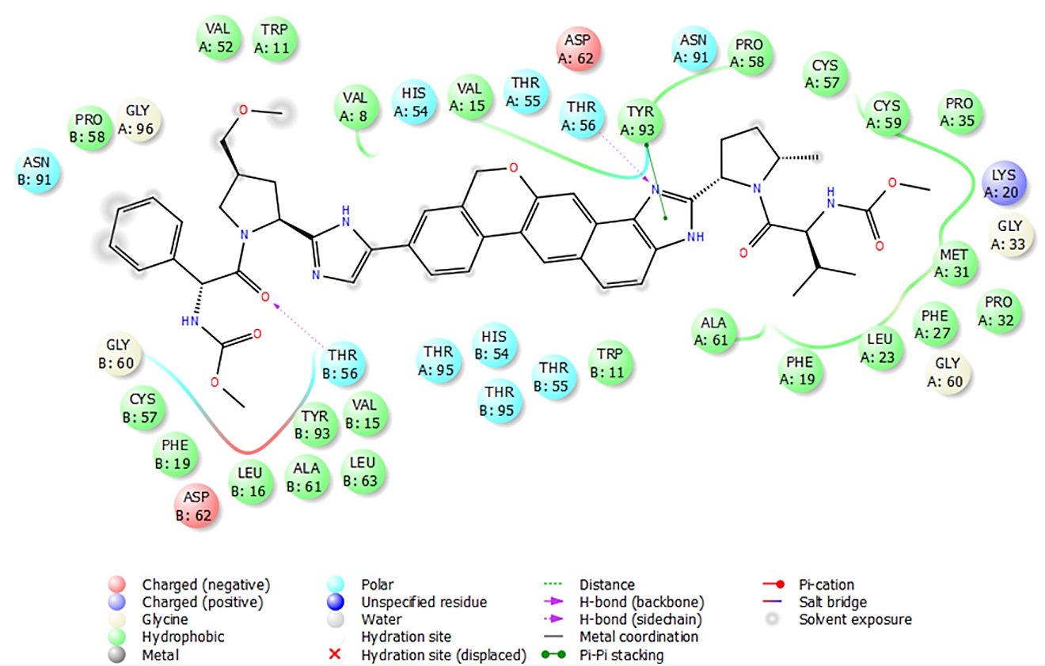
Fig. S16 The 2D interaction diagram of velpatasvir binding to HCV NS5A GT-4a

Fig. S17 Differences between ombitasvir and pibrentasvir structure

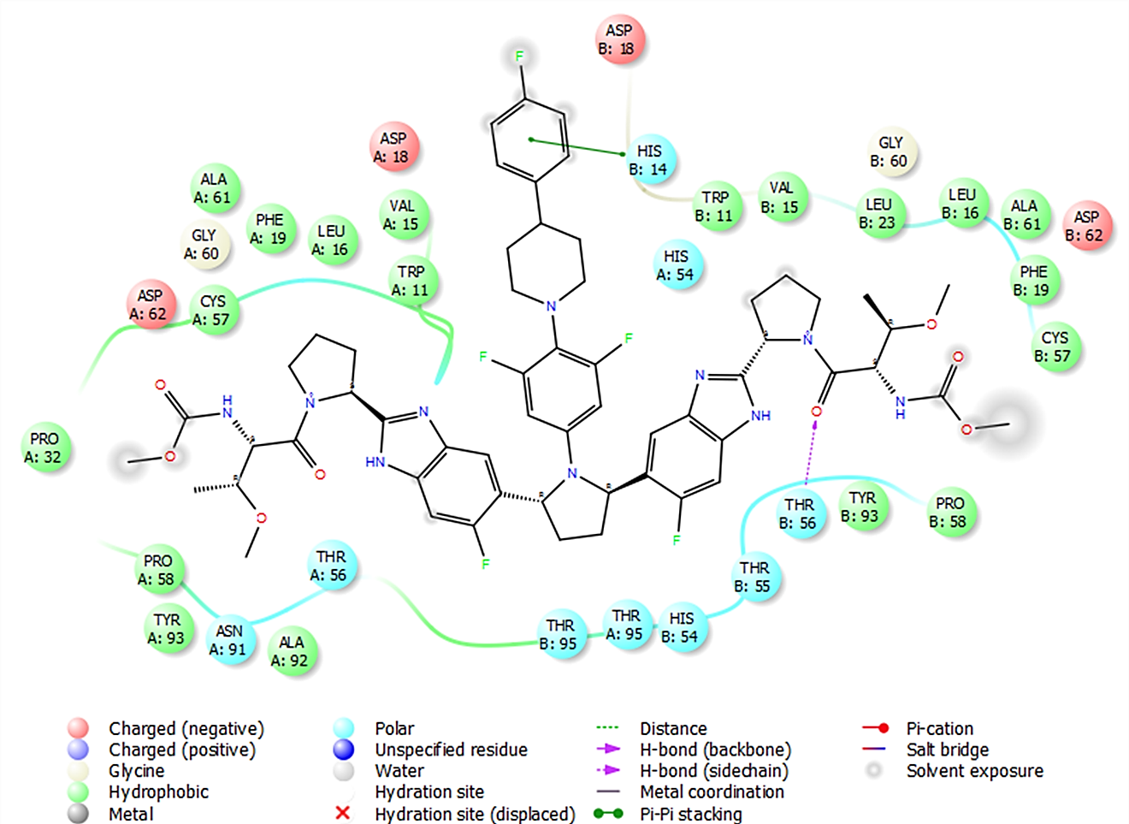
Fig. S18 2D interaction diagram of pibrentasvir binding to HCV NS5A GT-4a

Fig. S19 Position of the AH relative to the membrane during 200 ns simulation (A) at the beginning (B) after 125 ns (C) at the end of the simulation

Fig. S20 RMSF plot for the modeled HCV NS5A protein GT-4a. The alpha-helical and beta-strand regions are highlighted in red and blue backgrounds, respectively

Fig. S21 Radius of gyration (rGyr) for apo protein and protein-ligand complexes during 200 ns simulation time

Fig. S22 Protein-ligand contacts of HCV NS5A GT-4a with respective compounds daclatasvir, elbasvir, ombitasvir, ledipasvir, velpatasvir, and pibrentasvir

Fig. S23 Protein-ligand contacts of HCV NS5A GT-4a with daclatasvir

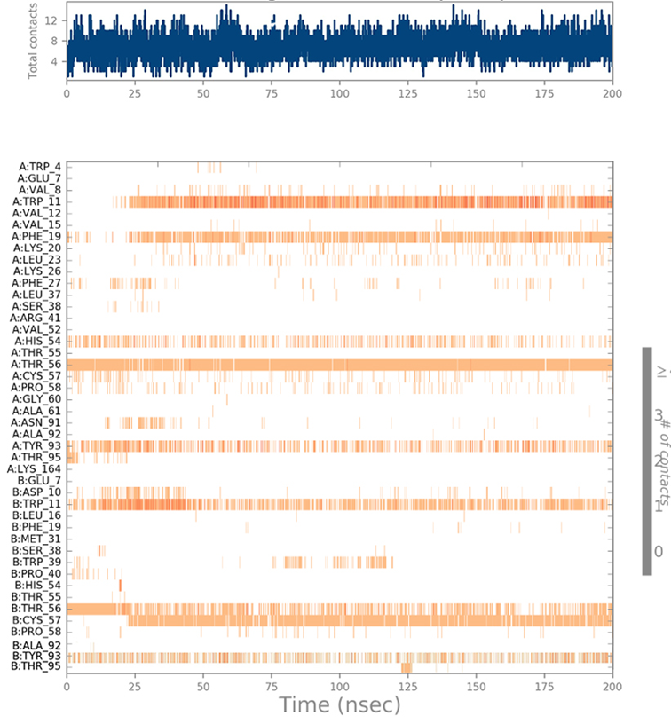
Fig. S24 Timeline representation of daclatasvir—Receptor interactions. The top section depicts the total number of contacts made by the protein with the ligand as the simulation progresses. In each trajectory, the bottom section depicts residues interacting with the ligand. According to the scale to the right of the plot, several residues make several contacts with the ligand, which is represented by a darker shade of orange.

Fig. S25 Protein-ligand contacts of HCV NS5A GT-4a with elbasvir
Fig. S26 Protein-ligand contacts of HCV NS5A GT-4a with ombitasvir
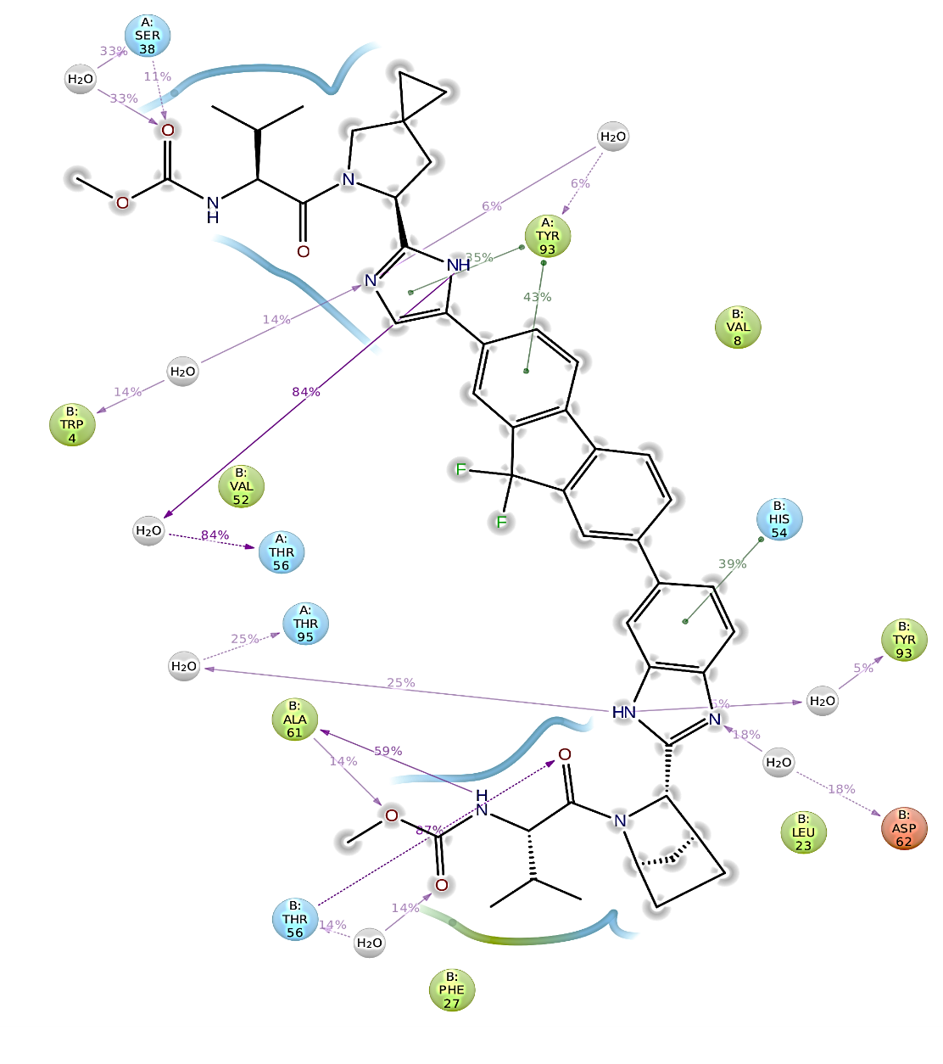
Fig. S27 Protein-ligand contacts of HCV NS5A GT-4a with ledipasvir
Fig. S28 Protein-ligand contacts of HCV NS5A GT-4a with velpatasvir
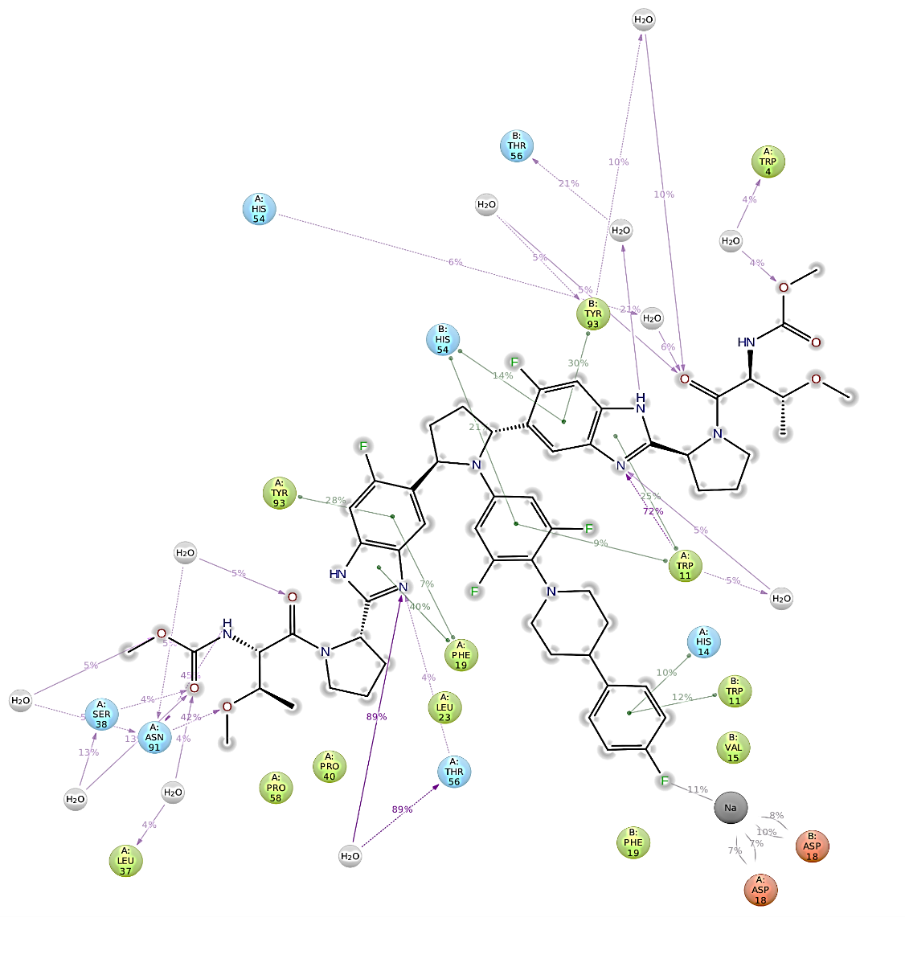
Fig. S29 Protein-ligand contacts of HCV NS5A GT-4a with pibrentasvir

