Supporting materials

Isolation, Identification and Pathogenic Effects of Trichoderma spp. from Auricularia auricula
Hui Dang ¹, Qianqian Kong ¹, William Winchester², Xin Wan ¹, Yu Lei ¹, Haisheng Zhang ¹, Yu Zhao ¹, Xinyu Liu ¹, Ben Bin Xu³, Baoshan Zhang ^{1*}, Zhe Wang ^{2*}

College of Food Engineering & Nutritional Science, Shaanxi Normal
University/Research Center of Fruit and Vegetable Deep-processing Technology, Xi’an 710119, China
²Chemistry Department, Oakland University, Rochester, 48309, USA
³ Mechanical and Construction Engineering, Faculty of Engineering and Environment, Northumbria University, Newcastle upon Tyne, NE1 8ST, UK
*Corresponding author: 2212978825@qq.com (BS Zhang) and zhewang@oakland.edu (Zhe Wang)

Table S1- S6
Table S1 The information from collected samples
Number | Date | Sites | Quantity | A.auricula logs
1 | 2019.10.4 | Shaanxi Zhongbo  Agricultural  Technology  Development co.，  Ltd. | 7 | 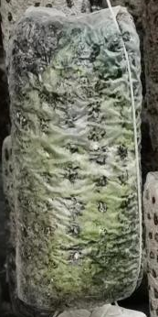
2 | 2019.10.4 | Zhashui Jinxin fungus industry development Co., Ltd | 6 | 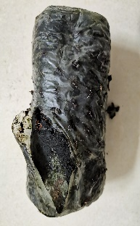
3 | 2019.10.4 | Zhashui edible fungi technology research demonstration base | 8 | 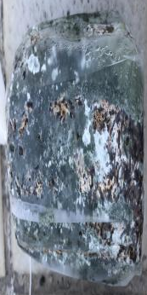
4 | 2019.10.11 | Shaanxi Qinfeng Agricultural Development Co., Ltd | 4 | 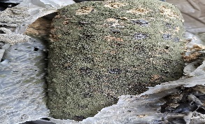
5 | 2019.10.12 | Shaanxi Wild Forest Food Co., Ltd | 7 | 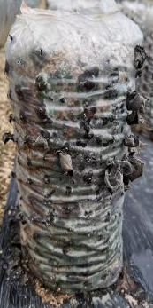
6 | 2019.10.12 | Zhashui agaric small Ecological Agriculture Co., Ltd | 5 | 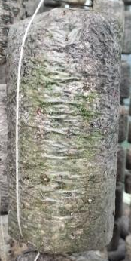

Table S2 Colony morphology of KQQ-3
Incubation time(d) | 1 | 2 | 3 | 4
Colonymor phology | 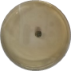 | 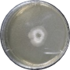 | 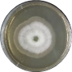 | 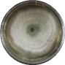
Incubation time(d) | 5 | 6 | 7 | the back of colony
Colony morphology | 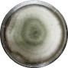 | 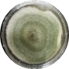 | 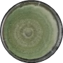 | 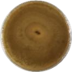

Table S3 Colony morphology of H 29
Incubation time(d) | 0 | 1 | 2 | 3 | 4 | 5 | 6 | 7
Colony morphology | 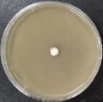 | 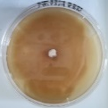 | 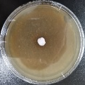 | 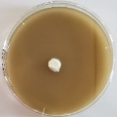 | 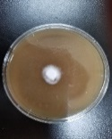 | 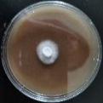 | 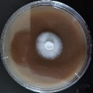 | 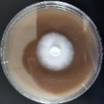
Incubation time(d) | 8 | 9 | 10 | 11 | 12 | 13 | 14
Colony morphology |  | 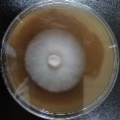 | 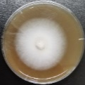 | 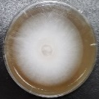 | 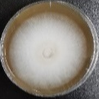 |  | 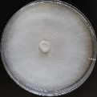

Table S4 Colony morphology of HW 15
Incubation time(d) | 0 | 1 | 2 | 3 | 4 | 5 | 6 | 7
Colony morphology | 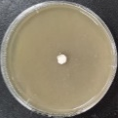 | 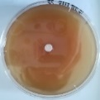 | 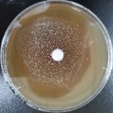 | 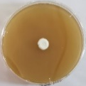 | 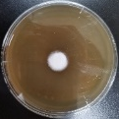 | 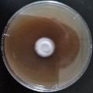 | 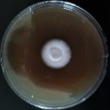 | 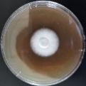
Incubation time(d) | 8 | 9 | 10 | 11 | 12 | 13 | 14 | 15
Colony morphology | 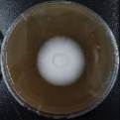 | 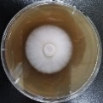 | 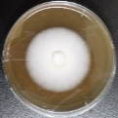 | 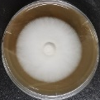 | 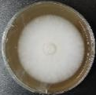 | 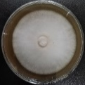 | 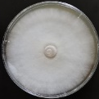

Table S5 Comparison of mycelium growth rate between A.auricula and T.pleuroticola
Strains | H 29 | HW 15 | T.pleuroticola
Growth rate(cm/d) | 0.56±0.016 b | 0.52±0.022 b | 1.83±0.04 a
Different letters mean a significant difference at the 5% level

Table 6 Confrontation culture of T.pleuroticola with A.auricula
Incubation time(h) | H 29 | T. pleuroticola and H 29 | HW 15 | T. pleuroticola and HW 15
0 | 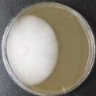 | 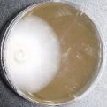 | 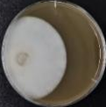 | 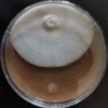
12 | 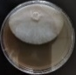 | 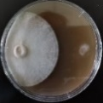 | 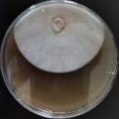 | 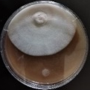
24 | 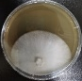 | 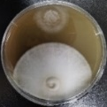 | 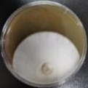 | 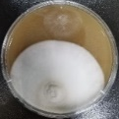
36 | 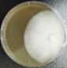 | 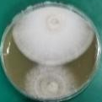 | 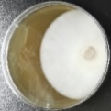 | 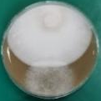
48 | 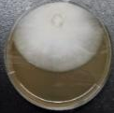 | 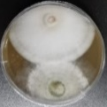 | 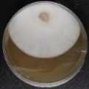 | 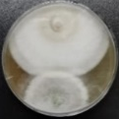
60 | 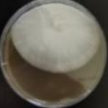 | 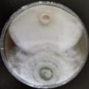 | 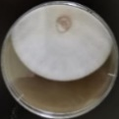 | 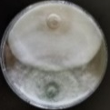
72 | 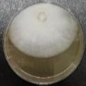 | 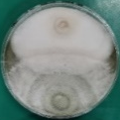 | 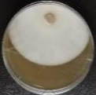 | 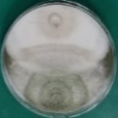
96 | 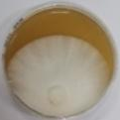 | 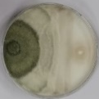 | 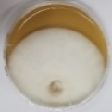 | 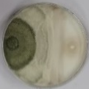
120 | 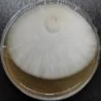 | 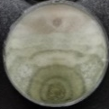 | 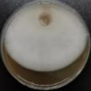 | 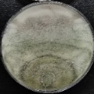
144 | 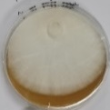 | 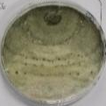 | 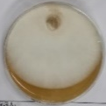 | 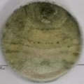
the back of colony | 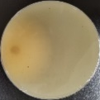 | 