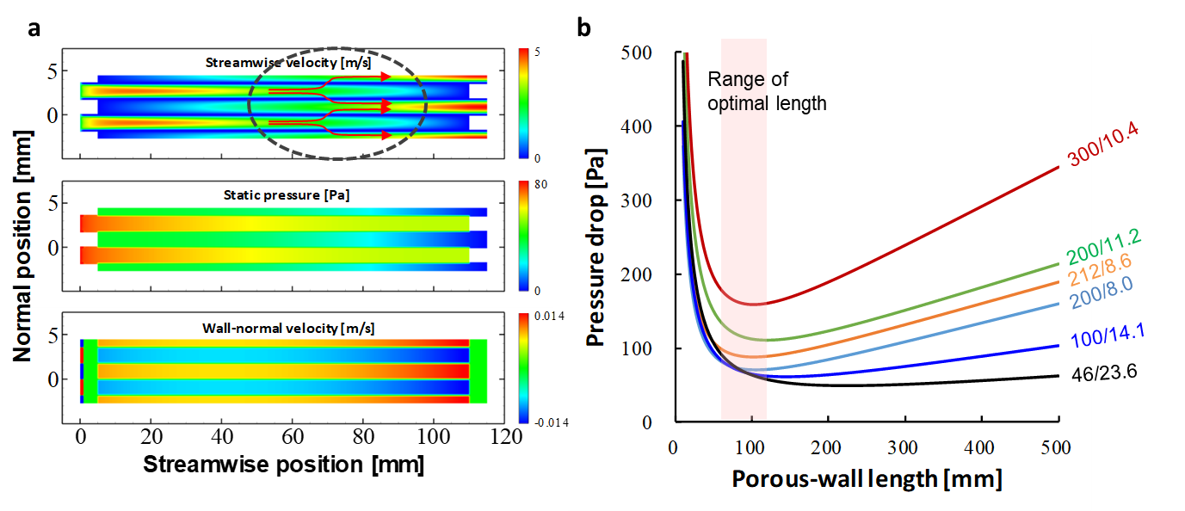

Extended Data Fig. 1 ǀ Modelling and CFD simulation of the ceramic filter. a, Linear velocity and static pressure inside the CF cells as per CFD simulation. b, Model prediction of the pressure drop with respect to the porous-wall length of various CF CPSIs to ascertain the range of optimal length.

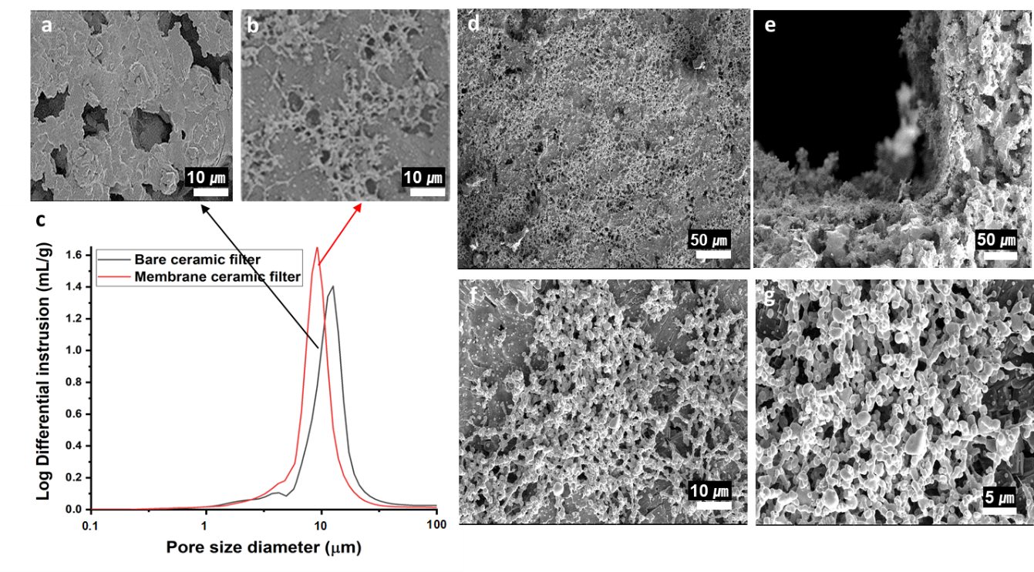

Extended Data Fig. 2 ǀ Membrane coating on the ceramic filter: SEM images of CCF wall surfaces. a, Bare ceramic filter. b, CF after membrane coating. c, Distribution of CCF pore size diameter before and after membrane coating. d–g, Various magnifications of SEM images of membrane-coated CCF: Surface image (× 1,000) (d), Cross-sectional image (× 1,000) (e), Surface image (× 5,000) (f), and Surface image (× 10,000) (g).

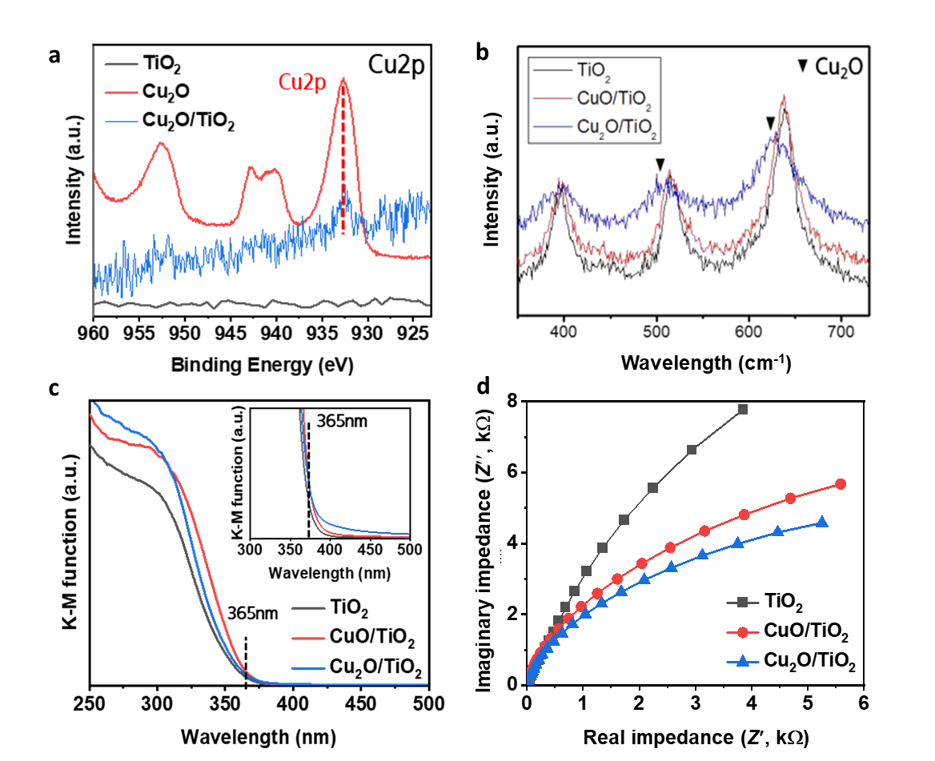

Extended Data Fig. 3 ǀ Catalyst characterisations of CuO/TiO₂, Cu₂O/TiO₂, Cu₂O, and TiO₂ catalysts. a, XPS spectra assigned to the Cu2p position. b, Raman spectra. c, UV-visible absorbance. d, Electrochemical impedance spectroscopy (EIS) Nyquist plot.
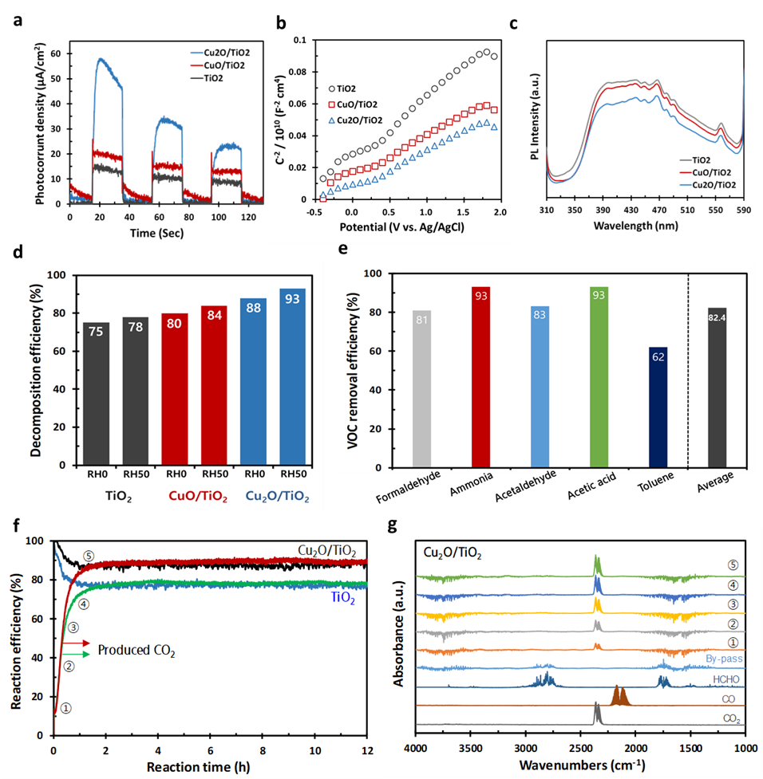

Extended Data Fig. 4 ǀ Synthesis of Cu₂O/TiO₂ photocatalysts. a, Photocurrent density by chronoamperometry: using 1 LED with a power density of 50 mW/cm² (365 nm) at 0.5 V (vs. Ag/AgCl). b, Charge carrier density (cm⁻³) analysis by Mott–Schottky plot: 3.06 × 10²⁰ cm⁻³ for Cu₂O/TiO₂, 2.81 × 10²⁰ cm⁻³ for CuO/TiO₂, and 1.73 × 10²⁰ cm⁻³ for TiO₂ at flat band potential (E_{FB}) of −0.4 V. c, Photoluminescence: 300-nm excitation by UV and response emission of 310 to 590 nm on the powder samples. d, VOC (HCHO) decomposition efficiencies of Cu₂O/TiO₂, CuO/TiO₂, and TiO₂ catalysts. Note that the efficiencies were calculated by ratio of CO₂ produced by the PCO reaction to a given concentration of HCHO gas. The detailed reaction conditions are available in the supplementary materials. e, VOC removal efficiencies of five VOCs over the honeycomb (100 CPSI) coated by the Cu₂O/TiO₂ catalyst. The 100 L chamber test sequentially proceeded with each VOC at 10 ppm in an air balance for 30 min. This test was conducted three times for each VOC gas. The final average value indicated the arithmetic mean of the efficiencies. f, VOC reaction efficiencies (HCHO removal and CO₂ production) of CCF coated with Cu₂O/TiO₂ and TiO₂ catalysts. Detailed reaction conditions are available in the supplementary materials. g, FT-IR spectra at different stages of the reaction corresponding to the five points shown in Extended Data Fig. 4f. Note that the FT-IR spectrum of by-pass, and gaseous FT-IR spectra of HCHO, CO, and CO₂ gases are indicated as per the references.

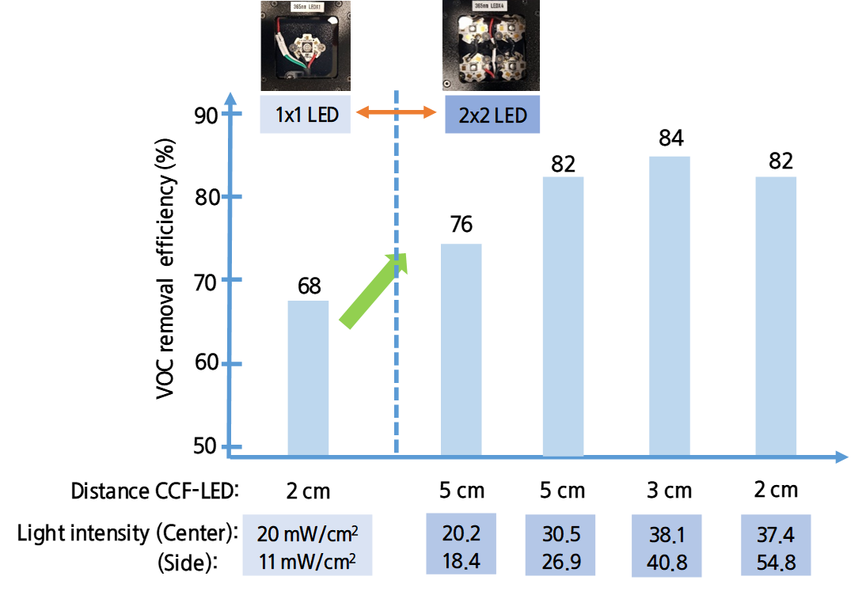

Extended Data Fig. 5 ǀ VOC removal efficiency of CCF along with distance of CCF-LED and light intensity of 1-LED and 2×2 LED array. The reaction test used LEDs (1 LED and 2×2 LED array) with a 365-nm wavelength. The reaction on the Cu₂O/TiO₂ catalyst was performed under HCHO at 25 ppm in an air balance at RT and RH 50% with a flow rate of 10 L/min. The catalyst coating was 43.4 g/L.

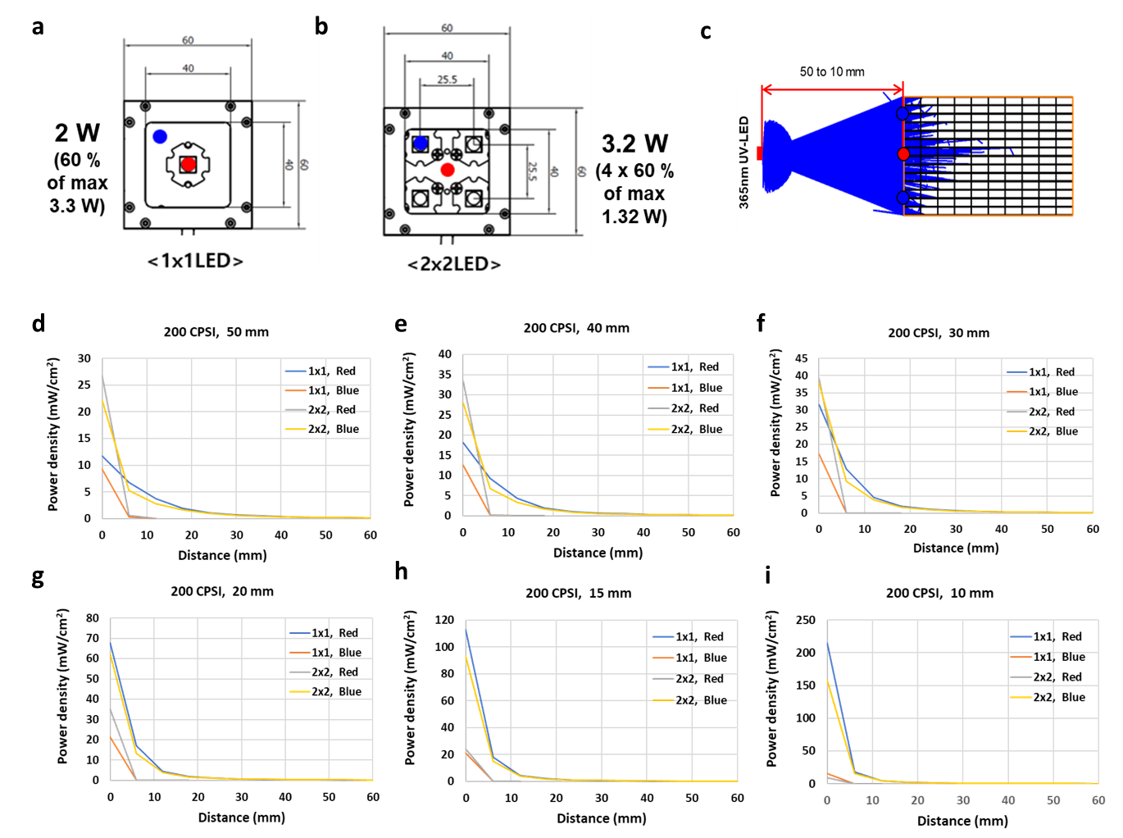

Extended Data Fig. 6 ǀ The light intensity and light propagation distance with respect to the CCF–LED distance using ray tracing simulations for 1-LED and 2 × 2 LED arrays. a, b, Illustration of 1-LED (a) and 2 × 2 LED arrays (b). c, Ray tracing result (Top view): Rays (Blue). d–i, Power distance with respect to the distance between the light source and CCF: 50 (d), 40 (e), 30 (f), 20 (g), 15 (h), and 10 mm (i).

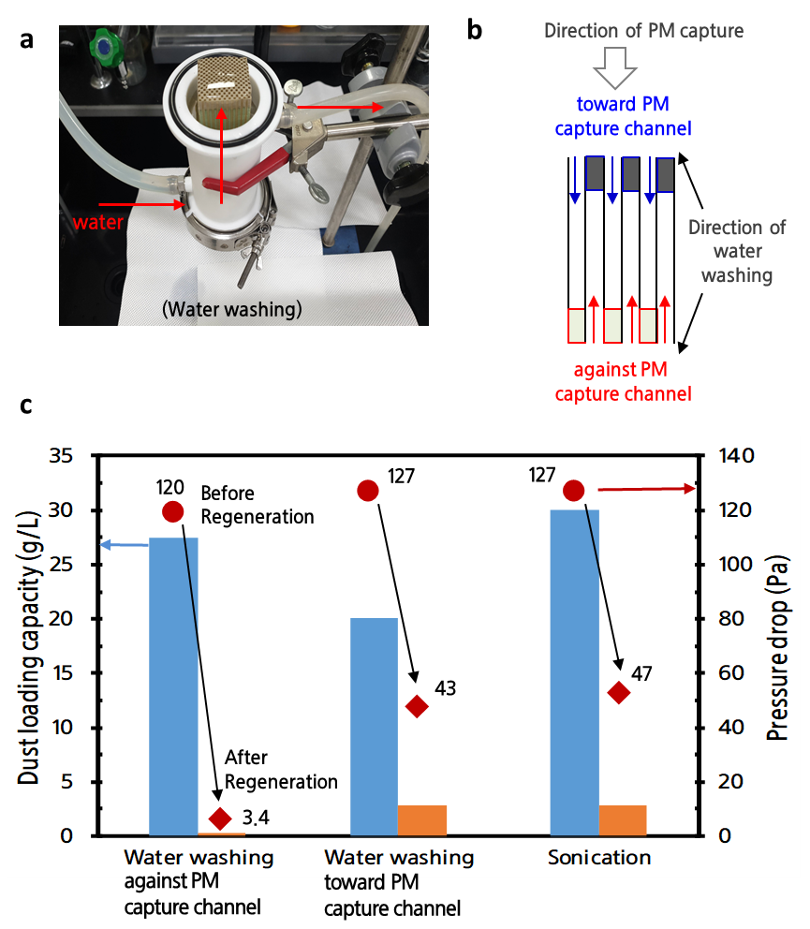

Extended Data Fig. 7 ǀ Regeneration of CCF. a, Image and b, illustration of facile water washing of CCF. c, Regeneration performances (dust loading capacity and pressure drop) with respect to water washing and sonication.

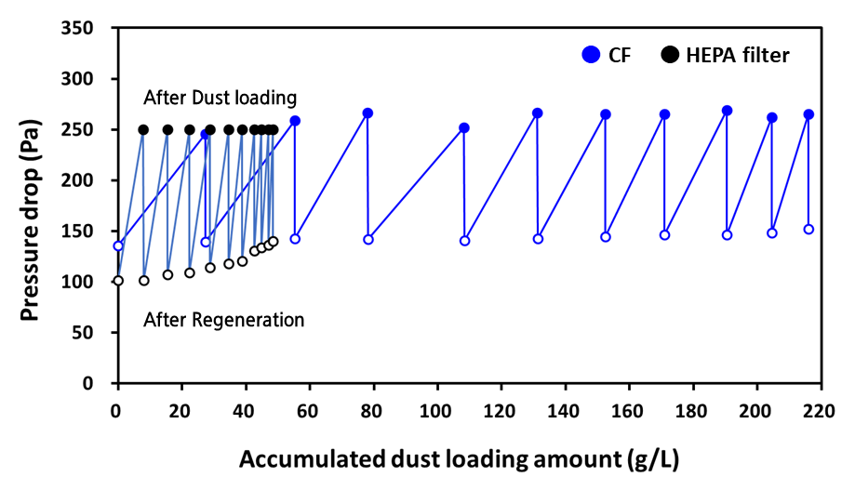

Extended Data Fig. 8 ǀ Regeneration with water washing of CF and commercial HEFA filter. (blue), dust loading amount profile of the CF according to regeneration cycles with water washing in the CF (total dust loading amount, 215.8 g/L, average 21.6 g/L). (black), dust loading amount profile of the HEFA filter according to the regeneration cycles with water washing in the HEFA filter (total dust loading amount, 48.4 g/L, average 4.8 g/L).

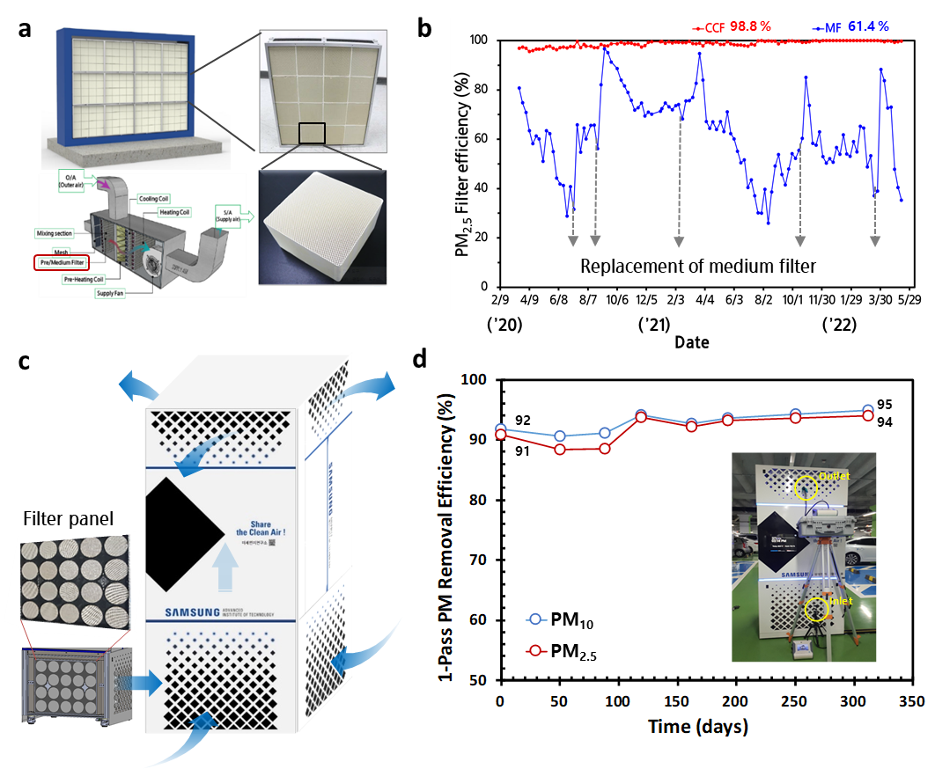

Extended Data Fig. 9 ǀ CF applications for sharing the clean air. a, CF panel system installed at the HVAC facility of the building. b, PM_{2.5} FE of CF and MF measured for 30 months in the building. c, Free-standing proto-type CF system. d, FE of PM₁₀ and PM_{2.5} of the proto-type CF system measured for approximately 12 months. The efficiency was measured using a single-pass test method, which assessed the concentration of inlet and outlet PMs using an isokinetic sampling probe, as shown in the inset.
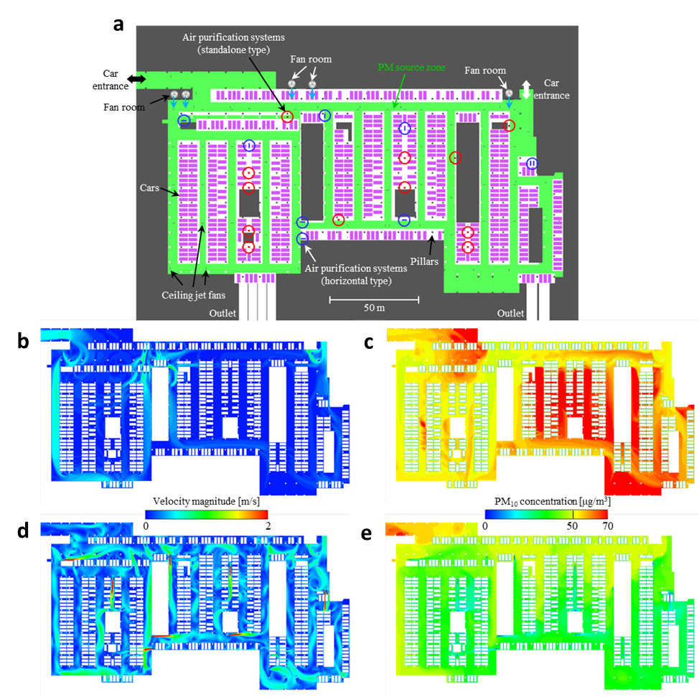

Extended Data Fig. 10 ǀ Results predicted from CFD simulation for an underground parking lot. a, Computational domain (top view). b, Contours of air velocity magnitude with only the fan rooms operating. c, Contours of PM₁₀ concentration with only the fan rooms operating. d, Contours of air velocity magnitude with the installation of 21 CCF proto systems and ceiling jet fans. e, Contours of PM₁₀ concentration with the installation of 21 CCF proto systems and ceiling jet fans. The locations of the CCF proto systems are represented by red (standalone, 4,000 m³/h) and blue (horizontal, 8,000 m³/h) circles in a. All results were obtained at 1 m above the floor level in b–e.
Extended Data Table 1 ǀ Physical properties of various commercial filters, and wall length and pressured drop estimated from the pressure drop model
Ceramic cell density (CPSI/mil) | 200/11.2 | 200/8.0 | 212/8.6
Channel height (mm) | 1.51 | 1.59 | 1.53
Wall thickness (mm) | 0.284 | 0.203 | 0.218
Nominal porosity (%) | 50.7 | 55.8 | 55.3
Median pore diameter (μm) | 15.03 | 13.2 | 13.5
Estimated permeability (m²) | 9.37E−13 | 1.01E−12 | 1.01E−12
Optimal porous-wall length (mm) | 119 | 105 | 102
Estimated pressure drop (Pa) | 111 | 71 | 89

Extended Data Table 2 ǀ Physical properties and measuring data: pressure drop and PM removal efficiency of bare and membraned ceramic filters (at 115 mm). Note that these properties were measured using mercury intrusion porosimetry (MIP).
Ceramic filters |  | Bare CF | Membraned CF
Material |  | Cordierite
Cell density (CPSI) / wall depth (mil) |  | 200 / 8.0
Mean pore diameter (μm) |  | 11.6 | 8.3
Porosity (%) |  | 54.0 | 55.9
Δp (pressure drop) (Pa) at 1 m/s |  | 62 | 136
Filter Efficiency (FE) (%)  at particle mass | PM₁ | 34.9 | 94.5
Filter Efficiency (FE) (%)  at particle mass | PM_{2.5-1} | 62.4 | 99.1
Filter Efficiency (FE) (%)  at particle mass | PM_{10-2.5} | 83.8 | 99.6
Filter Efficiency (FE) (%)  at particle mass | PM_{2.5} | 51.1 | 97.7
Filter Efficiency (FE) (%)  at particle mass | PM₁₀ | 53.6 | 98.0

Extended Data Table 3 ǀ CCF performance along the catalyst coating zone with lengths of 0 to 115 mm
CCF samples |  | 0 mm coating | 25 mm coating | 50 mm coating | 75 mm coating | 115 mm coating
Catalyst (g) |  | 0 | 1.89  (52.2 g/L) | 3.02  (41.7 g/L) | 4.58  (42.2 g/L) | 6.41  (38.8 g/L)
VOC removal efficiency (%)  at 10 L/min |  | - | 71.5 | 79.0 | 67.2 | 60.6
Initial Pressure drop (Pa)  at 1 m/s (86.8 L/min) |  | 137.6 | 163.2 | 208.9 | 286.2 | 551.0
Initial Filter Efficiency (%)  at particle mass | PM₁ | 95.3 | 92.2 | 89.8 | 85.5 | 80.8
Initial Filter Efficiency (%)  at particle mass | PM_{2.5–1} | 99.1 | 99.1 | 98.3 | 97.8 | 92.9
Initial Filter Efficiency (%)  at particle mass | PM_{10–2.5} | 99.5 | 99.8 | 99.5 | 99.1 | 93.2
Initial Filter Efficiency (%)  at particle mass | PM_{2.5} | 97.9 | 97.0 | 95.8 | 93.9 | 88.6
Initial Filter Efficiency (%)  at particle mass | PM₁₀ | 98.1 | 97.4 | 96.4 | 94.7 | 89.1

