Supplementary Information

Long-lifetime water-washable ceramic catalyst filter for air purification
Hyuk Jae Kwon^{1,7}*, Dong Sik Yang^{1,7}, Min Seok Koo^{1,7}, Sang Min Ji¹, Joonseon Jeong¹, Sehyeong Oh¹, Su Keun Kuk¹, Hyeon-su Heo¹, Dong Jin Ham¹, Mi Jong Kim¹, Hyoungwoo Choi¹, Jong-Min Lee¹, Joong-Won Shur², Woo-Jin Lee², Chang-Ook Bin², Nikolay Timofeev³, Wu Huiqing⁴, Liming Wang⁴, Taewoo Lee⁵, Daniel J. Jacob⁶, Jhoon Kim¹, Hyun Chul Lee¹*
Pressure drop prediction for CF selection
The model predicting the pressure drop of the CFs was investigated using continuity and momentum equations and Darcy’s law for porous wall developed by Masoudi et al.⁸ and Konstandopoulos & Johnson²². The model accuracy of 32 to 770 CPSI was compared to that of computational fluid dynamics (CFD) simulations (Fig. S1). To better understand the flow characteristics inside the CF channels, we investigated the velocity and pressure distributions of the CFs using CFD simulations. Extended Data Fig. 1a shows the contours of the streamwise velocity, static pressure, and wall-normal velocity. Along the streamwise direction, the streamwise velocity decreased at the inlet channel but increased at the outlet channel owing to the through-wall flow. The static pressure decreased along the streamwise direction owing to the skin friction force. The wall-normal velocity was fastest at the end of inlet channel, implying that the pressure drop across the wall was greatest at this position because of Darcy’s law. Note that the contours of streamwise velocity and static pressure are at the channel centre plane, whereas the contours of wall-normal velocity are at the wall centre plane. Extended Data Fig. 1b shows the predicted pressure drop of the CFs with the porous-wall length (excluding the plug length). As the porous-wall length decreases to zero, the pressure drop increases because the through-wall velocity is increased. When the porous-wall length approaches infinity, the pressure drop also increases because the viscous friction at the channel wall becomes significant. The optimal porous-wall lengths were observed in the range of 60–120 mm, which is the minimum pressure drop range of 46–300 CPSI (number of cells/wall thickness). Therefore, we selected a suitable commercial CF with approximately 200 CPSI because CPSI values lower than 200 CPSI, such as 46 and 100 CPSI, exhibit low amounts of catalyst per given area for light illumination, whereas CPSI values higher than 200 exhibit a high pressure drop in the optimal range of the filter length.

Ray tracing simulation
Two cases of filter illumination were considered, as shown in Extended Data Fig. 6: (a) one LED on the central axis and (b) 2x2 LED array. The light source to CCF distance was varied in the range of 10–50 mm. There was a set of detectors inside the CCF at different distances from the front face of the CCF with a step of 5 mm. One set of detectors indicated by a red dot in Extended Data Fig. 6a, b was disposed on the axis of one LED (a) and another set of detectors indicated by a blue dot was in front of one of the 2 × 2 LEDs (b). Extended Data Fig. 6c qualitatively illustrates the depth of light penetration inside the CCF in case of one LED. The longest penetration length was observed to exhibit light rays close to the optical axis and propagate nearly parallel to the cell walls. The power of the slanted light rays decays quickly in the beginning of the cells. The reason for this behaviour is the relatively high absorption/reflection ratio (73/27) characterising the TiO₂ coating used in the modelling. Slanted light rays “attack” the cell walls in the beginning of CCF and lose their power very quickly after a few bounces. Extended Data Fig. 6d–i illustrates the light power density inside CCF at different distances from the front face for the “red” and “blue” detectors and for two light source cases (a and b). The maximum length of light propagation inside the CCF was observed to be 20–30 mm along the CCF length.

CFD simulation for underground parking lot
For the application of air purification systems equipped with CCFs, we focused on an underground parking lot located in Hwaseong city, Republic of Korea. There are 2 car entrances and 3 fan rooms at the upper side of parking lot (Extended Data Fig. 10a). Two outlets exist at the lower side of parking lot for ventilation. In addition, 84 jet fans were installed in the ceiling aid deliver air. For the CFD simulations, we developed a 3D CAD model of an underground parking lot, including 21 air purification systems (9 horizontal-type for 8,000 m³/h and 12 standalone-type for 4,000 m³/h), underground offices, pillars, cars, and ceiling jet fans. In the fan rooms, we applied velocity-inlet boundary conditions which correspond to volumetric flow rates of 71,000, 106,500, and 35,000 m³/h. In the car entrances and outlets, zero-gauge pressure was assumed. For the other walls, we used a no-slip boundary condition with standard wall functions. The flow rates of the air purification systems were 8,000 and 4,000 m³/h for the horizontal and standalone types, respectively. In addition, the flow rate of a ceiling jet fan was set at 2,280 m³/h. For PM, the PM₁₀ concentration of intake air flow through the fan rooms was set at 50 μg/m³. The PM removal efficiency of the air purification system was set at 0.9 based on the experimental results. For the estimation of the traffic-related PM emission, we assumed that the parking lot traffic type to be stagnant city traffic and all vehicles to be passenger cars, i.e. the PM emission per driven kilometre was 0.039 g/km⁽²⁹⁾. We assumed that the number of vehicles passing the through roads was 1500 cars/day and the mean driven kilometres by each car was 0.5 km/car, from which the daily PM emission of 29.25 g/day was calculated. This PM emission was modelled as a source term, which was uniformly imposed in a volume (represented by a green surface in Extended Data Fig. 10a) with the height in the range of 0–1.5 m⁽³⁰⁾. Extended Data Fig. 10b shows the contours of velocity magnitude 1 m above the floor level when only the fan rooms are in operation. We found some quiescent zones in the middle and lower- parts where the magnitude of velocity was small. Consequently, the PM₁₀ concentration was relatively high in those regions because the PM had accumulated (Extended Data Fig. 10c). Extended Data Fig. 10d represents the contours of magnitude of velocity in the presence of air purification systems in conjunction with ceiling jet fans. Well-distributed flow patterns were displayed by air purification systems and ceiling jet fans. As a result, the overall PM₁₀ concentration was significantly lower than that of the uncontrolled case, indicating a reduction of 32% by volume-average concentration (Extended Data Fig. 10e). The results show that the air purification systems with CCFs may be applied for the reduction of PM concentration of semi-indoor spaces, such as underground parking lots, with the ingress of external air.

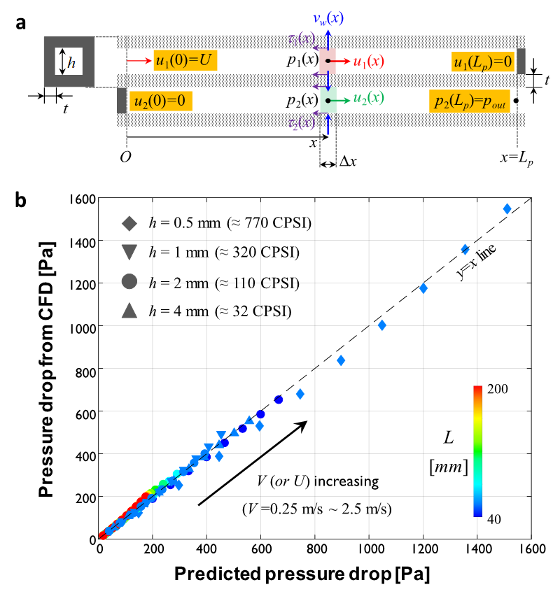

Fig. S1 ǀ Modelling and CFD simulation of the CF. a, Modelling of the CF, where u: streamwise velocity, v_{w}: transverse velocity at the porous wall, p: pressure, and τ: wall shear stress. b, Comparison between the pressure drop from CFD and model-predicted pressure drop of CF.

