Supporting Information
Presence and role of viruses in anaerobic digestion of food waste under environmental variability
Authors: Lu Fanª, Wei Peng^{a,b,c,*}, Haowen Duanª, Fan Lü^{a,b,c}, Hua Zhang^{a,b,c}, Pinjing He ^{a,b,c,*}

Affiliation:
a Institute of Waste Treatment and Reclamation, Tongji University, Shanghai, 200092, China
b Shanghai Institute of Pollution Control and Ecological Security, Shanghai, 200092, China
c Shanghai Engineering Research Center of Multi-Source Solid Wastes Co-processing and Energy Utilization, Shanghai, 200092, China

*Correspondence to: Pinjing He, email: solidwaste@tongji.edu.cn; Wei Peng, email: weipeng@tongji.edu.cn.

Supplementary Descriptions
Description S1. Details of the operation of incubation reactors
Slurry from LG was activated as inoculum in three reactors for 12 days. Feeding every four days from October 9, 2021, and the feeding of the three reactors remained the same for 44 days. Starting from the 45th day, the feeding was adjusted according the needs of the group and a semi-continuous feeding strategy of every two days was implemented. The specific daily feeding information shown in Table S1. The feedstock was replenished through the reactor inlet and a sterile injection syringe was used to collect solid-liquid mixture through the outlet. The fresh mixture was stored at -40 °C for further analysis. Gas sampling bag was used to collect biogas. Biogas production was counted using the peristaltic pump with a gas meter. Biogas components (CH₄ and CO₂) were measured using biogas analyzer (Geotech, Britain) which connected to reactor for real-time measurement during sampling.

Figure S1. Taxonomic assignments of vOTUs in five full-scale reactors. The label “Unclassified Family” means the vOTU could not be attributed to a specific family, but can be annotated at genus or species level. The label “Others” represented the total relative abundance of remaining taxa.
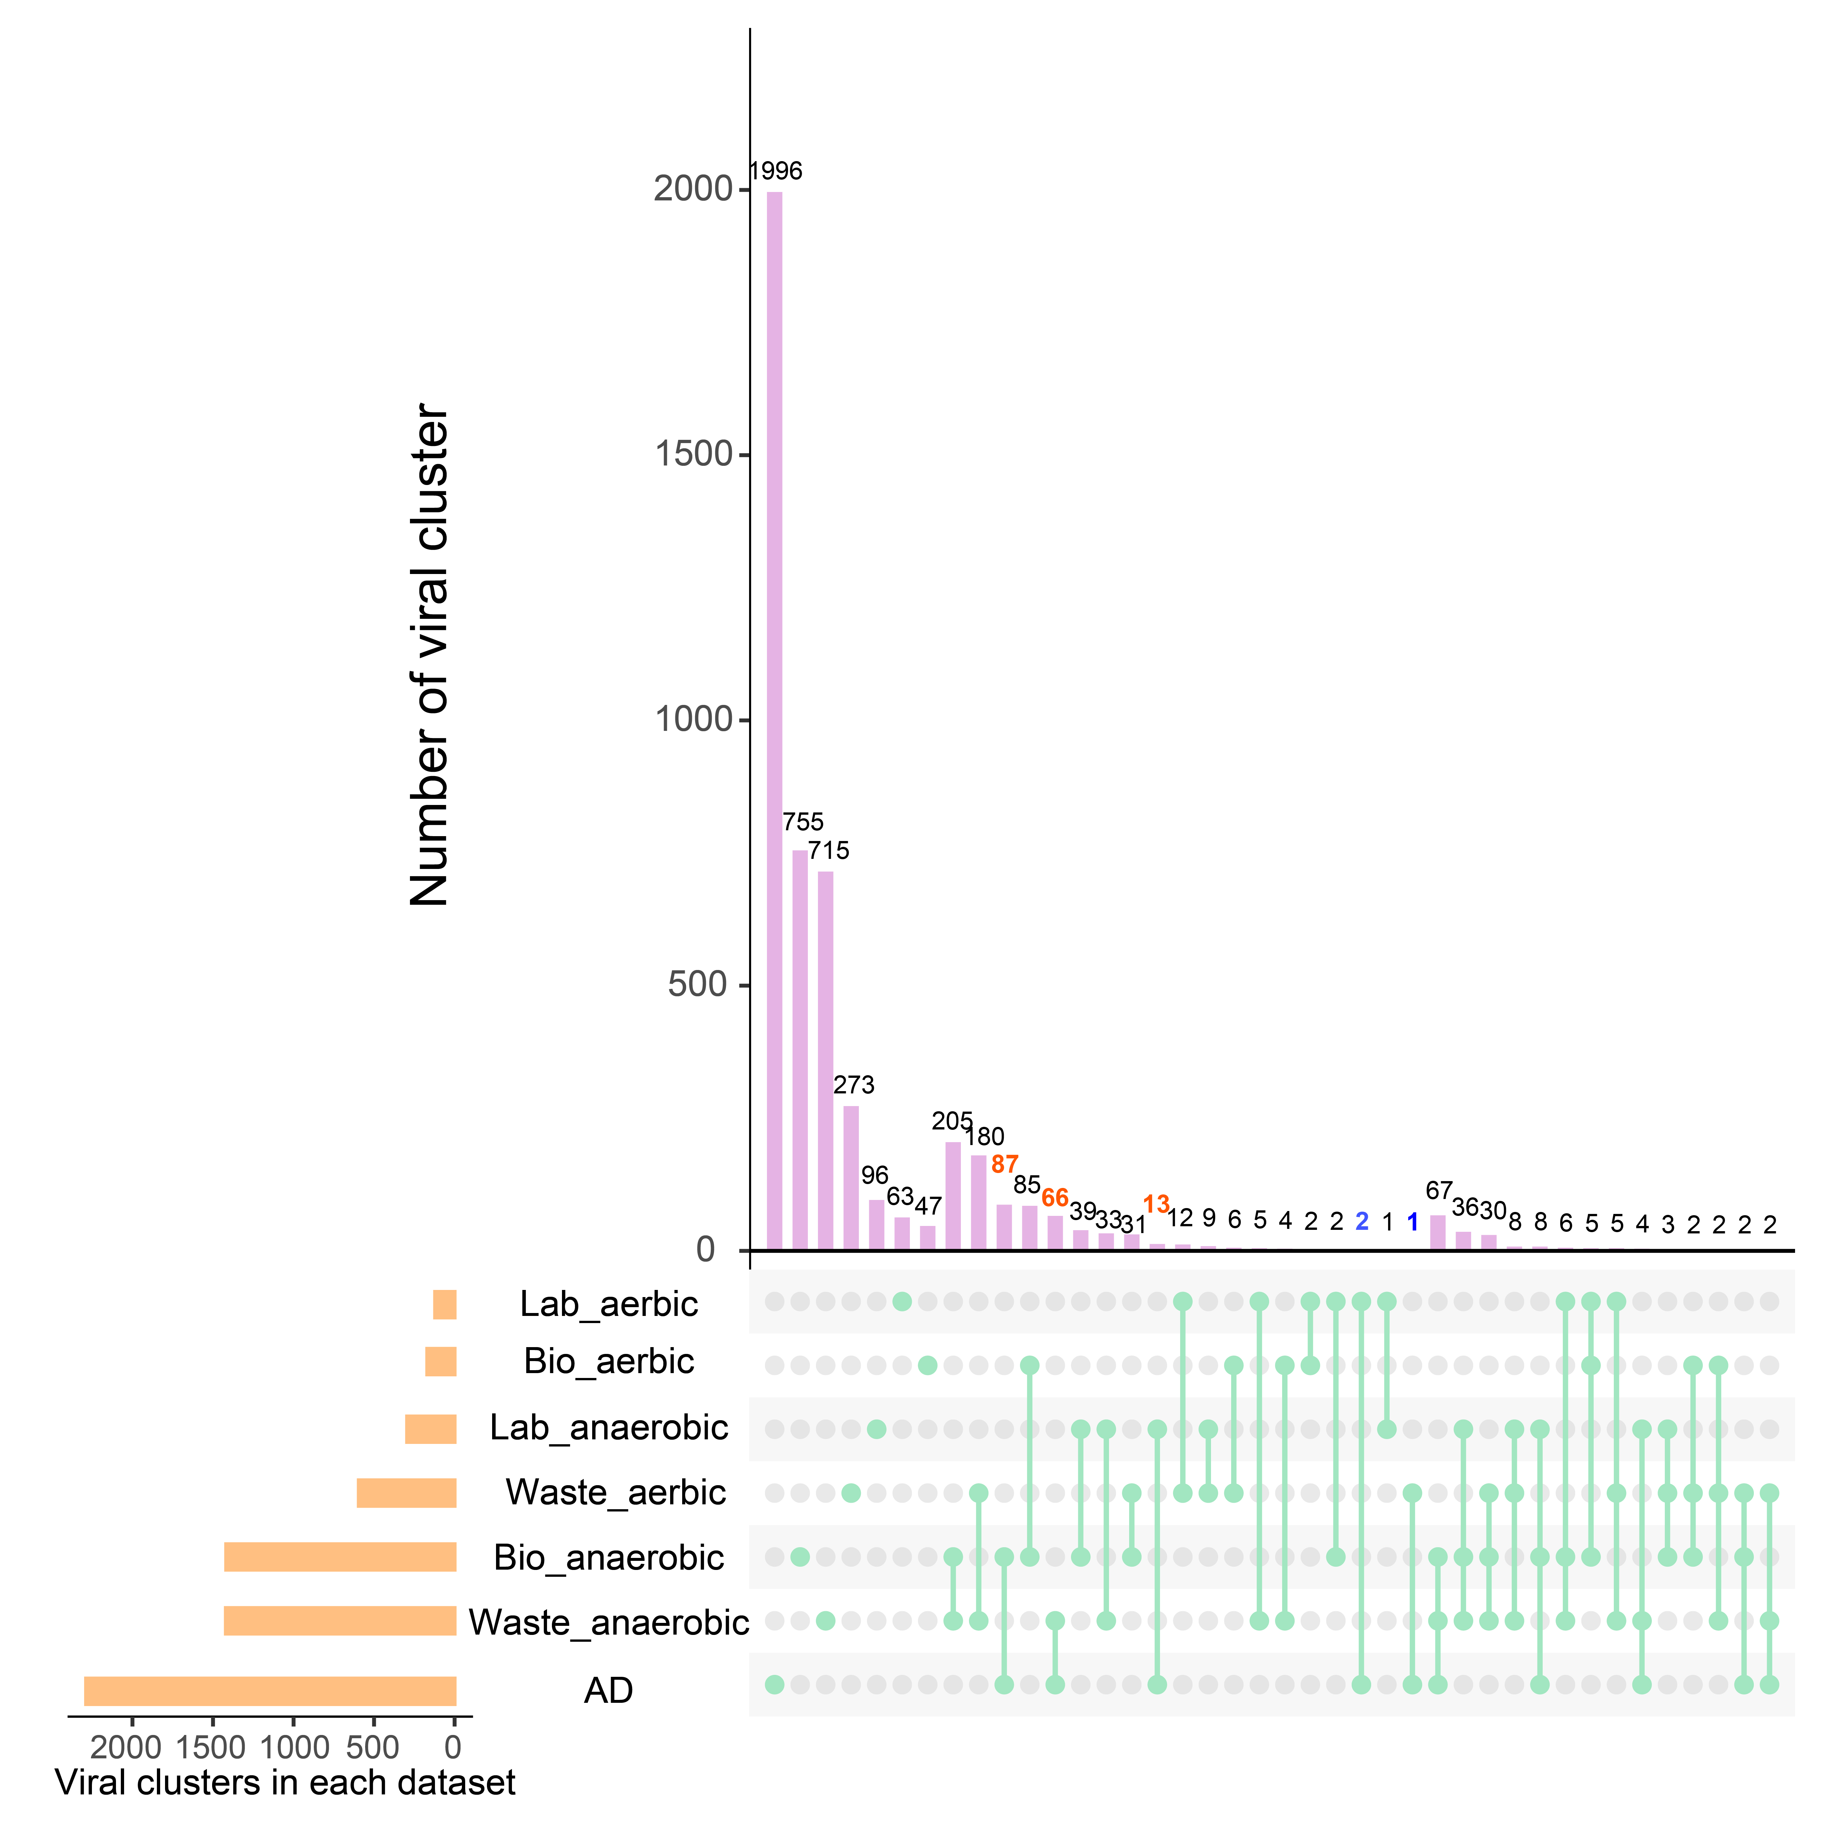
Figure S2. The UpSet chart of shared viral clusters among AD and other ecosystems. The numbers of shared clusters between AD and anaerobic environments, AD and aerobic environments are labeled orange and blue, respectively. “Lab”, “Bio”, and “Waste” denoted the IMG/VR v3.0 taxonomy units: lab enrichment, bioreactor, and wastewater.

Figure S3. Relative abundance (%) of viral taxa at family level with predicted annotation in lab-scale reactors.

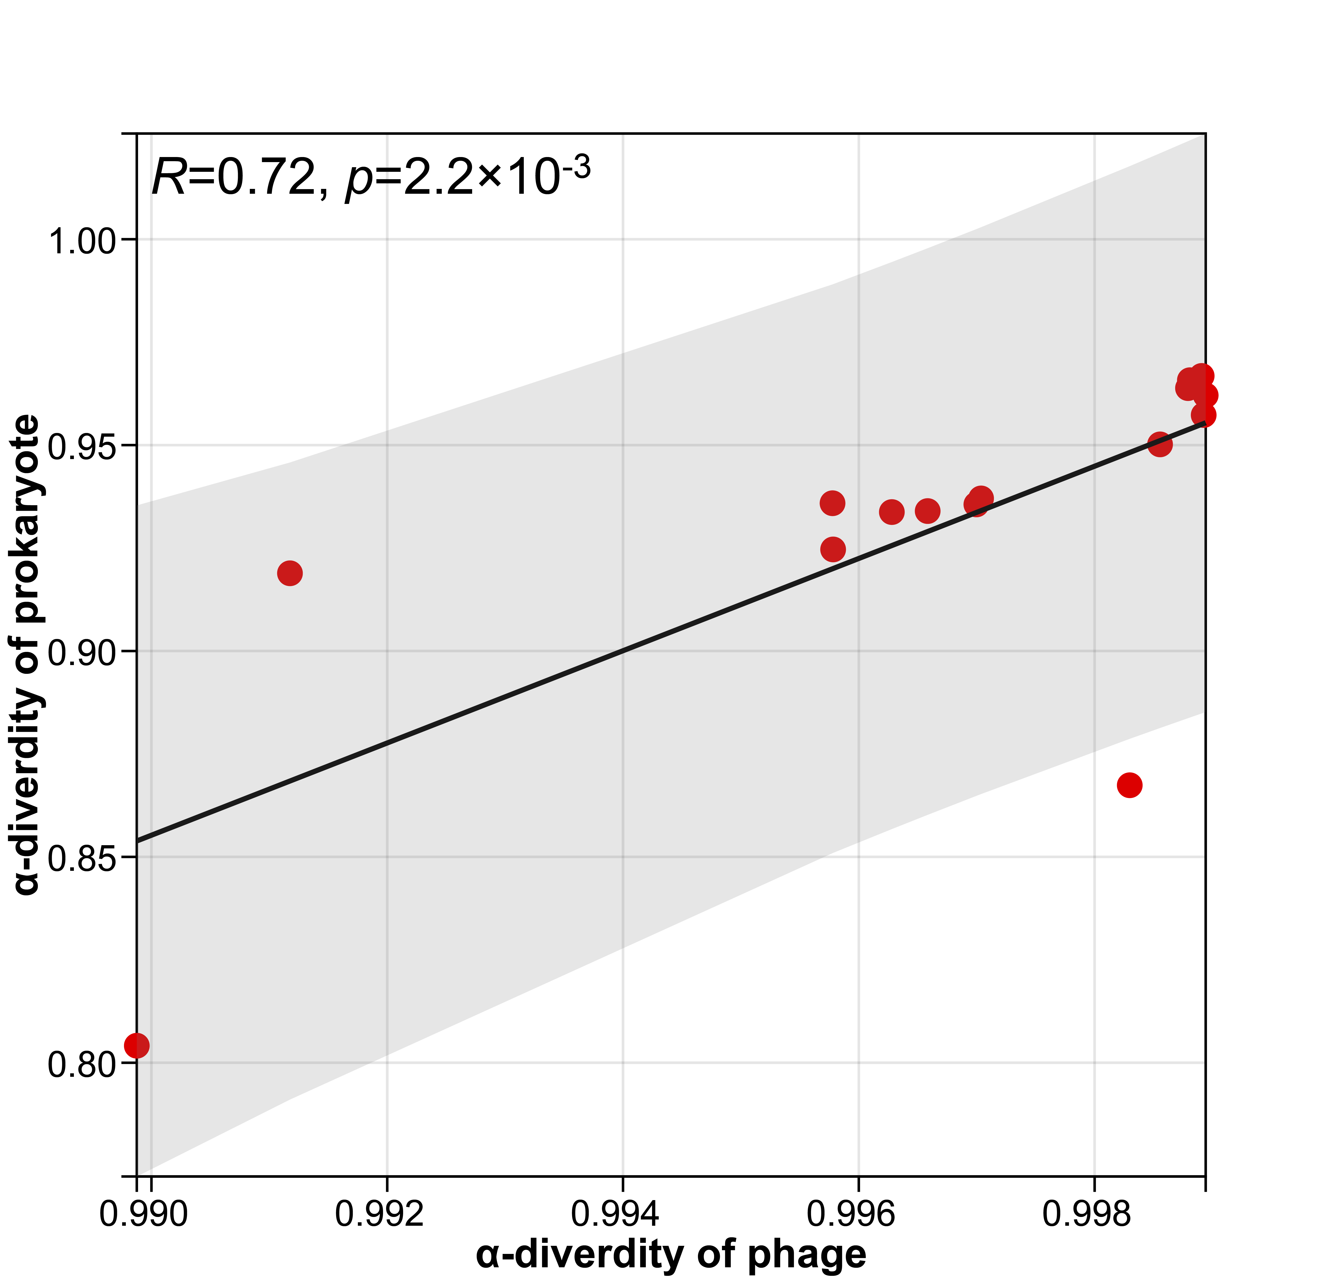
Figure S4. Pearson correlations of Simpson index between viruses and prokaryotes.

Figure S5. The charts show the relative abundance (%) of prokaryotes taxa at phylum level in lab-scale reactors. “Others” denotes the total relative abundance of remaining taxa.

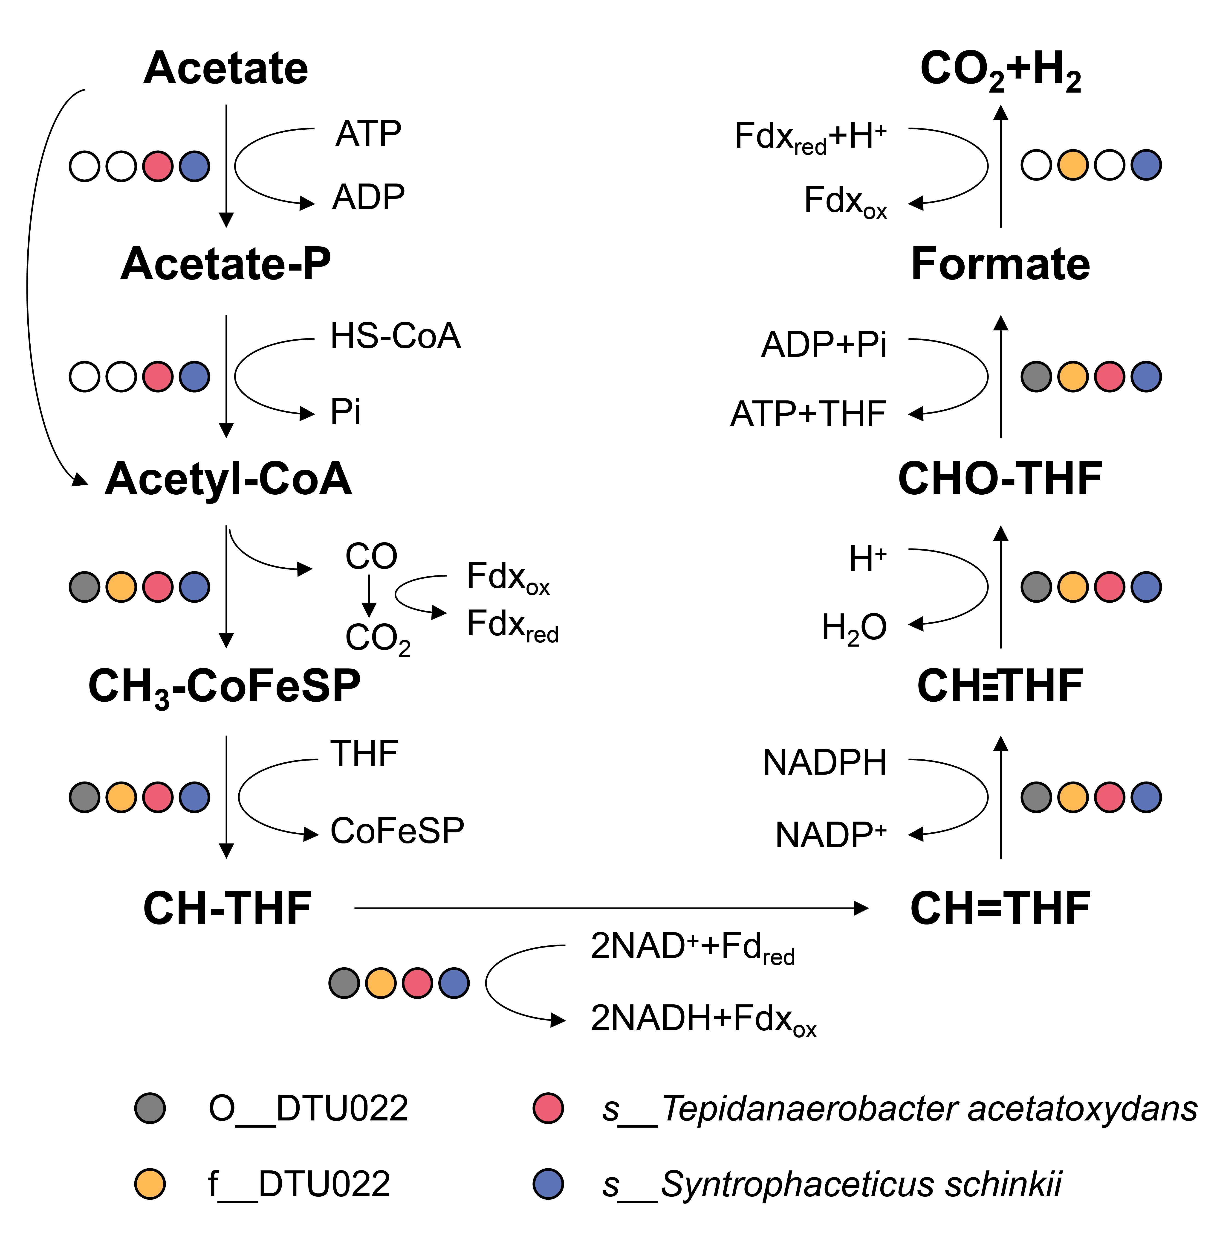
Figure S6. The metabolic pathway of acetate oxidation through the oxidative Wood-Ljungdahl (WL) pathway.
Figure S7. A network representing CRISPR-based interactions from all samples involving the viruses (circle nodes) and their hosts (square nodes). The edges represent the Pearson correlation between viruses and their hosts.

Figure S8. Networks of key functional microorganisms and viruses interactions. (a) SRB; (b) SAOB; (c) Archaea. The circle nodes represent viruses and square node are used to indicate hosts. The edges linking two points are calculated by Pearson correlation.

Figure S9. Pearson correlations between SAOB and their viruses across 15 samples.

