Supplemental Methods—Calculation formulas for the models

CT score = 0.089 +
0.315* ShortRunEmphasis_AllDirection_offset7_SD+
0.260* MinIntensity+
0.236* Quantile0.025+
0.203* GLCMEnergy_angle45_offset7-
0.013*VoxelValueSum -
0.199* GLCMEntropy_AllDirection_offset1_SD +
0.404* ClusterProminence_AllDirection_offset7_SD+
0.051* LongRunLowGreyLevelEmphasis_angle90_offset1+
0.514*LowIntensitySmallAreaEmphasis+
0.361* ShortRunLowGreyLevelEmphasis_AllDirection_offset4_SD+
0.122* LongRunEmphasis_angle0_offset1+
0.017*LongRunLowGreyLevelEmphasis_angle0_offset4+
0.385* GLCMEnergy_angle0_offset7-
0.209* GLCMEntropy_angle45_offset7+
0.350* LongRunEmphasis_AllDirection_offset1+
0.254*LongRunLowGreyLevelEmphasis_angle0_offset1
PET score =0.089+
0.569* GLCMEnergy_angle0_offset7-
0.351* ShortRunEmphasis_angle90_offset1-
0.372* Variance+
0.123* ClusterProminence_angle90_offset4+
0.845* InverseDifferenceMoment_angle0_offset4-
1.280* ClusterProminence_angle45_offset1-
0.349* LongRunHighGreyLevelEmphasis_AllDirection_offset1+
0.240* InverseDifferenceMoment_angle90_offset1+
1.057* IntensityVariability-
0.181* Inertia_angle0_offset4+
0.534* LongRunHighGreyLevelEmphasis_angle135_offset1+
1.222* ShortRunHighGreyLevelEmphasis_AllDirection_offset1_SD+
0.617* Inertia_angle90_offset4+
0.137* LongRunHighGreyLevelEmphasis_angle0_offset4-
1.091* ClusterProminence_AllDirection_offset1_SD-
0.349* uniformity+
0.112* LongRunHighGreyLevelEmphasis_angle45_offset1+
1.522* Percentile90-
1.381* HaralickCorrelation_AllDirection_offset1_SD
Integrated score =-0.067+
0.356* LongRunEmphasis_angle0_offset4+
0.206* GLCMEnergy_angle90_offset7+
0.558*LowIntensitySmallAreaEmphasis+
0.317*Inertia_AllDirection_offset1_SD+
0.020* LongRunHighGreyLevelEmphasis_angle90_offset1+
0.480* LongRunLowGreyLevelEmphasis_angle135_offset7+
0.687* LongRunHighGreyLevelEmphasis_AllDirection_offset1+
0.030*skewness-
0.803*HaralickCorrelation_AllDirection_offset1_SD-
0.065*VoxelValueSum+
0.150* GLCMEnergy_angle0_offset4+
0.344* ClusterShade_angle90_offset7+
0.616* Percentile85+
1.554*ShortRunHighGreyLevelEmphasis_AllDirection_offset1_SD+
0.068*MinIntensity-
0.443*GLCMEntropy_AllDirection_offset1_SD+
0.520*inverseDifferenceMoment-
0.406* ClusterShade_angle45_offset1+
1.027*ShortRunEmphasis_AllDirection_offset4_SD-
0.972* ClusterProminence_angle90_offset4+
0.533* LongRunHighGreyLevelEmphasis_angle90_offset4+
1.212* ClusterShade_angle90_offset4-
1.081*ClusterProminence_AllDirection_offset1_SD+
0.607* LongRunLowGreyLevelEmphasis_angle90_offset1+
0.376* LongRunEmphasis_angle90_offset1
Features of PET combined with CT radiomics include:LongRunEmphasis_angle0_offset4(P), GLCMEnergy_angle90_offset7(T), LowIntensitySmallAreaEmphasis(T), Inertia_AllDirection_offset1_SD(P), LongRunHighGreyLevelEmphasis_angle90_offset1(P), LongRunLowGreyLevelEmphasis_angle135_offset7(T), LongRunHighGreyLevelEmphasis_AllDirection_offset1(T), skewness(P), HaralickCorrelation_AllDirection_offset1_SD(P), VoxelValueSum(T), GLCMEnergy_angle0_offset4(T), ClusterShade_angle90_offset7(T), Percentile85(T), ShortRunHighGreyLevelEmphasis_AllDirection_offset1_SD(P), MinIntensity(T), GLCMEntropy_AllDirection_offset1_SD(T), inverseDifferenceMoment(P), ClusterShade_angle45_offset1(P), ShortRunEmphasis_AllDirection_offset4_SD(T), ClusterProminence_angle90_offset4(T), LongRunHighGreyLevelEmphasis_angle90_offset4(P), ClusterShade_angle90_offset4(P), ClusterProminence_AllDirection_offset1_SD(P), LongRunLowGreyLevelEmphasis_angle90_offset1(T), LongRunEmphasis_angle90_offset1(T).
(T) indicates that the feature comes from the CT image, (P) indicates that the feature comes from the PET image.

Supplemental Figures
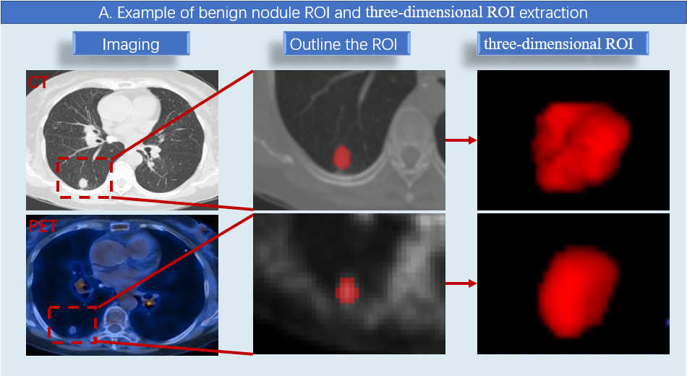
Fig. S1—Seventy-six-year-old woman with postoperative pathological diagnosis of granulomatous lesions, nodules sized approximately 1.4 cm × 1.2 cm. CT; computed tomography, PET; positron emission tomography, ROI; region of interest.

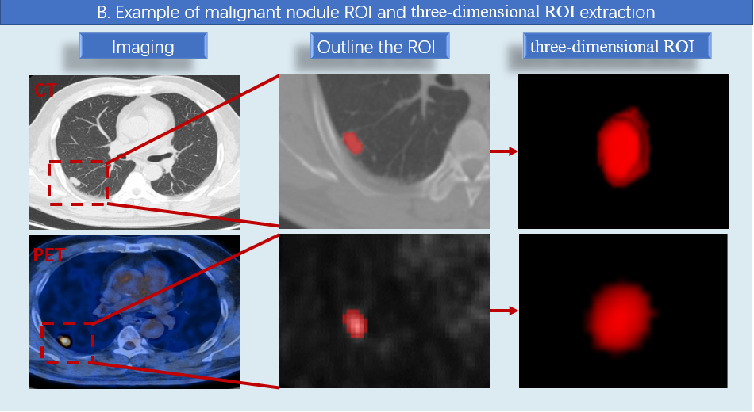
Fig. S2—Fifty-three-year-old man with postoperative pathological diagnosis of adenosquamous carcinoma, nodules sized approximately: 2.1 cm × 1.0 cm. CT; computed tomography, PET; positron emission tomography, ROI; region of interest.

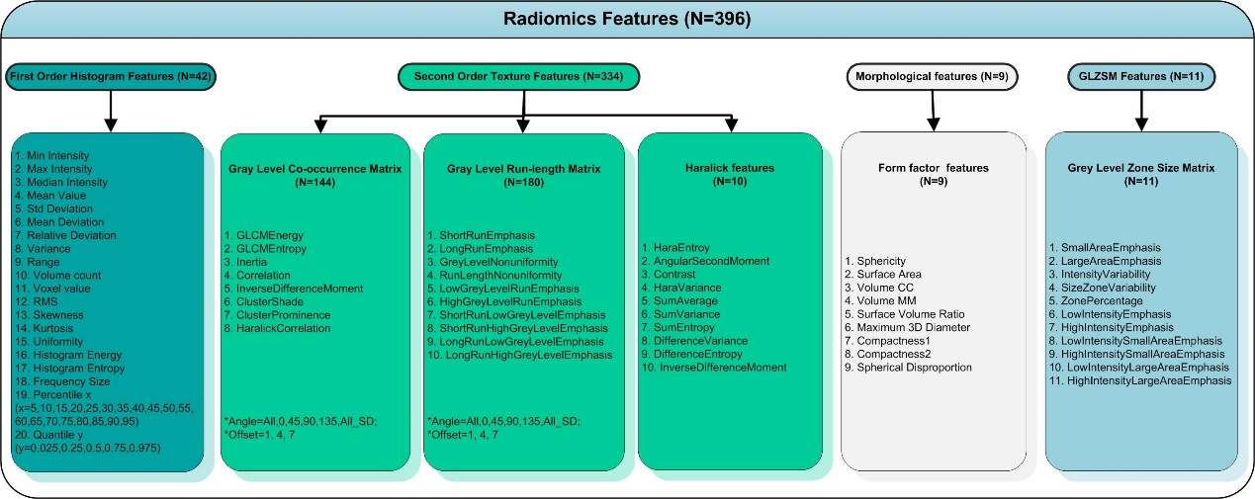
Fig. S3—Details of radiomics features

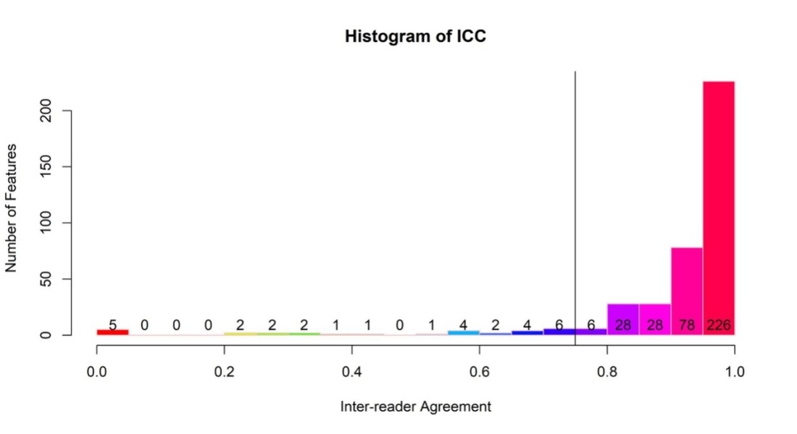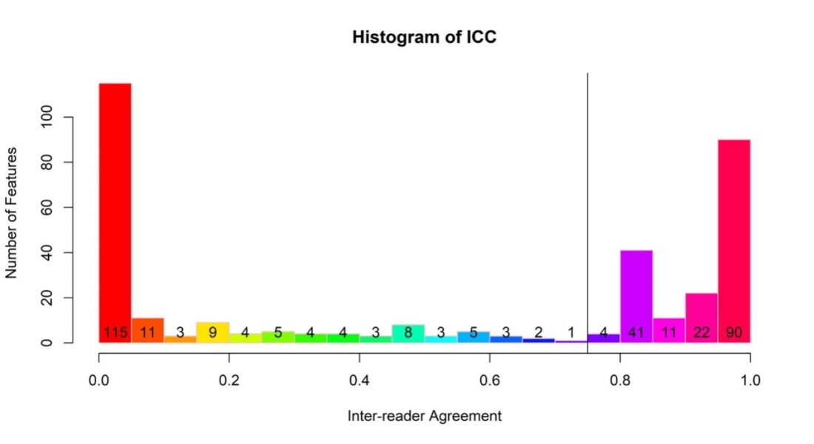
Fig. S4—Intraclass Correlation Coefficient (ICC) results.

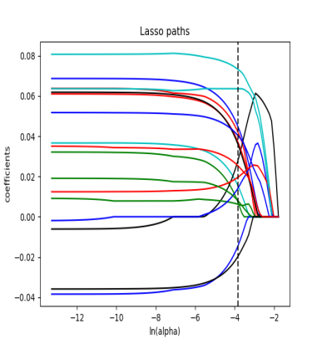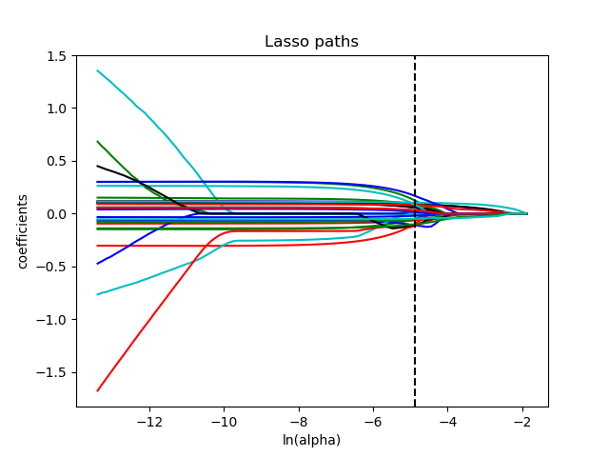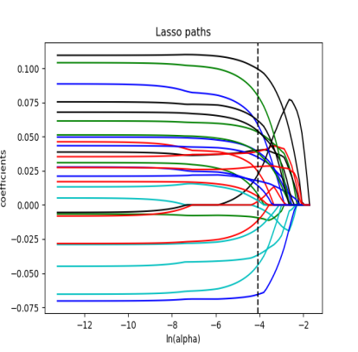
Fig. S5—From left to right: LASSO images of CT alone, PET alone, and CT combined with PET. CT; computed tomography, PET; positron emission tomography, LASSO; least absolute shrinkage and selection operator.

