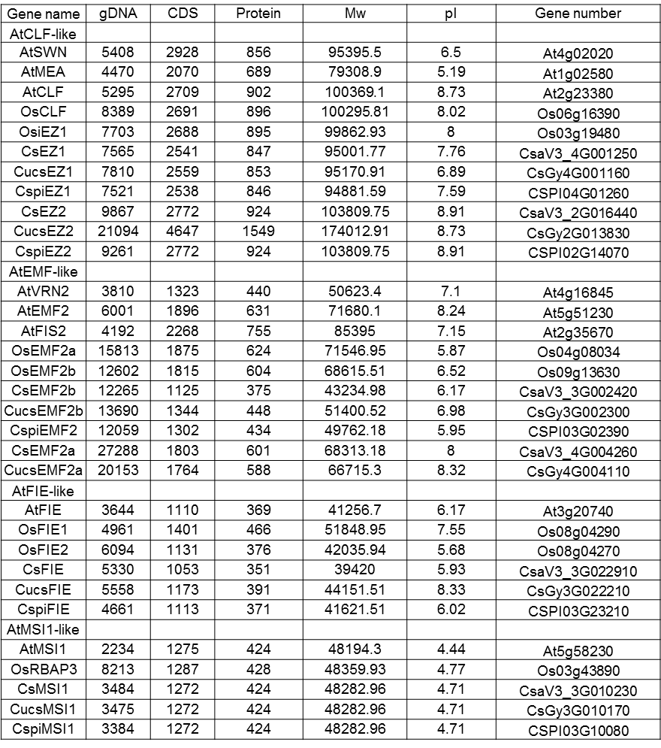
- Characteristics of the putative cucumber PRC2 core genes.

