Additional Figure legends

Additional Figure 1. Changes in body weight among airway models

Additional Figure 2. Inflammatory cytokines. (A) Level of IL-6 in lung homogenates, (B) Tumor necrosis factor-α (TNF-α) in BALF.
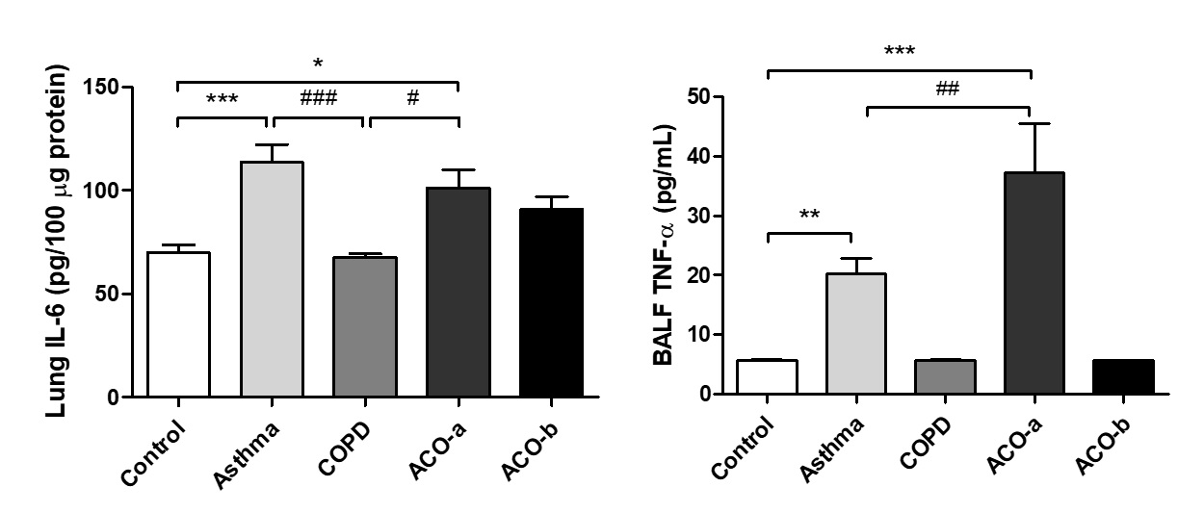
BALF, bronchoalveolar lavage fluid; IL, interleukin

