Article
Whole genome analysis of Comamonas sp. USTBZA1 for biodegrading diethyl phthalate
Zhenzhen Zhao ¹, Chao Liu ¹, Qianqian Xu ¹, Meijie Song, Hai Yan ^{1,}*
1 School of Chemistry and Biological Engineering, University of Science and Technology Beijing, Beijing 100083, China
*Corresponding author: Prof Hai Yan; mail: haiyan@ustb.edu.cn.
Table S1. Reported esterase /hydrolases for PAEs hydrolysis.
Enzyme | Genbank Number | Bacterium | Reference
EstS1, Triacylglycerol lipase | AEW03609.1 | Sulfobacillus acidophilus DSM10332 | [1]
dialkyl PE hydrolase | AFK31309.1 | Acinetobacter sp. M673 | [2]
DphA, dialkyl PEs hydrolase | AGY55959.1 | uncultured bacterium，Metagenomic library | [3]
DphB, dialkyl PEs hydrolase | AGY55960.1 | uncultured bacterium，Metagenomic library | [3]
EstG, esterase | AJO67804.1 | Sphingobium sp. SM42 | [4]
Lipase (EstSP1) | WP_010186968.1 | Sphingomonas sp. PAMC 26605 | [5]
monoethylhexylphthalate hydrolase | BAE78500.1 | Gordonia sp. P8219 | [6]
MEHP hydrolase (MehpH) , mono-ethylhexylphthalate hydrolase | BAU22081.1 | Rhodococcus sp. EG-5 | [7]
carboxylesterase | AIZ00845.1 | Bacillus sp. K91 | [8]
alpha/beta hydrolase | WP_011541842.1 | Sphingopyxis alaskensis RB2256 | [9]
Table S2. Characteristic parameters of DEP and its products by LC/MS analysis.
No. | Compound | CAS number | Formula | Molecular weight | Retention time (min) | m/z (type)
Ⅰ | Diethyl phthalate (DEP) | 84-66-2 | C₁₂H₁₄O₄ | 222.237 | 11.438 | 221.0820 [M-H]⁻
Ⅱ | Monoethyl phthalate (MEP) | 2306-33-4 | C₁₀H₁₀O₄ | 194.184 | 6.600 | 193.0506 [M-H]⁻
Ⅲ | Phthalic acid (PA) | 88-99-3 | C₈H₆O₄ | 166.131 | 1.160 | 165.0195 [M-H]⁻
Table S3. The bioinformatics job for whole-genome sequencing.
 | Before filtering | After filtering | Filtering result
total reads | 9.955978 M | 9.878178 M | -
total bases | 1.493397 G | 1.470048 G | -
Q20 bases | 1.465249 G (98.115182%) | 1.446919 G (98.426610%) | -
Q30 bases | 1.411102 G (94.489442%) | 1.394951 G (94.891512%) | -
GC content | 60.714899% | 60.756047% | -
reads passed filters | - | - | 9.878178 M (99.218560%)
reads with low quality | - | - | 75.774000 K (0.761090%)
reads with too many N | - | - | 820 (0.008236%)
reads too short | - | - | 1.206000 K (0.012113%)
Table S4. Genome properties and statistics of Comamonas sp. USTBZA1.
Features | Value
Genome size | 5684228 bp
DNA scaffolds | 90
DNA G + C content (%) | 60.76
Scaffold N50 length | 319259
Total genes | 4776366
number of CDSs | 5248
tRNA genes | 78
rRNA operon | 6
Genes assigned to KEGG | 2470
Genes assigned to COGs | 4273
Genes with Pfam domains | 4167
CRISPR repeats | 0

Table S5. Gene numbers involved in xenobiotics biodegradation pathways in strain USTBZA1.
Number | Pathway ID | Description | Gene number
1 | ko00362 | Benzoate degradation | 87
2 | ko00625 | Chloroalkane and chloroalkene degradation | 6
3 | ko00626 | Naphthalene degradation | 6
4 | ko00930 | Caprolactam degradation | 6
5 | ko00621 | Dioxin degradation | 16
6 | ko00980 | Metabolism of xenobiotics by cytochrome P450 | 9
7 | ko00642 | Ethylbenzene degradation | 3
8 | ko00982 | Drug metabolism - cytochrome P450 | 10
9 | ko00627 | Aminobenzoate degradation | 20
10 | ko00361 | Chlorocyclohexane and chlorobenzene degradation | 13
11 | ko00984 | Steroid degradation | 11
12 | ko00791 | Atrazine degradation | 3
13 | ko00622 | Xylene degradation | 20
14 | ko00364 | Fluorobenzoate degradation | 8
15 | ko00983 | Drug metabolism - other enzymes | 13
16 | ko00624 | Polycyclic aromatic hydrocarbon degradation | 21
17 | ko00623 | Toluene degradation | 11
18 | ko00643 | Styrene degradation | 9
19 | ko00633 | Nitrotoluene degradation | 3
Table S6. Genes (pht and lig) involved in PA biodegradation in Comamonas sp. USTBZA1.
Location | Gene ID | Gene Name | Length (bp) | Swiss-Prot Description
Scaffold 5 | gene2750 | ligC | 960 | 2-hydroxy-4-carboxymuconate semialdehyde hemiacetal dehydrogenase [EC: 1.1.1.312]
Scaffold 5 | gene2751 | ligB | 870 | protocatechuate 4,5-dioxygenase, beta chain [EC: 1.13.11.8]
Scaffold 5 | gene2752 | ligA | 450 | protocatechuate 4,5-dioxygenase, alpha chain [EC: 1.13.11.8]
Scaffold 5 | gene2753 | ligI | 918 | 2-pyrone-4,6-dicarboxylate lactonase [EC: 3.1.1.57]
Scaffold 5 | gene2755 | ligK | 684 | 4-hydroxy-4-methyl-2-oxoglutarate aldolase [EC: 4.1.3.17]
Scaffold 5 | gene2756 | ligJ | 1029 | 4-oxalmesaconate hydratase [EC: 4.2.1.83]
Scaffold 5 | gene2757 | pcaK | 1398 | 4-hydroxybenzoate transporter
Scaffold 18 | gene4474 | pht3 | 1332 | phthalate 4,5-dioxygenase [EC: 1.14.12.7]
Scaffold 18 | gene4475 | pht4 | 1005 | phthalate 4,5-cis-dihydrodiol dehydrogenase [EC: 1.3.1.64]
Scaffold 18 | gene4477 | pht5 | 993 | 4,5-dihydroxyphthalate decarboxylase [EC: 4.1.1.55]
Scaffold 18 | gene4478 | pht1 | 1329 | phthalate transporter
Scaffold 18 | gene4479 | pht2 | 963 | phthalate 4, 5-dioxygenase reductase component [EC: 1.18.1.-]
Scaffold 19 | gene4551 | ligJ | 1035 | 4-oxalmesaconate hydratase [EC: 4.2.1.83]
Scaffold 19 | gene4552 | ligK | 684 | 4-hydroxy-4-methyl-2-oxoglutarate aldolase [EC: 4.1.3.17]
Scaffold 19 | gene4554 | ligI | 921 | 2-pyrone-4,6-dicarboxylate lactonase [EC: 3.1.1.57]
Scaffold 19 | gene4555 | ligA | 450 | protocatechuate 4,5-dioxygenase, alpha chain [EC: 1.13.11.8]
Scaffold 19 | gene4556 | ligB | 873 | protocatechuate 4,5-dioxygenase, beta chain [EC: 1.13.11.8]
Scaffold 19 | gene4557 | ligC | 960 | 2-hydroxy-4-carboxymuconate semialdehyde hemiacetal dehydrogenase[EC: 1.1.1.312]
Scaffold 19 | gene4582 | pht4 | 1119 | phthalate 4,5-cis-dihydrodiol dehydrogenase [EC: 1.3.1.64]
Scaffold 19 | gene4583 | pht2 | 939 | phthalate 4, 5-dioxygenase reductase component [EC: 1.18.1.-]
Scaffold 19 | gene4585 | pht5 | 963 | 4,5-dihydroxyphthalate decarboxylase [EC: 4.1.1.55]
Scaffold 19 | gene4586 | pht3 | 753 | phthalate 4,5-dioxygenase [EC: 1.14.12.7]

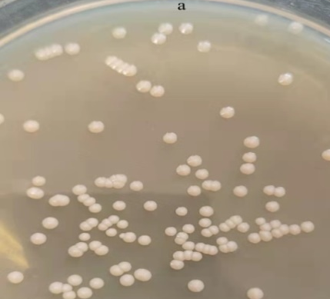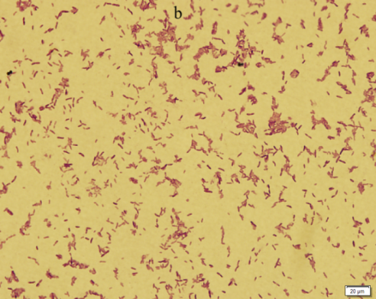
Figure S1. Colonies of strain USTBZA1 on a LB plate (a) and its photomicrograph (b).
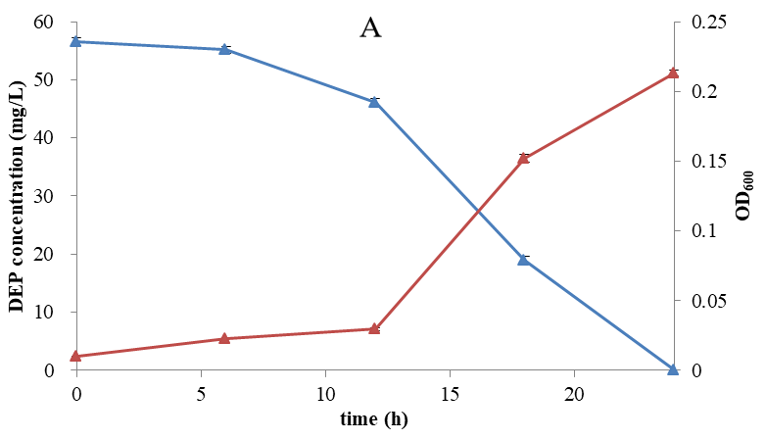
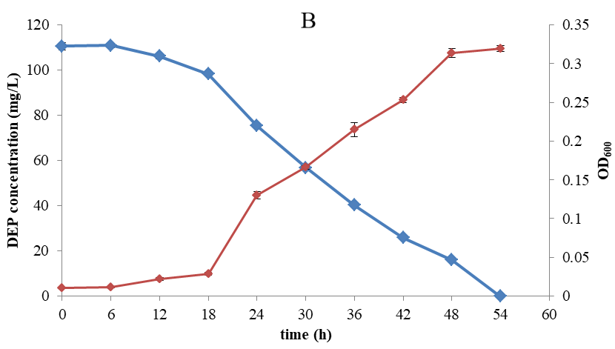
Figure S2. Time course of microbial growth (OD₆₀₀) and biodegradation curve of DEP by strain USTBZA1. A: at initial concentration of 55 mg/L; B: at initial concentration of 110 mg/L.

Figure S3. Biodegradation ratios of different substrates and the OD₆₀₀ of Comamonas sp. USTBZA1. The biodegradation time of DMP, DEP, MMP, MEP, PA and PCA was 1 day, the biodegradable time of DBP, BBP, DEHP and DOP were 3 day, 7 day, 10 day and 10 day, respectively.
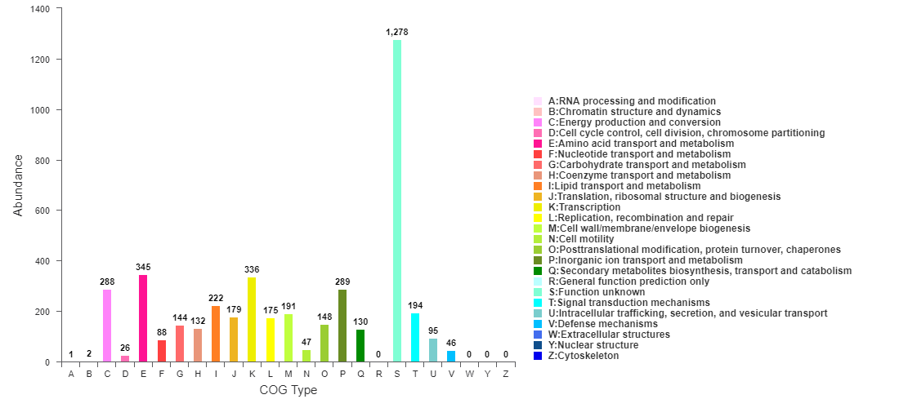
Figure S4. COG function classification of Comamonas sp. USTBZA1.
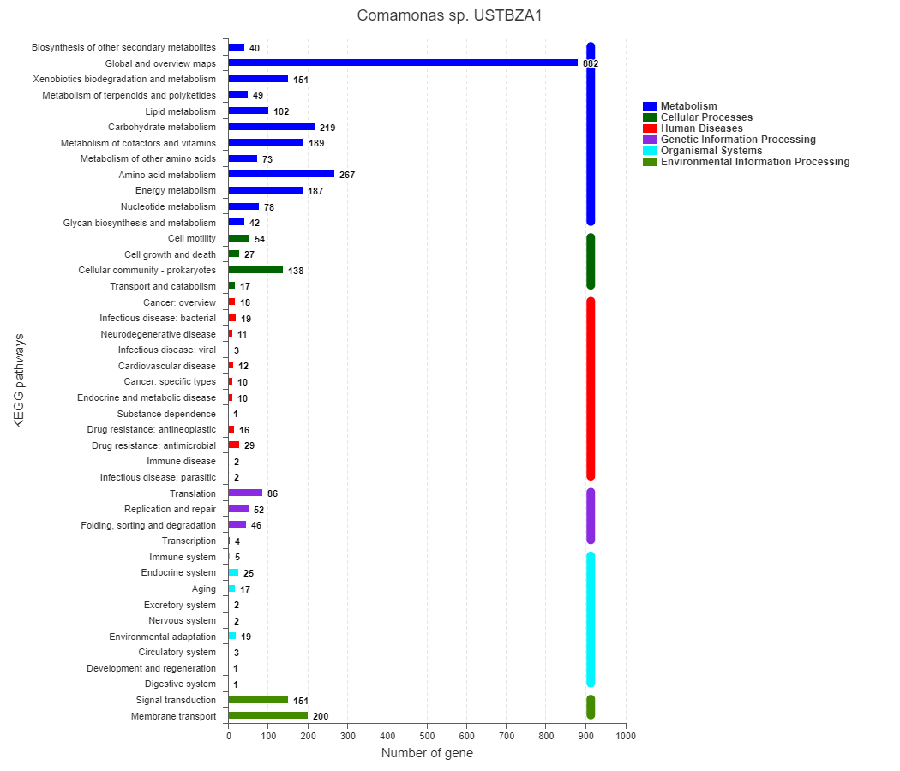
Figure S5. Statistical diagram of KEGG annotation pathway classification of Comamonas sp. USTBZA1.

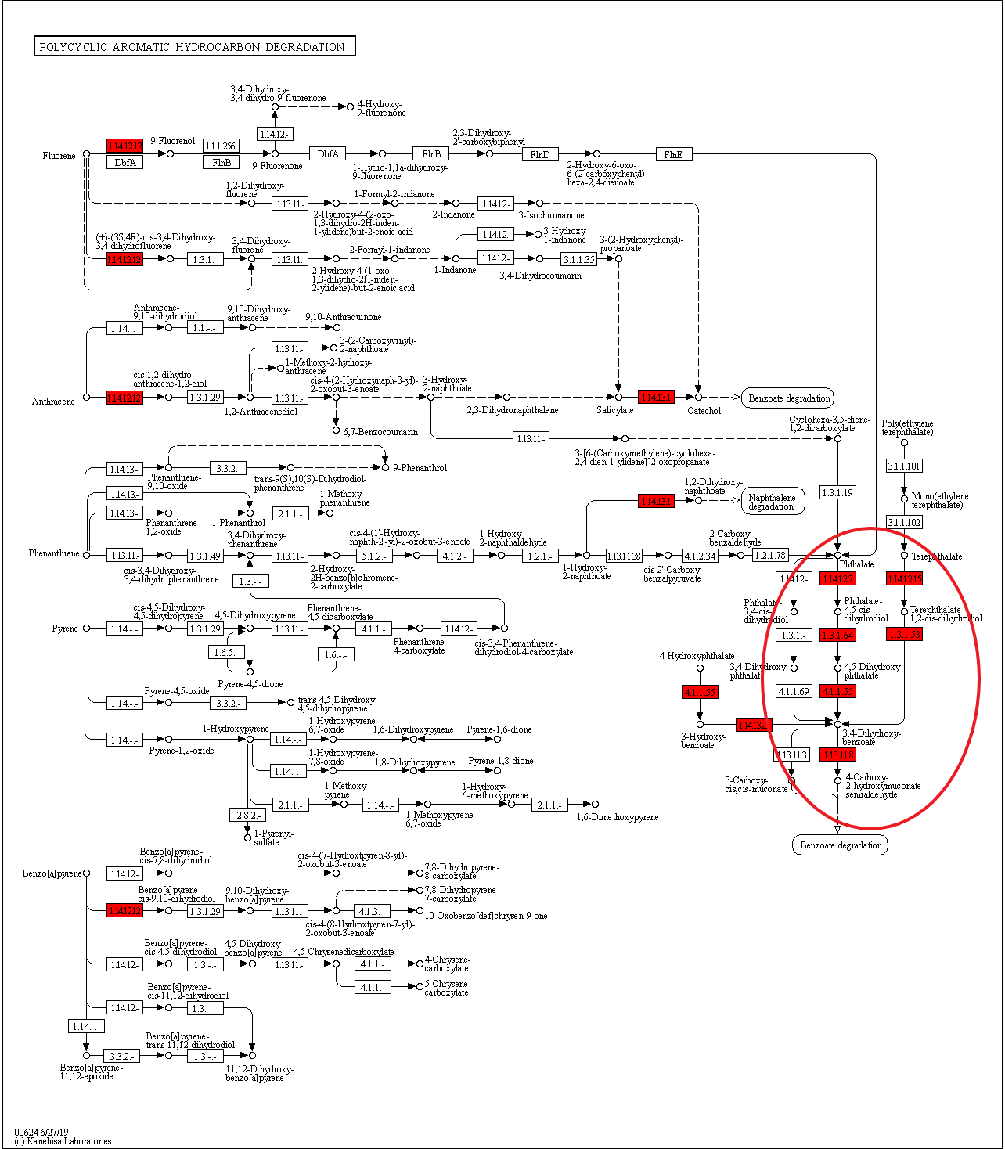
Figure S6. Polycyclic aromatic hydrocarbon degradation pathway in Comamonas sp. USTBZA1 based on KEGG annotation (red circle).
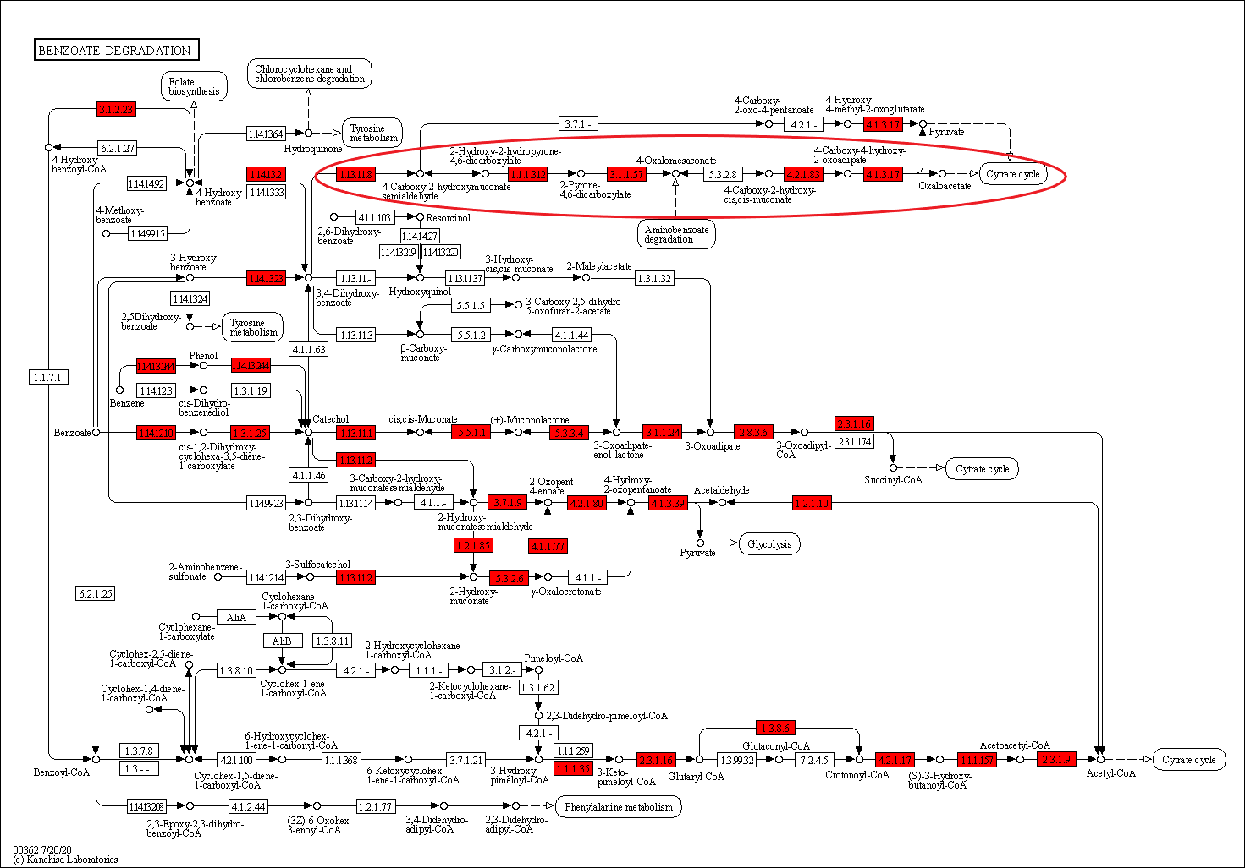
Figure S7. Benzoate degradation pathway in Comamonas sp. USTBZA1 based on KEGG annotation (red circle).
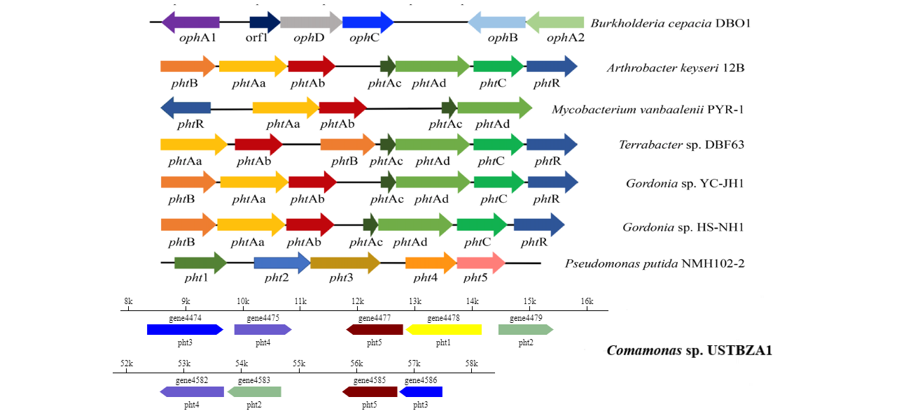
Figure S8. Comparison of reported pht genes between active bacteria and Comamonas sp. USTBZA1.
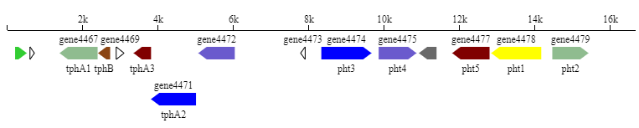
Figure S9. Gene organization of tph genes in Comamonas sp. USTBZA1.

Reference
- Zhang XY, Fan X, Qiu YJ, et al. Newly identified thermostable esterase from Sulfobacillus acidophilus: properties and performance in phthalate ester degradation [J]. Applied Environment Microbiology, 2014, 80(22): 6870-6878.
- Wu J, Liao X, Yu F,et al. Cloning of a dibutyl phthalate hydrolase gene from Acinetobacter sp. strain M673 and functional analysis of its expression product in Escherichia coli [J]. Applied Microbiology Biotechnology, 2013, 97(6): 2483-91.
- Jiao Y, Chen X, Wang X, et al. Identification and characterization of a cold-active phthalate esters hydrolase by screening a metagenomic library derived from biofilms of a wastewater treatment plant [J]. PLoS One, 2013, 8(10): e75977.
- Whangsuk W, Sungkeeree P, Nakasiri M, et al. Two endocrine disrupting dibutyl phthalate degrading esterases and their compensatory gene expression in Sphingobium sp. SM42 [J]. International Biodeterioration and Biodegradation, 2015, 99: 45-54.
- Hong DK, Jang S, Lee CW. Gene cloning and characterization of a psychrophilic phthalate esterase with organic solvent tolerance from an Arctic bacterium Sphingomonas glacialis PAMC26605 [J]. Journal of Molecular Catalysis B, 2016, 133: S337-S345.
- Nishioka T, Iwata M, ImaokaT, et al. A mono-2-ethylhexyl phthalate hydrolase from a Gordonia sp. that is able to dissimilate di-2-ethylhexyl phthalate [J]. Applied Environment Microbiology, 2006, 72(4): 2394-2399.
- Iwaki H, Nishimura A, Hasegawa Y (2012) Isolation and characterization of marine bacteria capable of utilizing phthalate [J]. World Journal of Microbiology and Biotechnology, 28(3): 1321-1325.
- Ding J，Wang C，Xie Z，Li J，Yang Y，Mu Y，Tang X，Xu B，Zhou J，Huang Z. Properties of a newly identified esterase from Bacillus sp. K91 and its novel function in diisobutyl phthalate degradation [J]. PLoS One，2015，10(3): e0119216.
- Yang F, Feng H, Massey IY, et al. Genome-Wide Analysis Reveals Genetic Potential for Aromatic Compounds Biodegradation of Sphingopyxis [J]. BioMed Research International, 2020, 27: 5849123.

