Title: Descriptive epidemiology and survival analysis of acromegaly in Korea
Running title: Acromegaly epidemiology in Korea
Author: Soo Jin Yun^{1,2*}, Jung Kuk Lee^{3*}, Jinsun Park^{1,2}, So Young Park¹, Sang Ouk Chin¹
Affiliation:
¹Department of Endocrinology and Metabolism, Kyung Hee University College of Medicine, Seoul, Korea
²Department of Medicine, Graduate School of Medicine, Kyung Hee University, Seoul, Korea.
³Department of Biostatistics, Yonsei University Wonju College of Medicine, Wonju, Korea
* These authors contributed equally to the manuscript.

Corresponding author: Sang Ouk Chin, M.D., Ph.D.
Department of Endocrinology and Metabolism, Kyung Hee University College of Medicine,
#26 Kyungheedae-ro, Dongdaemoon-gu, Seoul, Korea (02447)
Tel: +82-2-958-8200
Fax: +82-2-968-1848
Email: jan27th@khu.ac.kr
Number of Figures: 2
Number of Tables: 2

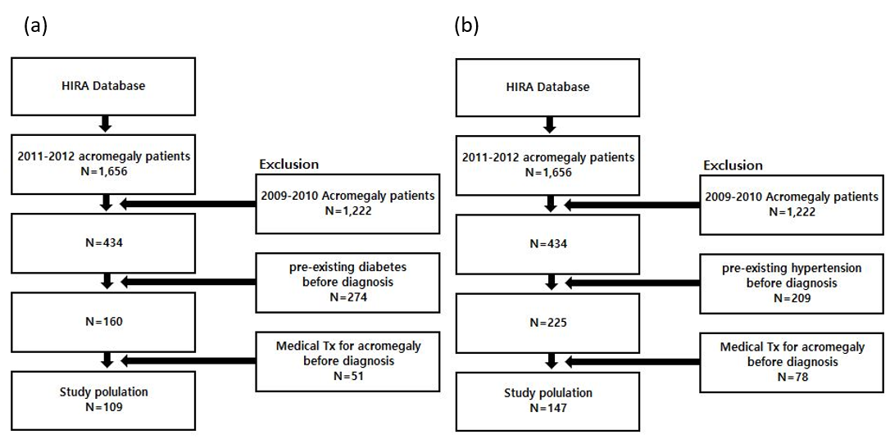
Supplementary Figure 1. Flow chart for analysis on the treatment effect; (a) diabetes, (b) hypertension

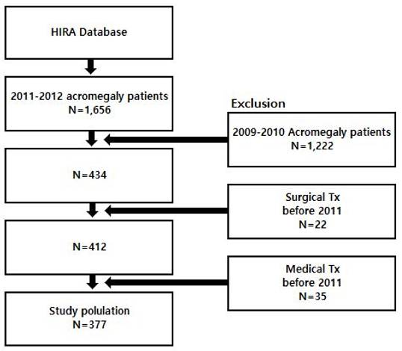
Supplementary Figure 2. Flow chart for survival analysis

