Rhodobacter ruber sp. nov., isolated from a freshwater pond

Wen-Ming Chen¹, Ting-Hsuan Chang¹, Der-Shyan Sheu², Li-Cheng Jheng³ and Shih-Yi Sheu²*
¹Laboratory of Microbiology, Department of Seafood Science, National Kaohsiung University of Science and Technology, No. 142, Hai-Chuan Rd. Nan-Tzu, Kaohsiung City 811, Taiwan
²Department of Marine Biotechnology, National Kaohsiung University of Science and Technology, No. 142, Hai-Chuan Rd. Nan-Tzu, Kaohsiung City 811, Taiwan
³Department of Chemical and Materials Engineering, National Kaohsiung University of Science and Technology, No. 415, Jiangong Rd. Sanmin, Kaohsiung City 807, Taiwan

Subject category for the Contents list: New Taxa (Proteobacteria).
Running title: Rhodobacter ruber sp. nov.

Corresponding author*
Dr. Shih-Yi Sheu
E-mail: sys816@nkust.edu.tw

Supplementary Table S1. Number of genes associated with the eggNOG categories of coding proteins in Rhodobacter ruber CCP-1^{T} genome.

Functional group of genes |  |  | Counts | %
Cellular processes and signaling
D | Cell cycle control, cell division, chromosome partitioning |  | 34 | 0.9
M | Cell wall/membrane/envelope biogenesis |  | 189 | 5.0
N | Cell motility |  | 94 | 2.5
O | Post-translational modification, protein turnover, and chaperones |  | 117 | 3.1
T | Signal transduction mechanisms |  | 100 | 2.7
U | Intracellular trafficking, secretion, and vesicular transport |  | 45 | 1.2
V | Defense mechanisms |  | 32 | 0.9
W | Extracellular structures |  | 0 | 0
Y | Nuclear structure |  | 0 | 0
Z | Cytoskeleton |  | 0 | 0
Information storage and processing
A |  | RNA processing and modification | 0 | 0
B |  | Chromatin structure and dynamics | 3 | 0.1
J |  | Translation, ribosomal structure and biogenesis | 173 | 4.6
K |  | Transcription | 204 | 5.4
L |  | Replication, recombination and repair | 123 | 3.3
Metabolism
C |  | Energy production and conversion | 187 | 5.0
E |  | Amino acid transport and metabolism | 353 | 9.4
F |  | Nucleotide transport and metabolism | 76 | 2.0
G |  | Carbohydrate transport and metabolism | 250 | 6.6
H |  | Coenzyme transport and metabolism | 128 | 3.4
I |  | Lipid transport and metabolism | 123 | 3.3
P |  | Inorganic ion transport and metabolism | 156 | 4.1
Q |  | Secondary metabolites biosynthesis, transport, and catabolism | 69 | 1.8
Poorly characterized
R |  | General function prediction only | 352 | 9.4
S |  | Function unknown | 324 | 8.6
Not in eggNOG |  |  | 626 | 16.7
Total |  |  | 3758 | 100

Supplementary Table S2. Average nucleotide identity, average amino acid identity and digital DNA-DNA hybridization scores of Rhodobacter ruber CCP-1^{T} in comparison with the type strains of other related Rhodobacter species with whole genome sequence are publicly available.

strains | Accession no. | ANI (%) | AAI (%) | dDDH (%)
Rhodobacter tardus CYK-10^{T} | NZ_JAABNR000000000 | 73.9 | 73.6 | 22.3
Rhodobacter blasticus ATCC 33485^{T} | NZ_PZKE00000000 | 76.0 | 77.3 | 22.0
Rhodobacter flagellatus SYSUG03088^{T} | NZ_VMDU00000000 | 76.3 | 77.9 | 21.4
Rhodobacter thermarum YIM 73036^{T} | NZ_QMJY00000000 | 76.1 | 77.7 | 21.5
Rhodobacter megalophilus DSM 18937^{T} | NZ_FZOV00000000 | 74.8 | 76.1 | 22.0
Rhodobacter viridis JA737^{T} | NZ_QJTK00000000 | 72.8 | 70.6 | 23.0
Rhodobacter capsulatus ATCC 11166^{T} | NZ_QKZO00000000 | 72.9 | 70.6 | 23.2
Rhodobacter vinaykumarii JA123^{T} | NZ_OBMN00000000 | 73.6 | 70.4 | 21.9
Rhodobacter maris JA276^{T} | NZ_OBMT00000000 | 72.3 | 70.6 | 22.6
Rhodobacter aestuarii JA296^{T} | NZ_QAXT00000000 | 71.3 | 70.4 | 22.9
Rhodobacter sediminicola JA983^{T} | NZ_VDEK00000000 | 75.2 | 76.1 | 21.7
Rhodobacter veldkampii DSM 11550^{T} | NZ_SNYP00000000 | 74.5 | 72.9 | 21.7

Supplementary Table S3. Genome characteristics of Rhodobacter ruber CCP-1^{T} and five type strains of the genus Rhodobacter used for comparison according to Rapid Annotation of microbial genomes using Subsystem Technology.

Strain | Genome size (Mbp) | Scaffolds | G+C content (%) | GenBank/EMBL/DDBJ accession number
Rhodobacter ruber CCP-1^{T} | 3.96 | 23 | 66.2 | NZ_JAAATW000000000
Rhodobacter tardus CYK-10^{T} | 4.59 | 114 | 66.0 | NZ_JAABNR000000000
Rhodobacter flagellatus SYSU G03088^{T} | 3.62 | 42 | 67.7 | NZ_VMDU00000000
Rhodobacter blasticus ATCC 33485^{T} | 3.59 | 69 | 66.5 | NZ_PZKE00000000
Rhodobacter thermarum YIM 73036^{T} | 3.65 | 83 | 66.8 | NZ_QMJY00000000
Rhodobacter capsulatus ATCC 11166^{T} | 3.67 | 24 | 66.5 | NZ_QKZO00000000

Supplementary Table S4. Negative reactions in API ZYM and API 20NE kits and carbon source utilization for Rhodobacter ruber CCP-1^{T}.

API ZYM kit
C14 lipase, cystine arylamidase, trypsin, α-chymotrypsin, α-galactosidase, β-glucuronidase, N-acetyl-β-glucosaminidase, α-mannosidase and α-fucosidase activities
API 20NE kit
indole production, D-glucose acidification, arginine dihydrolase and urease activities, gelatin hydrolysis, and assimilation of glucose, arabinose, mannose, mannitol, N-acetyl-glucosamine, maltose, gluconate, caprate, adipate, malate, citrate and phenyl-acetate
Carbon source utilization
D-galactose, maltose, Tween 80, glycerol, acetate, gluconate, succinate, caprate, adipate, malate, citrate, L-glutamic acid, L-serine, L-leucine, L-asparagine and L-ornithine

Supplementary Fig. S1. Rhodobacter ruber CCP-1^{T} was isolated during the characterization of microorganisms present in the freshwater crocodile pond (GPS location: 22°33'45'' N 120°32'07'' E; 25 ºC, pH 6.5, 0% NaCl) in the Chaozhou Township of Pingtung County, Taiwan on 4 April 2016.

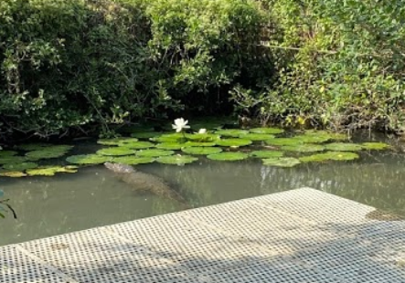

Supplementary Fig. S2. Maximum-likelihood phylogenetic tree based on 16S rRNA gene sequences showing the position of Rhodobacter ruber CCP-1^{T} and type strains of species of the genus Rhodobacter. Numbers at nodes are bootstrap percentages > 70 % based on the tree making algorithms. Yoonia rosea Fg36^{T} was used as an out-group. Bar, 0.01 substitutions per nucleotide position.

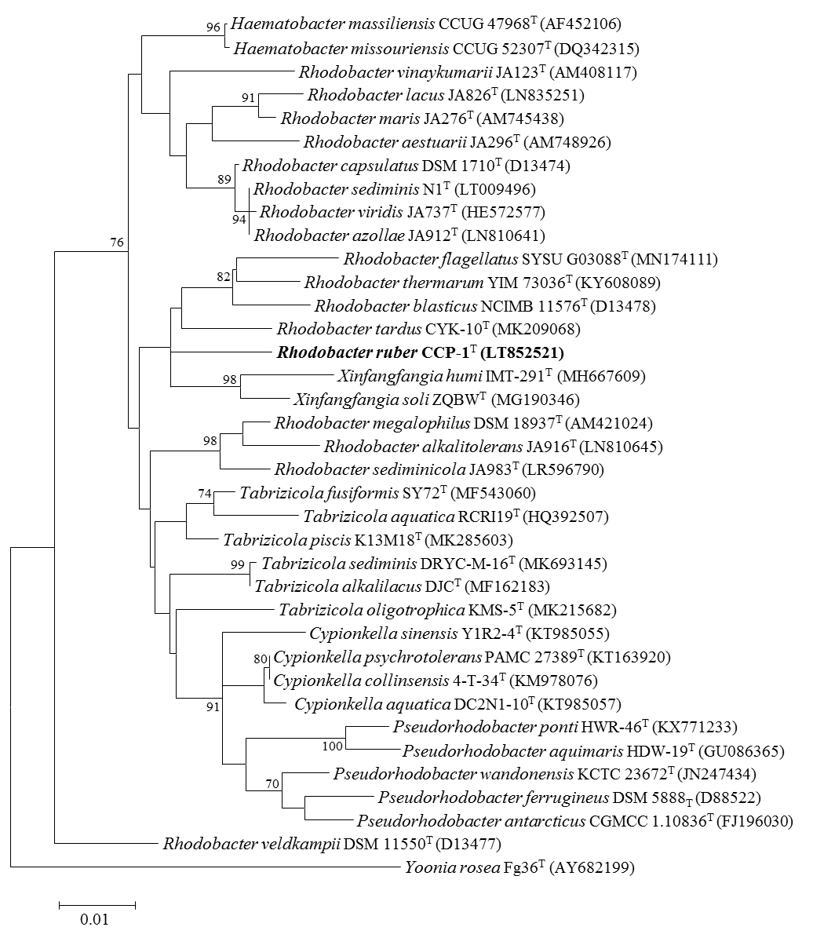
Supplementary Fig. S3. Maximum-parsimony phylogenetic tree based on 16S rRNA gene sequences showing the position of Rhodobacter ruber CCP-1^{T} and type strains of species of the genus Rhodobacter. Numbers at nodes are bootstrap percentages > 70 % based on the tree making algorithms. Yoonia rosea Fg36^{T} was used as an out-group.
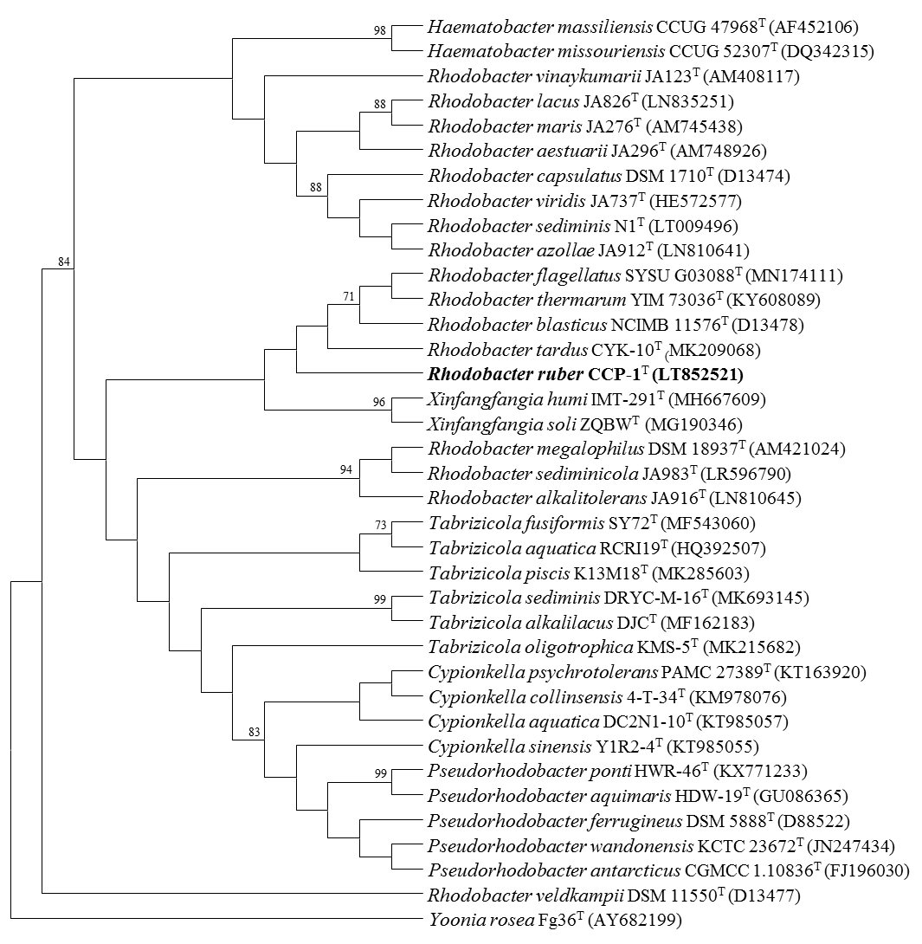

Supplementary Fig. S4. Subsystem category distribution and subsystem feature counts of (A) Rhodobacter ruber CCP-1^{T} and (B) Xinfangfangia humi CIP 111625^{T} according to Rapid Annotation of microbial genomes using Subsystem Technology (RAST).
(A)
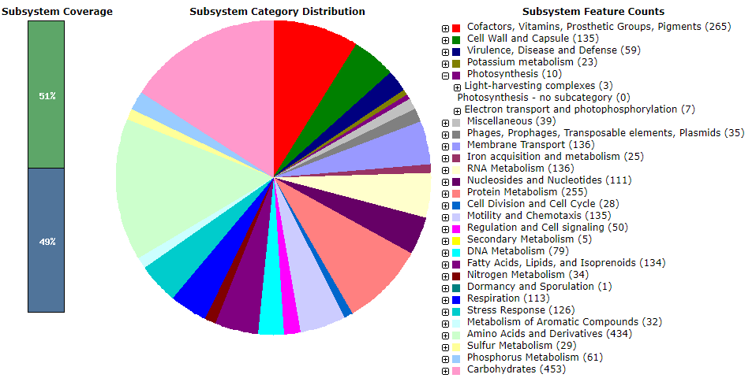

(B)
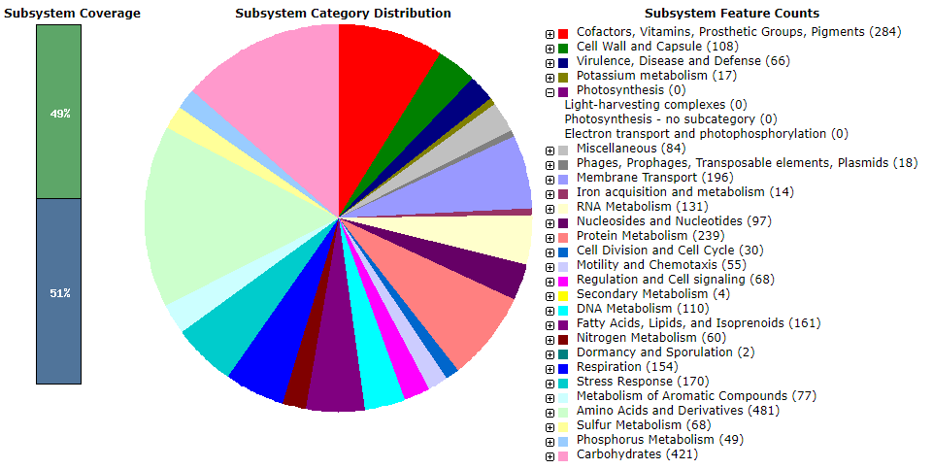

Supplementary Fig. S5. Comparative gene content analyses. (A) Rhodobacter ruber CCP-1^{T} and Rhodobacter capsulatus ATCC 11166^{T}; (B) Rhodobacter rubrum CCP-1^{T}, Rhodobacter tardus CYK-10^{T}, Rhodobacter flagellatus SYSU G03088^{T}, Rhodobacter blasticus ATCC 33485^{T} and Rhodobacter thermarum YIM 73036^{T}.

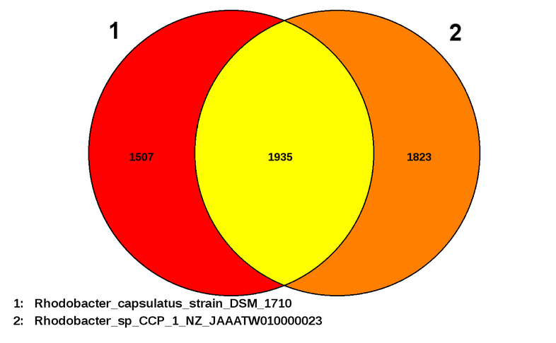

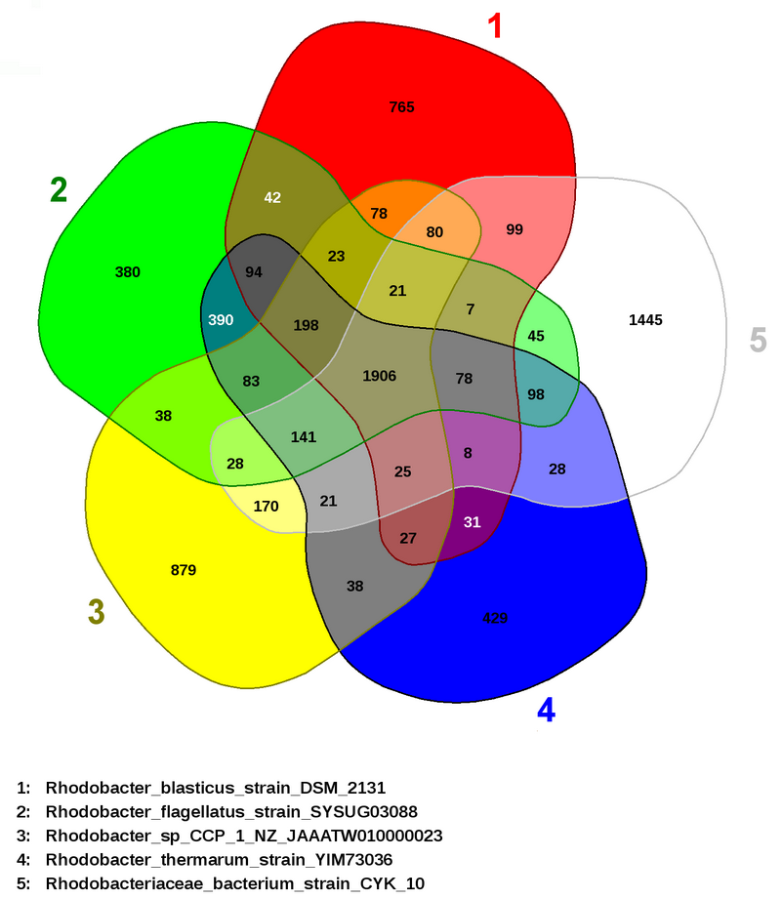
(B)

Supplementary Fig. S6. Transmission electron micrograph of cells of Rhodobacter ruber CCP-1^{T}. Cells were aerobically grown on R2A agar for 3 days at 25 ºC. Bar, 0.5 μm.

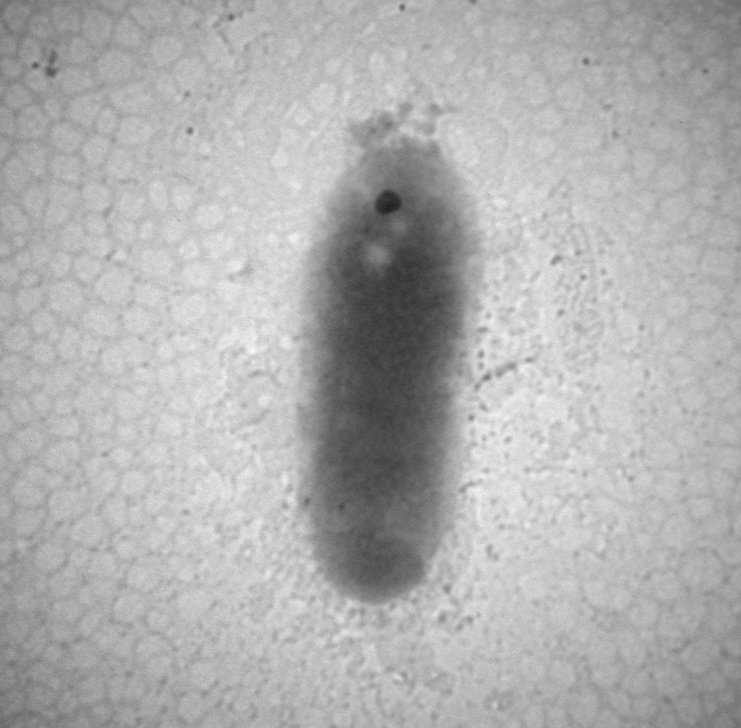

Supplementary Fig. S7. Absorption spectrums of bacteriochlorophyll a of Rhodobacter ruber CCP-1^{T}. The presence of bacteriochlorophyll a indicated by maximum of 765 nm in the absorption spectrum on a spectrophotometer.

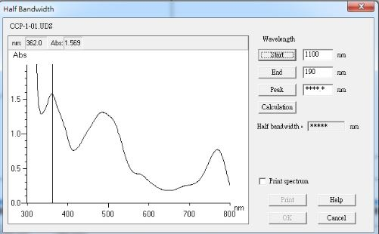
765
Supplementary Fig. S8. TLC chromatograms of polar lipids of Rhodobacter ruber CCP-1^{T}. Components were revealed by staining the preparations with 10% molybdophosphoric acid in ethanol and heating them at 150 ºC for 10 min. Abbreviations: PE, phosphatidylethanolamine; PG, phosphatidylglycerol; PC, phosphatidylcholine; APL1-APL2, uncharacterized aminophospholipids; PL1-PL2, uncharacterized phospholipids.

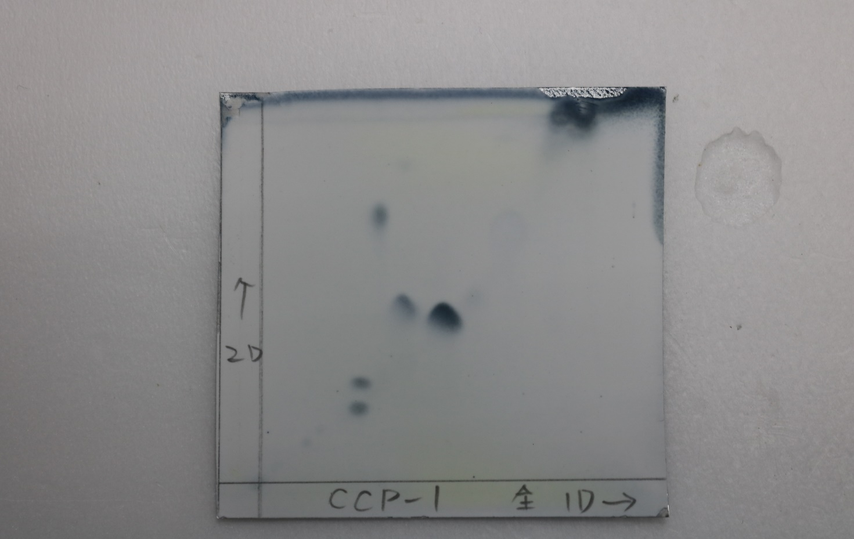
PE
PG
PL2
PL1
APL2
PC
APL1

Supplementary Fig. S9. HPLC chromatogram of respiratory quinone of Rhodobacter ruber CCP-1^{T}. The only respiratory quinone of strain CCP-1^{T} was ubiquinone-10 (Q-10).

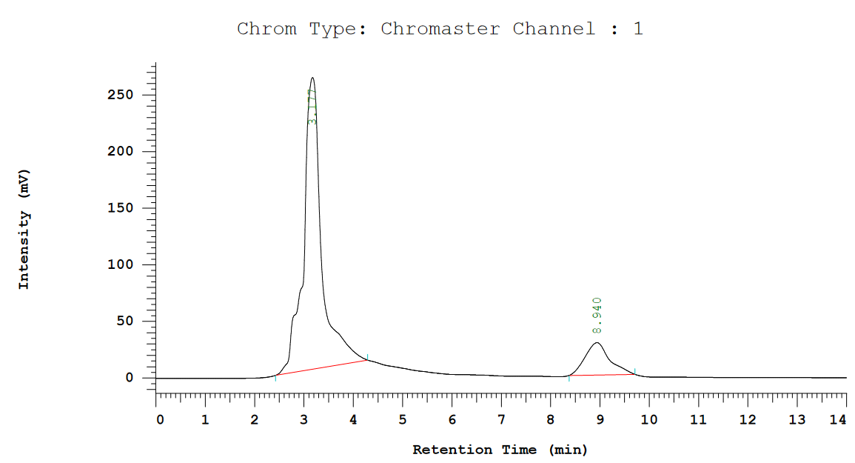
Q-10

