Table of contents for SI

- Supplementary Notes (1~6)
  - Fitting of linearity and symmetry of multi-state potentiation and depression.
  - Discussion about linear output characteristics and all-analog input.
  - Discussion about non-linear classifications.
  - Simulation, interfaces and experimental realization of three-layer artificial neural network.
  - Scaled devices with channel length of 480nm and 180nm.
  - The benchmark of energy efficiency.
- Supplementary Figures (1~8)
  - The endurance characteristics of T-type devices with A_{FE}/A_{DE} ratio = 0.67.
  - Modeling of MoS₂ FET and MFMIS FeFET.
  - 22nm projection of FeFET.
  - Pre- and Post-layout simulations based on the scaled TIIO cell.
  - The effect of row/column lines in array-level circuit.
  - Noise extraction from variation data.
  - Noise extraction from variation data of scaled devices.
  - Scaled devices.
- Supplementary Tables (1~15)
  - Parameters of device dimensions.
  - Comparison of mainstream and emerging memory technologies.
  - Endurance and retention data of typical works for benchmark.
  - Typical Read-after-write parameters with pulsed MW method.
  - Switching energy and speed of typical works for benchmark.
  - Training Datasets (210 points) of the ring classification demonstration.
  - Test Datasets (90 points) of the ring classification demonstration.
  - Training settings of the ring classification demonstration.
  - Network configuration of Encoder-Decoder structure.
  - Training settings for depth estimation.
  - Fitting Parameters of MoS₂ FET.
  - Fitting Parameters of FeFET.
  - Design parameters of scaled device.
  - The performance benchmark with other advanced published devices.
  - A summary of variation numbers.
- Supplementary Reference

Supplementary Notes
Supplementary Note 1. Fitting of linearity and symmetry of multi-state potentiation and depression
During the long-term potentiation (LTP) and long-term depression (LTD) processes, weight updates can be modeled by the equation below which describe the conductance (G) evolution with pulse number (P), respectively:
$G_{LTP}=C\left(1-e^{-\frac{P}{A}}\right)+G_{min}$ , (1)
$G_{LTD}=D\left(1-e^{-\frac{P-P_{max}}{A}}\right)+G_{max}$ , (2)
$α=1.726/(A+0.162)$, (3)
Here, $G_{max}$ and $G_{min}$ refer to the maximum and minimum conductance of the FeFET, respectively. $P_{max}$ is the maximum number of pulses. Parameter $α$ is the measurement index for the nonlinearity of weight updates. The conductance versus pulse number was fitted with equations above and then we get nonlinearity. The lower $|α|$ is, the more linear devices are. Allowing for the desirable specifications for synaptic devices, we highlight the characteristic that a sub-1 absolute value of nonlinearity can satisfy the related requirement ^{6, 24, 54}.

Supplementary Note 2. Discussion about linear output characteristics and all-analog input
For IMC with nonlinear I-V characteristics, the data input will inevitably require analog-to-digital conversion, quantization and compensation of non-idealities, which involves explosive hardware resource budget of peripheral circuits and occupies most of the energy consumption during training and inference. However, for lots of scenes like sound localization and discrete cosine transformation (DCT), all-analog computing is essential to acquire higher accuracy. This requires linear output I-V of the NVM device to faithfully reproduce the features of input signals and thus brings about a good learning. In this work, the output I-V (Extended Data Fig.6b) of duplex FeFET shows a 128-level, linear, symmetric behavior for both positive and negative input. In this condition, we could use full batch data for analog inference in every iteration, avoiding the energy efficiency drop induced by peripheral ADC circuits.

Supplementary Note 3. Discussion about non-linear classifications
Classifications are a broad class of machine learning applications devoted to assigning input data to a predefined category based on its features. If the boundary between the categories has a linear relationship to the input data, such as MNIST database, a simple logistic regression algorithm with only one ANN layers may do a good job. For more complex group, which cannot be classified by any straight lines or flat planes, a multi-layer ANN can often give a positive result. Here, the ring data classification we projected is simple but pretty persuasive. With 4 neurons in the hidden layer, the ring feature was transferred to another space, where the data could be classified by some flat planes.

Supplementary Note 4. Simulation, interfaces and experimental realization of three-layer artificial neural network
While fabricated core TIIO array accomplished multiply and accumulate (MAC), we wrote Python codes to assist in realizing functions which should belong to peripheral circuits. This section contains:
- Generating a dataset randomly;
- Initializing parameters randomly;
- Activation functions;
- Quantification and normalization of measured data;
- Calculation of cost and accuracy;
- Forward Propagation (FP) algorithm;
- Back Propagation (BP) algorithm;
- Optimizers;
- Initializing hyperparameters;
Of notes, the codes are considered as a supplement to the core hardware, so the absolute performance of codes are beyond the scope of this article. Here, the interface means data communications between software and hardware. There were always two versions of codes: the one with interface and the one without interface. The former is for experimental test, while the latter is for simulation and pre-test optimization.

- Generating a dataset randomly.
The dataset is in form of (X, Y), where X is the abscissa of datapoint, Y is the ordinate of datapoint, and they were both in [-5, 5]. To make the dataset ring-like, the radius and angle of each point were randomly generated in the uniform distribution. There were two types of points: “inside” points, labeled as “1”, and “outside” points, labeled as “0”. The number ratio of them was also 3:7. Then, we got ring-like (X, Y), where the X = radius $×$ cos(angle), and Y = radius $×$sin(angle). There were 300 points in the dataset, 70% of them (210 points, Supplementary Table 6) were defined as training data and involved in BP calculation, while 30% of them (90 points, Supplementary Table 7) were reserved for test data and represent unexperienced objects for trained ANN. They have been shuffled and will be imported to the hardware then.

- Initializing parameters randomly.
The size of fabricated ANN is 2$×$4$×$1, while in the points of hardware, the size becomes 2$×$8$×$1, because every 8-bit signed weight is combined with two 7-bit unsigned weights. Thus, the size of L1 weights, L1 bias, L2 weights, L2 bias are 4$×$2$×$2, 4$×$1, 4$×$2$×$1, 1$×$1, respectively. These weights were quantified to 256 levels, from -128 to 128 level, just identical to that of the hardware. The initial weights and biases were generated in the normal distribution within the range of [-16 levels, 16 levels].

- Activation functions.
We used two different activation functions in hidden neurons and output neuron to get a faster learning and convergence. For the output neuron, we used classic Sigmoid function,
$f(x)=\frac{1}{1+e^{-x}}$ , (4)
with the derivative of Sigmoid function,
$f'(x)=f(x)∙(1-f(x))$ , (5)
The value range of Sigmoid is (0,1), making it a good function for classifications. However, the Sigmoid function suffers from the vanishing gradient problem, and makes learning speed very slow. Thus, we chose the Leaky-ReLU as the activation function of hidden neurons,
$f(x)=\left\{\begin{aligned}x, x>0 \\ alpha∙x, x≤0\end{aligned}\right.$ , (6)
with the derivative of Leaky-ReLU,
$f'(x)=\left\{\begin{aligned}1, x>0 \\ alpha, x≤0\end{aligned}\right.$ , (7)
where alpha is the small slope for negative values.

- Quantification and normalization of measured data.
The calculated result in program is completely different from the final data written to the hardware, because the input and output of the hardware are the corresponding voltages and currents. Therefore, corresponding quantification and normalization algorithms are indispensable for data conversion.
To quantify the measured quantities, we define 256 levels, the maximum is integer 128, and the minimum is integer -128. Firstly, weights in software are in [-2, 2], so the scale factor is 1/64. Similarly, the weights in hardware [-2μA, 2μA] are also normalized. This relation can be written as:
$weights in program ⟺ defined 256 levels ⇔ weights in hardware$ , (8)

- Calculation of cost and accuracy.
For reducing iterations, we chose batch gradient descent (BGD) as training input algorithm and import all 210 samples one time, and cost function here was defined to collect all the samples:
$Cost=\frac{1}{N}\sum_{i=1}^{N}{{Loss}^{(i)}}=\frac{1}{N}\sum_{i=1}^{N}{f({output}^{(i)}, {label}^{(i)})}$ , (9)
where output^{(i)} is the result of ANN when inputting one sample (the i-th). The difference with output^{(i)} and label^{(i)} represents the progress of learning. In this regard, how to emphasis this difference depends on the choose the function types.
For cost calculation, Binary Cross Entropy (BCE) was the optimal function for classification of binary result. The BCE function is described as:
$BCE Cost=-\frac{1}{N}\sum_{i=1}^{N}{({label}^{(i)}∙\log{{(output}^{(i)})}+(1-{label}^{(i)})∙\log{{(1-output}^{(i)})})}$ , (10)
The accuracy is defined as the ratio:
$Accuracy=\frac{Num. of correctly calssified samples}{Num. of all samples}$ , (11)
The initial value of accuracy depends on the specific scene. To take the ring data classification as an example, only 30% “inside” points (1) were incorrectly classified as “outside” (0), so the accuracy started from 0.7.

- Forward Propagation (FP) algorithm
First, all data (300$×$2) was normalized as a voltage list, and imported to the layer 1 of TIIO array (2$×$4). It should be noted here that we temporally combine the training data with test data for simplicity. They would be separated before the BP process. The MAC was finished on hardware, and the current list (300$×$4) were processed by interface 1, where they added bias (4$×$1), then were activated by a Leaky-ReLU, and normalized as a voltage list (300$×$4). Similarly, this voltage list was imported into layer 2 of TIIO array (4$×$1), and the output was a current list (300$×$1). Adding bias (1x1), being activated by a Sigmoid function, the result was the final output (300$×$1). Then the output was separated to two parts, the first 210 values as training output and the rest 90 values as the test output. Finally, the training cost, training accuracy, test cost, and test accuracy were all calculated.

- Back Propagation (BP) algorithm
By the chain rule, correction of any weight in a neuron network could be calculated withs knowing functions or their derivatives. Here we chose one chain for example:
$input x⟺weight L1_1⟺hidden neuron⟺weight L2_1⟺output⟺Cost$ , (12)
We can write it in a simplified form:
$x⟺w_{1_1}⟺h_{1}⟺w_{2_1}⟺o_{1}⟺Cost$ , (13)
For a typical GD algorithm, the correction of one weight is:
$w1⇐w1-η∙\frac{∂Cost}{∂w_{1_1}}$ , (14)
where the η is learn rate.
The differential term could be written as below:
$\frac{∂Cost}{∂w_{1_1}}=\frac{∂Cost}{∂o_{1}}∙\frac{∂o_{1}}{∂w_{1_1}}=\frac{∂Cost}{∂o_{1}}∙\frac{∂o_{1}}{∂h_{1}}∙\frac{∂h_{1}}{∂w_{1_1}}$ , (15)
These three differential terms were easy to get. So, we can get corrections for all weights though different chains. These corrected weights would work in the next epoch.

- Optimizers.
In the last section, the learn rate (η), was treated like a constant. However, for BGD, the ANN was easy to be stacked at a local minimum in the loss surface, or in some cases, a saddle point. These problems would make the ANN stop learning before arriving the global minimum. That’s why we use optimizers. Here, we used the “Adam” algorithm to have an adaptive learn rate. The “Adam” is written as below:
$m⇐β_{1}∙m+(1-β_{1})∙gradient$ , (16)
$m_{t}=\frac{m}{1-{β_{1}}^{epoch}}$ , (17)
$v⇐β_{2}∙v+(1-β_{2})∙{gradient}^{2}$ , (18)
$v_{t}=\frac{v}{1-{β_{2}}^{epoch}}$ , (19)
$Δweight=η∙\frac{m_{t}}{\sqrt{v_{t}}+epsilon}$ , (20)

- Initializing hyperparameters.
As involved above, there was a dozen of hyperparameters need to set in the neuron network. Now we give a summary of these hyperparameters in Supplementary Table 8.

Supplementary Note 5. Scaled devices with channel length of 480nm and 180nm
To present the good scalability of FeFET in this work, we fabricated and measured scaled devices with minimal designed channel length of 500nm, 200nm, and 100 nm (measured lengths are about 480nm, 180nm, and 85 nm). Supplementary Table 13 presents all the key geometric parameters of devices with designed channel length from 3 μm to 100 nm, where the scaled devices kept the same A_{FE}/A_{DE} area ratios for training and inference.
Supplementary Fig. 8a,b,d,e show the microscope and SEM images of the scaled devices with 480nm and 180nm channel lengths, and the corresponding double-sweep transfer characteristic curves are plotted in Supplementary Fig. 8c,f. While the date of the 85nm one is shown in Extended Data Fig. 2b-d. Even for the channel length of 85 nm, the memory window still exhibits obvious FE areal dependence, and the memory window narrowed with $A_{FE}/A_{DE}$, which is consistent with the micrometer-scale devices.

Supplementary Note 6. The benchmark of energy efficiency
We implemented a thorough and comprehensive model calculation for energy projection, which includes:
- Model calibration of FeFET.
- Performance and energy efficiency projection under 22 nm technology node with pre- and post- layout simulation.
- The power contribution of row/column lines.
Model calibration of FeFET.
We used the LEVEL 62 TFT model in Cadence to fit the experimentally measured transfer curve of MoS₂ FET. The I_{D} is numerically calculated according to:
$I_{D}=\left\{\begin{aligned}μ_{FET}C_{ox}\frac{W}{L}\left(V_{GT}V_{DS}-\frac{{V_{DS}}^{2}}{2α_{sat}}\right), &V_{DS}<α_{sat}V_{GT} \\ μ_{FET}C_{ox}\frac{W}{L}\frac{{V_{GT}}^{2}α_{sat}}{2}, &V_{DS}≥α_{sat}V_{GT}\end{aligned}\right.$ , (21)
where $μ_{FET}$is the mobility of FET, $C_{ox}$is the oxide capacitance, $α_{sat}$ is the proportionality constant of saturation voltage $V_{sat}$, and $V_{GT}=V_{GS}-V_{TH}$.
The mobility of FET is expressed as:
$\frac{1}{μ_{FET}}=\frac{1}{μ_{0}}+\frac{1}{μ_{1}{(2V_{GT}/V_{sth})}^{MMU}}$ , (22)
where $μ_{0}$ is the high field mobility, $μ_{1}$ is the low field mobility, and MMU is the low field mobility exponent.
With the above model, we can now quantitatively understand the obtained experimental data. The solid lines in Supplementary Fig. 2a and 2b are the best ﬁtting results using the parameters listed in Supplementary Table 11, 12. Both physical parameters and the transport characteristics in the model are highly consistent with the experimental data, suggesting that the model is reliable and robust. Then we built the FeFET through the combination of ferroelectric dynamic compact model (PHIMO_FeCAP Compact Model 1.0.0, doi:10.21981/HM1T-3Z54, corresponding fitting parameters listed in Supplementary Table 12) and the MoS₂ device model above to fit the experimental results of FeFET (Supplementary Fig. 2c). All models have been calibrated against experimental data and will be carried out for circuit simulations.
Performance and energy efficiency projection under 22 nm technology node with pre- and post- layout simulation.
Supplementary Fig. 3a and b plot the redesigned TIIO cell layout in Cadence. Here, the key device parameters are shown in Supplementary Fig. 3d, which are exactly as reported in the main text. To reduce parasitic capacitance, all interconnection lines are laid out on the top layer, far away from the core cell by deep vias combined with 500 nm low κ dielectric isolation layer (schematic cross section in Supplementary Fig. 3c). Next, we designed the scaling rules for the TIIO cell according to the geometric scale of the 22 nm node SOI device in the literatures and ITRS reports, in which the gate length, EOT and V_{dd} of FET are 22 nm, 0.85 nm and 0.85V, respectively. In the case of maintaining the ratio of FE and DE, we redesigned the FE areas for T-type and I-type devices respectively according to the new FET scale. Supplementary Fig. 3c plots the compact cell layout for 22 nm technology, which still uses deep via technology to reduce parasitic capacitance, consistent with the method in Supplementary Fig. 3a and d.
Next, we extracted intrinsic capacitance (C total), coupled capacitance (CC total) and resistance (R) from the 22 nm layout nets in Supplementary Fig. 3b to evaluate and calculate power consumption. Supplementary Fig. 4c lists the absolute values of capacitance and resistance for all netlists. Subsequently, we performed a one-bit operation pre- (Functional simulation) and post- (Functional simulation with parasitic effects) simulation on 22 nm TIIO cell according to the voltage sequential of training and inference respectively. As a standard procedure, training involves turning on the T-type selector and then adjusting the ferroelectric weights with the identical voltage pulse of 2.636V and 5 ns through BL. The inference only needs to measure the I_{D} across FeFET with voltage signal through VIN (here the inference voltage pulse is set to 0.1V).
Supplementary Fig. 4a and b show the voltage-current waveform sequence diagrams of the pre- and post-simulation of training process, respectively. Based on timing simulation results and extracted capacitance characteristics, we quantitatively calculate the power and energy efficiency for one-bit training (Supplementary Fig. 4d) and inference (Supplementary Fig. 4e). The pre-simulation energy efficiency of the training process exceeds 2110 TOPS/W, which is very close to the number (2200 TOPS/W) we estimated in the main text. However, after considering the timing delay, the post-simulation result is only about half of the pre-simulation, ~1151 TOPS/W. Since the voltage applied to BL is for weight update, the operation voltage (~ 2.6 V) here is significantly higher than that of other nodes, which is the major source of power consumption. Different from training, the inference process does not involve BL operations, so we notice that the energy efficiency of pre- and post-simulation for inference is about 166 TOPS/W, which is consistent with the number estimated in the original version.
The power contribution of row/column lines.
We also consider about the power consumption of interconnect line charging and discharging. In further simulation, shown in Supplementary Fig. 5, we choose the middle cell of three typical array scales of 3×9 (physical implementation in this work), 14×14 (a typical size for MNIST), 128×128 (monocular depth estimation in this work) with BL line for energy efficiency calculation. Obviously, as the array size increases, the interconnection BL/WL lines will also be proportionally extended (Supplementary Fig. 5a-c). Similar to the conclusion of a single cell simulation, the increase in power consumption of large-scale array still comes from the BL line, whose power consumption increased from 13.7 nW for 1×1 array to 53.6 nW for 128×128 array, resulting in a decrease in training energy efficiency to 305 TOPS/W (Supplementary Fig. 5d and e).

Supplementary Figures:

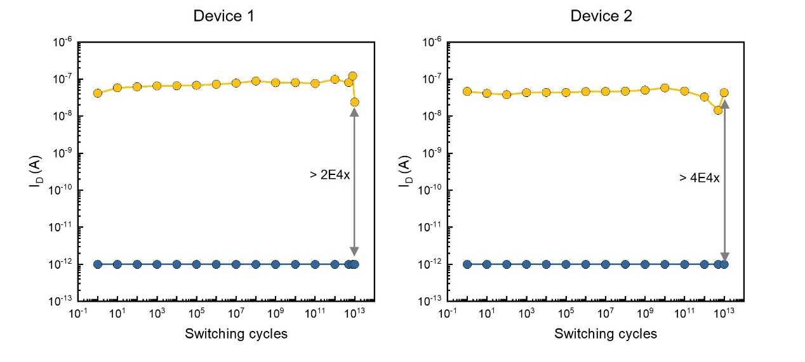
Supplementary Figure 1. The endurance characteristics of T-type devices with A_{FE}/A_{DE} ratio = 0.67.

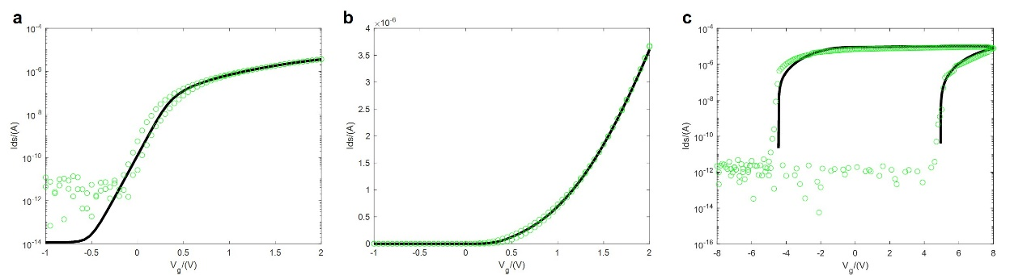
Supplementary Figure 2. Modeling of MoS₂ FET and MFMIS FeFET. a, b, The fitting of measured data of MoS₂ FET in log scale (a) and linear scale (b). c, The fitting of FeFET with MFMIS structure by connecting ferroelectric capacitors with different areas to the gate of MoS₂ FET. The green circles are measured data.

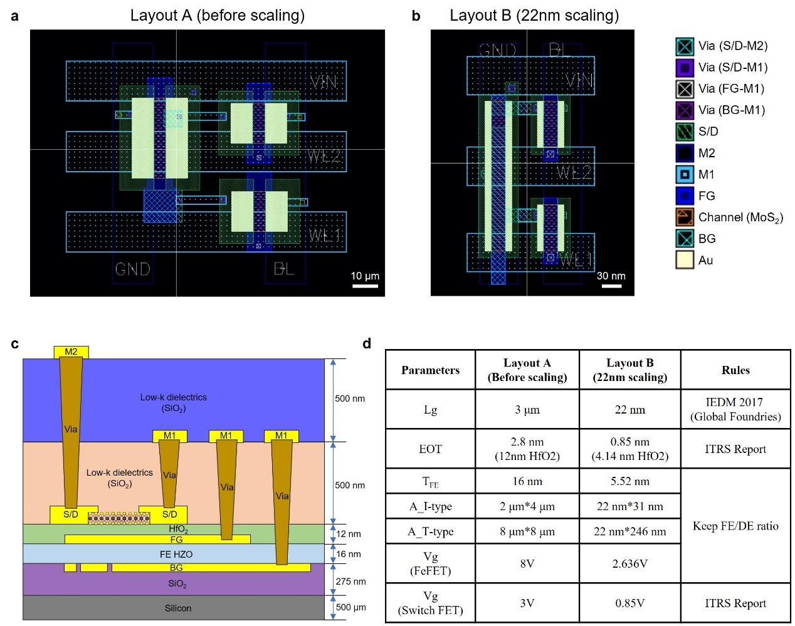
Supplementary Figure 3. 22nm projection of FeFET. a,b, Layout design of one TIIO cell before scaling (a) and that scaled to 22nm-node (b). Scale bar, 10μm and 30nm, respectively. c, The cross-section schematic of 22nm-node process for TIIO device. Compared to physical array in Fig.3, the row lines and column lines are moved to BEOL, with the various vias through 500nm-thick low-k dielectrics. d, The parameters used for Layout A and B, and the scaling rules.

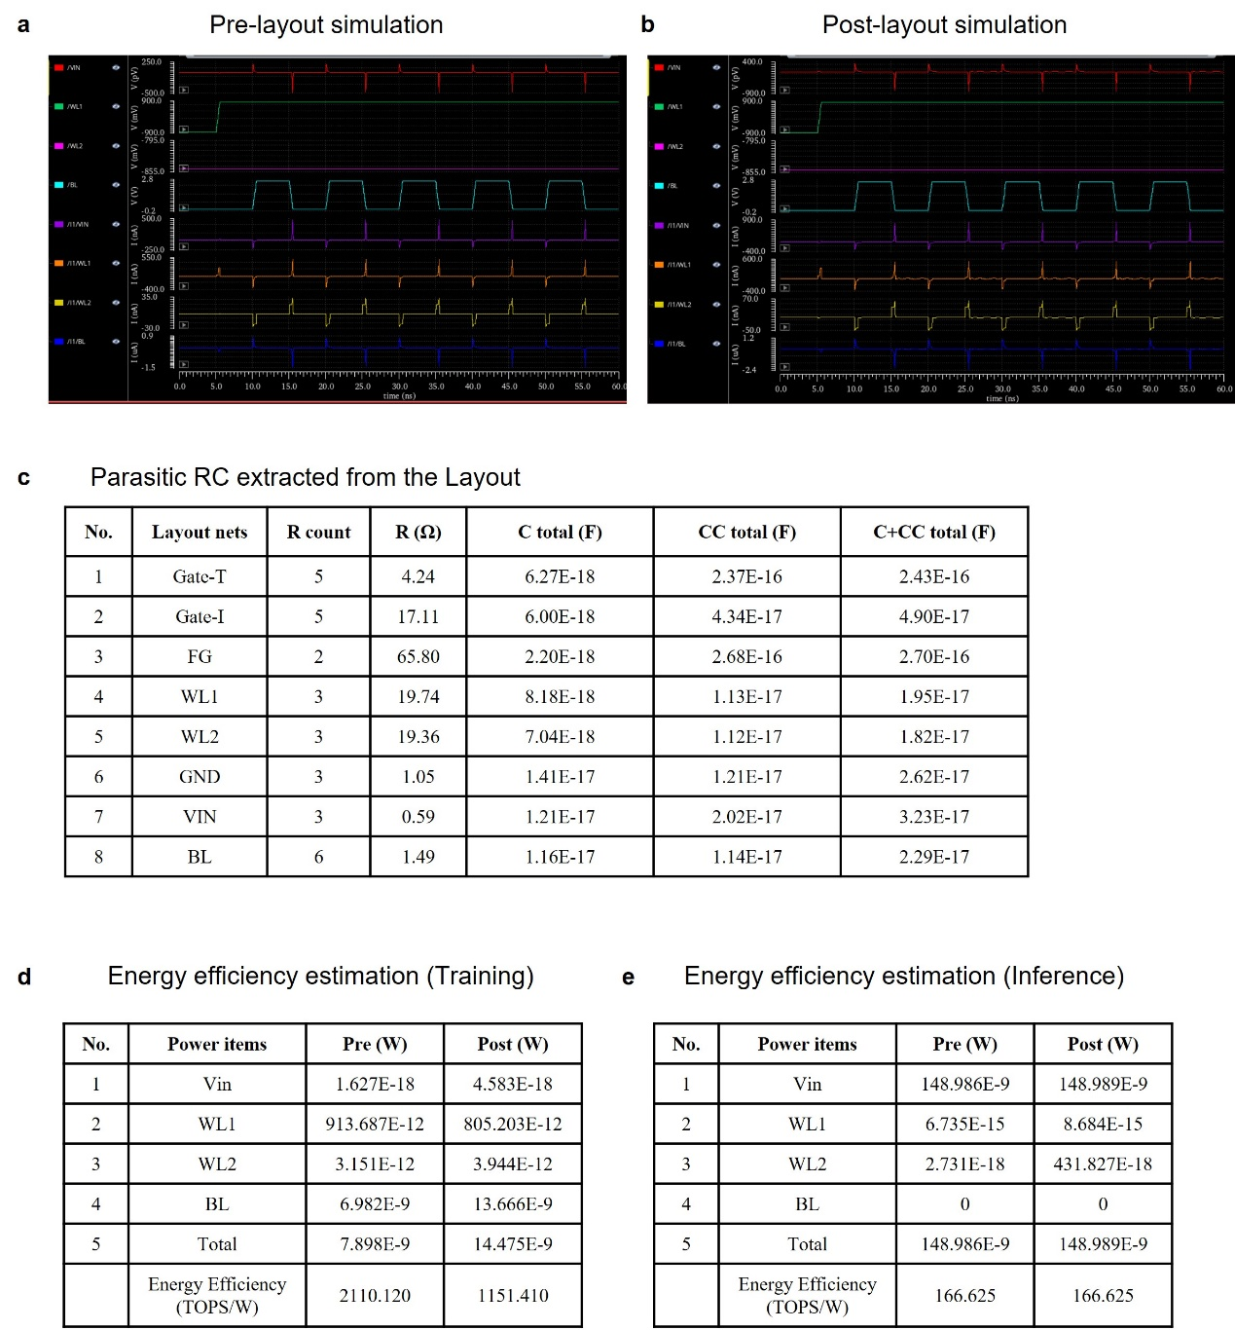
Supplementary Figure 4. Pre- and Post-layout simulations based on the scaled TIIO cell. a, b, The waveforms of TIIO cell for training in pre-layout simulations (a) and post-layout simulations (b). One training cycle contains five 20μs pulses on the gate of duplex FeFET. c, The parasitic RC extracted from Post-Layout simulation. The total resistance (R), intrinsic capacitance (C), coupled capacitance (CC) of each node are listed. d, e, The energy efficiency estimation based on the pre- and post-layout simulations for training (d) and inference (e).

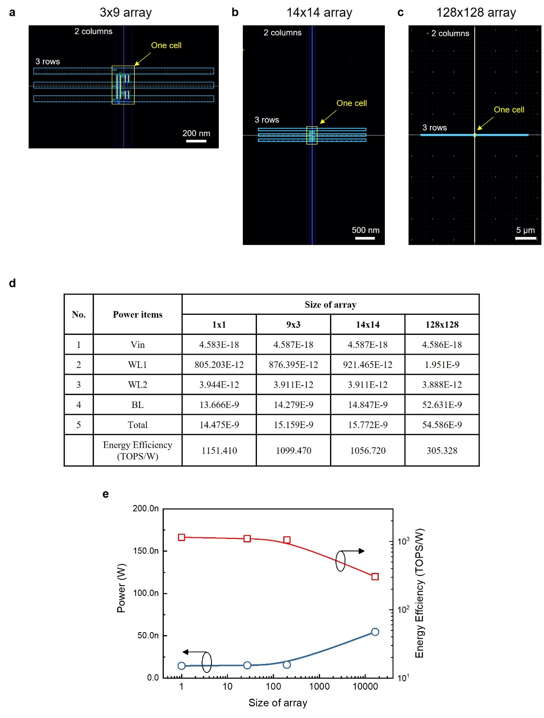
Supplementary Figure 5. The effect of row/column lines in array-level circuit. a-c, The scaled TIIO cell with extended row/column lines identical to the size of 3×9 array (a), 14×14 array (b) and 128×128 array (c). Scale bar, 200nm, 500nm, 5μm, respectively. d-e, Post-layout simulations and calculated powers and energy efficiencies for four sizes.

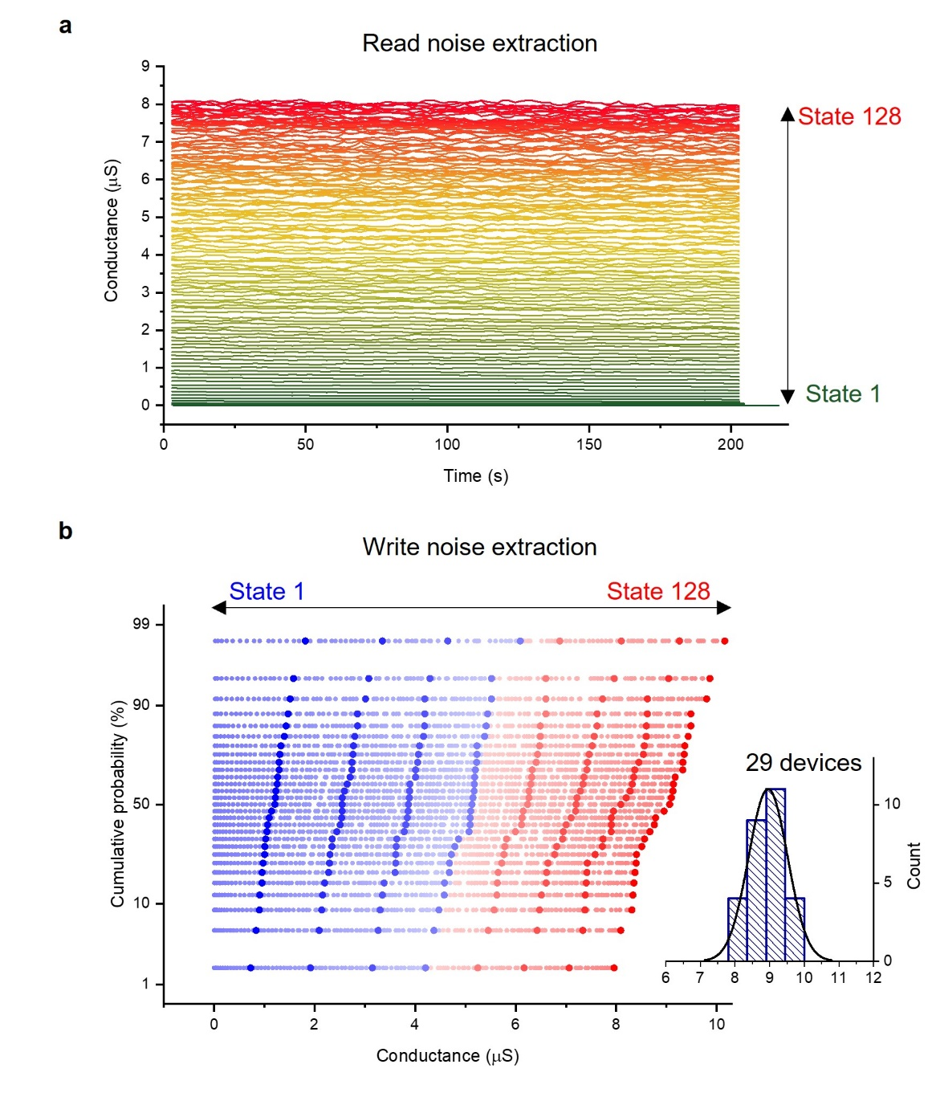
Supplementary Figure 6. Noise extraction from variation data. a, Retention of 128 conductance states for read noise extraction. b, Device-to-device variation of 128 conductance states for write noise extraction. The 128-level conductance data of 29 devices are sorted from highest to lowest, and plotted as cumulative probability. Thus, the data has 128 columns and 29 rows. The absolute variation becomes larger with the increasing of state number. Inset, the statistics of the maximum conductance (State 128) of 29 devices.
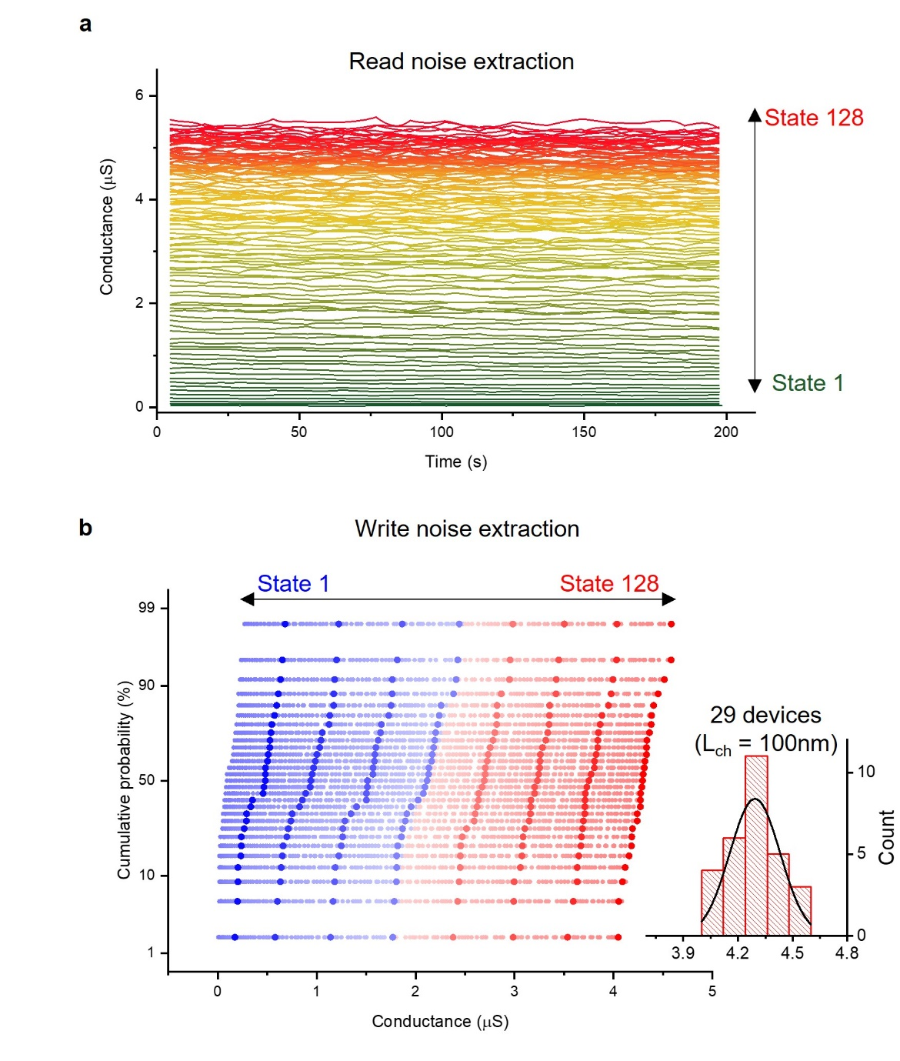
Supplementary Figure 7. Noise extraction from variation data of scaled devices. a, Retention of 128 conductance states of a scaled device with 100nm channel length for read noise extraction. b, Device-to-device variation of 128 conductance states from scaled devices with 100nm channel length for write noise extraction. The 128-level conductance data of 29 devices are sorted from highest to lowest, and plotted as cumulative probability. Inset, the statistics of the maximum conductance (State 128) of 29 devices.

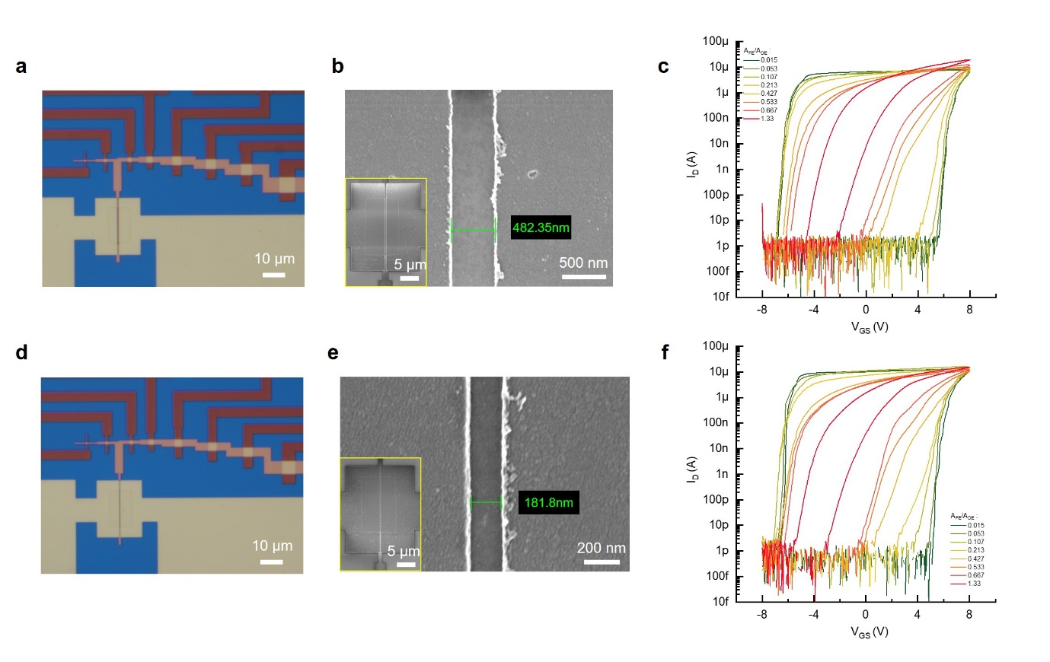
Supplementary Figure 8. Scaled devices. a, d, Optical images of devices with channel length of 480nm and 180nm, respectively. b, e, SEM images of these two channel lengths. c, f, Transfer characteristics of scaled FeFETs of these two channel lengths with different A_{FE}/A_{DE} ratios.
Supplementary Tables:

Supplementary Table 1. Parameters of device dimensions.
Num. | Parameters’ name | Symbol | Value
1 | Channel length | L_{ch} | 3 μm
2 | Gate length | L_{g} | 6 μm
3 | Channel width | W_{ch} | 20 μm
4 | Channel width of selector | W_{sel} | 10 μm
5 | Thickness of HZO | T_{HZO} | 16 nm
6 | Thickness of HfO₂ | T_{HfO2} | 12 nm
7 | DE area | A_{DE} | 150 μm²
8 | FE area for ratio 0.053  (I-type) | A_{FE} | 8 μm²
9 | FE area for ratio 0.43  (T-type) | A_{FE} | 64 μm²
10 | FE area for ratio 0.67 | A_{FE} | 100 μm²
11 | FE area for ratio 1.3 | A_{FE} | 200 μm²

Supplementary Table 2. Comparison of mainstream and emerging memory technologies.
Memory  technologies | SRAM | DRAM | Flash | PCM | RRAM | MRAM | Fe-  RAM | Fe-  FET | FTJ | This work | Ref.
Mechanism | Cross  inverter | Capacitor  charge | Tunnel  charge | Phase  change | Filament | Spin-  transfer | Polarization |  |  |  | (20, 43, 55-62)
Cell  structure | 6T | 1T-1C | 1/1.5/  2T | 1T(D)-1R | 1T(D)-1R | 1T-1MTJ | 1T1Fe/  2T2Fe | 1Fe/  1T1Fe | 1T1R/  1D1R | 2T1Duplex | (20, 43, 55-62)
On/Off | N.A. | N.A. | >1E4 | 10-1E4 | 10-1E6 | <10 | 1E2-1E3 | >1E3 | >1E4 | >1E6 | (20, 43, 55-62)
Nonvolatile | No | No | Yes | Yes | Yes | Yes | Yes | Yes | Yes | Yes | (20, 43, 55-62)
Multibit  storage | No | No | Yes | Yes | Yes | Yes | No | Yes | Yes | Yes | (20, 43, 55-62)
Linearity | N.A. | N.A. | low | low | low | N.A. | N.A. | low | Medium | High | (20, 43, 55-62)
Destructive  read | No | Yes | No | No | No | No | Yes | No | No | No | (20, 43, 55-62)
Write voltage | <1V | <1V | <20V | <3V | <3V | <2V | 1-3V | <5V | ~2V | 6-8V | (20, 43, 55-62)
Write energyª | ~1fJ | ~1pJ | 1fJ-100pJ | 100fJ-100pJ | 10fJ-1nJ | 5fJ-10pJ | ~100fJ | 1fJ-100fJ | 1fJ-1pJ | 3.4pJ ^{b};  0.82fJ ^{c} | (20, 43, 55-62)
Standby power | High | Medium | Low | Low | Low | Low | Low | Low | Low | Low | (20, 43, 55-62)
Write speed | <1ns | ~10ns | 100ns-1ms | 400ps-500ns | 100ps-1μs | 210ps-100ns | 1ns-1μs | 10ns-10us | 300ps-1μs | 4.8ns | (20, 43, 55-62)
Read speed | <1ns | ~10ns | 10ns-10μs | ~10ns | ~10ns | ~10ns | 1-100ns | 1-10ns | ~1ns | ~1ns | (20, 43, 55-62)
Endurance | >1E16 | >1E16 | 1E4-1E6 | 1E2-1E12 | 1E2-1E12 | 1E9-1E12 | 1E9-1E11 | 1E3-1E11 | 1E7-1E10 | >1E13 | (20, 43, 55-62)
Retention | Volatile | Volatile | 10 years |  |  |  |  |  |  |  | (20, 43, 55-62)
ª energy/bit
^{b} 3.4pJ was measured by experiments in this work; Normalized switching energy was ~22.7 fJ/(bit$∙$μm²), one of the lowest value among memory technologies.
^{c} 0.82fJ was calculated by being projected to advanced 22nm FDSOI node.

Supplementary Table 3. Endurance and retention data of typical works for benchmark.
Memory Type | Structure | Endurance  (Cycles) ª | Retention  (s) | Ref.
RRAM | Pt/Ta₂O_{5-x}/TaO_{2-x}/Pt | 1E12 | 3.15E8^{b} | (63)
RRAM | Ta/HfO₂/Pd | 1E6 | 3.15E8 | (64)
RRAM | Ti/Ti:NiN/Pt/Ti | 1E7 | >1E6 | (65)
RRAM | Ti/TiO_{2-x}/Al₂O₃/Pt | 5E3 | 3.15E8 | (66)
RRAM | ITO/LaAlO₃/SrTiO₃ | 2E3 | 3.15E8 | (67)
RRAM | Pt/GO:SiO₂/Zr:SiO₂/GO:SiO₂/TiN | 1E12 | 1.24E7 | (68)
RRAM | ITO/HfO_{x}/ITO | 5E7 | 3.15E8 | (69)
RRAM | Ta/HfO₂/Pt | 1.2E11 | 3.15E8 | (70)
RRAM | Pt/Pt: SiO₂/Ta | 3E7 | 1.58E8 | (71)
RRAM | TiN/TiO_{x}/HfO_{x}/TiN | 1E6 | 3.15E8 | (72)
RRAM | W/AlO/TaO_{x}/Doped ZrO_{x}/Ru | 1E11 | 3.15E8 | (73)
RRAM | Pt/TaO_{x}/Pt | 1E9 | 3.15E8 | (74)
RRAM | Ni/GeO/STO/TaN | 1E6 | 3.15E8 | (75)
RRAM | TiN/Hf/HfO_{x}/TiN | 5E7 | 3.15E8 | (76)
RRAM | TiN/TiO_{x}/HfO_{x}/TiN | 1E6 | 3.15E8 | (77)
PCRAM | ScSbTe | 4E7 | 3.15E8 | (78)
PCRAM | Pt/NbO_{x}/TiO_{y}/NbO_{x}/TiN | 5E3 | 3.15E8 | (79)
PCRAM | LV nMOS | 1E6 | 3.15E8 | (80)
PCRAM | PCM-IMW2014 | 1E9 | 3.15E8 | (81)
PCRAM | Sb-rich_Si-Sb-Te | 2.2E4 | 3.15E8 | (82)
PCRAM | W/TiN/Carbon-doped-Ge₂Sb₂Te₅/BEC | 1E8 | 3.15E8 | (83)
PCRAM | TiN/GeSbTe-MOCVD/TiAlN | 5E8 | 3.15E8 | (84)
PCRAM | GST-225 | 1E9 | 6.30E8 | (85)
PCRAM | GST | 1E8 | 3.15E8 | (86)
PCRAM | GaSb-Ge | 1E9 | 3.15E8 | (87)
PCRAM | Sb rich-GST | 2E11 | 1.42E8 | (88)
MRAM | STT-MARM-CoFeB/MgO-IEDM2018 | 1E10 | 3.15E8 | (89)
MRAM | STT-MARM-ISSCC2019 | 1E6 | 3.15E8 | (90)
MRAM | Quad-MTJ-VLSI2020 | 1E11 | 3.15E8 | (91)
MRAM | 22nm STT-MRAM-IEDM2019 | 1E9 | 3.15E8 | (92)
MRAM | eSTT-MRAM-IMW2020 | 5E7 | 3.15E8 | (93)
MRAM | 1Gb-STT-MRAM-IMW2021 | 1E10 | 6.30E8 | (94)
MRAM | STT-MRAM-IEDM2019 | 2E11 | 3.15E8 | (95)
MRAM | STT-MRAM-IEDM2019 | 1E10 | 3.15E8 | (96)
FeRAM | 8/10nm HZO-IMW2021 | >1E9 | 3.15E8 | (97)
FeRAM | 4nm HZO-VLSI2021 | 1E10 | 3.15E8 | (98)
FeRAM | 10nm HZO-JEDS2021 | 1E9 | 3.15E8 | (99)
FeRAM | 11nm HZO-VLSI2020 | 1E9 | 3.15E8 | (100)
FeRAM | 10nm HZO-IEDM2021 | 1E11 | 3.15E8 | (101)
FeRAM | 10nm HZO-IEDM2019 | 1E11 | 3.15E8 | (102)
FeRAM | AFE HZO-IEDM2020 | 1E12 | 1E4 | (164)
FeRAM | 10nmHZO-VLSI2022 | 1E10 | 3.15E8 | (166)
FeRAM | AFE 8nm HZO-IEDL2022 | 1E10 | N.A. | (167)
FeRAM | AFE HZO-IEDM2021 | 1E12 | >10 | (169)
FeRAM | Supperlattice-ZrO₂/HfO₂-IEDM2019 | >1E6 | >3600 | (172)
FeRAM | HZO-IEDM2022 | 1E12 | 3.15E8 | (175)
FTJ | Co/BFO/CCMO/YAO | >4E6 | 1E9 | (103)
FTJ | Ag/BTO/Nb:STO | 1E9 | 3.15E9 | (104)
FTJ | Ti/Au/Al₂O₃/Zr:HfO₂/p-Si | 1E7 | 3.15E8 | (105)
FTJ | Graphene/CIPS/Cr | >5E3 | 3.15E8 | (106)
Si-FeFET | Si-5.5nmHZO/SiO₂ | 1E7 | 1E9 | (107)
Si-FeFET | Si-9.37nm HZO/SiO₂ | 1E5 | 3.15E8 | (108)
Si-FeFET | Si-5nm HZO/SiO₂ | 1E6 | 3.15E8 | (109)
Si-FeFET | Si-6.5nm HZO/SiO₂ | 1E8 | 3.15E8 | (110)
Si-FeFET | Si-10nm HZO/3nm SiO₂ | 500 | 3.15E8 | (111)
Si-FeFET | Si-HZO/ZrO₂ | 1E4 | 3.15E8 | (112)
Si-FeFET | Si-4.2nm ZrO₂/no IL | 1E7 | 3.15E8 | (113)
Si-FeFET | Si-10nm HfSiO/SiO₂ | 1E5 | 3.15E8 | (40)
Si-FeFET | Si-HfSiO/SiO₂ | 1E5 | 3.15E8 | (114)
Si-FeFET | Si-HfSiO/SiO₂ | 2E4 | 3600 | (45)
Si-FeFET | Si-9nm HfSiO | 1E4 | 3.15E8 | (115)
Si-FeFET | Si-10nm HfSiO | 1E5 | 3.6E4 | (116)
Si-FeFET | Si-20nm HfSiO/SiON | 1E5 | 3.15E8 | (117)
Si-FeFET | Si-10nm HZO/9nm HfO₂/1nm SiO₂ | 1E10 | >1E4 | (23)
Si-FeFET | Si-HfAlO/TiN/SiO₂ | 1E4 | 3.15E8 | (118)
Si-FeFET | ≤10nm HZO GAA NS-VLSI2022 | 1E11 | 3.15E8 | (165)
Si-FeFET | Si-HZO-Al2O3-IEDM2022 | 5E9 | 3.15E8 | (174)
Si-FeFET | Si-10nm HZO-IEDM2022 | >1E8 | >2.3E6 | (176)
Other-FeFET | IWO-HZO-VLSI2022 | 1E10 | N.A. | (170)
Other-FeFET | Superlattice-HZO-VLSI2022 | 1E10 | >1000 | (171)
Other-FeFET | IGZO-10nmHZO-IEDM2022 | >1E7 | 3.15E8 | (177)
Other-FeFET | ZnO-12nm HZO-IEDM2022 | 1E8 | 3.15E8 | (178)
2D-  FeFET | FL MoS₂-14nm HZO | 100 | 5E3 | (119)
2D-  FeFET | FL MoS₂- 150nm P(VDF-TrFE) | 1E3 | 3E4 | (120)
2D-  FeFET | FL MoTe₂- 180nm PVDF | 100 | 5E3 | (121)
2D-  FeFET | FL MoS₂- 260nm PZT | 100 | 1E4 | (122)
2D-  FeFET | 1~3MoS₂- 100nm PZT | 500 | 1E4 | (123)
2D-  FeFET | 3L WSe₂- 500nm PZT | 400 | 2E4 | (124)
2D-  FeFET | FL MoS₂- AlScN | 1E4 | 1E5 | (125)
2D-  FeFET | FL MoS₂- CIPs/Graphene/hBN | 1E4 | 3.15E8 | (126)
Flash | NOR Flash | 1E5 | 3.15E8 | (56)
Flash | NAND Flash | 1E4 | 3.15E8 | (56)
Flash | eFlash | 1E5 | 3.15E8 | (80)
Flash | eFlash-45nm split-gate | 1E6 | 6.30E8 | (127)
Flash | Vertical-split-gate-eFlash | 1E5 | 3.15E8 | (128)
Flash | SONOS-Metal/Al₂O₃/SiN/Si₃N₄/Si | 1E5 | 3.15E8 | (129)
SRAM | -- | >1E16 | volatile | (56)
DRAM | -- | >1E16 | ~0.064 | (56)
ª data measured in references
^{b} 10years≈3.15E8s for simplification

Supplementary Table 4. Typical Read-after-write parameters with pulsed MW method.

 | This work | IEDM21  (19.3.1-4) | EDL22  (43, 5, 717-720) | EDL21  (42, 12, 1774-1777)
Read-after-write delay | 20 ns | 1 ms | 10 ns | 100 μs
IV sweep time | 20 μs | 1 ms | 500 μs | 100 μs

Supplementary Table 5. Switching energy and speed of typical works for benchmark.
Memory Type | Structure | Switching  energy  (pJ/bit) | Area  (μm²) | Speed  (ns) | Ref.
RRAM | Pt/TaO_{x}/Ta₂O₅/Pt | 7 | 900 | 10 | (73)
RRAM | TiN/Hf/HfO_{x}/TiN | <0.1 | 1E-4 | 5 | (76)
RRAM | CNT/AlO_{x}/CNT | 1E-4 | <2.5E-5 | ~10 | (130)
RRAM | Ta/Pt/TaO_{x}/Ti/Pt | 1.9/5.8  (set/reset) | 4 | 0.105/0.12  (set/reset) | (131)
RRAM | Ag/BNO/graphene | 1E-4  ~1E-3 | 3.6E-3 | 1E6 | (132)
RRAM | TiN/HfO₂/TiN | 0.03 | 2.5E-3 | 0.1 | (133)
RRAM | TiN/AlO_{x}/Ti/Pt | 0.02/2  (set/reset) | 2.5E-3 | 10 | (134)
RRAM | Pt/Ta/TaO_{x}/Pt/Ti | 0.115(200%)  8.7(1820%) | 100 | 10 | (135)
RRAM | Ta/Al₂O₃/ZrTe | 0.1-10 | 2E-2 | 10-100 | (136)
PCRAM | LV nMOS | 144 | 0.29 | 100 | (80)
PCRAM | Sb rich-GST | 3.6 | 1.275E-4 | 30 | (88)
PCRAM | TiN/GST/TiN | 0.675/50  (set/reset) | 4.42E-3 | 10 | (137)
PCRAM | CNT/GST | 0.1 | 2.8E-5 | 20 | (138)
PCRAM | (Top:Ti/Ni)/MoTe₂/Au/Ti | 6 | 0.1 | 5 | (139)
PCRAM | Pt/TiNO_{x}/NbO₂/Nb₂O₅/Pt | 0.3-0.8 | 4 | 20 | (140)
PCRAM | Ti/Au/VO₂/Au/Ti | 57.6 | 3.14E-2 | 2 | (141)
PCRAM | Ge2Sb2Te5 nanowires | 70 | 9E-4 | 50 | (142)
PCRAM | d-GST | 1.5/580  (set/reset) | 1.256E-3 | 50 | (143)
PCRAM | Pt/NbO_{x}/Pt | 0.1 | 1.21E-2 | 0.7/2.3  (set/reset) | (144)
PCRAM | GST-APL2008 | 0.1 | 2.83E-4 | 2.5/0.4  (set/reset) | (145)
MRAM | Quad-MTJ-VLSI2020 | N.A. | 8.55E-4 | 10 | (91)
MRAM | p-MTJ-IEDM2012 | 0.09 | 7.07E-4 | 3 | (146)
MRAM | PtMn/Co₇₀Fe₃₀/Ru/Co₄₀Fe₄₀B₂₀/MgO/Co₆₀Fe₂₀B₂₀ | 0.286 | 6.5E-3 | 0.56 | (147)
MRAM | STT-MRAM-VLSI2018 | 0.12 | 7.07E-4 | 10 | (148)
MRAM | W/Hf/Fe₆₀Co₂₀B₂₀/Hf/MgO/Fe₆₀Co₂₀B₂₀/Ta/Ru | 0.23 | 5.7E-3 | 2 | (149)
MRAM | Ta/CoFeB/MgO/CoFeB/Co/Ru/Co/Ru | 0.008 | 0.04 | 0.5 | (150)
MRAM | Pd/Ta/CoFeB/MgO/CoFeB/BE | 0.006 | 1.962E-3 | 0.5 | (151)
MRAM | SOT-MRAM-VLSI2019 | 0.22 | 2.826E-3 | 0.3 | (152)
MRAM | Ta/Pt/[Co/Pt]₆/Co/Ru/[Co/Pt]₂/Co/Ta/Co₂₀Fe₆₀B₂₀/MgO/  Co_{18.75}Fe_{56.25}B₂₅/Ta/Ru | 6.3E-3 | 5.024E-3 | 1.25 | (153)
MRAM | SOT-MRAM-IMW2019 | 0.13 | 2.826E-3 | 0.21 | (154)
MRAM | W/CoFeB/MgO/CoFeB/SAF | 0.35 | 3.018E-3 | 0.21 | (155)
FeRAM | 8/10nm HZO-IMW2021 | 0.08 ª | 0.2 | 16 | (97)
FeRAM | 10nm HZO-JEDS2021 | Switching energy/area =0.475pJ/μm^{2 a} |  | 10 | (99)
FeRAM | 11nm HZO-VLSI2020 | Switching energy/area =0.475pJ/μm^{2 a} |  | 14 | (100)
FeRAM | 10nm HZO-IEDM2021 | 0.09792 ª | 0.16 | 40 | (101)
FeRAM | 10nm HZO-IEDM2019 | 0.01 | 0.27 | 100 | (102)
FeRAM | Au/BLT/Pt/Ti | N.A. | 1E4 | 1E3 | (156)
FeRAM | 10nm HfO₂:Si-ITED2022 | 0.1 | 0.16 | 4 | (157)
FeRAM | AFE HZO-IEDM2020 | N.A. | N.A. | 10 | (164)
FeRAM | 10nmHZO-VLSI2022 | N.A. | N.A. | 10 | (166)
FeRAM | 5nm HZO-IEDM2021 | N.A. | N.A. | 5 | (168)
FeRAM | 15nm HZO-IEDM2019 | N.A. | N.A. | 0.925 | (173)
FeRAM | AFE HZO-IEDM2021 | N.A. | 8E-3 | 2 | (169)
FeRAM | Supperlattice-ZrO₂/HfO₂-IEDM2019 | 0.1 | N.A. | 10 | (172)
FTJ | Ag/BTO/Nb:STO | 5E-4 | 1.96E-3 | 0.6 | (104)
FTJ | Ag/PZT/Nb:STO | 5.3E-3 | 1.96E-3 | 0.3 | (54)
FTJ | Au/Co/BTO/LSMO/NdGaO₃ | 0.13 | 3.14E-2 | 10 | (158)
FTJ | TiN/HZO/Pt | 1.8 | 2.5 | 100 | (159)
Si-FeFETs | Si- 5.5nm HZO /SiO₂ | N.A. | 50 | 1E5 | (107)
Si-FeFETs | Si- 6.5nm HZO/SiO₂ | N.A. | 2.5E-3 | 100 | (110)
Si-FeFETs | Si- 10nm HZO/3nm SiO₂ | N.A. | 1000 | 70 | (111)
Si-FeFETs | Si-FDSOI22nm-IEDM17 | 1E-3 | 0.025 | 10 | (45, 160)
Si-FeFETs | Si-9nm-HfSiO | 3E-3 | 3.7E-3 | 20 | (43, 115)
Si-FeFETs | Si- 10nm HfSiO | N.A. | 2.4E-3 | 500 | (116)
Si-FeFETs | Si- 20nm HfSiO/SiON | N.A. | 7.2E-3 | 1000 | (117)
Si-FeFETs | Si-MFMFET-IEDM18 | 1E-1 | 1 | 100 | (125)
Si-FeFETs | Si- HfAlO/TiN/SiO₂ | N.A. | 144 | 500 | (118)
Si-FeFETs | Si-HKMG-28nm | 0.06 | 2.448E-3 | 50 | (161)
Si-FeFETs | Si-3D NAND | 1E-3 | 0.026 | 100 | (160)
Si-FeFETs | Superlattice-HZO-VLSI2022 | ~7.5 | 1 | 100 | (171)
MoS₂-FeFETs | FL MoS₂- 14nm HZO | N.A. | 2 | 5E5 | (119)
MoS₂-FeFETs | 1~3MoS₂- 100nm PZT | N.A. | ~20 | 1E6 | (123)
MoS₂-FeFETs | 3L WSe₂- 500nm PZT | N.A. | ~5 | 1E6 | (124)
MoS₂-FeFETs | FL MoS₂-CIPS/Graphene/hBN | N.A. | ~50 | 5E3 | (126)
MoS₂-FeFETs | 6nm HZO/2nm Al₂O₃ | 100/5E-3  (set/reset) | 4 | 1E7 | (162)
MoS₂-FeFETs | 1L MoS₂- HfAlO/Ti/Si₃N₄ | N.A. | 23.4 | 1.1E3 | (163)
Flash | eFlash(FG)  40nm feature size | ~100 | 40-60F² | ~100 | (20)
Flash | eFlash(SGMONOS)  16nm FinFET | ~100 | 40-50F² | <100 | (20)
Flash | eFlash(SONOS)  28nm HKMG | 1-10 | 50-60F² | ~100 | (20)
Flash | NAND Flash  16nm feature size | ~0.001 | 4F² | 1E5-1E6 | (56-57, 60)
Flash | NOR Flash  45nm feature size | ~100 | 10F² | 1E3-1E4 | (56-57, 60)
SRAM | 7nm FinFET | ~1E-3 | 120-150F² | <1 | (20)
DRAM | 22nm FinFET | ~1 | 40F² | >10 | (20)
ª Values were estimated by this equation: $\frac{E_{Switch}}{Area}=\frac{({2P}_{r}×Area×E_{c})}{Area}=2P_{r}×E_{c}$

Supplementary Table 6. Training Datasets (210 points) of the ring classification demonstration.

X | Y | X | Y | X | Y | X | Y | X | Y
2.743 | -2.93 | -3.426 | 0.922 | -0.86 | 0.9 | 1.274 | 4.17 | 1.476 | -3.205
1.384 | 4.304 | 2.077 | 3.47 | -0.054 | 0.102 | -0.14 | -0.289 | 2.924 | -2.74
1.323 | 0.162 | 1.269 | 3.782 | 3 | -2.25 | 0.853 | -4.141 | -2.787 | -4.108
-1.477 | 4.032 | -3.595 | -2.273 | 4.569 | 0.464 | 4.284 | -2.161 | -0.085 | 4.447
1.115 | -0.671 | 4.324 | 0.568 | -3.286 | 2.643 | -0.141 | -4.936 | 0.119 | -0.962
-0.068 | -0.023 | -3.193 | 1.933 | -0.913 | 3.498 | -0.352 | 0.831 | 1.325 | -4.492
-2.461 | -3.246 | 0.165 | 0.383 | -4.847 | -1.131 | 4.042 | -0.933 | 2.662 | 3.215
-3.157 | -2.775 | -2.204 | 3.626 | -3.886 | -1.191 | -4.072 | 2.414 | -1.475 | -4.382
-0.781 | -0.1 | -3.087 | 2.698 | -1.181 | -4.812 | 0.404 | -0.138 | -0.613 | 0.226
4.195 | -1.47 | 3.786 | 3.109 | 1.994 | 3.051 | 3.079 | -3.772 | 1.377 | 4.078
-0.274 | 0.491 | 1.424 | 4.275 | -3.819 | 2.325 | 0.191 | -0.928 | 4.304 | 0.917
3.279 | 1.476 | -4.086 | -0.75 | 1.019 | -4.645 | -0.939 | -0.189 | 1.735 | -3.679
-2.565 | -3.5 | -3.671 | 0.772 | -0.817 | -0.4 | 1.097 | 3.483 | -0.178 | -4.291
-1.339 | 3.292 | 2.019 | -3.778 | 0.743 | 0.167 | -3.56 | -2.589 | -0.833 | 3.698
1.228 | -0.029 | -0.711 | 3.948 | -3.303 | 1.668 | -0.472 | 0.089 | 0.956 | 3.896
-1.15 | 0.336 | -3.687 | -0.03 | -4.06 | 1.876 | 3.525 | -0.735 | 2.983 | 2.164
0.156 | -0.463 | 4.137 | 1.333 | -3.887 | -1.245 | -0.602 | 0.473 | 3.319 | -2.192
-3.561 | 1.943 | -1.843 | -3.958 | 2.294 | -4.406 | 1.353 | -4.463 | -0.021 | 0.285
3.902 | 0.993 | 3.619 | -1.416 | -0.871 | 0.755 | 0.921 | -0.016 | 4.083 | -1.348
-4.312 | -1.701 | 0.304 | -3.732 | 2.048 | -3.253 | 0.314 | -0.116 | 3.902 | 0.773
4.577 | 0.103 | 4.139 | -0.627 | -3.948 | -2.681 | -3.705 | 0.397 | 0.864 | -3.56
-3.686 | -1.572 | 2.253 | -3.126 | 4.775 | 0.985 | -2.432 | 3.182 | 1.256 | -3.506
0.002 | -0.439 | -0.024 | 0.301 | -0.902 | -4.017 | 1.151 | -3.939 | -3.33 | -2.675
0.568 | -4.297 | -1.4 | 4.361 | -1.674 | 3.285 | 0.169 | 0.306 | 2.479 | -2.691
4.254 | 0.156 | 0.139 | 0.436 | 2.165 | 2.81 | -1.174 | 0.233 | -0.832 | 3.638
0.844 | 0.204 | -1.816 | -3.291 | 3.124 | 1.816 | -0.434 | -0.261 | -2.889 | 2.462
4.683 | 0.082 | -1.191 | 4.256 | 2.847 | -2.658 | -0.352 | -0.381 | 0.184 | 0.017
-0.151 | -4.855 | 1.425 | 4.536 | -0.123 | 0.109 | -0.03 | -4.706 | -3.708 | 2.009
-2.647 | 4.137 | 0.314 | -0.492 | -4.237 | 0.682 | 1.199 | -3.381 | 0.57 | -3.601
-0.468 | 0.665 | -1.317 | 4.514 | 3.395 | -1.139 | 0.309 | -0.076 | 0.068 | 0.204
3.528 | -1.151 | -4.288 | 1.85 | -4.228 | 1.479 | 0.773 | -1.039 | -0.477 | 4.507
-0.035 | 4.962 | 3.759 | 2.732 | -2.135 | 3.493 | -0.083 | 0.986 | -4.084 | 0.376
-0.162 | -1.416 | -3.822 | 1.923 | 2.756 | 2.39 | 0.95 | 0.685 | -3.155 | -2.466
-0.538 | -0.71 | -0.16 | -0.086 | 3.3 | -3.681 | 3.724 | 0.524 | -4.071 | 1.842
-0.068 | -0.547 | 3.354 | 2.922 | -2.746 | -2.485 | 3.3 | -1.282 | -0.101 | 1.211
-0.399 | 0.071 | 4.096 | -0.413 | 0.492 | 0.492 | -4.485 | -2.012 | 0.823 | 3.465
-2.299 | -2.719 | -0.135 | 0.302 | -3.395 | 3.087 | 0.583 | -1.217 | -4.23 | -1.002
-1.601 | -4.601 | -0.906 | 0.264 | 1.015 | -0.572 | 0.624 | 0.837 | 0.355 | 0.005
-3.339 | -3.229 | 0.478 | 1.073 | -0.723 | -4.449 | -1.673 | -3.12 | 0.253 | -1.342
-0.507 | 0.35 | 0.541 | -0.032 | -1.318 | -4.638 | 0.082 | 0.22 | 1.103 | 4.847
4.453 | 1.638 | 3.8 | -2.617 | -0.021 | 0.15 | -2.417 | 3.885 | 1.245 | 4.124
4.336 | -1.247 | 4.298 | 2.125 | -2.579 | -2.748 | 3.87 | -1.464 | 3.74 | 2.912

Supplementary Table 7. Test Datasets (90 points) of the ring classification demonstration.

X | Y | X | Y | X | Y | X | Y | X | Y
3.674 | -2.683 | 3.933 | 1.088 | 2.915 | 2.533 | 3.827 | 0.162 | 2.012 | 4.447
4.828 | -1.003 | 0.313 | -1.024 | 2.887 | 3.98 | 1.867 | 4.082 | 0.004 | 0.012
-0.62 | -0.347 | 0.781 | -0.908 | -1.865 | 3.147 | 1.314 | -3.686 | -3.1 | 2.53
-0.075 | -0.045 | -3.923 | 2.223 | -0.2 | 4.168 | 3.898 | -2.515 | 0.377 | 0.201
2.229 | -3.704 | -0.816 | 1.027 | -3.817 | 0.585 | 1.311 | -0.083 | -4.426 | 0.827
0.007 | -0.128 | 2.111 | 4.144 | -0.625 | 3.618 | -1.59 | 4.481 | -1.304 | 0.734
-0.512 | -0.154 | 0.036 | 3.746 | -4.226 | -0.819 | 3.464 | 0.783 | 4.098 | -2.442
-1.02 | 0.147 | -2.425 | 4.249 | -0.512 | -1.282 | -0.244 | -1.24 | -1.393 | -3.775
-0.39 | -0.351 | 4.222 | -1.748 | 0.024 | 0.194 | -0.309 | -3.607 | -0.765 | -4.163
1.342 | 3.574 | 2.489 | -3.199 | 3.725 | 2.677 | 2.307 | 3.26 | 3.747 | 1.522
0.426 | -0.198 | 0.26 | 4.736 | 3.984 | 0.841 | 4.034 | 1.955 | -0.714 | 0.1
0.209 | 0.024 | 0.144 | -0.791 | 1.553 | 3.334 | 1.545 | 3.87 | -0.456 | 0.524
1.452 | -4.056 | 4.156 | 0.557 | -1.902 | 4.416 | -0.902 | -3.617 | 0.504 | -0.543
0.5 | -0.331 | 3.029 | -3.465 | -1.37 | 4.594 | -3.566 | -0.898 | 3.182 | 1.824
0.442 | -4.371 | -2.873 | -2.784 | 0.872 | 4.133 | 1.315 | 4.738 | 0.115 | 0.303
3.405 | -3.253 | -0.614 | -0.21 | 3.173 | -3.527 | -4.902 | -0.175 | 1.716 | 4.277
-0.827 | 4.001 | 3.855 | -2.617 | -4.66 | -0.552 | 0.097 | -0.31 | -1.049 | -0.057
-0.491 | 3.732 | -0.638 | -0.472 | 4.751 | -0.782 | -4.226 | 2.243 | -0.973 | -3.559

Supplementary Table 8. Training settings of the ring classification demonstration.

Learning rate | 0.2
Radius of all input data | 5
Train data percent | 0.7
Number of samples | 300
Data noise | None
Scale factor | 64
h normal factor | 12.5
Alpha in “Leaky-ReLU” function | 0.2
Epsilon of Adam | 1E-6
Beta1 of Adam | 0.9
Beta2 of Adam | 0.99

Supplementary Table 9. Network configuration of Encoder-Decoder structure.
Module | Block | Output Size | Kernel
Encoder  (Densenet 169) | Convolution | 480*640 | 7*7 conv, stride 2
Encoder  (Densenet 169) | Pooling | 240*320 | 3*3 max pool, stride 2
Encoder  (Densenet 169) | Dense Block 1 | 120*160 | (1*1 conv, 3*3 conv) × 6
Encoder  (Densenet 169) | Transition Layer 1 | 60*80 | 1*1 conv  2*2 average pool, stride 2
Encoder  (Densenet 169) | Dense Block 2 | 60*80 | (1*1 conv, 3*3 conv)×12
Encoder  (Densenet 169) | Transition Layer 2 | 30*40 | 1*1 conv  2*2 average pool, stride 2
Encoder  (Densenet 169) | Dense Block 3 | 30*40 | (1*1 conv, 3*3 conv)×32
Encoder  (Densenet 169) | Transition Layer 3 | 15*20 | 1*1 conv  2*2 average pool, stride 2
Encoder  (Densenet 169) | Dense Block 4 | 15*20 | (1*1 conv, 3*3 conv)×32
Decoder | Convolution | 15*20 | 1*1 conv
Decoder | Upsampling Block 1 | 30*40 | bilinear upsample  3*3 conv  3*3 conv
Decoder | Upsampling Block 2 | 60*80 | bilinear upsample  3*3 conv  3*3 conv
Decoder | Upsampling Block 3 | 120*160 | bilinear upsample  3*3 conv  3*3 conv
Decoder | Upsampling Block 4 | 240*320 | bilinear upsample  3*3 conv  3*3 conv
Decoder | Upsampling Block 5 | 480*640 | 1*1 conv  bilinear upsample

Supplementary Table 10. Training settings for depth estimation.

Learning rate | 1E-5
Batch size | 4
Beta 1 of Adam | 0.9
Beta 2 of Adam | 0.999
Epsilon of Adam | 1E-8
Weight decay | None
Training epoch | 20

Supplementary Table 11. Fitting Parameters of MoS₂ FET.

Parameter | Value
eta | 2.2 (SS=132 mV/dec)
V_{th0} | 0.26 V
μ₀ (High field mobility) | 4.89 cm²/V*s
μ₁ (Low field mobility) | 0.00052 cm²/V*s
μ_{s} (Subthreshold mobility） | 0.677 cm²/V*s
Mmu  (Low field mobility exponent) | 2.1
EOT | 2.8 nm
Cgo | 18.5 n

Supplementary Table 12. Fitting Parameters of FeFET.

Parameter | Value
T_{FE} | 16 nm
Ps (Saturated polarization) | I: 60 μC/cm² (Inference)
Ps (Saturated polarization) | T: 100 μC/cm² (training)
Pr (Remanent polarization) | 5 μC/cm²
Ec (Coercive field) | 3×10⁸ V/m
V₀ | 0.275
ε_{FE} | 18

Supplementary Table 13. Design parameters of scaled device.
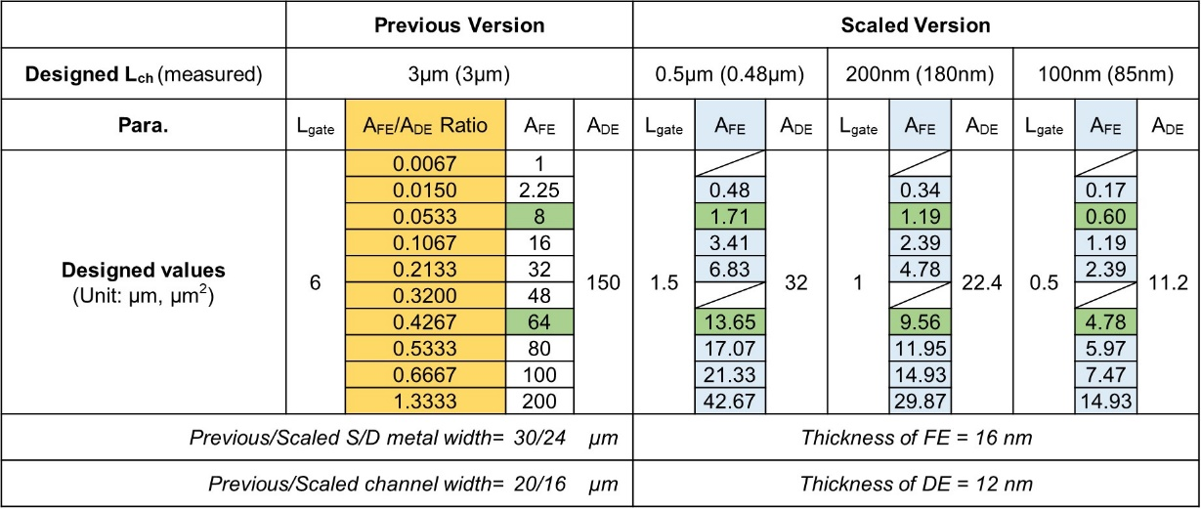

Supplementary Table 14. The performance benchmark with other advanced published devices.

 | This  work | IEDM17  [45] | VLSI22  [165] | VLSI22  [171] | IEDM18  [23] | IEDM18 [108]
Structure | Planar | FDSOI | GAA | Planar | Planar | Fin
FE | HZO | HZO | HZO | HZO | HZO | HZO
Channel | MoS₂ | Si | Si | IWO | Si | Si
t_{FE} | 16nm | ~5nm | <10nm | 6nm | 10nm | 9.37nm
Lg | 85 nm | 20~500nm | 300nm | 50nm | ~6μm | 20nm
Retention | 10Y  @85ºC | 7D  @250ºC | 10Y | >10³s | 10⁴s  @150ºC | 10Y  @25ºC
Endurance | >10¹² | 10⁵ | >10¹¹ | >10¹⁰ | 10¹⁰ | 10⁵

Supplementary Table 15. A summary of variation numbers.
Variation type | Standard σ
Variation type | Unscaled device | Scaled device (100nm L_{ch})
Read variation | 0.056 μS | 0.040μS
Write variation | 0.043 μS | 0.017μS

Supplementary Reference:
- Luo, Z. et al. High-precision and linear weight updates by subnanosecond pulses in ferroelectric tunnel junction for neuro-inspired computing. Nat. Commun. 13, 699 (2022). doi: 10.1038/s41467-022-28303-x
- Chang, T., Chang, K., Tsai, T., Chu, T. & Sze S. M. Resistance random access memory. Materials Today. 19, 254-264 (2016). doi: 10.1016/j.mattod.2015.11.009
- Zahoor, F., Zulkifli, T. Z. A. & Khanday, F. A. Resistive random access memory (RRAM): an overview of materials, switching mechanism, performance, multilevel cell (mlc) storage, modeling, and applications. Nanoscale Res Lett. 15, 90 (2020). doi: 10.1186/s11671-020-03299-9
- Lee, J. S., Lee, S. & Noh, T. W. Resistive switching phenomena: a review of statistical physics approaches. Appl. Phys. Rev. 2, 031303 (2015). doi: 10.1063/1.4929512
- Sebastian, A., Gallo, M. L., Khaddam-Aljameh, R. & Eleftheriou, E. Memory devices and applications for in-memory computing. Nat. Nanotechnol. 15, 529-544 (2020). doi: 10.1038/s41565-020-0655-z
- Munjal, S. & Khare, N. Advances in resistive switching based memory devices. J. Phys. D: Appl. Phys. 52, 433002 (2019). doi: 10.1088/1361-6463/ab2e9e
- Milo, V., Malavena, G., Compagnoni, C. M. & Ielmini, D. Memristive and CMOS devices for neuromorphic computing. Materials. 13, 166 (2020). doi: 10.3390/ma13010166
- Chen, A., Hutchby, J., Zhirnov, V. & Bourianoff, G. Emerging Nanoelectronic Devices (John Wiley & Sons, Inc., 2014). doi: 10.1002/9781118958254
- Wong, H.-S. P. & Salahuddin, S. Memory leads the way to better computing. Nat. Nanotechnol. 10, 191-194 (2015). doi: 10.1038/nnano.2015.29
- Lee, M. et al. A fast, high-endurance and scalable non-volatile memory device made from asymmetric Ta₂O_{5-x}/TaO_{2-x} bilayer structures. Nat. Mater. 10, 625-630 (2011). doi: 10.1038/nmat3070
- Li, Y., Wang, Z., Midya, R., Xia, Q. & Yang, J. J. Review of memristor devices in neuromorphic computing: materials sciences and device challenges. J. Phys. D: Appl. Phys. 51, 503002 (2018). doi: 10.1088/1361-6463/aade3f
- Jeon, D. S., Park, J. H., Kim, M. J. & Kim, T. G. Low power NiN-based resistive switching memory device using Ti doping. Appl. Phys. Lett. 109, 183507 (2016). doi: 10.1063/1.4966951
- Prezioso, M. et al. Training and operation of an integrated neuromorphic network based on metal-oxide memristors. Nature 521, 61-64 (2015). doi: 10.1038/nature14441
- Wu, S. et al. Bipolar resistance switching in transparent ITO/LaAlO₃/SrTiO₃ memristors. ACS Appl. Mater. Interfaces 6, 8575-8579 (2014). doi: 10.1021/am501387w
- Chang, K. et al. High performance, excellent reliability multifunctional graphene oxide doped memristor achieved by self-protective compliance current structure. In 2014 IEEE International Electron Devices Meeting (IEDM) 33.3.1-33.3.4 (IEEE, 2014). doi: 10.1109/IEDM.2014.7047161
- Shang, J. et al. Thermally stable transparent resistive random access memory based on all-oxide heterostructures. Adv. Funct. Mater. 24, 2171–2179 (2014). doi: 10.1002/adfm.201303274
- Jiang, H. et al. Sub-10 nm Ta channel responsible for superior performance of a HfO₂ memristor. Sci. Rep. 6, 28525 (2016). doi: 10.1038/srep28525
- Choi, B. J. et al. Electrical performance and scalability of Pt dispersed SiO₂ nanometallic resistance switch. Nano Lett. 13, 3213-3217 (2013). doi: 10.1021/nl401283q
- Chen, Y. S. et al. Highly scalable hafnium oxide memory with improvements of resistive distribution and read disturb immunity. In 2009 IEEE International Electron Devices Meeting (IEDM) 1-4 (IEEE, 2009). doi: 10.1109/IEDM.2009.5424411
- Kim, Y. et al. Bi-layered RRAM with unlimited endurance and extremely uniform switching. In 2011 Symposium on VLSI Technology – Digest of Technical Papers 52-53 (IEEE, 2011).
- Wei, Z. et al. Highly reliable TaO_{x} ReRAM and direct evidence of redox reaction mechanism. In 2008 IEEE International Electron Devices Meeting (IEDM) 1-4 (IEEE, 2008). doi: 10.1109/IEDM.2008.4796676
- Cheng, C. H., Chinb, A. & Yeha, F. S. Novel ultra-low power RRAM with good endurance and retention. In 2010 Symposium on VLSI Technology 85-86 (IEEE, 2010). doi: 10.1109/VLSIT.2010.5556180
- Govoreanu, B. et al. 10×10nm² Hf/HfO_{x} crossbar resistive RAM with excellent performance, reliability and low-energy operation. In 2011 IEEE International Electron Devices Meeting (IEDM) 31.6.1-31.6.4 (IEEE, 2011). doi: 10.1109/IEDM.2011.6131652
- Lee, H. Y. et al. Low power and high speed bipolar switching with a thin reactive Ti buffer layer in robust HfO₂ based RRAM. In 2008 IEEE International Electron Devices Meeting (IEDM) 1-4 (IEEE, 2008). doi: 10.1109/IEDM.2008.4796677
- Rao, F. et al. Reducing the stochasticity of crystal nucleation to enable subnanosecond memory writing. Science 358, 1423-1427 (2017). doi: 10.1126/science.aao3212
- Kim, K. M. et al. Low-power, self-rectifying, and forming-free memristor with an asymmetric programing voltage for a high-density crossbar application. Nano Lett. 16, 6724−6732 (2016). doi: 10.1021/acs.nanolett.6b01781
- Sandre, G. D. et al. A 4 Mb LV MOS-selected embedded phase change memory in 90 nm standard CMOS technology. IEEE J. Solid-State Circuits 46, 52-63 (2011). doi: 10.1109/JSSC.2010.2084491
- Hokenmaier, W. et al. A 90nm 32-Mb Phase Change Memory with Flash SPI Compatibility. In 2014 IEEE 6th International Memory Workshop (IMW) 1-4 (IEEE, 2014). doi: 10.1109/IMW.2014.6849379
- Wu, L. et al. Sb-rich Si-Sb-Te phase-change material for phase-change random access memory applications. IEEE Trans. Electron Devices 58, 4423-4426 (2011). doi: 10.1109/TED.2011.2167152
- Song, Z. T. et al. High endurance phase change memory chip implemented based on carbon-doped Ge₂Sb₂Te₅ in 40 nm node for embedded application. In 2018 IEEE International Electron Devices Meeting (IEDM) 27.5.1-27.5.4 (IEEE, 2018). doi: 10.1109/IEDM.2018.8614538
- Zheng, J.F. et al. MOCVD GST for high speed and low current phase change memory. In 2011 11th Annual Non-Volatile Memory Technology Symposium Proceeding 1-6 (IEEE, 2011). doi: 10.1109/NVMTS.2011.6137102
- Cheng, H. Y. et al. Atomic-level engineering of phase change material for novel fast-switching and high-endurance PCM for storage class memory application. In 2013 IEEE International Electron Devices Meeting (IEDM) 30.6.1-30.6.4 (IEEE, 2013). doi: 10.1109/IEDM.2013.6724726
- Pellizzer, F. et al. A 90nm phase change memory technology for stand-alone non-volatile memory applications. In 2006 Symposium on VLSI Technology – Digest of Technical Papers 122-123 (IEEE, 2006). doi: 10.1109/VLSIT.2006.1705247
- Cheng, H. Y. et al. Novel fast-switching and high-data retention phase-change memory based on new Ga-Sb-Ge material. In 2015 IEEE International Electron Devices Meeting (IEDM) 3.5.1-3.5.4 (IEEE, 2015). doi: 10.1109/IEDM.2015.7409620
- Kim, I. S. et al. High performance PRAM cell scalable to sub-20nm technology with below 4F² cell size, extendable to DRAM applications. In 2010 Symposium on VLSI Technology 203-204 (IEEE, 2010). doi: 10.1109/VLSIT.2010.5556228
- Sato, H. et al. 14ns write speed 128Mb density embedded STT-MRAM with endurance >10¹⁰ and 10yrs retention @85°C using novel low damage MTJ integration process. In 2018 IEEE International Electron Devices Meeting (IEDM) 27.2.1-27.2.4 (IEEE, 2018). doi: 10.1109/IEDM.2018.8614606
- Wei, L. et al. A 7Mb STT-MRAM in 22FFL FinFET Technology with 4ns read sensing time at 0.9V using write-verify-write scheme and offset-cancellation sensing technique. In 2019 IEEE International Solid- State Circuits Conference (ISSCC) 214-216 (IEEE, 2019). doi: 10.1109/ISSCC.2019.8662444
- Miura, S. et al. Scalability of quad interface p-MTJ for 1X nm STT-MRAM with 10 ns low power write operation, 10 years retention and endurance > 10¹¹. In 2020 IEEE Symposium on VLSI Technology 1-2 (IEEE, 2020). doi: 10.1109/TED.2020.3025749
- Gallagher, W. J. et al. 22nm STT-MRAM for reflow and automotive uses with high yield, reliability, and magnetic immunity and with performance and shielding options. In 2019 IEEE International Electron Devices Meeting (IEDM) 2.7.1-2.7.4 (IEEE, 2019). doi: 10.1109/IEDM19573.2019.8993469
- Wang, Z. et al. STT-MRAM for embedded memory applications” in 2020 IEEE International Memory Workshop (IMW) 1-3 (IEEE, 2020). doi: 10.1109/IMW48823.2020.9108144
- Sun, J. J. et al. Commercialization of 1Gb standalone spin-transfer torque MRAM In 2021 IEEE International Memory Workshop (IMW) 1-4 (IEEE, 2021). doi: 10.1109/IMW51353.2021.9439616
- Aggarwal, S. et al. Demonstration of a reliable 1 Gb standalone spin transfer torque MRAM for industrial applications. In 2019 IEEE International Electron Devices Meeting (IEDM) 2.1.1-2.1.4 (IEEE, 2019). doi: 10.1109/IEDM19573.2019.8993516
- Lee, K. et al. 1Gbit high density embedded STT-MRAM in 28nm FDSOI technology. In 2019 IEEE International Electron Devices Meeting (IEDM) 2.2.1-2.2.4 (IEEE, 2019). doi: 10.1109/IEDM19573.2019.8993551
- Okuno, J. et al. High-endurance and low-voltage operation of 1T1C FeRAM arrays for nonvolatile memory application. In 2021 IEEE International Memory Workshop (IMW) 1-3 (IEEE, 2021). doi: 10.1109/IMW51353.2021.9439595
- Tahara, K. et al. Strategy toward HZO BEOL-FeRAM with low-voltage operation (≤ 1.2 V), low process temperature, and high endurance by thickness scaling. In 2021 Symposium on VLSI Technology 1-2 (IEEE, 2021).
- Okuno, J. et al. 1T1C FeRAM memory array based on ferroelectric HZO with capacitor under bitline. IEEE J. Electron Devices Soc. 10, 29-34 (2022). doi: 10.1109/JEDS.2021.3129279
- Okuno, J. et al. SoC compatible 1T1C FeRAM memory array based on ferroelectric Hf_{0.5}Zr_{0.5}O₂. In 2020 IEEE Symposium on VLSI Technology 1-2 (IEEE, 2020). doi: 10.1109/VLSITechnology18217.2020.9265063
- Lin, Y.-D. et al. Improving edge dead domain and endurance in scaled HfZrO_{x} FeRAM. In 2021 IEEE International Electron Devices Meeting (IEDM) 6.4.1-6.4.4 (IEEE, 2021). doi: 10.1109/IEDM19574.2021.9720692
- Francois, T. et al. Demonstration of BEOL-compatible ferroelectric Hf_{0.5}Zr_{0.5}O₂ scaled FeRAM co-integrated with 130nm CMOS for embedded NVM applications” in 2019 IEEE International Electron Devices Meeting (IEDM) 15.7.1-15.7.4 (IEEE, 2019). doi: 10.1109/IEDM19573.2019.8993485
- Boyn, S. et al. High-performance ferroelectric memory based on fully patterned tunnel junctions. Appl. Phys. Lett. 104, 052909 (2014). doi: 10.1063/1.4864100
- Ma, C. et al. Sub-nanosecond memristor based on ferroelectric tunnel junction. Nat. Commun. 11, 1439 (2020). doi: 10.1038/s41467-020-15249-1
- Ryu, H., Wu, H., Rao, F. & Zhu, W. Ferroelectric tunneling junctions based on aluminum oxide/ zirconium-doped hafnium oxide for neuromorphic computing. Sci. Rep. 9, 20383 (2019). doi: 10.1038/s41598-019-56816-x
- Wu, J. et al. High tunnelling electroresistance in a ferroelectric van der Waals heterojunction via giant barrier height modulation. Nat. Electron. 3, 466-472 (2020). doi: 10.1038/s41928-020-0441-9
- Chatterjee, K. et al. Self-aligned, gate last, FDSOI, ferroelectric gate memory device with 5.5-nm Hf_{0.8}Zr_{0.2}O₂, high endurance and breakdown recovery. IEEE Electron Device Lett. 38, 1379-1382 (2017). doi: 10.1109/LED.2017.2748992
- Luo, Q. et al. Hybrid 1T e-DRAM and e-NVM realized in one 10 nm node ferro FinFET device with charge trapping and domain switching effects” in 2018 IEEE International Electron Devices Meeting (IEDM) 2.6.1-2.6.4 (IEEE, 2018). doi: 10.1109/IEDM.2018.8614650
- Chen, K.-T. et al. Non-Volatile ferroelectric FETs using 5-nm Hf_{0.5}Zr_{0.5}O₂ with high data retention and read endurance for 1T memory applications. IEEE Electron Device Lett. 40, 399-402 (2019). doi: 10.1109/LED.2019.2896231
- Bae, J.-H. et al. Highly scaled, high endurance, Ω-Gate, nanowire ferroelectric FET memory transistors. IEEE Electron Device Lett. 41, 1637-1640 (2020). doi: 10.1109/LED.2020.3028339
- Zeng, B. et al. 2-Bit/Cell operation of Hf_{0.5}Zr_{0.5}O₂ based FeFET memory devices for NAND applications. IEEE J. Electron Devices Soc. 7, 551-556 (2019). doi: 10.1109/JEDS.2019.2913426
- Xiao, W. et al. Memory window and endurance improvement of Hf_{0.5}Zr_{0.5}O₂-based FeFETs with ZrO₂ seed layers characterized by fast voltage pulse measurements. Nanoscale Res. Lett. 14, 254 (2019). doi: 10.1186/s11671-019-3063-2
- Liu, H. et al. ZrO₂ ferroelectric FET for non-volatile memory application. IEEE Electron Device Lett. 40, 1419-1422 (2019). doi: 10.1109/LED.2019.2930458
- Trentzsch, M. et al. A 28nm HKMG super low power embedded NVM technology based on ferroelectric FETs. In 2016 IEEE International Electron Devices Meeting (IEDM) 11.5.1-11.5.4 (IEEE, 2013). doi: 10.1109/IEDM.2016.7838397
- Müller, J. et al. Ferroelectricity in HfO₂ enables nonvolatile data storage in 28 nm HKMG” in 2012 Symposium on VLSI Technology (VLSIT) 25-26 (IEEE, 2012). doi: 10.1109/VLSIT.2012.6242443
- Mulaosmanovic, H. et al. Evidence of single domain switching in hafnium oxide based FeFETs: enabler for multi-level FeFET memory cells. In 2015 IEEE International Electron Devices Meeting (IEDM) 26.8.1-26.8.3 (IEEE, 2015). doi: 10.1109/IEDM.2015.7409777
- Mulaosmanovic, H., Breyer, E. T., Mikolajick, T. & Slesazeck, S. Ferroelectric FETs with 20-nm-thick HfO₂ layer for large memory window and high Performance. IEEE Trans. Electron Devices 66, 3828-3833 (2019). doi: 10.1109/TED.2019.2930749
- Yoon, S.-J. et al. Improvement in long-term and high-temperature retention stability of ferroelectric field-effect memory transistors with metal–ferroelectric–metal–insulator-semiconductor gate-stacks using Al-doped HfO₂ thin films. IEEE Trans. Electron Devices 67, 499-504 (2020). doi: 10.1109/TED.2019.2961117
- Cha, M.-Y. et al. MoS₂-based ferroelectric field-effect transistor with atomic layer deposited Hf_{0.5}Zr_{0.5}O₂ films toward memory applications. AIP Advances 10, 065107 (2020). doi: 10.1063/5.0010829
- Kobayashi, T., Hori, N., Nakajima, T. & Kawae, T. Electrical characteristics of MoS₂ field-effect transistor with ferroelectric vinylidene fluoride-trifluoroethylene copolymer gate structure. Appl. Phys. Lett. 108, 132903 (2016). doi: 10.1063/1.4945327
- Cho, Y. et al. Nanowatt use 8 V switching nonvolatile memory transistors with 2D MoTe₂ channel and ferroelectric P(VDF-TrFE). Nano Energy 81, 105686 (2021). doi: 10.1016/j.nanoen.2020.105686
- Zhang, X. et al. MoS₂ field-effect transistors with lead zirconate-titanate ferroelectric gating. IEEE Electron Device Lett. 36, 784-786 (2015). doi: 10.1109/LED.2015.2440249
- Lipatov, A., Sharma, P., Gruverman, A. & Sinitskii, A. Optoelectrical molybdenum disulfide (MoS₂) -ferroelectric memories. ACS Nano 9, 8089-8098 (2015). doi: 10.1021/acsnano.5b02078
- Ko, C. et al. Ferroelectrically gated atomically thin transition-metal dichalcogenides as nonvolatile memory. Adv. Mater. 28, 2923-2930 (2016). doi: 10.1002/adma.201504779
- Liu, X. et al. Post-CMOS compatible aluminum scandium nitride/2D channel ferroelectric field-effect-transistor memory. Nano Lett. 21, 3753-3761 (2021). doi: 10.1021/acs.nanolett.0c05051
- Wang, X. et al. Van der Waals engineering of ferroelectric heterostructures for long-retention memory. Nat. Commun. 12, 1109 (2021). doi: 10.1038/s41467-021-21320-2
- Lee, Y. K. et al. Highly scalable 2nd-generation 45-nm split-gate embedded flash with 10-ns access time and 1M-cycling endurance” in 2016 IEEE 8th International Memory Workshop (IMW) 1-4 (IEEE, 2016). doi: 10.1109/IMW.2016.7495275
- Hsu, T.-H. et al. A vertical split-gate flash memory featuring high-speed source-side injection programming, read disturb free, and 100k endurance for embedded flash (eFlash) scaling and computing-in-memory (CIM). In 2020 IEEE International Electron Devices Meeting (IEDM) 6.3.1-6.3.4 (IEEE, 2020). doi: 10.1109/IEDM13553.2020.9372036
- Shim, S. I., Yeh, F. C., Wang, X. W. & Ma, T. P. SONOS-Type flash memory cell with metal/Al₂O₃/SiN/Si₃N₄/Si structure for low-voltage high-speed program/erase operation. IEEE Electron Device Lett. 29, 512-514 (2008). doi: 10.1109/LED.2008.920979
- Tsai, C.-L., Xiong, F., Pop, E. & Shim, M. Resistive random access memory enabled by carbon nanotube crossbar electrodes. ACS Nano 7, 5360-5366 (2013). doi: 10.1021/nn401212p
- Torrezan, A. C., Strachan, J. P., Medeiros-Ribeiro, G. & Williams, R. S. Sub-nanosecond switching of a tantalum oxide memristor. Nanotechnology 22, 485203 (2011). doi: 10.1088/0957-4484/22/48/485203
- Zhao, H. et al. Atomically thin femtojoule memristive device. Adv. Mater. 29, 1703232 (2017). doi: 10.1002/adma.201703232
- Veksler, D., Bersuker, G. & Bushmaker, A. W. Switching variability factors in compliance-free metal oxide RRAM. In 2019 IEEE International Reliability Physics Symposium (IRPS) 1-5 (IEEE, 2019). doi: 10.1109/IRPS.2019.8720579
- Wu, Y., Yu, S., Lee, B. & Wong, P. Low-power TiN/Al₂O₃/Pt resistive switching device with sub-20μA switching current and gradual resistance modulation. J. Appl. Phys. 110, 094104 (2011). doi: 10.1063/1.3657938
- Strachan, J. P., Torrezan, A. C., Medeiros-Ribeiro, G. & Williams, R. S. Measuring the switching dynamics and energy efficiency of tantalum oxide memristors. Nanotechnology 22, 505402 (2011). doi: 10.1088/0957-4484/22/50/505402
- Jameson, J. R. & Kamalanathan, D. Subquantum conductive-bridge memory. Appl. Phys. Lett. 108, 053505 (2016). doi: 10.1063/1.4941303
- Kuzum, D., Jeyasingh, R. G. D., Lee, B. & Wong, H.-S. P. Nanoelectronic programmable synapses based on phase change materials for brain-inspired computing. Nano Lett. 12, 2179–2186 (2012). doi: 10.1021/nl201040y
- Xiong, F., Liao, A. D., Estrada, D. & Pop, E. Low-power switching of phase-change materials with carbon nanotube electrodes. Science 332, 568-570 (2011). doi: 10.1126/science.1201938
- Zhang, F. et al. An Ultra-fast Multi-level MoTe₂-based RRAM” in 2018 IEEE International Electron Devices Meeting (IEDM) 22.7.1-22.7.4 (IEEE, 2018). doi: 10.1109/IEDM.2018.8614512
- Kumar, S. et al. Spatially uniform resistance switching of low current, high endurance titanium–niobium-oxide memristors. Nanoscale 9, 1793-1798 (2017). doi: 10.1039/C6NR07671H
- Zhou, Y. et al. Voltage-triggered ultrafast phase transition in vanadium dioxide switches. IEEE Electron Device Lett. 34, 220-222 (2013). doi: 10.1109/LED.2012.2229457
- Lee, S.-H., Jung, Y. & Agarwal, R. Highly scalable non-volatile and ultra-lowpower phase-change nanowire memory. Nat. Nanotechnol. 2, 626-630 (2007). doi: 10.1038/nnano.2007.291
- Sebastian, A. et al. Temporal correlation detection using computational phase-change memory. Nat. Commun. 8, 1115 (2017). doi: 10.1038/s41467-017-01481-9
- Pickett, M. D. & Williams, R. S. Sub-100 fJ and sub-nanosecond thermally driven threshold switching in niobium oxide crosspoint nanodevices. Nanotechnology 23, 215202 (2012). doi: 10.1088/0957-4484/23/21/215202
- Wang, W. J. et al. Fast phase transitions induced by picosecond electrical pulses on phase change memory cells. Appl. Phys. Lett. 93, 043121 (2008). doi: 10.1063/1.2963196
- Kitagawa, E. et al. Impact of ultra low power and fast write operation of advanced perpendicular MTJ on power reduction for high-performance mobile CPU. In 2012 IEEE International Electron Devices Meeting (IEDM) 29.4.1-29.4.4 (IEEE, 2012). doi: 10.1109/IEDM.2012.6479129
- Zhao, H. et al. Low writing energy and sub nanosecond spin torque transfer switching of in-plane magnetic tunnel junction for spin torque transfer random access memory. J. Appl. Phys. 109, 07C720 (2011). doi: 10.1063/1.3556784
- G. Jan, et al. Demonstration of Ultra-Low Voltage and Ultra Low Power STT-MRAM designed for compatibility with 0x node embedded LLC applications. In 2018 IEEE Symposium on VLSI Technology 65-66 (IEEE, 2018). doi: 10.1109/VLSIT.2018.8510672
- Shi, S., Ou, Y., Aradhya, S. V., Ralph, D. C. & Buhrman, R. A. Fast low-current spin-orbit-torque switching of magnetic tunnel junctions through atomic modifications of the free-layer interfaces. Phys. Rev. Applied 9, 011002 (2018). doi: 10.1103/PhysRevApplied.9.011002
- Fukami, S., Anekawa, T., Ohkawara, A., Zhang, C. & Ohno, H. A sub-ns three-terminal spin-orbit torque induced switching device. In 2016 IEEE Symposium on VLSI Technology 1-2 (IEEE, 2016). doi: 10.1109/VLSIT.2016.7573379
- Grezes, C. et al. Ultra-low switching energy and scaling in electric-field-controlled nanoscale magnetic tunnel junctions with high resistance-area product. Appl. Phys. Lett. 108, 012403 (2016). doi: 10.1063/1.4939446
- Garello, K. et al. Manufacturable 300mm platform solution for Field-Free Switching SOT-MRAM” in 2019 IEEE Symposium on VLSI Technology T194-T195 (IEEE, 2019). doi: 10.23919/VLSIT.2019.8776537
- Kanai, S., Matsukura, F. & Ohno, H. Electric-field-induced magnetization switching in CoFeB/MgO magnetic tunnel junctions with high junction resistance. Appl. Phys. Lett. 108, 192406 (2016). doi: 10.1063/1.4948763
- Garello, K., Yasin, F. & Kar, G. S. Spin-orbit torque MRAM for ultrafast embedded memories: from fundamentals to large scale technology integration. In 2019 IEEE 11th International Memory Workshop (IMW) 1-4 (IEEE, 2019). doi: 10.1109/IMW.2019.8739466
- Garello, K. et al. SOT-MRAM 300mm integration for low power and ultrafast embedded memories. In 2018 IEEE Symposium on VLSI Circuits T194-T195 (IEEE, 2018). doi: 0.23919/VLSIT.2019.8776537
- Park, B. H. et al. Lanthanum-substituted bismuth titanate for use in non-volatile memories. Nature 401, 682-684 (1999). doi: 10.1038/44352
- Francois, T. et al. High-performance operation and solder reflow compatibility in BEOL-integrated 16-kb HfO₂: Si-based 1T-1C FeRAM arrays. IEEE Trans. Electron Devices 69, 2108-2114 (2022). doi: 10.1109/TED.2021.3138360
- Chanthbouala, A. et al. Solid-state memories based on ferroelectric tunnel junctions. Nat. Nanotechnol. 7, 101-104 (2012). doi: 10.1038/nnano.2011.213
- Chen, L. et al. Ultra-low power Hf_{0.5}Zr_{0.5}O₂ based ferroelectric tunnel junction synapses for hardware neural network applications. Nanoscale 10, 15826-15833 (2018). doi: 10.1039/C8NR04734K
- Florent, K. et al. Vertical ferroelectric HfO₂ FET based on 3-D NAND architecture: towards dense low-power memory. In 2018 IEEE International Electron Devices Meeting (IEDM) 2.5.1-2.5.4 (IEEE, 2018). doi: 10.1109/IEDM.2018.8614710
- Ni, K. et al. In-Memory computing primitive for sensor data fusion in 28 nm HKMG FeFET technology. In 2018 IEEE International Electron Devices Meeting (IEDM) 16.1.1-16.1.4 (IEEE, 2018). doi: 10.1109/IEDM.2018.8614527
- Chen, L. et al. A van der Waals synaptic transistor based on ferroelectric Hf_{0.5}Zr_{0.5}O₂ and 2D Tungsten Disulfide. Adv. Electron. Mater. 6, 2000057 (2020). doi: 10.1002/aelm.202000057
- Yap, W. C., Jiang, H., Liu, J., Xia, Q. & Zhu, W. Ferroelectric transistors with monolayer molybdenum disulfide and ultra-thin aluminum-doped hafnium oxide. Appl. Phys. Lett. 111, 013103 (2017). doi: 10.1063/1.4991877
- Chang, S.-C. et al. Anti-ferroelectric Hf_{x}Zr_{1-x}O₂ capacitors for high-density 3-D embedded-DRAM. In 2020 IEEE International Electron Devices Meeting (IEDM) 28.1.1-28.1.4 (IEEE, 2020). doi: 10.1109/IEDM13553.2020.9372011
- Liao, C.-Y. et al. Endurance > 10¹¹ cycling of 3D GAA nanosheet ferroelectric FET with stacked HfZrO₂ to homogenize corner field toward mitigate dead zone for high-density eNVM. In 2022 IEEE Symposium on VLSI Technology and Circuits (VLSI Technology and Circuits) 1–2 (IEEE, 2022). doi: 10.1109/VLSITechnologyandCir46769.2022.9830345
- Hsieh, E. R. et al. NVDimm-FE: A high-density 3D architecture of 3-bit/c 2TnC FE to break great memory wall with 10 ns of PGM-pulse, 10¹⁰ cycles of endurance, and decade lifetime at 103°C. In 2022 IEEE Symposium on VLSI Technology and Circuits (VLSI Technology and Circuits) 359–360 (IEEE, 2022). doi: 10.1109/VLSITechnologyandCir46769.2022.9830515
- Lomenzo, P. D. et al. Memory window enhancement in antiferroelectric RAM by Hf doping in ZrO₂. IEEE Electron Device Lett. 43, 1447–1450 (2022). doi: 10.1109/LED.2022.3189159
- Sung, M. et al. Low voltage and high speed 1Xnm 1T1C FE-RAM with ultra-thin 5nm HZO. In 2021 IEEE International Electron Devices Meeting (IEDM) 33.3.1-33.3.4 (IEEE, 2021). doi: 10.1109/IEDM19574.2021.9720545
- Chang, S.-C. et al. FeRAM using anti-ferroelectric capacitors for high-speed and high-density embedded memory. In 2021 IEEE International Electron Devices Meeting (IEDM) 33.2.1-33.2.4 (IEEE, 2021). doi: 10.1109/IEDM19574.2021.9720510
- Khanna, A. et al. BEOL compatible ferroelectric routers for run-time reconfigurable compute-in-memory accelerators. In 2022 IEEE Symposium on VLSI Technology and Circuits (VLSI Technology and Circuits) vol. 3 240–241 (IEEE, 2022). doi: 10.1109/VLSITechnologyandCir46769.2022.9830498
- Aabrar, K. A. et al. A thousand state superlattice (SL) FEFET analog weight cell. In 2022 IEEE Symposium on VLSI Technology and Circuits (VLSI Technology and Circuits) 242–243 (IEEE, 2022). doi: 10.1109/VLSITechnologyandCir46769.2022.9830333
- Ni, K. et al. A Novel Ferroelectric Superlattice Based Multi-Level Cell Non-Volatile Memory. In 2019 IEEE International Electron Devices Meeting (IEDM) 28.8.1-28.8.4 (IEEE, 2019).doi: 10.1109/IEDM19573.2019.8993670
- Lyu, X., Si, M., Shrestha, P. R., Cheung, K. P. & Ye, P. D. First direct measurement of sub-nanosecond polarization switching in ferroelectric hafnium zirconium oxide. In 2019 IEEE International Electron Devices Meeting (IEDM) 15.2.1-15.2.4 (IEEE, 2019). doi: 10.1109/IEDM19573.2019.8993509
- Zhou, Y. et al. Ferroelectric and interlayer co-optimization with in-depth analysis for high endurance FeFET. In 2022 IEEE International Electron Devices Meeting (IEDM) 6.2.1-6.2.4 (IEEE, 2022).
- Lin, Y.-D. et al. Highly reliable, scalable, and high-yield HfZrOx FRAM by barrier layer engineering and post-metal annealing. In 2022 IEEE International Electron Devices Meeting (IEDM) 32.1.1-32.1.4 (IEEE, 2022).
- Datta, S. et al. Total ionizing dose effect in tri-gate silicon ferroelectric transistor memory. In 2022 IEEE International Electron Devices Meeting (IEDM) 32.7.1-32.7.4 (IEEE, 2022).
- Chen, C. K. et al. First demonstration of ultra-low Dit top-gated ferroelectric oxide-semiconductor memtransistor with record performance by channel defect self-compensation effect for BEOL-compatible non-volatile logic switch. In 2022 IEEE International Electron Devices Meeting (IEDM) 6.1.1-6.1.4 (IEEE, 2022).
- Kong, Q. et al. First demonstration of BEOL-compatible 3D Fin-gate oxide semiconductor Fe-FETs. In 2022 IEEE International Electron Devices Meeting (IEDM) 12.3.1-12.3.4 (IEEE, 2022).
- Feng, N., Ji, N., Li, H. & Zhang, L. PHIMO_FeCAP Compact Model. nanoHUB (2022). doi:10.21981/HM1T-3Z54

