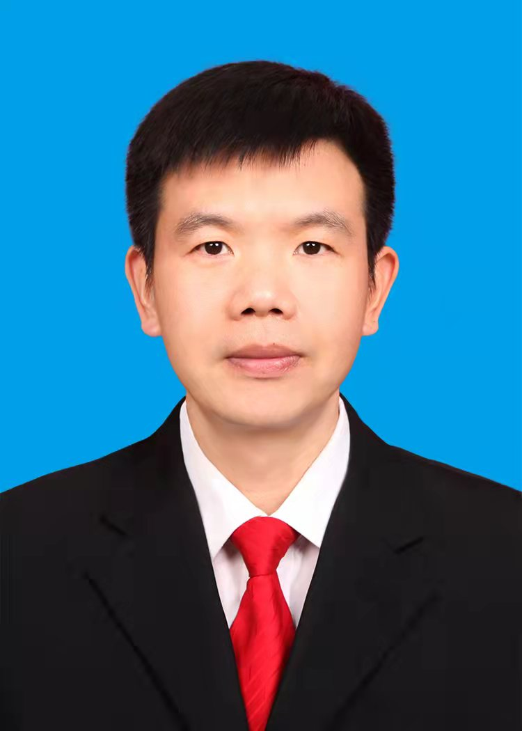
Hu Qingsong is a professor at the School of Information and Control Engineering, China University of Mining and Technology. He is a member of the Standardization Working Committee of the Chinese Institute of Electronics and a member of the Professional Committee of Mining Informatization and Intelligentization of the Chinese Society for Nonferrous Metals.His research intersts include moving object localization, WSN and IOT.


Cai Xueting is currently studying for a master's degree at China University of Mining and Technology. Her research interest is moving object localization.

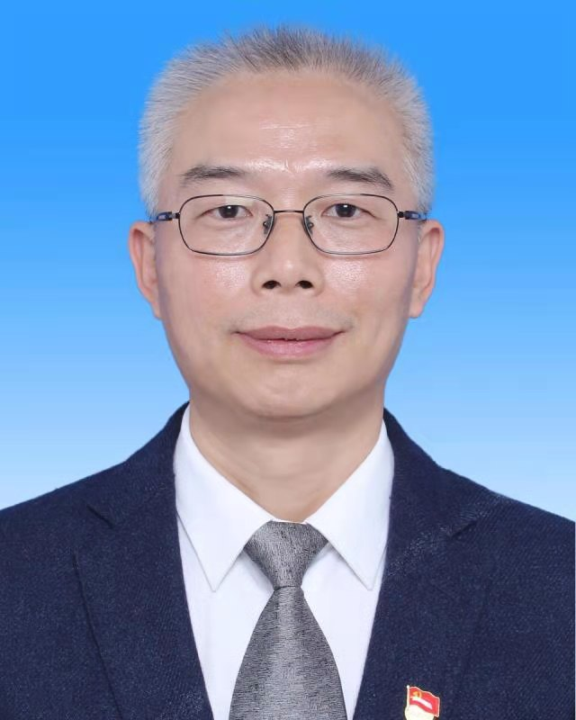
Li Shiyin is a professor and associate dean of the School of Information and Control Engineering, China University of Mining and Technology. He is a director of the Information Branch of China Coal Industry Association.He is a director of the Information Branch of China Coal Industry Association. His research interests include smart mines, underground wireless communication and precise positioning in coal mines.

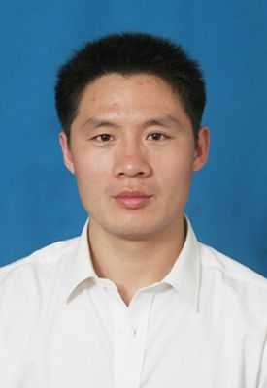
Sun Yanjing is a professor, deputy dean of the School of Information and Control Engineering, China University of Mining and Technology, a senior member of the Institute of Electronics, a member of the Computer Society, a member of IEEE, and a member of IEICE.His research interests include wireless communications，underground wireless communication , In-Band Full-Duplex technology, signal processing in images and wireless sensor networks.

