Additional file 1. Approach to scoring of histopathological parameters to evaluate ischaemia severity in skeletal muscle.

INFLAMMATION: |  | The terminology ‘inflammation’ refers when leukocyte accumulatios are part of an active inflammatory process in combination of other concurrent features such as vascular changes, presence of necrosis, fibrosis and disruption of muscle fibre architecture. Leukocyte ‘infiltration’ is most appropriately used when leukocyte accumulations are present in tissue without other disruption or pathology [1].
0 | Normal | Absence or minor presence of vascular associated leukocyte accumulations.
1 | Mild | Localised or mildly scattered leukocyte accumulation in tissue, with no evidence of significant damage of muscle fibre bundles (e.g. leukocyte infiltration).
2 | Moderate | Moderately scattered or multifocal cluster leukocyte accumulation, with disruption of several muscle fibres and with/without presence of active phagocytosis.
3 | Severe | Leukocyte accumulation scattered across large areas of muscle, or with large multifocal clusters, accompanied by a significant loss of muscle fibre integrity with active phagocytosis and accompanied with or without moderate/severe presence of necrosis and/or fibrosis.

FIBROSIS: |  | Muscle fibrosis is often the end result of an initial inflammatory process. In H&E staining, fibrosis is characterised by increased amounts of pale eosinophilic fibrillar material (collagen deposition) separating and surrounding adjacent myofibers [2]. In the Mallory’s Trichrome stain, collagen fibres appear stained in blue (recommended staining).
0 | Normal | Normal connective tissue, collagen is present in epimysium, perimysium and endomysium at normal levels.
1 | Mild | Early changes consisting of mild increase of deposits of pale eosinophilic material (H&E) or blue-stained fibrillar collagen (Mallory Trichrome) in endomysium and perimysium.
2 | Moderate | Moderate increased deposition of endomysial connective tissue separating and surrounding adjacent fibres with attenuation of several muscle fibres.
3 | Severe | Marked presence of collagen deposits in large areas with generalised attenuation and loss of tissue architecture and often with presence of necrotic muscle fibres (dark, purple-stained myoblasts).

NECROSIS: |  | Necrosis is histologically characterised by hypereosinophilic (pale) fibres in H&E, or purple-stained myofibers under Mallory’s Trichrome staining (recommended staining). Necrotic myofibers may or may not exhibit concurrent inflammation, fibrosis and dystrophic mineralisation (calcification) [3,4].
0 | Normal | Normal appearance of muscle fibres, characterised by presence of peripheral nuclei, and regular polygonal shape.
1 | Mild | Necrotic fibres are focal to a small region, affecting only a few myofibres, very often presence dystrophic mineralisation (calcification). Affected fibres can appear vacuolated and fragmented, pale (H&E) or purple (Mallory trichrome), swollen, round, peripheral nuclei are lost, with minor or no phagocytosis.
2 | Moderate | Necrotic fibres are localised to one area, affecting only one bundle of myofibres. Affected fibres can appear vacuolated and fragmented, pale (H&E) or purple (Mallory trichrome), swollen, round, peripheral nuclei are lost. It may be accompanied with moderated leukocyte accumulation and/or active phagocytosis surrounding.
3 | Severe | Necrotic fibres are localised to more than one focal area, affecting several muscle fibre bundles. It may be accompanied with moderate leucocyte accumulation and/or active phagocytosis surrounding.

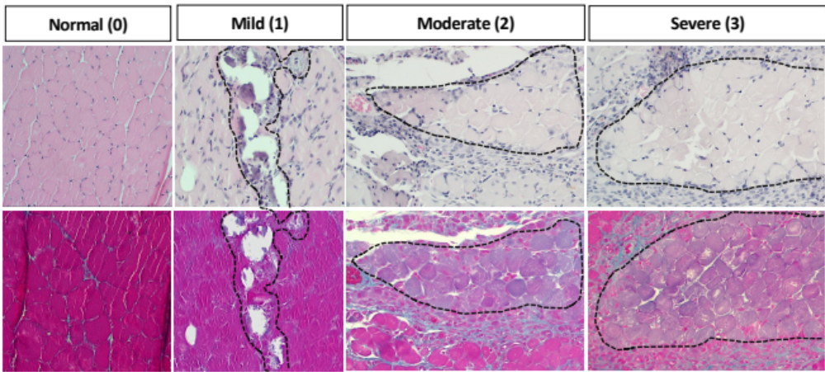

ADIPOCYTE (fat) INFILTRATION: |  | Regeneration impairment leads to fibre substitution with ectopic tissues including inter-muscle (perymisium) and intra-muscle (endomysium) accumulation of adipocytes [5].
0 | Normal | Adipose tissue is present in normal sites (e.g in perymisium surrounding neurovascular bundles, subcutaneous fat surrounded by epimysium).
1 | Mild | Scattered accumulation of adipose tissue (in small clusters) in the perymisium and endomysium.
2 | Moderate | Large clusters or moderately scattered accumulation of adipose tissue in the perymisium and endomysium. Hint: adipocyte infiltration is not present in all fields of view at 10X (not counting areas of severe inflammation)
3 | Severe | Markedly increased and widely spread large clusters of adipocyte accumulation in the perymisium and endomysium. Hint: Adipocyte infiltration present in all fields of view at 10X.
FIBRE DEGENERATION / REGENERATION: |  | Regenerative myofibers are histologically characterised by the presence of centralised nuclei and cytoplasmic basophilia (slight purple stain) due to large amounts of RNA in actively differentiating and growing cells [6]. They can appear near areas of active necrosis or degeneration and leukocyte infiltration, as macrophages play an important role in phagocytising associated debris [7].
0 | Normal | Normal appearance of muscle fibres, characterised by presence of peripheral nuclei, and regular polygonal shape. Very few myofibers with a central nucleus may be still present.
1 | Late-stage regeneration | Presence of more mature myofibers, morphology and size of myofibers returning to normal appearance and regular shape, but still with large areas of centralised nuclei present. Muscle fibres have lost the basophilic staining of an actively regenerating myotubes and inflammation has resolved.
2 | Early-stage regeneration | Presence of muscle fibres markedly smaller and homogeneous in size. Myofibers show hypertrophic centralised nuclei (enlarged) and cytoplasmic basophilia. Areas of active inflammation (mild to moderate) may still be present in surrounding areas.
3 | Fibre Degeneration | Degeneration can exhibit a variety of microscopic changes including irregular shapes, cell swelling or, shrunken fibres, hypereosinophilia (pale colour) and necrosis. Accompanied with large areas of leukocyte accumulation (severe inflammation) with marked attenuation or disruption of several muscle fibres.

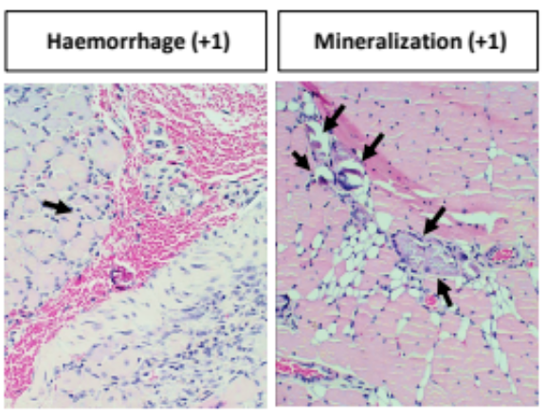
HAEMORRHAGE: |  | Extravascular accumulation of blood characterised by presence of free erythrocytes adjacent to and between muscle bundles or surrounding individual muscle fibres. Legions can range from focal and discrete to extensive and widespread. It typically occurs following an insult in muscle such as blunt trauma, intramuscular injection or inflammation [8].
0 | Absence | Not observed
1 | Presence | Present on its own or accompanied by muscle necrosis/fibrosis/inflammation. Haemorrhage will only be recorded when it is not present in an area of inflammation/degeneration (i.e. extravascular blood present in inflammation/degeneration may be due the degeneration of capillaries or small vessels and therefore it is not counted as an unexpected event).

References:
This table was complied with guidance the work from Thuilliez et. al. [33] and from the National Toxicology Program (NTP) Nonneoplastic Lesion Atlas:

[1] Crabbs TA. (2014) Musculoskeletal System–Skeletal Muscle: Inflammation. Cesta MF, Herbert RA, Brix A, Malarkey DE, Sills RC (Eds.), in: National Toxicology Program Atlas of Nonneoplastic Lesions in Rats and Mice. Available: https://ntp.niehs.nih.gov/nnl/musculoskeletal/index.htm [last accessed 17th August 2022].
[2] Crabbs TA. (2014) Musculoskeletal System–Skeletal Muscle: Fibrosis. Cesta MF, Herbert RA, Brix A, Malarkey DE, Sills RC (Eds.), in: National Toxicology Program Atlas of Nonneoplastic Lesions in Rats and Mice. Available: https://ntp.niehs.nih.gov/nnl/musculoskeletal/index.htm [last accessed 17th August 2022].
[3] Crabbs TA. (2014) Musculoskeletal System–Skeletal Muscle: Necrosis. Cesta MF, Herbert RA, Brix A, Malarkey DE, Sills RC (Eds.), in: National Toxicology Program Atlas of Nonneoplastic Lesions in Rats and Mice. Available: https://ntp.niehs.nih.gov/nnl/musculoskeletal/index.htm [last accessed 17th August 2022].
[4] Crabbs TA. (2014) Musculoskeletal System–Skeletal Muscle: Mineralization. Cesta MF, Herbert RA, Brix A, Malarkey DE, Sills RC (Eds.), in: National Toxicology Program Atlas of Nonneoplastic Lesions in Rats and Mice. Available: https://ntp.niehs.nih.gov/nnl/musculoskeletal/index.htm [last accessed 17th August 2022].
[5] Sciorati C, Clementi E, Manfredi AA, Rovere-Querini P. Fat deposition and accumulation in the damaged and inflamed skeletal muscle: cellular and molecular players. Cell Mol Life Sci. 2015;72(11):2135-2156. doi:10.1007/s00018-015-1857-7.
[6] Crabbs TA. (2014) Musculoskeletal System–Skeletal Muscle: Regeneration. Cesta MF, Herbert RA, Brix A, Malarkey DE, Sills RC (Eds.), in: National Toxicology Program Atlas of Nonneoplastic Lesions in Rats and Mice. Available: https://ntp.niehs.nih.gov/nnl/musculoskeletal/index.htm [last accessed 17th August 2022].
[7] Crabbs TA. (2014) Musculoskeletal System–Skeletal Muscle: Degeneration. Cesta MF, Herbert RA, Brix A, Malarkey DE, Sills RC (Eds.), in: National Toxicology Program Atlas of Nonneoplastic Lesions in Rats and Mice. Available: https://ntp.niehs.nih.gov/nnl/musculoskeletal/index.htm [last accessed 17th August 2022].
[8] Crabbs TA. (2014) Musculoskeletal System–Skeletal Muscle: Haemorrhage. Cesta MF, Herbert RA, Brix A, Malarkey DE, Sills RC (Eds.), in: National Toxicology Program Atlas of Nonneoplastic Lesions in Rats and Mice. Available: https://ntp.niehs.nih.gov/nnl/musculoskeletal/index.htm [last accessed 17th August 2022].

