Performance Metrics for Nanofiltration-based Selective Separation for Resource Extraction and Recovery

Supporting Information Submitted to

Nature Water

as Analysis

August 2022

Ruoyu Wangª, Rongrong He^{b}, Tao He^{b}, Menachem Elimelech^{c}, and Shihong Lin* ^{a,d}

ª Department of Civil and Environmental Engineering, Vanderbilt University, Nashville, Tennessee 37235-1831, USA

^{b} Shanghai Advanced Research Institute, Chinese Academy of Sciences, Shanghai 201210, China

^{c} Department of Chemical and Environmental Engineering, Yale University, New Haven, Connecticut 06520-8286, USA

^{d} Department of Chemical and Bimolecular Engineering, Vanderbilt University, Nashville, Tennessee 37235-1831, USA

*Email: shihing.lin@vanderbilt.edu

Supplementary Text
S1: Modeling module-scale performance with the solution-diffusion-electromigration (SDEM) model
The SDEM model^{1–3} assumes that any point inside the membrane is in thermodynamic equilibrium with a virtual bulk electrolyte solution, i.e., ${\overline{μ}}_{i}=μ_{i}$, or:
$$μ_{i}^{0}+ln\left({\overline{γ}}_{i}{\overline{c}}_{i}\right)+z_{i}\overline{φ}=μ_{i}^{0}+ln\left(γ_{i}c_{i}\right)+z_{i}φ$$ | (S1)
where the left-hand-side of Equation S1 is the real electrochemical potential of ion $i$ inside the membrane (${\overline{μ}}_{i}$) and the right-hand-side is the electrochemical potential in the virtual solution ($μ_{i}$). $μ_{i}^{0}$ is the electrochemical potential of standard state. ${\overline{γ}}_{i}$ ($γ_{i}$), ${\overline{c}}_{i}$ ($c_{i}$), and $\overline{φ}$ ($φ$) are real (virtual) activity coefficients, concentrations, and electrical potentials, respectively. The ion flux across the membrane is driven by the electrochemical potential gradient and can be expressed as:
$$J_{i}=-{\overline{c}}_{i}D_{i}\frac{d{\overline{μ}}_{i}}{dx}$$ | (S2)
where $D_{i}$ is the diffusion coefficient of ion $i$. With the virtual solution approach and ideal solution assumption, Equation S2 becomes:
$$J_{i}=-\frac{{\overline{c}}_{i}}{c_{i}}D_{i}\frac{dc_{i}}{dx}-z_{i}{\overline{c}}_{i}D_{i}\frac{dφ}{dx}$$ | (S3)
If the partition coefficient is defined as $K_{i}=\frac{{\overline{c}}_{i}}{c_{i}}$, we can obtain:
$$J_{i}=-K_{i}D_{i}\frac{dc_{i}}{dx}-z_{i}K_{i}D_{i}c_{i}\frac{dφ}{dx}$$ | (S4)
where the product of the partition and diffusion coefficients is then defined as ion permeability, $P_{i}=K_{i}D_{i}$. Thus, Equation S4 is equivalent to Equation 5 in the main text. The virtual solution concept was first used by Spiegler and Kedem in the hyperfiltration theory based on irreversible thermodynamics.⁴ The main advantage of the virtual solution approach is to avoid explicitly determining the partition and diffusion coefficients.
The SDEM model describes local ion transport across the membrane with the modified Nernst-Planck equation (Equation 5 in the main text). With a given feed solution composition and a set of ion permeabilities, permeate composition can be solved as a function of permeate flux with the charge neutrality (Equation S5) and steady-state (Equation S6) conditions:
$$\sum_{i}{z_{i}c_{i}}=0$$ | (S5)

$$J_{i}=J_{w}c_{p,i}$$ | (S6)
where $c_{i}$ is the concentration of ion $i$ in the virtual solution or the external feed and permeate, and $c_{p,i}$ is permeate concentration of ion $i$. Yaroshchuk and Bruening provided an analytical solution of the SDEM model for a ternary electrolyte system.² Thus, a pair of ion permeabilities can be fitted to describe the coupon-scale ion transport behavior after accounting for concentration polarization (Equation 7 in the main text), given experimental results of Li⁺ and Mg²⁺ rejections at a certain permeate flux.
The module behavior was then modeled via a finite difference method to relate mass transfer in differential elements. Each differential element either has the same membrane area or the same increment of water recovery ($WR$). Since $WR$ increases as feed water flows past more membrane area, the module-scale behaviors can be equivalently modeled as a function of $WR$ instead of a function of position along the module. The inputs were the applied pressure and the initial feed solution composition.
The modified Nernst-Planck equation (Equation 5 in the main text) and the local permeate flux (Equation 8 in the main text) were solved iteratively with ion permeabilities as a function of interfacial feed solution composition (Equation 6 in the main text) to determine the local permeate composition and thus local ion rejections. Species conservation was maintained in the retentate and permeate when coupling the adjacent differential elements:
$$c_{p,i}^{loc}(WR)=\frac{d\left(\left(1-WR\right)c_{b,i}(WR)\right)}{dWR}$$ | (S7)
where $c_{p,i}^{loc}(WR)$ and $c_{b,i}(WR)$ are local permeate concentration and bulk retentate (or brine, subscript “b” for brine) concentration of ion $i$ at water recovery $WR$, respectively. Cumulative permeate concentration, $c_{p,i}^{cum}(WR)$, can be calculated as:
$$c_{p,i}^{cum}(WR)=\frac{\int{c_{p,i}^{loc}(WR)dWR}}{WR}$$ | (S8)
Local and cumulative rejections were then calculated by:
$$R_{i}^{loc}\left(WR\right)=1-\frac{c_{p,i}^{loc}(WR)}{c_{b,i}(WR)}$$ | (S9a)
$$R_{i}^{cum}\left(WR\right)=1-\frac{c_{p,i}^{cum}(WR)}{c_{f,i}}$$ | (S9b)
where $c_{f,i}$ is the initial (or influent) feed concentration of ion $i$. Local and cumulative selectivity can also be determined according to Equation 1 in the main text.
Representative module scale behavior is described in Figure 4 in the main text. Additional information, including the distribution of permeate flux, osmotic pressure difference (between the feed and permeate), and ion permeabilities, is presented in Figure S1.

S2: Estimation of osmotic pressure of the LiCl-MgCl₂ mixed electrolyte solution
For relatively dilute solutions, the van’t Hoff equation is usually applied to estimate the solution osmotic pressure:
$$π=\sum_{i}{\frac{c_{i}}{{MW}_{i}}RT}$$ | (S10)
where $c_{i}$ is ion mass concentration of ion $i$, ${MW}_{i}$ is the molecular weight of ion $i$, $R$ is ideal gas constant and $T$ is solution temperature. Transmembrane osmotic pressure, $∆π_{m}$, can be then estimated with feed side interfacial concentrations and permeate concentrations:
$$∆π_{m}=RT\sum_{i}{\frac{\left(c_{fm,i}-c_{p,i}\right)}{{MW}_{i}}}$$ | (S11)
For a more accurate estimation of osmotic pressure, solution non-ideality can be accounted for by Pitzer model.⁵

S3: Li/Mg MF separation experiments using commercial membranes
Li/Mg NF separation experiments were carried out in a lab-customized crossflow filtration system with stainless-steel membrane coupons. Effective membrane area of each coupon is 7.1 cm². Three commercial thin-film composite polyamide NF membranes, NFX (Synder), and NF90 and NF270 (Filmtec, Dow), were tested. Pure water permeability was first measured at 6 bar after pre-compaction of the membrane samples. Li/Mg separation was then conducted at 6 bar with both retentate and permeate streams circulating back to the feed tank. The feed solutions were prepared with LiCl and MgCl₂ (Sigma Aldrich) to achieve a total concentration of 2, 4, and 6 g L⁻¹, and an MLR of 20, 40, and 60. After filtration reaches steady state, permeate flux was measured and permeate samples were collected for ion concentration measurements. Li⁺ and Mg²⁺ concentrations were measured by inductively coupled plasma optical emission spectroscopy (ICP-OES). The permeate flux, $J_{w}$, of the NF experiments was determined using the following equation:
$$J_{w}=\frac{∆V}{A_{F}∆t}$$ | (S12)
where $∆V$ is the permeate volume produced in the period of $∆t$ and $A_{F}$ is the effective filtration area of the membrane coupon. The observed ion rejection, $R_{i}$, was calcualted as
$$R_{i}=1-\frac{c_{p,i}}{c_{f,i}}$$ | (S13)
where $c_{p,i}$ and $c_{f,i}$ are concentrations of the target ion in the permeate and feed solution, respectively. Li/Mg selectivity and ion permeabilities were further analyzed (Figure S2).

S4: The impact of water flux on Li/Mg selectivity
Li/Mg selectivity, $S_{Li/Mg}$, as a function of water flux at a coupon-scale is modeled for the polyelectrolyte membrane. The feed solution is LiCl and MgCl₂ with a total concertation of 2 or 6 g L⁻¹. The bulk mass based MLR is 20. The applied pressure varies up to 10 bar to control the water flux. $S_{Li/Mg}$ first increases and then decreases with water flux (Figure 5B in the main text). At the low water flux regime where the CP effect is mild, both $R_{Li}$ and $R_{Mg}$ increase with permeate water flux (Figure S6A), known as the “dilution effect”.^{6,7} $S_{Li/Mg}$ increases in this regime due to its stronger sensitivity to $R_{Mg}$, which is intrinsic to the definition of selectivity (Equation 1 in the main text).
As water flux further increases, $S_{Li/Mg}$ decreases as a combined result of the continuous increase of $R_{Li}$ and the slight reduction of $R_{Mg}$ (Figure S6A). Mg²⁺ transport behavior is mainly characterized by Mg²⁺ permeability, $P_{Mg}$. A higher $P_{Mg}$ means that Mg²⁺ becomes more permeable, which tends to result in a reduced $R_{Mg}$ when it outperforms the “dilution effect” (Figure S6B). Therefore, the reduction of $R_{Mg}$ in the high water flux regime may be explained by the impact of flux on $P_{Mg}$ via the enhanced CP effect. A higher water flux results in more severe CP which increases the total interfacial concentration (mainly Mg²⁺ concentration as MLR is high). Since ion permeability is assumed to be a function of local interfacial feed concentrations (Equation 6 in the main text), and $P_{Mg}$ has shown a positive correlation with interfacial feed concentrations (i.e., positive $α_{1}$ and $α_{2}$ values for Mg²⁺ with the LbL membrane in Table S2), a higher flux is thus detrimental to $S_{Li/Mg}$.
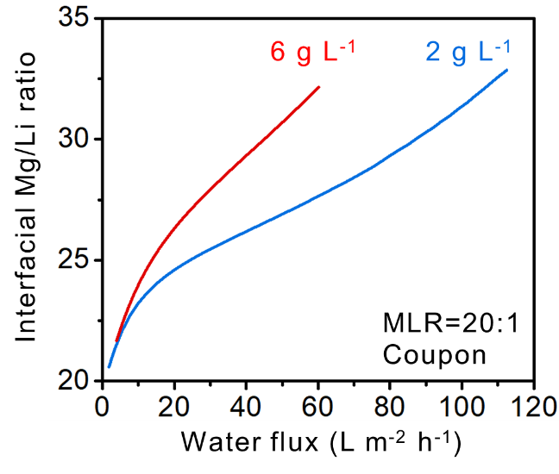
Figure S3. Interfacial Mg/Li ratio as a function of water flux at coupon-scale. Simulation used feed solutions of LiCl and MgCl₂ with 2 or 6 g L⁻¹ total concentration and bulk MLR of 20. Concentration polarization was accounted for with a mass transfer coefficient of 100 L m⁻² h⁻¹ for both LiCl and MgCl₂.

Supplementary Tables
Table S1. Literature data and experimental results in this study of Li/Mg separation
Membrane | Mg conc. (mg/L) | Li conc. (mg/L) | MLR | Mg rejection (%) | Li rejection (%) | Selectivity | Ref.
Desal DL | 9120.0 | 152.0 | 60.0 | 65.0 | -80.0 | 5.1 | 8
Desal DL | 5785.0 | 132.0 | 43.8 | 60.0 | -10.0 | 2.8 | 8
PAN/DAPP/TMC | 469.3 | 23.5 | 20.0 | 46.0 | -40.7 | 2.6 | 9
NF270 | 2820.0 | 141.0 | 20.0 | 80.0 | 45.0 | 2.8 | 10
NF90 | 2820.0 | 141.0 | 20.0 | 94.0 | 87.0 | 2.2 | 10
NF270 | 705.0 | 141.0 | 5.0 | 89.0 | 33.0 | 6.1 | 10
NF90 | 705.0 | 141.0 | 5.0 | 99.5 | 62.0 | 76.0 | 10
NF270 | 1410.0 | 141.0 | 10.0 | 85.0 | 41.0 | 3.9 | 10
NF90 | 1410.0 | 141.0 | 10.0 | 99.0 | 65.0 | 35.0 | 10
NF270 | 2115.0 | 141.0 | 15.0 | 86.0 | 45.0 | 3.9 | 10
NF90 | 2115.0 | 141.0 | 15.0 | 98.0 | 77.5 | 11.3 | 10
PEI/GQDs-NH2/TMC | 469.3 | 23.5 | 20.0 | 97.0 | 20.0 | 26.7 | 11
Dual-skin layer NF | 469.3 | 23.5 | 20.0 | 97.2 | 6.5 | 33.4 | 12
Dual-skin layer NF | 438.1 | 43.8 | 10.0 | 97.3 | 7.0 | 34.4 | 12
Dual-skin layer NF | 486.6 | 12.2 | 40.0 | 97.3 | 6.5 | 34.6 | 12
Dual-skin layer NF | 938.5 | 46.9 | 20.0 | 96.7 | 6.7 | 28.3 | 12
Dual-skin layer NF | 1407.8 | 70.4 | 20.0 | 96.1 | 6.0 | 24.1 | 12
MBCN-0.02 | 494.9 | 6.8 | 73.0 | 97.5 | 37.5 | 25.0 | 13
MBCN-0.02 | 1484.6 | 20.3 | 73.0 | 92.0 | -50.0 | 18.8 | 13
(PES-GO)/PEI/TMC | 469.3 | 23.5 | 20.0 | 95.1 | 22.0 | 15.9 | 14
PES/CNC-COOH/PA | 480.7 | 16.0 | 30.0 | 96.1 | 21.8 | 20.1 | 15
PES/CNC-COOH/PA | 492.7 | 8.2 | 60.0 | 95.6 | 11.6 | 20.0 | 15
PEI-TMC | 469.3 | 23.5 | 20.0 | 95.0 | 19.0 | 16.2 | 16
PIP-MWCNTs/PEI/TMC | 471.5 | 22.0 | 21.4 | 95.0 | 18.0 | 16.4 | 17
NF-IL-2% | 252.6 | 16.5 | 15.3 | 86.5 | -26.0 | 9.3 | 18
NF-IL-2% | 505.3 | 16.5 | 30.7 | 82.0 | -45.0 | 8.1 | 18
NF-IL-2% | 757.9 | 16.5 | 46.0 | 80.0 | -49.0 | 7.5 | 18
NF-IL-2% | 1010.5 | 16.5 | 61.4 | 75.0 | -55.0 | 6.2 | 18
PA-B2-E3 | 2400.0 | 100.0 | 24.0 | 92.3 | 29.0 | 9.2 | 19
PES/(PIP-PHF)/TMC | 471.5 | 22.0 | 21.4 | 91.5 | -10.0 | 12.9 | 20
MWCNTs-COOK | 469.3 | 23.5 | 20.0 | 98.6 | 21.6 | 57.7 | 21
PES/CQDs-NH2-TMC | 480.7 | 16.0 | 30.0 | 94.7 | 22.9 | 14.4 | 22
SPE-PEI600 | 500.1 | 3.3 | 150.0 | 89.1 | -30.9 | 12.0 | 23
SPE-PEI600 | 1250.4 | 8.3 | 150.0 | 84.7 | -38.1 | 9.0 | 23
SPE-PEI600 | 2500.7 | 16.7 | 150.0 | 79.6 | -43.1 | 7.0 | 23
TFN/PEI-3 | 469.3 | 23.5 | 20.0 | 97.4 | 5.0 | 36.5 | 24
Cu-MPD | 474.3 | 20.2 | 23.5 | 91.5 | 32.3 | 8.0 | 25
PSS/PAH2.5 (LbL) | 463.0 | 27.0 | 20.0 | 99.9 | 58.6 | 279.0 | 26
PSS/PAH2.5 (LbL) | 468.0 | 12.6 | 40.0 | 99.9 | 57.6 | 370.3 | 26
PSS/PAH2.5 (LbL) | 477.0 | 8.6 | 60.0 | 99.9 | 58.0 | 381.6 | 26
PSS/PAH2.5 (LbL) | 892.0 | 47.5 | 20.0 | 99.7 | 24.6 | 250.2 | 26
PSS/PAH2.5 (LbL) | 1230.0 | 60.0 | 20.0 | 99.4 | -40.8 | 249.2 | 26
PSS/PAH2.5 (LbL) | 1310.0 | 66.0 | 20.0 | 99.0 | -55.0 | 153.2 | 26
PSS/PAH2.5-X (LbL) | 468.0 | 23.8 | 20.0 | 99.7 | 22.1 | 262.3 | 26
PSS/PAH2.5-X (LbL) | 500.0 | 13.8 | 40.0 | 99.7 | 29.6 | 255.2 | 26
PSS/PAH2.5-X (LbL) | 506.0 | 9.0 | 60.0 | 99.8 | 34.0 | 330.2 | 26
PSS/PAH2.5-X (LbL) | 957.0 | 49.8 | 20.0 | 99.4 | -13.8 | 196.2 | 26
PSS/PAH2.5-X (LbL) | 1230.0 | 60.0 | 20.0 | 99.1 | -55.8 | 176.7 | 26
PSS/PAH2.5-X (LbL) | 1530.0 | 86.0 | 20.0 | 98.5 | -90.7 | 126.0 | 26
PES/PSS/PAH (LbL) | 469.3 | 23.5 | 20.0 | 99.0 | 28.6 | 71.4 | 27
PES/PSS/PAH (LbL) | 486.6 | 12.2 | 40.0 | 98.9 | 28.0 | 65.5 | 27
PES/PSS/PAH (LbL) | 492.7 | 8.2 | 60.0 | 99.0 | 25.7 | 74.3 | 27
PES/PSS/PAH (LbL) | 938.5 | 46.9 | 20.0 | 98.0 | -22.1 | 61.0 | 27
PES/PSS/PAH (LbL) | 1407.8 | 70.4 | 20.0 | 96.5 | -60.2 | 45.8 | 27
NFX | 469.3 | 23.5 | 20.0 | 89.1 | -84.1 | 16.9 | This study
NFX | 486.6 | 12.2 | 40.0 | 73.7 | -72.8 | 6.6 | This study
NFX | 492.7 | 8.2 | 60.0 | 85.5 | -122.2 | 15.4 | This study
NFX | 938.5 | 46.9 | 20.0 | 86.2 | -79.7 | 13.1 | This study
NFX | 1407.8 | 70.4 | 20.0 | 86.3 | -89.8 | 13.9 | This study
NF90 | 469.3 | 23.5 | 20.0 | 96.6 | 28.8 | 20.8 | This study
NF90 | 486.6 | 12.2 | 40.0 | 94.9 | 3.2 | 19.2 | This study
NF90 | 492.7 | 8.2 | 60.0 | 94.9 | 5.1 | 18.5 | This study
NF90 | 938.5 | 46.9 | 20.0 | 96.1 | 15.6 | 21.7 | This study
NF90 | 1407.8 | 70.4 | 20.0 | 95.8 | 4.7 | 22.7 | This study
NF270 | 469.3 | 23.5 | 20.0 | 51.7 | -10.2 | 2.3 | This study
NF270 | 486.6 | 12.2 | 40.0 | 38.8 | -8.0 | 1.8 | This study
NF270 | 492.7 | 8.2 | 60.0 | 46.9 | -12.2 | 2.1 | This study
NF270 | 938.5 | 46.9 | 20.0 | 51.9 | -10.2 | 2.3 | This study
NF270 | 1407.8 | 70.4 | 20.0 | 49.9 | -15.4 | 2.3 | This study

Table S2. Correlation coefficients of ion permeabilities of different membranes
Membranes | $$α_{1}$$ |  | $$α_{2}$$ |  | $$α_{3}$$
Membranes | Li⁺ | Mg²⁺ | Li⁺ | Mg²⁺ | Li⁺ | Mg²⁺
LbL (PSS/PAH) | 0.1688 | 0.0008 | 0.026 | 0.0007 | 3.0603 | 0.0179
NFX | -0.6788 | -0.0429 | 0.0794 | 0.0055 | 8.017 | 0.2191
NF90 | -0.1632 | -0.0076 | 0.0154 | 0.0008 | 1.9761 | 0.0614
NF270 | -16.763 | -2.4129 | 1.8194 | 0.2385 | 64.8623 | 9.6706

Table S3. Water permeability, fitted ion permeabilities, and permeability ratios of literature membranes and commercial membranes tested in this study
Membrane | P_{w} (LMH bar⁻¹) | P_{Li} (μm s⁻¹) | P_{Mg} (μm s⁻¹) | P_{Li} / P_{w} (bar) | P_{Li} / P_{Mg} | Ref.
Desal DL | 6.1 | 32.2 | 1.2 | 19.0 | 26.6 | 8
Desal DL | 6.1 | 39.1 | 5.1 | 23.0 | 7.6 | 8
PAN/DAPP/TMC | 2.6 | 21.8 | 0.8 | 30.6 | 26.7 | 9
NF270 | 19.7 | 4.9 | 1.1 | 0.9 | 4.5 | 10
NF90 | 3.3 | 0.0 | 0.0 | 0.0 | 2.8 | 10
NF270 | 19.7 | 21.3 | 2.0 | 3.9 | 10.5 | 10
NF90 | 3.3 | 1.4 | 0.0 | 1.5 | 112.2 | 10
NF270 | 19.7 | 13.8 | 2.1 | 2.5 | 6.5 | 10
NF90 | 3.3 | 0.8 | 0.0 | 0.8 | 51.5 | 10
NF270 | 19.7 | 7.5 | 1.2 | 1.4 | 6.3 | 10
NF90 | 3.3 | 0.2 | 0.0 | 0.2 | 16.2 | 10
PEI/GQDs-NH2/TMC | 11.9 | 3.0 | 0.1 | 0.9 | 42.8 | 11
Dual-skin layer NF | 12.0 | 5.6 | 0.1 | 1.7 | 54.1 | 12
Dual-skin layer NF | 12.0 | 6.7 | 0.1 | 2.0 | 58.9 | 12
Dual-skin layer NF | 12.0 | 5.0 | 0.1 | 1.5 | 54.5 | 12
Dual-skin layer NF | 12.0 | 3.3 | 0.1 | 1.0 | 46.4 | 12
Dual-skin layer NF | 12.0 | 0.8 | 0.0 | 0.2 | 40.3 | 12
MBCN-0.02 | 5.6 | 1.5 | 0.0 | 0.9 | 38.0 | 13
MBCN-0.02 | 5.6 | 0.8 | 0.0 | 0.5 | 34.4 | 13
(PES-GO)/PEI/TMC | 11.2 | 2.9 | 0.1 | 0.9 | 25.9 | 14
PES/CNC-COOH/PA | 4.2 | 3.9 | 0.1 | 3.3 | 31.7 | 15
PES/CNC-COOH/PA | 3.4 | 3.5 | 0.1 | 3.7 | 31.7 | 15
PEI-TMC | 5.0 | 5.3 | 0.2 | 3.8 | 26.6 | 16
PIP-MWCNTs/PEI/TMC | 14.0 | 8.4 | 0.3 | 2.2 | 26.4 | 17
NF-IL-2% | 5.5 | 12.3 | 0.6 | 8.0 | 20.0 | 18
NF-IL-2% | 5.5 | 13.0 | 0.7 | 8.5 | 19.0 | 18
NF-IL-2% | 5.5 | 12.4 | 0.7 | 8.1 | 18.2 | 18
NF-IL-2% | 5.5 | 14.4 | 0.8 | 9.4 | 17.4 | 18
PA-B2-E3 | 1.5 | 0.9 | 0.1 | 2.1 | 15.0 | 19
PES/(PIP-PHF)/TMC | 6.7 | 9.1 | 0.4 | 4.9 | 23.2 | 20
MWCNTs-COOK | 12.3 | 2.8 | 0.0 | 0.8 | 90.9 | 21
PES/CQDs-NH2-TMC | 33.0 | 3.4 | 0.1 | 0.4 | 23.0 | 22
SPE-PEI600 | 10.0 | 13.0 | 0.6 | 4.7 | 21.6 | 23
SPE-PEI600 | 10.0 | 11.0 | 0.6 | 3.9 | 18.0 | 23
SPE-PEI600 | 10.0 | 3.3 | 0.2 | 1.2 | 16.1 | 23
TFN/PEI-3 | 30.6 | 13.5 | 0.2 | 1.6 | 60.5 | 24
Cu-MPD | 16.2 | 8.4 | 0.7 | 1.9 | 12.8 | 25
PSS/PAH2.5 (LbL) | 7.9 | 0.9 | 0.0 | 0.4 | 420.2 | 26
PSS/PAH2.5 (LbL) | 7.9 | 0.9 | 0.0 | 0.4 | 568.3 | 26
PSS/PAH2.5 (LbL) | 7.9 | 0.8 | 0.0 | 0.4 | 584.4 | 26
PSS/PAH2.5 (LbL) | 7.9 | 1.6 | 0.0 | 0.7 | 393.3 | 26
PSS/PAH2.5 (LbL) | 7.9 | 2.1 | 0.0 | 1.0 | 445.2 | 26
PSS/PAH2.5 (LbL) | 7.9 | 2.7 | 0.0 | 1.2 | 287.7 | 26
PSS/PAH2.5-X (LbL) | 6.2 | 1.4 | 0.0 | 0.8 | 406.8 | 26
PSS/PAH2.5-X (LbL) | 6.2 | 1.1 | 0.0 | 0.6 | 383.0 | 26
PSS/PAH2.5-X (LbL) | 6.2 | 1.0 | 0.0 | 0.6 | 495.0 | 26
PSS/PAH2.5-X (LbL) | 6.2 | 2.1 | 0.0 | 1.2 | 325.8 | 26
PSS/PAH2.5-X (LbL) | 6.2 | 2.1 | 0.0 | 1.2 | 330.5 | 26
PSS/PAH2.5-X (LbL) | 6.2 | 2.4 | 0.0 | 1.4 | 289.8 | 26
PES/PSS/PAH (LbL) | 18.4 | 4.5 | 0.0 | 0.9 | 110.0 | 27
PES/PSS/PAH (LbL) | 18.4 | 4.1 | 0.0 | 0.8 | 99.8 | 27
PES/PSS/PAH (LbL) | 18.4 | 4.1 | 0.0 | 0.8 | 112.6 | 27
PES/PSS/PAH (LbL) | 18.4 | 5.2 | 0.1 | 1.0 | 103.8 | 27
PES/PSS/PAH (LbL) | 18.4 | 6.5 | 0.1 | 1.3 | 88.5 | 27
NFX | 2.1 | 7.0 | 0.2 | 12.0 | 46.4 | This study
NFX | 2.1 | 10.0 | 0.4 | 17.0 | 23.7 | This study
NFX | 2.1 | 8.1 | 0.2 | 13.9 | 42.9 | This study
NFX | 2.1 | 7.2 | 0.2 | 12.3 | 39.9 | This study
NFX | 2.1 | 6.2 | 0.1 | 10.6 | 45.4 | This study
NF90 | 3.3 | 1.6 | 0.0 | 1.8 | 32.9 | This study
NF90 | 3.3 | 2.1 | 0.1 | 2.3 | 31.3 | This study
NF90 | 3.3 | 2.0 | 0.1 | 2.2 | 29.8 | This study
NF90 | 3.3 | 1.6 | 0.0 | 1.7 | 35.6 | This study
NF90 | 3.3 | 1.2 | 0.0 | 1.3 | 38.3 | This study
NF270 | 19.7 | 65.7 | 8.9 | 12.0 | 7.4 | This study
NF270 | 19.7 | 127.5 | 18.3 | 23.3 | 6.9 | This study
NF270 | 19.7 | 80.9 | 10.9 | 14.8 | 7.4 | This study
NF270 | 19.7 | 64.3 | 8.6 | 11.8 | 7.5 | This study
NF270 | 19.7 | 66.4 | 7.8 | 12.1 | 8.5 | This study

Supplementary Figures

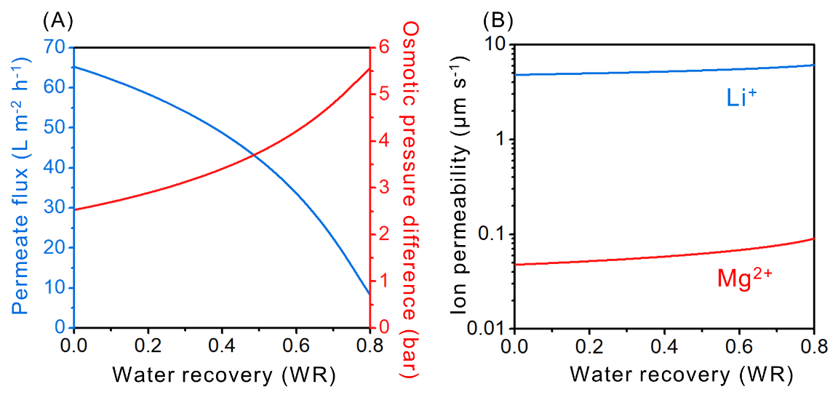
Figure S1. (A) Permeate flux and transmembrane osmotic pressure as a function of water recovery (WR). (B) Ion permeability as a function of WR. Simulation used 6 bar and a feed solution of LiCl and MgCl₂ with 2 g L⁻¹ total concentration and MLR of 20. Concentration polarization was accounted for by an assumed mass transfer coefficient of 100 L m⁻² h⁻¹ for both LiCl and MgCl₂.

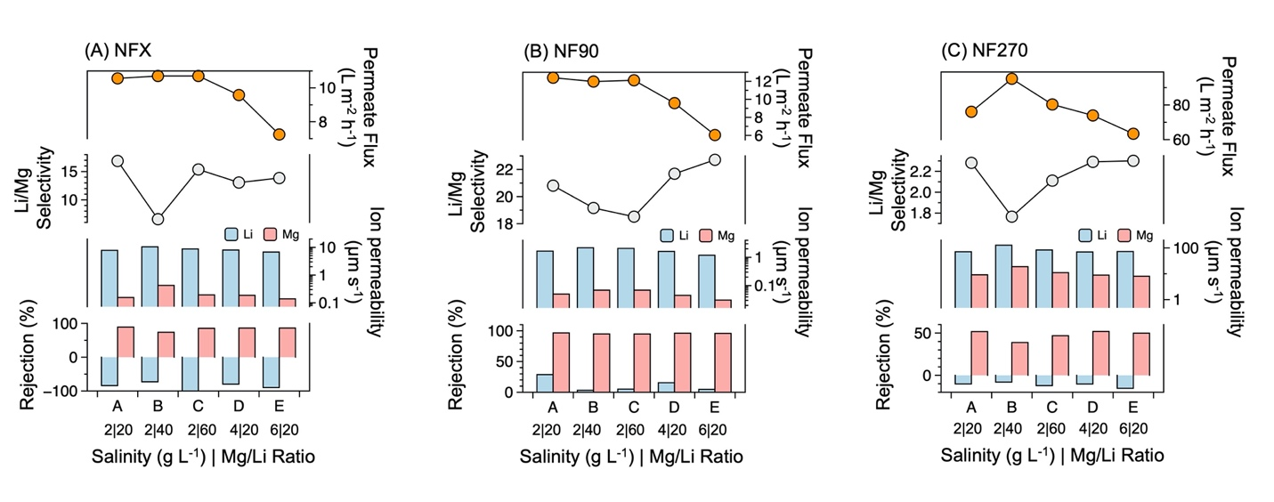
Figure S2. Li/Mg separation performance of (A) NFX, (B) NF90, and (C) NF270. From top to bottom: permeate flux, Li⁺/Mg²⁺ selectivity, fitted ion permeabilities, and measured rejections as a function of feed composition. Concentration polarization was accounted for by an assumed mass transfer coefficient of 100 L m⁻² h⁻¹ for both LiCl and MgCl₂.

Figure S3. Interfacial Mg/Li ratio as a function of water flux at coupon-scale. Simulation used feed solutions of LiCl and MgCl₂ with 2 and 6 g L⁻¹ total concentration and bulk MLR of 20. Concentration polarization was accounted for with a mass transfer coefficient of 100 L m⁻² h⁻¹ for both LiCl and MgCl₂.

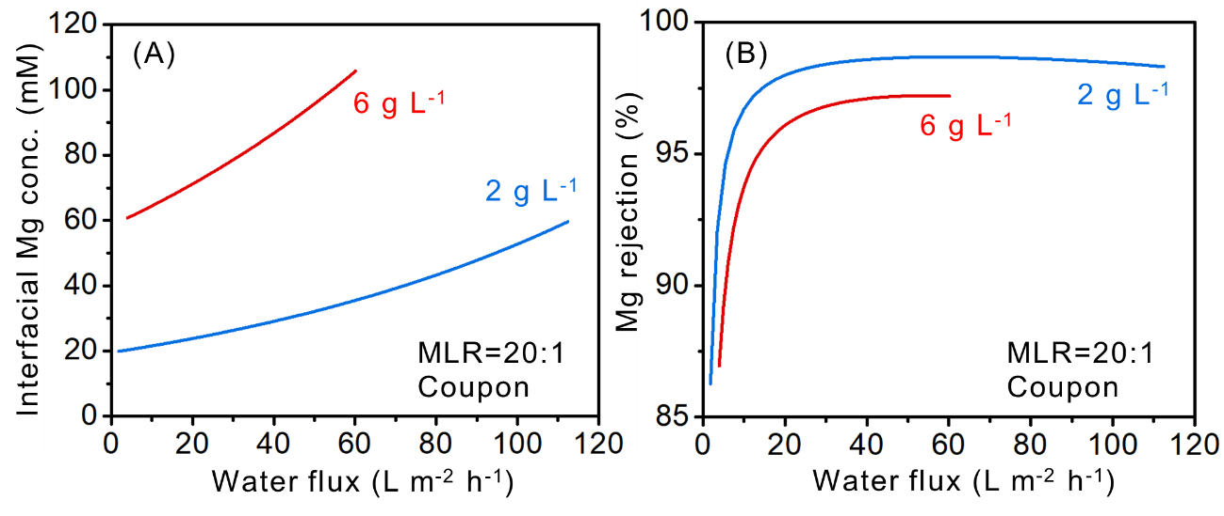
Figure S4. (A) Interfacial Mg concentration and (B) Apparent Mg rejection as a function of water flux at coupon-scale. Simulation used feed solutions of LiCl and MgCl₂ with 2 and 6 g L⁻¹ total concentration and bulk MLR of 20. Concentration polarization was accounted for with a mass transfer coefficient of 100 L m⁻² h⁻¹ for both LiCl and MgCl₂.

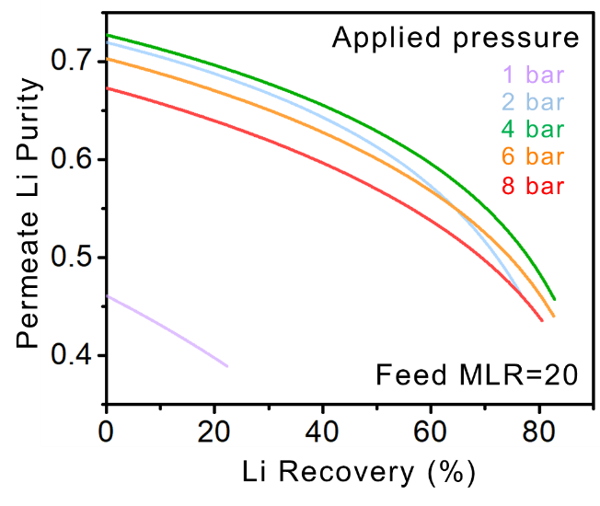
Figure S5. Permeate Li purity as a function of Li recovery with a feed MLR of 20 at different applied pressures. Simulation used 1, 2, 4, 6 and 8 bar and a feed solution of LiCl and MgCl₂ with 2 g L⁻¹ total concentration and MLR of 20. Concentration polarization was accounted for with a mass transfer coefficient of 100 L m⁻² h⁻¹ for both LiCl and MgCl₂.

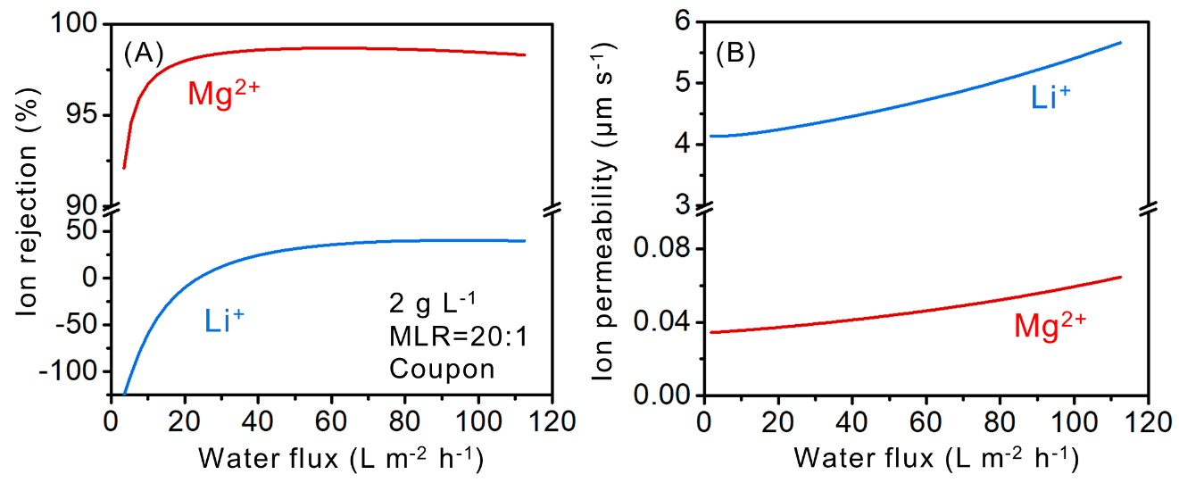
Figure S6. (A) Ion rejection and (B) Ion permeability as a function of water flux at coupon-scale. Simulation used feed solutions of LiCl and MgCl₂ with 2 g L⁻¹ total concentration and bulk MLR of 20. Concentration polarization was accounted for with a mass transfer coefficient of 100 L m⁻² h⁻¹ for both LiCl and MgCl₂.

References
1. Yaroshchuk, A., Bruening, M. L., Eduardo, E. & Bernal, L. Solution-Diffusion-Electro-Migration model and its uses for analysis of nanofiltration, pressure-retarded osmosis and forward osmosis in multi-ionic solutions. J. Memb. Sci. 447, 463–476 (2013).
2. Yaroshchuk, A. & Bruening, M. L. An analytical solution of the solution-diffusion-electromigration equations reproduces trends in ion rejections during nanofiltration of mixed electrolytes. J. Memb. Sci. 523, 361–372 (2017).
3. Yaroshchuk, A., Bruening, M. L. & Zholkovskiy, E. Modelling nanofiltration of electrolyte solutions. Adv. Colloid Interface Sci. 268, 39–63 (2019).
4. Spiegler, K. S. & Kedem, O. Thermodynamics of hyperfiltration (reverse osmosis): criteria for efficient membranes. Desalination 1, 311–326 (1966).
5. Pitzer, K. S. & Kim, J. J. Thermodynamics of Electrolytes. IV. Activity and Osmotic Coefficients for Mixed Electrolytes. J. Am. Chem. Soc. 96, 5701–5707 (1974).
6. Jin, X., She, Q., Ang, X. & Tang, C. Y. Removal of boron and arsenic by forward osmosis membrane: Influence of membrane orientation and organic fouling. J. Memb. Sci. 389, 182–187 (2012).
7. Yang, Z., Guo, H. & Tang, C. Y. The upper bound of thin-film composite (TFC) polyamide membranes for desalination. J. Memb. Sci. 590, 117297 (2019).
8. Sun, S., Cai, L., Nie, X., Song, X. & Yu, J. Separation of magnesium and lithium from brine using a Desal nanofiltration membrane. J. Water Process Eng. 7, 210–217 (2015).
9. Li, X. et al. Preparation and characterization of positively charged polyamide composite nanofiltration hollow fiber membrane for lithium and magnesium separation. Desalination 369, 26–36 (2015).
10. Kumar, B., Bilal, M., Kentish, S. & Duc, L. Lithium enrichment from a simulated salt lake brine using an integrated nanofiltration-membrane distillation process. J. Environ. Chem. Eng. 7, (2019).
11. Xu, P., Hong, J., Xu, Z., Xia, H. & Ni, Q. Novel aminated graphene quantum dots (GQDs-NH2)-engineered nanofiltration membrane with high Mg2+/Li+ separation efficiency. Sep. Purif. Technol. 258, 118042 (2021).
12. Yang, Z., Fang, W., Wang, Z., Zhang, R. & Zhu, Y. Dual-skin layer nanofiltration membranes for highly selective Li+/Mg 2+ separation. J. Memb. Sci. 620, (2021).
13. Bi, Q., Zhang, C., Liu, J., Liu, X. & Xu, S. Positively charged zwitterion-carbon nitride functionalized nanofiltration membranes with excellent separation performance of Mg 2 + / Li + and good antifouling properties. Sep. Purif. Technol. 257, 117959 (2021).
14. Xu, P. et al. “Bridge” graphene oxide modi fi ed positive charged nano fi ltration thin membrane with high e ffi ciency for Mg2+/Li+ separation. Desalination 488, (2020).
15. Guo, C. et al. Ultra-thin double Janus nanofiltration membrane for separation of Li+ and Mg2+: “Drag” effect from carboxyl-containing negative interlayer. Sep. Purif. Technol. 230, 115567 (2020).
16. Xu, P. et al. Positive charged PEI-TMC composite nanofiltration membrane for separation of Li+ and Mg2+ from brine with high Mg2+/Li+ ratio. Desalination 449, 57–68 (2019).
17. Zhang, H. Z., Xu, Z. L., Ding, H. & Tang, Y. J. Positively charged capillary nanofiltration membrane with high rejection for Mg2 + and Ca2 + and good separation for Mg2 + and Li +. Desalination 420, 158–166 (2017).
18. Wu, H. et al. A novel nanofiltration membrane with [MimAP][Tf2N] ionic liquid for utilization of lithium from brines with high Mg2+/Li+ ratio. J. Memb. Sci. 603, 117997 (2020).
19. Li, W. et al. A positively charged composite nanofiltration membrane modified by EDTA for LiCl / MgCl 2 separation. Sep. Purif. Technol. 186, 233–242 (2017).
20. Shen, Q., Xu, S., Xu, Z.-L., Zhang, H.-Z. & Dong, Z.-Q. Novel thin-film nanocomposite membrane with water-soluble polyhydroxylated fullerene for the separation of Mg2+/Li+ aqueous solution. J. Appl. Polym. Sci. 48029 (2019). doi:10.1002/app.48029
21. Xu, P., Hong, J., Xu, Z., Xia, H. & Ni, Q. MWCNTs-COOK-assisted high positively charged composite membrane : Accelerating Li+ enrichment and Mg2+ removal. Compos. Part B 212, 108686 (2021).
22. Guo, C. et al. Amino-rich carbon quantum dots ultrathin nanofiltration membranes by double “one-step” methods : Breaking through trade-off among separation, permeation and stability. Chem. Eng. J. 404, 127144 (2021).
23. Lu, D. et al. Constructing a selective blocked-nanolayer on nanofiltration membrane via surface-charge inversion for promoting Li+ permselectivity over Mg2+. J. Memb. Sci. 635, (2021).
24. Aghili, F., Asghar, A., Bruggen, B. Van Der & Rahimpour, A. A highly permeable UiO-66-NH2/polyethyleneimine thin-film nanocomposite membrane for recovery of valuable metal ions from brackish water. Process Saf. Environ. Prot. 151, 244–256 (2021).
25. Wang, L. et al. Novel Positively Charged Metal-Coordinated Nanofiltration Membrane for Lithium Recovery. ACS Appl. Mater. Interfaces 13, 16906–16915 (2021).
26. He, R. et al. Polyelectrolyte-based Nanofiltration Membranes with Exceptional Performance in Mg2+/Li+ Separation in a Wide Range of Solution Conditions. J. Memb. Sci. Under Review (2022).
27. He, R. et al. Unprecedented Mg2+/Li+ separation using layer-by-layer based nanofiltration hollow fiber membranes. Desalination 525, (2022).

