Maternal temperature stress modulates acclimation and thermal biology in Octopus maya (Cephalopoda: Octopodidae) juvenile progeny
Jorge Arturo Vargas-Abúndez¹, Alejandra Plata-Díaz², Maite Mascaró³ Claudia Caamal-Monsreal³, Gabriela Rodríguez-Fuentes⁴, Alejandro Jiménez-Be³, Carlos Rosas³
¹ Unidad Multidisciplinaria de Docencia e Investigación, Facultad de Ciencias, Universidad Nacional Autónoma de México. Puerto de abrigo s/n, Sisal, Yucatán, México
² Posgrado en Ciencias del Mar y Limnología, Universidad Nacional Autónoma de México, Facultad de Ciencias. Puerto de abrigo s/n, Sisal, Yucatán, México
³ Unidad Multidisciplinaria de Docencia e Investigación, Facultad de Ciencias, Universidad Nacional Autónoma de México. Puerto de abrigo s/n, Sisal, Yucatán, México
⁴ Unidad de Química en Sisal, Facultad de Química, Universidad Nacional Autónoma de México, Sisal, Yucatán, México

Corresponding Author: CR, crv@ciencias.unam.mx

Abstract
High temperatures alter the physiological condition of Octopus maya embryos, juveniles, and adults, and the time of exposure could have a key role in their thermal tolerance. The present study evaluates the effects of temperature and exposure time on octopus juveniles obtained from thermal-stressed and non-stressed females when exposed to optimal (25°C) and high temperatures (30°C) for 20 and 30 days, respectively. The results showed a transgenerational temperature effect that was expressed with low survival, depressed routine resting and high metabolic rates. Moreover, a collapse of antioxidant defense enzymes and high radical oxygen species (ROS) levels were detected in juveniles from thermally stressed females. Stress was lethal for animals acclimated at 30°C, while the performance of juveniles acclimated at optimal temperature (25°C) was conditioned by high ROS and low high metabolic rate (HMR) levels even after 30 days of experiment. In contrast, juveniles from non-thermally stressed females had an optimal performance when acclimated at 25°C but at 30°C, they had a comparatively higher HMR during the first eight days. These results suggest energy surplus in those animals to escape from warming scenarios before experiencing ROS accumulation. Further studies should confirm if epigenetic alterations could be involved.
Keywords: epigenetic, metabolism, climate change, respirometry, peroxidation, oxidative damage, transgenerational effect.

1. Introduction
The current anthropogenic global warming – estimated in an increment of sea temperature from 1 to 3°C for the next decades – is expected to generate profound metabolic alterations in marine ectotherm invertebrates, which can have consequences in the distribution and abundance of a wide number of species (Brown et al. 2004; Lefevre 2016; Madeira et al. 2016). Mobile species may tend to move to an environment where thermal conditions are more favorable but could provoke changes in the energetic relationship among the original components of the ecosystem (Cheung et al. 2008; Maharaj et al. 2018; Ángeles-González et al. 2021a, 2021b). Although the physiological processes are enhanced under high temperatures and result in high energy production, they also provoke the increment of deleterious reactive oxygen species (ROS; Johnstone et al. 2019). The mitochondrial respiratory chain is one of the main ROS (e.g., hydroxyl and superoxide radicals, singlet oxygen, etc.) and reactive nitrogen species (RNS; e.g., nitric oxide, peroxynitrite, etc.) produced naturally through physiological and non-physiological processes (Fridovich 1986; Feidantsis et al. 2021).
Oxidative stress produced by ROS consists of deleterious cumulative biomolecular cell damage, mainly oxidation of lipids, proteins, and nucleic acids (Storey 1996; Hulbert et al. 2007). The progressive accumulation of these biomolecules in cells and tissues modifies the function of these structural elements and enzymatic activity, generating damage to the proteasomal system (Beckman and Ames 1998; Grune et al. 2001; Passos and Von Zglinicki 2006). The cell antioxidant defense mechanisms (ANTIOX) consist of a group of enzymes (e.g. catalase, glutathione peroxidase, peroxiredoxin; Di Giulio et al., 1989) complemented by some low-weight non-enzymatic molecules (e.g. vitamins A, C, and E, bilirubin, beta-carotene, uric acid, and flavonoids; Rahal et al., 2014) that progressively reduce ROS into safe compounds (e.g. O₂ and H₂O; Halliwell 2013) or break the autocatalytic chain of radical reactions (Cadenas 1989), respectively. However, in organisms subjected to heat stress, ROS production can surpass the ANTIOX system, producing a condition named pejus, in which the organism survival depends on the exposure time to heat stress or ability to reduce metabolism, and consequently, ROS production (Pörtner 2010; Pörtner et al. 2017; Rodríguez-Fuentes et al. 2017). Numerous theories have been related to the cumulative oxidative damage produced by ROS in cells with degenerative processes associated to senescence in the individuals (e.g. somatic mutational theory, mitochondrial-DNA mutational hypothesis of cell aging, and the free radical theory of aging; Harman 1956). However, the most worrying consequence of global warming might be the effect of thermal stress overpassing the capacity of individual generations to neutralize ROS with profound costs for the ecology of populations and communities (Parmesan 2006; Massamba-N´Siala et al. 2014). Moreover, increasing thermal stress length during the reproductive phases results even more in a stronger transgenerational response (Salinas and Munch 2012; Dupont et al. 2013). Therefore, to predict the way in which populations could react to changes in the environment -taking into account the transgenerational effect of thermal stress- is a milestone for understanding the full effects of global warming (Hendry et al. 2008).
Evidence has suggested that thermal tolerance between generations can be enhanced through thermal preconditioning of adults to trigger an epigenetic response that could increase the thermal tolerance of their offspring. To mention some, the process has been defined as cross-generation plasticity (CGP), when the environment experienced by parents influences offspring phenotype: F0–F1; multigenerational plasticity (MGP) when the environment experienced by previous generations is evident to the F2 and beyond: F1–F2+; and carry-over effects (COE) that occur within the development (e.g. embryo to larva; Byrne et al. 2020). Although thermal stress in parents has been suggested as an effective mechanism for coping with temperature increases, thereby enhancing progeny performance under thermal stress through epigenetic inheritance (Fellous et al. 2015, 2022; Eirin-Lopez and Putnam 2021), studies performed on the mussel Mytilus californicus and Octopus maya embryos have provided evidence for negative parental effects on offspring thermal tolerances (Dominguez-Castanedo et al. unpubl data; Waite and Sorte 2022).
Octopus maya supports one of the most important octopus fisheries at the world level, with an annual production of around 20,000 Tons and it is considered that their catch has reached the maximum sustainable yield. This species, endemic of the Yucatan Peninsula; is relatively sensitive to thermal stress (Ángeles-González et al. 2020, 2021b) as embryos (Caamal-Monsreal et al. 2016), juveniles (Noyola et al. 2013a) and adults (Juárez et al. 2015). When temperature was evaluated in adult O. maya females, the number of spawned and fertilized eggs was lower above 27ºC than in females maintained at 24ºC (Juárez et al. 2015). These results indicate that high temperature affects negatively, not only the capacity of females to produce eggs but also the way in which sperms fertilize them in the oviductal gland. In experiments with male octopus, temperatures of 28ºC or higher provoked testicular damage, reducing their parental contribution in progeny (López-Galindo et al. 2019). These results evidence that temperatures from 28°C to 30°C deeply affect the reproductive performance of this octopus species. Studies of temperature effects on gene expression of O. maya females (Juárez et al. 2019) showed that the white body (located in the brain) at high temperatures up-regulates the expression of genes related to nutrient transport, proteolysis, and response to temperature stimulus, probably associated with embryo development. Moreover, other studies have demonstrated that females invest additional energy during the reproductive process to maintain energy reserves for parental care (Roumbedakis et al. 2018; Juárez et al. 2019; Lin et al. 2019), which indicates that high temperatures could be affecting their ability to channel enough energy to all the events involved in reproduction (Meza-Buendía et al. 2021). Until now, our research group has identified that for O. maya an adverse parental carry-over of thermal effects exists, which may be associated with trade-offs between the female condition (less aerobic scope and energy for yolk synthesis at high temperatures) and the investment required (yolk quantity) to have a successful offspring (Dominguez-Castanedo et al. unpubl data). In a recent study, smaller sizes, less yolk, higher metabolic rates, and lower CAT activity and total glutathione (GSH) concentrations were observed in embryos from thermally stressed females than those observed in embryos from females maintained in optimal thermal conditions, indicating that maternal thermal stress exerts sever effects in the progeny of this octopus species.
Previous studies have also demonstrated that exposure time is another variable that should be considered when thermal sensibility is evaluated in ectotherm organisms (Pörtner 2017). Furthermore, metabolic and growth alterations have been observed in O. maya juveniles exposed to 30°C constant for more than 20 days when compared with animals exposed to temperature increments of 1°C d⁻¹ until reaching 30°C (Juárez et al. 2016). To explain these results, the hypothesis is that octopuses exposed to a thermal ramp have the opportunity to make metabolic and energetic adjustments that allow them to maintain their homeostasis. On the contrary, octopuses kept in high constant temperatures were unable to maintain physiological stability, mainly because of ROS accumulation and the collapse of the ANTIOX defense mechanism.
The Yucatán peninsula has two well-differentiated oceanographic areas. One in the northern zone where a seasonal upwelling maintains the shelf floor temperature from 22 to 24°C in summer, while they can reach more than 30°C on the floor of the western zone temperatures (Fig. 1; Enriquez et al. 2013).
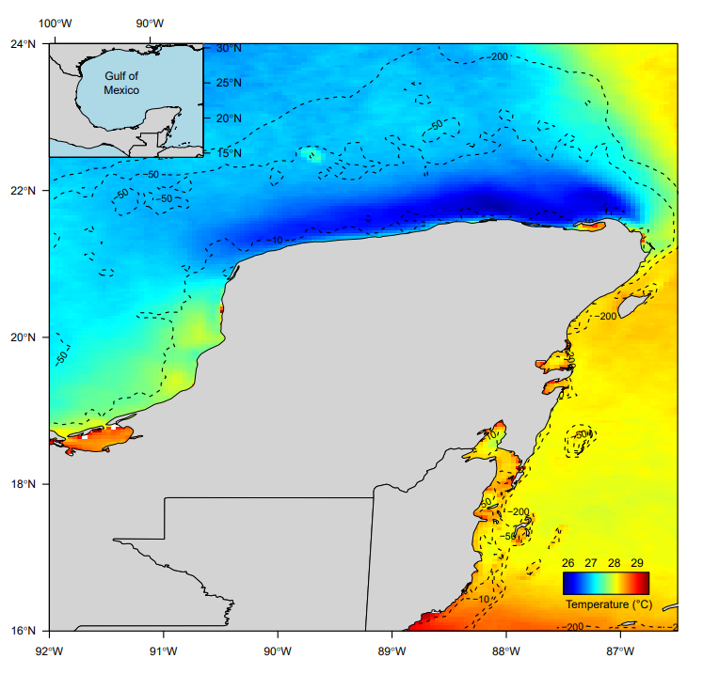
Fig. 1 Temperature variation in the continental shelf of the Yucatán peninsula, Mexico (2010 – 2020 data). Note: blue color in the zone with the influence of seasonal upwelling (north coast) and green and yellow zones in the western coast where upwelling has no influence. Octopus maya distribution is limited to the isobath of 50 m of the continental Yucatán peninsula shelf (Avendaño et al., 2019).

In consequence, oceanographic conditions drive the octopus population to have different biological cycles. In the northern zone, reproduction occurs year-round where the upwelling maintains the temperatures below 26°C even in summer (Fig. 1). In the western zone, the reproductive peak is concentrated in winter, when polar winds chill the platform (Angeles-Gonzalez et al. 2017; Juárez et al. 2018; Markaida et al. 2016). In such circumstances, females that spawn in the western zone incubate the embryos during the winter months (January to March) when temperatures are expected to be maintained from 22 to 26°C. Considering that in the western zone there is no influence of upwelling is highly probable that this zone, in warming scenarios, experiencing short and hard winters followed by high temperatures that could extend the summer season with high temperatures (IPCC 2021). In such a scenario, hatchlings could be exposed to fast temperature increments and sub-optimal thermal conditions that could affect their performance affecting at the end the population (Noyola et al. 2013a; Noyola et al. 2013b). In the past, variations in octopus landings were associated with thermal anomalies resulting from El Niño–Southern Oscillation (ENSO) events (Comisión Nacional de Pesca y Acuacultura, 2016). Using that information Ángeles-Gonzalez et al. (2017) found that the octopus fishery production is negatively affected in the western zone of the Yucatan Peninsula when temperature increases 2°C above average during an ENSO event. This effect has led to the hypothesis that the ENSO anomaly could be causing octopus migration from the western to eastern zone, where temperature increase is limited by seasonal upwelling. If this hypothesis is true, in warming scenarios or during the ENSO anomalies juveniles feel obligated to migrate to cooler environments before the thermal conditions affect their physiological condition irreversibly. The results obtained in early O. maya juveniles showed that 20 days at 30°C reduces their growth rate and survival because of the energetic costs associated to maintain the high metabolic rate in high temperatures (Noyola et al. 2013b), indicating that if juveniles do not migrate to low temperature environments their performance could be compromised.
Until now, evidence has demonstrated that high temperatures alter the physiological condition of O. maya embryos, juveniles, and adults and that time of exposure could have a key role in their thermal tolerance. This fact can be explained because animals depend on the duration of energetic reserves and the ability of antioxidant defense mechanisms to neutralize ROS when exposed to high temperature environments (Caamal-Monsreal et al. 2016; Meza-Buendia et al. 2021; Noyola et al. 2013b). Besides the time of exposure, thermal tolerance has also been observed to depend on the thermal history of the broodstock, which has a key role in the transgenerational thermal tolerance.
Until now, we know that in the scenario of thermal stress O. maya embryos, from thermally stressed females showed a reduction in their physiological performance and also in their survival (Domíngues-Castanedo et al unpublished data). Based on that, in the present study we design a series of experiments with the aim to evaluate the effects of thermal stress and time of exposure to optimal (25°C) and high temperatures (30°C) on O. maya juveniles obtained from thermal stressed and non-stressed females to provide an answer to the following question: i) Is there a relationship between maternal thermal condition and the ability of animals to make adjustments in their respiratory metabolism (Routine and high metabolic rate) and antioxidant defense mechanisms during conditioning time to optimal (25°C) and high temperatures (30°C), independently of the embryo physiological condition? ii) When the juveniles from embryos spawned by non-stressed females are exposed to thermal stress, what is the relationship between respiratory metabolism, the antioxidant defense mechanisms, and the exposure time allowing (or not) animals to survive?
In this sense, this study postulates the hypothesis that maternal thermal stress experienced by the embryos limited the physiological performance of juveniles, preventing animals from responding to thermal stress potentially present in warming scenarios.
In the case of animals from non-thermally stressed females, the limitations of the antioxidant system are expressed through ROS accumulation, which could explain the deterioration and mortality previously observed in juveniles exposed to temperatures above the optimal range (22 to 27°C) for more than 20 days (Noyola et al. 2013b).

2. Materials and methods

2.1 Origin of animals
Newly hatched O. maya were obtained from wild-caught females that were thermally stressed (30°C) and one non-thermally stressed (24°C). Capture and conditioning of the females was performed as described previously (Meza-Buendía et al. 2021). Briefly, O. maya males and females sexually mature (400–700 g) were captured in the Sisal coast off the Yucatan Peninsula (21° 9′ 55′′ N, 90° 1′ 50′′ W) by a local drift-fishing method known as ‘Gareteo’. The specimens were caught during one collection trip in March 2019 and transferred to outdoor 6-m-diameter flow-through systems provided with shade mesh, protein skimmers and 500-μm bag filters. Conditioning lasted 10 days (35 ± 1 salinity; dissolved oxygen (DO) ˃ 5.5 mg L⁻¹; 28 ± 1 ℃) with a density of 1 animal m⁻² and 2-PVC open tubes per animal as refuge. Octopuses were fed twice a day (0900 and 1700 hr) with a semi-moist paste made with squid and crab meat, gelatin, a vitamin–mineral premix and ascorbic acid, at a ratio of 8% of its body weight (Tercero et al., 2015).
After the conditioning period, six sexually mature and fertilized females were randomly selected and placed in 80-L individual tanks, three at 30℃ and three at 24°C. Octopuses were maintained in experimental conditions for 20 days and fed ad libitum with the same paste used during the conditioning period. A fiberglass box per tank was placed as a refuge and spawn settlement. Seawater in tanks was kept in semi-closed recirculation systems coupled with a rapid-rate sand filter. Water parameters showed similar values as above; pH was kept above 8 and photoperiod at 12L/12D with low light intensity (30 Lux m⁻²). For the 30℃ treatment, seawater temperature was gradually increased at a rate of 2℃ per day and maintained with an 1,800-Watt heater connected to an automatic temperature controller. Temperature of 24℃ was controlled with room air conditioning.

2.2. Juveniles
Spawned eggs from both females were incubated for 55-60 days in 30-L seawater plastic tanks connected to a semi-closed recirculation system and maintained at 24 or 30°C following the same thermal treatment of the females (Moguel et al. 2010). The system was provided with mechanical, biological and ultraviolet (UV) filtration. Water temperature was controlled with room air conditioning, or heaters and parameters were kept according to the female temperature treatment. Three-week of age hatchlings from each female group (24 and 30°C) were randomly exposed to 25 or 30°C, 30 days in the case of juveniles from stressed females (36 juveniles per experimental group), and 20 days in the case of juveniles from non-stressed females (52 juveniles per experimental group). All organisms were individually kept in 1.41-L plastic containers submerged in 50-L tanks (18H × 72L × 45W cm) with 11-17 containers per tank and three tanks per experimental group. Tanks of the same temperature treatment were connected to a 300-L semi-closed recirculatory seawater system equipped with mechanical and UV filtration. Octopus containers were provided with a PVC as a refuge, which had two openings covered with plastic mesh (2 mm) that prevented juveniles from escaping. Air stones and water recirculation in tanks provided current for proper water oxygenation of each container. Water temperature was controlled with CW1000 aquarium chillers and 1,800-Watt titanium heaters. Juvenile octopuses were individually fed twice a day (09:00 and 17:00 h) with a heat-dried (40°C) pelleted diet made of the same ingredients used for the adult diet (Martínez et al. 2014). Every day, feces and uneaten food were siphoned out before feeding. Juvenile survival was recorded daily. Wet weight was assessed by measuring (precision 0.001 g, balance model PMB 53, Adam Equipment, USA) of randomly selected individuals, every five days for juveniles (n = 5-8) from stressed females, and every 4 days for juveniles (n = 10-12) from unstressed females.

2.3. Routine Oxygen consumption
Routine oxygen consumption of juvenile O. maya was measured individually in semi-closed respirometric chambers (17 mL) at the corresponding acclimation temperature (25 or 30°C; n = 5-8 juveniles from the stressed female, n = 6-8 juveniles from the unstressed female). A chamber without octopus was used as a control chamber to evaluate the oxygen consumption of bacteria that could interfere in the final metabolic rate evaluation of the animals. The respirometric trials were run for the time animals consumed 1 mg L⁻¹ which corresponded to approximately 20% of the oxygen in chamber at the beginning of the trial. Trials were performed in an isolated and semi-dark environment to minimize animal stress. Temperature was carefully monitored, and controlled with room air conditioning and a 200-W immersion heater attached to an aeration stone to maintain a uniform temperature in the bath during measurements. Dissolved oxygen measurements were recorded for each chamber every second using flow-through oxygen sensors (Loligo systems, Denmark) connected by an optical fiber to Witrox 4 amplifiers (Loligo systems, Denmark). The sensors were calibrated for each experimental temperature using saturated seawater (100% DO) and a 5% sodium sulfite solution (0% DO). The metabolic rate (mg O₂ g⁻¹ h⁻¹) was calculated as:
$${VO}_{2}=\frac{{\left[O_{2}\right]}_{i}-{\left[O_{2}\right]}_{f}}{ΔT}×\frac{Vr}{ww}$$
where ${\left[O_{2}\right]}_{i}$ and ${\left[O_{2}\right]}_{f}$ are the oxygen concentration (mg L⁻¹) at the beginning and end of the respirometric trial, respectively; $ΔT$ trial period; Vr water volume (L) in the respirometric chamber minus the animal volume (g) and ww wet weight.

High metabolic rate (HMR)
Following a standardized method to induce HMR (Paschke et al. 2018), oxygen consumption was measured when animals were exposed to temperature that induced maximum respiratory rate (TIMR max) defined as 90% of critical thermal maxima (CTMax). For animals acclimated to 30°C a TIMR max = 33℃ was used, while a TIMR max = 31 ℃ was used for animals acclimated to 25°C considering CTMax data of Noyola et al. (2013). For each trial, acclimated individuals at each experimental temperature (25℃ or 30℃) were rapidly placed from their acclimation tank in a closed respirometric chamber submerged in a temperature-controlled seawater bath maintained at the corresponding TIMR max temperature for five minutes. An optical oxygen sensor (Loligo systems Denmark) was placed at the internal glass side of the respirometric chamber to allow following the oxygen concentration variations during the 5-min measurements. This time was chosen considering that in such a high temperature, more exposure time could provoke physiological damages, fatigue and anaerobiosis (Rodríguez-Fuentes et al. 2017; Paschke et al. 2018). Changes in oxygen concentration in the respirometric chamber were monitored every second using a flow-through optical oxygen sensor (Loligo system, Denmark) calibrated at the trial temperature (31 or 33℃). A control measurement was run simultaneously with the animal to evaluate the oxygen consumed by microorganisms in seawater. TIMR max was expressed as mg O₂ g⁻¹ h⁻¹and calculated as mentioned earlier (Steffensen 1989; Svendsen et al. 2016).

2.4. Antioxidant defense system (ANTIOX), oxidative damage, and acetylcholinesterase (AChE) and carboxylesterase (CbE) activities
After routine oxygen consumption and TIRM max measurements, octopuses were weighed and then stored in liquid nitrogen and -80°C for enzyme activity analysis. An average of six and nine whole octopuses were analyzed from stressed and unstressed females per each experimental time, respectively. Samples were homogenized in cold buffer Tris pH 7.4 at 100 mg tissue ml⁻¹ using a Potter-Elvehjem homogenizer. The homogenate samples used for superoxide dismutase (SOD), Glutathione-S Transferase (GST) and acetylcholinesterase (AChE) and carboxyl esterase (CbE) were centrifuged at 10,000 g at 4℃ for 5 min; the supernatant was separated for analysis; all assays were done in triplicate subsamples.
For the assessment of the antioxidant defense system, SOD activity, total glutathione (GSH), and GST were measured. SOD is an enzyme that alternately catalyzes dismutation (or partitioning) of the superoxide radical into ordinary molecular oxygen and hydrogen peroxide. A Sigma-Aldrich assay kit (19160) (USA) was used to evaluate SOD, using Dojindo’s highly water-soluble tetrazolium salt, WST-1(2-(4-Iodophenyl)-3-(4-nitrophenyl)-5-(2,4-disulfophenyl)-2H tetrazolium, monosodium salt) that produces a water-soluble formazan dye upon reduction with a superoxide anion. The reduction rate with O₂ is linearly related to the xanthine oxidase (XO) activity and inhibited by SOD.. GSH was measured with a Sigma-Aldrich Glutathione Assay Kit (CS0260) (USA). This kit utilizes an enzymatic recycling method with glutathione reductase (Baker et al. 1990). The GSH sulfhydryl group reacts with Ellman’s reagent and produces a yellow-colored compound that is read at 405 nm. Glutathione-S-Transferase was measured with a Sigma-Aldrich GST assay Kit (CS0410). This enzyme catalyzes the conjugation of the glutathione thiol group to compounds containing electrophilic centers. The kit utilizes a 1-Chloro-2,4-dinitrobenzene substrate (CDNB), which conjugates with the glutathione thiol group, forming a compound that can be read at 340 nm.
To evaluate the oxidative damage caused by ROS, lipid peroxidation (LPO) and carbonyl groups in oxidized proteins (PO) were measured in whole animal samples. LPO was evaluated using Peroxi Detect Kit (PD1, Sigma-Aldrich, USA) following the manufacturer’s instructions. In this assay, peroxide oxidizes Fe²⁺ ions at acidic pH, forming a colored adduct with xylenol orange that is measured at 560 nm; PO was estimated using the 2,4-dinitrophenylhydrazine alkaline protocols developed by Mesquita et al. (2014) and reported in nmol mg⁻¹ wet weight. For this assay, 200 μL of 2,4 dinitrophenylhydrazine (10 mM in 0.5 M HCL) was incubated with 200 μL of the sample homogenate and 100 μL of NaOH (6 M). Absorbance was read at 450 nm after 10 min of incubation at room temperature against a blank where an equal volume of homogenization buffer substitutes the protein solution.
For this study, two esterases were measured to evaluate physiological condition, AChE and CbE. AChE activity was measured using Ellman et al. (1961) method, adapted to a microplate reader (Rodríguez-Fuentes et al. 2008). Each well contained 10 μL of the enzyme supernatant and 180 μL of 5, 5-dithiobis (2 nitrobenzoic acid; DTNB) 0.5 mM in 0.05 M Tris buffer pH 7.4. The reaction started by adding 10 μL of acetylthiocholine iodide (final concentration 1 mM). The rate of change in absorbance at 405 nm was measured for 120 s. CbE activity was measured using ρ-nitrophenyl-α-arabinofuranoside (ρNPA) substrate, as indicated by Hosokawa and Satoh (2001) with some modifications. Each assay included 25 μL of the supernatant and 200 μL of ρNPA, the reaction was recorded at 405 nm for 5 min. SOD, AChE and CbE activities were reported as mg protein in the sample (Bradford 1976).

2.5. Statistical analysis
Changes in wet weight, routine oxygen consumption and high metabolic rate (TIMR max) of juveniles along experimental time were assessed by two-way analysis of variance (ANOVA), with time (days) and juvenile temperature treatment (24 or 30°C) as explanatory variables, and wet weight, routine oxygen consumption, or TIRM max as response variable. Data that did not meet the ANOVA requirements (linearity, normal distribution and homogeneity of variance) were pre-transformed with square root or natural logarithm. Validation of the ANOVA models was performed by careful inspection of residual distribution according to Zuur et al. (2007). ANOVA procedures were performed with R 4.0.4 (R Core Team 2022).
Variations in the enzymes involved in the ANTIOX system (SOD, GSH and GST), oxidative damage markers (LPO and PO) and the esterases AChE and CbE, through female and juvenile thermal treatments and time (day) were assessed by means of the Principal Coordinate Analyses (PCoA). The PCoA was computed from a resemblance matrix with dissimilarity measures (Euclidian distance) between every pair of samples. Raw data were pre-treated with natural logarithm (Log[X+1]) and z normalization. In each PCoA, a representation of the relative distances and position of within-group centroids was embedded. Representations were produced reutilizing the corresponding pre-treated resemblance matrix.
Multiple ANOVA with permutations (Anderson 2001) were used to distinguish differences in the multivariate enzyme dynamics between female temperature treatments, and among juvenile temperature and experimental times within each female temperature treatment. The underlying model was a two-way ANOVA per each female (stressed or unstressed) with juvenile thermal treatment as a fixed factor with two levels: 25°C (n = 23 and 44) and 30°C (n = 20 and 46); and, time (day) with 4 and 5 levels: 0, 5, 15 and 30 or 0, 4, 8, 12 and 20 (n = 3-11, average 7.9). Unrestricted permutation of raw data and permutations of residuals under the reduced model (999) were used to generate empirical distributions of pseudo-F values under the null hypotheses (Anderson 2017) for the first and latter models, respectively. Post hoc comparisons were applied following a similar procedure after the main test indicated significant differences (p < 0.05) between at least two centroids. Multivariate procedures were carried out using PRIMER 6 and PERMANOVA+ for PRIMER. All raw data are available in Data of the study of Maternal temperature stress modulates acclimation and thermal biology in Octopus maya (Cephalopoda: Octopodidae) juvenile progeny | Zenodo

3. Results

3.1 Wet weight and survival
Water temperature influenced the survival of juveniles hatched from the stressed females; juveniles exposed to 30°C did not survive more than 15 days, while those exposed to 25°C showed 80% survival at the end of the experiment. In contrast, all juveniles hatched from the unstressed females survived until the end of the experiment. Wet weight of octopus juveniles of both treatments was similar along the experimental time (ANOVA, F (1, 24-27) = 0.24, P > 0.05; Fig S1)

3.2. Routine Oxygen consumption
Although no statistical differences were observed between the experimental temperatures, a tendency to obtain higher respiratory metabolism was observed in animals maintained at 30°C (Fig. 2A; ANOVA, F (2,4-7) = 1.30, p = 0.28; Table S1). After 15 days at 30°C, the octopus maintained at 30°C died, while those at 25°C showed a metabolic rate like the ones obtained at the beginning of the experiment (Fig. 2A). In the case of juveniles hatched from the unstressed female (Fig. 2B), a significantly and fluctuating respiratory metabolism was observed with high values recorded in those maintained at 25°C on day 8 and high values in animals maintained at 30°C on day 12 (ANOVA, F (4,5-7) = 3.10, p = 0.02). At the end of the experiment the routine metabolic rate of O. maya juveniles maintained at 25 and 30°C was similar to those obtained at the beginning of the experiment (Fig. 2B; Table S1).
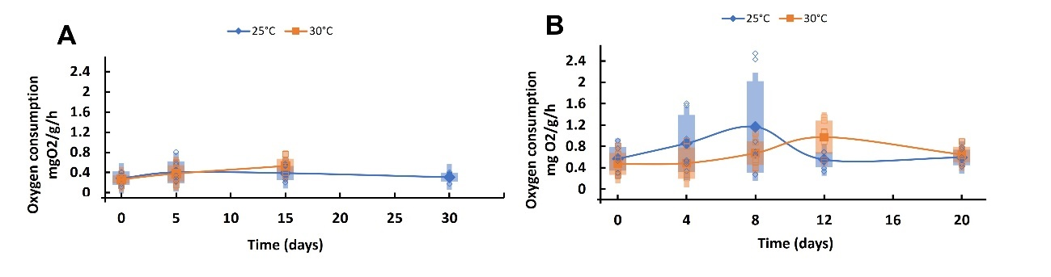Fig. 2 Routine oxygen consumption rate (mg O₂ g⁻¹ h⁻¹) of Octopus maya juveniles hatched from a thermally stressed female (30°C; A; n = 5-8) and a non-thermally stressed female (24°C; B; n = 6-8), acclimated at either 25 or 30°C. Solid points and tendency lines represent mean values, whereas open points represent the raw data. Cages represent ± standard deviation (SD).

3.3. High metabolic rate (HMR)
High metabolic rate (HMR) of juveniles from the stressed female maintained at 25 and 30°C both showed a significantly higher oxygen consumption on day 15 of the experiment, than recorded in the rest of the sampling times (Fig. 3A; ANOVA, F (3,4-6) = 6.22, P = 0.004; Table S2). The HMR of animals maintained at 25°C and measured on day 30 was similar to those obtained at the beginning of the experiment (Fig. 3A). The HMR of juveniles from unstressed female showed a higher metabolic rate of animals maintained at 30 than 25°C at least during the first eight days of the experiment (ANOVA, F (1,22) = 4.3, P = 0.04). After that time, a reduction on metabolic rate of the animals acclimated at 30°C was recorded, which at the end of the experiment were similar to those obtained in animals acclimated at 25°C and those recorded at the beginning of the experiment (Fig. 3B; Table S2).
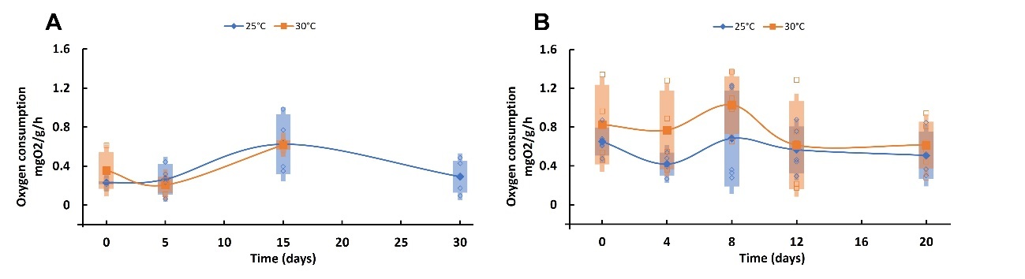
Fig. 3 Temperature-induced maximum metabolic rate (TIMR max; mg O₂ g⁻¹ h⁻¹) of Octopus maya juveniles hatched from a thermally stressed female (30°C; A; n = 2-5) and a non-thermally stressed female (24°C; B; n = 4-6), acclimated at either 25 or 30°C. Solid points and tendency lines represent mean values, whereas open points show the raw data. Cages represent ± standard deviation (SD).

3.4. ANTIOX system, oxidative damage, and AChE and CbE activities
Multivariate analyses on ANTIOX system enzymes (SOD, GST and GSH), oxidative damage markers (LPO and PO) and esterases AChE and CbE of juvenile octopuses showed a dimensional reduction with the first and second principal coordinates, containing 53.7, 54.3, 56 and 100% of the total variation in the data (Fig. 4 and 5; Tables S3 to S7).
The antioxidant defense mechanisms and oxidant damage of juveniles from the stressed females showed similar values across temperatures and experimental days, except for those at 25°C at the end of the experiment (day 30), which formed a cluster on the left-bottom side of the ordination, as better represented by the relative distance and position of centroids (embedded in figure; Fig. 4A; Table S3). This group was positively correlated with GSH on the first coordinate and with PO on the second one. These observations were supported by significant differences in the time-temperature interaction term (PERMANOVA, Pseudo-F (2,3-8) = 1.91; P = 0.034, 999 unique permutations). A significant increment of LPO and SOD was recorded in animals acclimated at 30°C on day 5 (Fig. 4A, blue dash line), followed by a collapse of all the ANTIOX defense enzymes on day 15 (Fig. 4A, red dash line; pair-wise t test, t = 1.71, P = 0.022, 759 unique permutations; Table S3).
In contrast, juveniles from the unstressed females showed more defined patterns (Fig. 4B; Table S4). Specifically, at the beginning of the experiment (day 0 and 4) both juvenile temperature samples (25 and 30°C) showed similar positions, in positive correlation with LPO on the first coordinate and with GST on the second one. Then, as experimental time proceeded, a reduction on the concentrations of LPO and GST and an increase in PO were recorded, in juveniles at 30°C (Fig. 4B; Red dash line). These trends were supported by significant differences for the experimental day (PERMANOVA, pseudo-F (4,8-11) = 6.43, P = 0.001, 999 unique permutations) and interaction terms (PERMANOVA, pseudo-F (4,8-11) = 2.22, P = 0.005, 999 unique permutations; Fig. 4B; Table S4).

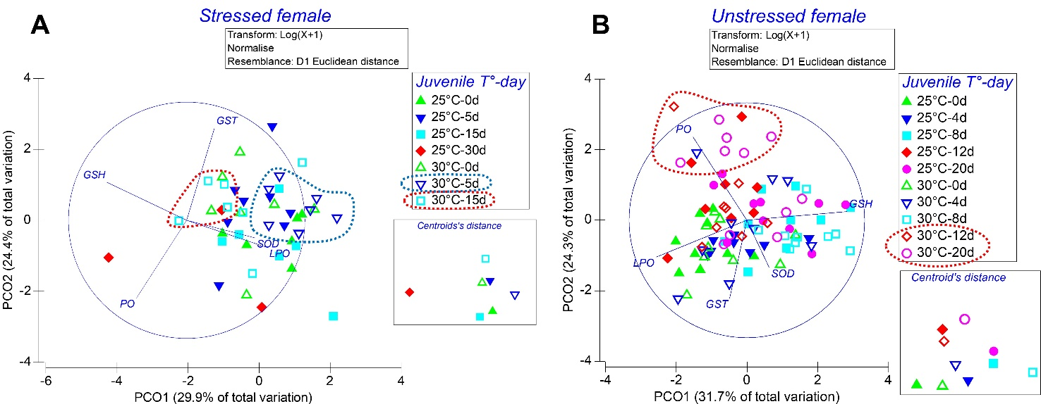

Fig. 4 Principal coordinate analysis split by maternal treatment (stressed female (A) and unstressed female (B)), showing the effect of juvenile temperature and experimental time (days) on enzymes involved in the ANTIOX system (superoxide dismutase [SOD], glutathione (GSH) and Glutathione-S Transferase GST) and oxidative damage markers lipid peroxidation (LPO) and oxidized proteins (PO) of the juvenile octopus progenies. A 2-D representation of the relative distance and location of within-group centroids is embedded in each figure.

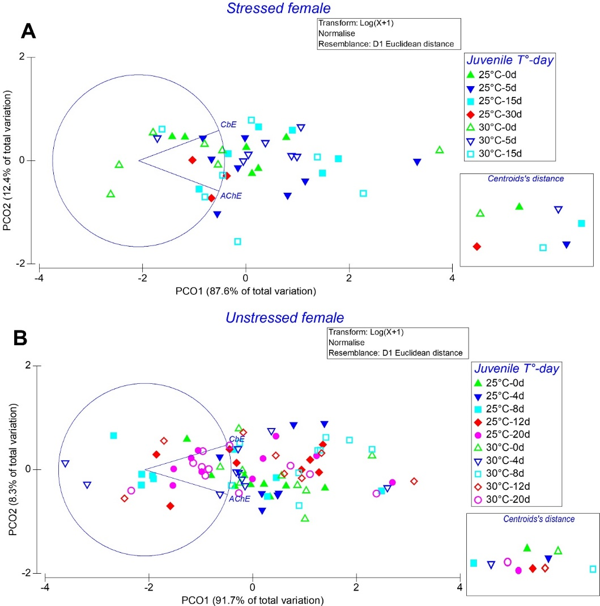
Fig. 5 Principal coordinate analysis (PCoA) split by maternal treatment (stressed female (A) and unstressed female (B), showing the effect of juvenile temperature and experimental time (days) on the esterase AChE and CbE of the juvenile octopus progenies. A 2-D representation of the relative distance and location of within-group centroids is embedded in each figure.

Esterases of juveniles from the stressed female were similar along the sampling times and temperatures, and no cluster formation was evident (Fig.5A; Table S5). Similar results were observed in juveniles from the unstressed female, except for day 8 samples of juveniles exposed to 30°C that moved to the right side of the ordination with respect to 25°C, indicating high levels of AChE and CbE in this sampling time (Fig. 5B; Table S6). This result was supported by significant differences in the juvenile temperature-experimental day interaction term (PERMANOVA, pseudo-F (4,8-11) = 2.62; P = 0.042, 999 unique permutations).

4. Discussion
The results obtained in this study support the idea that both adults and juveniles of O. maya in warming scenarios should migrate to colder areas avoiding the consequences of thermal stress (Angeles-Gonzalez et al. 2017). If adult females are exposed to temperatures around 30°C it is highly probable that juveniles experience a transgenerational effect, which could limit survival of the next generation in few days after hatching without any chances to surpass that environmental condition. In contrast, if juveniles from non-thermally stressed females are exposed to fast temperature increments after hatch (i.e., 30°C), they may have, at least for some time, the opportunity to migrate to colder environments before experiencing the consequences of ROS accumulation.
In another scenario where hatchlings are from thermally stressed females but hatch in 25°C environment, results obtained in the present study showed that those animals could have the opportunity to survive for long time if they can neutralize the ROS. Previous studies hypothesized that octopus females inhere ROS to octopus embryos, which are neutralized during the growth phase of the embryo (Olivares et al. 2019). That study also proposed that in warming scenarios, the high metabolism of females could provoke an increment of ROS in the ovary, provoking an additional ROS load to embryos during the egg synthesis. More recent results showed that thermally stressed octopus females inherited an extra load of ROS which affected embryo development (Domínguez-Castanedo un published data) indicating that high temperatures (30°C) have a clear and transgenerational effect in this species. This result means that embryos that hatch at 25°C should have physiological mechanisms that allow neutralizing the excess ROS coming from their embryo life. According to our results, these mechanisms could be taking more than 30 d, where hatchlings could require an environment with low (around 25°C) and stable temperature. In aquatic ectotherms, a decreased capacity to perform aerobically at higher temperatures is hypothesized to be the key physiological mechanism that may determine the response of many species to climate change (Nilsson et al. 2009; Pörtner 2001; Pörtner and Knust 2007). Previous studies have demonstrated that the limited capacity of the circulatory and ventilatory systems of cephalopods to keep pace with increased oxygen demand at higher temperatures causes a reduction in the aerobic scope and sets the boundaries of the whole-organism thermal tolerance. For that reason, a reduction of the HMR could be an auxiliary mechanism to be used by animals when ROS inherited from thermal stressed females takes a long time to be neutralized (Melzner et al. 2007; Meza-Buendia et al. 2021; Pörtner et al. 2017; Fig. 6). Results obtained in the present study suggest that metabolic depression could act as a mechanism to reduce ROS production, allowing the animals to move to a colder environment (i.e., 25°C). In an environment of 25°C octopus juveniles will produce less ROS and, at the same time, give the animals the time to neutralize ROS inherited from females, those accumulated since embryonic life (Domínguez-Castanedo et al., 2022; Olivarez et al., 2019), and those produced after hatching.
In this study juveniles from the temperature-stressed female died after 15 days of exposure to 30°C, presumably due to the limited capacity to neutralize ROS production. High levels of GSH and PO were observed in those organisms. Between non-enzymatic antioxidant is the endogenous reduced glutathione (GSH) that contains a thiol group which acts as a reducing agent. Glutathione reductase (GR) reduces glutathione disulfide (GSSG) to glutathione (GSH), contributing to the maintenance of the cellular redox status (Fassiano et al. 2017; Moreira et al. 2016; Regoli and Giuliani 2014). Although high levels of GSH could indicate a high intensity of antioxidant defense mechanisms, when a metabolic depression is observed (as provoked by 30°C), it could be showing that animals are in preparation for oxidative stress (POS) in a similar way as observed when animals are exposed to hypoxia levels (Hermes-Lima and Storey 1998). Moreover, high levels of PO suggest cellular damage that in O. maya hatchlings from thermally stressed females and maintained at 30°C resulted lethal, because at such high temperature the metabolic depression cannot control the PO production.
Hatchlings from non-stressed females but exposed at 30°C showed a higher HMR during the first eight days of the experiment compared to HMR values obtained in animals acclimated at 25°C. This result means that animals exposed to 30°C but from non-stressed females had a temporal surplus of energy as a consequence of acceleration of biochemical pathways linked with energy production. Furthermore, after eight days, the HMR of juveniles maintained at 30°C was reduced and maintained similarly to that observed in octopus held at 25°C. The results suggest that the first days surplus energy was reduced as a strategy that affected the octopus performance but acted as a mechanism to reduce the ROS accumulation, which avoided compromising their survival (Noyola et al. 2013). According to Gardiner et al., (2010), populations that can maintain their aerobic capacity at warmer temperatures have a higher thermal tolerance and are thereby predicted to persist longer than populations that experience a decline in aerobic performance as temperature increases (Gardiner et al. 2010; Noyola et al. 2013b). In O. maya, the results obtained in this study suggest that the ability of the octopus to maintain a high aerobic capacity is time limited and, in consequence, its ability to tolerate temperatures close to 30°C as previously shown in embryos (Domíngues-Castanedo et al. 2022; Caamal-Monsreal et al. 2016) and adults (López-Galindo et al. 2019; Meza-Buendía et al. 2021; Fig. 6).
According to OCLTT hypothesis (Pörtner et al. 2017) in high temperatures the reduction of HMR could be the results of the limits of animals to channel enough oxygen to the mitochondria when the standard metabolism is demanding more energy to satisfy the biochemical pathways, which react exponentially with temperature. Although standard metabolism measurements were not performed in octopus hatchlings, the RMR results of animals from stressed and non-stressed females maintained at 30°C suggests that the RMR was positively affected by high temperature. Thus, the ability of hatchlings to maintain a HMR for a long time was affected through the increments of energy demands, probably including basal metabolism.
A previous study in O. maya embryos postulated the hypothesis that explains the negative effect of maternal thermal stress in this octopus species. The hypothesis in this study proposed that thermally stressed females provoke epigenetic alterations that modify the energetic metabolism of embryos, with the consequence of high metabolic rates (Domíngues-Castanedo et al. 2022). The study also demonstrated that thermally stressed females transfer less yolk to the egg, which added to the high metabolic rate of the embryos resulted in embryos with a smaller size than those laid by non-stressed females. Embryos from thermally stressed females were also observed with high ROS levels and a limited ability of the antioxidant defense mechanisms to neutralize the oxidative damage indicating an excess of ROS at the end of the embryo development. In such circumstances, hatchlings from thermally stressed females could hatch with an extra load of ROS, which could provoke irreversible cellular damages if it is not neutralized fast. In this sense, the results of this study suggest that besides the metabolic wear that 30°C provoked in juveniles from the two experimental groups, animals from thermally stressed females could have the additional load of ROS inherited by females to embryos. In such conditions, juveniles from stressed females, and exposed at 30°C had two ROS sources: one probably inherited by females and the other from its own production, both enhanced by high temperature (Domingues-Castanedo et al. 2022; Fig. 6).
Although to date, it is still not known what kind of biochemical pathways are modified as a consequence of parental thermal stress, as in embryos, it may be related with the epigenetic alterations produced by parental thermal stress. This hypothesis lies on the fact that molecular mechanisms exist by which intermediary metabolites involved in different routes for obtaining cellular energy, such as α-ketoglutarate (α-CG) and cofactors, such as acetyl-CoA, S-adenosyl methionine (SAMe) and nicotinamide adenine dinucleotide (NAD+), are affected by epigenetic modifications (Thomas and David 2001). Moreover, the hypothesis is supported by a toxicological study that showed how microcystin tolerance was enhanced by maternal factors transferred to the progeny of the freshwater crustacean Daphnia magna (Ortiz-Rodríguez et al. 2012). These factors are involved in the modulation of the GST-mediated detox system (also relevant in the ANTIOX system), which is energetically costly. As a result, increased survival in the crustaceans with the maternal factor was at the expense of a reduction in growth rates, presumably due to energy allocations that accelerate metabolism and prepare the organisms to cope with future toxic challenges. Further studies should be performed in octopus to know both if in juveniles from stressed females epigenetic alterations exist and if this condition affects their growth.
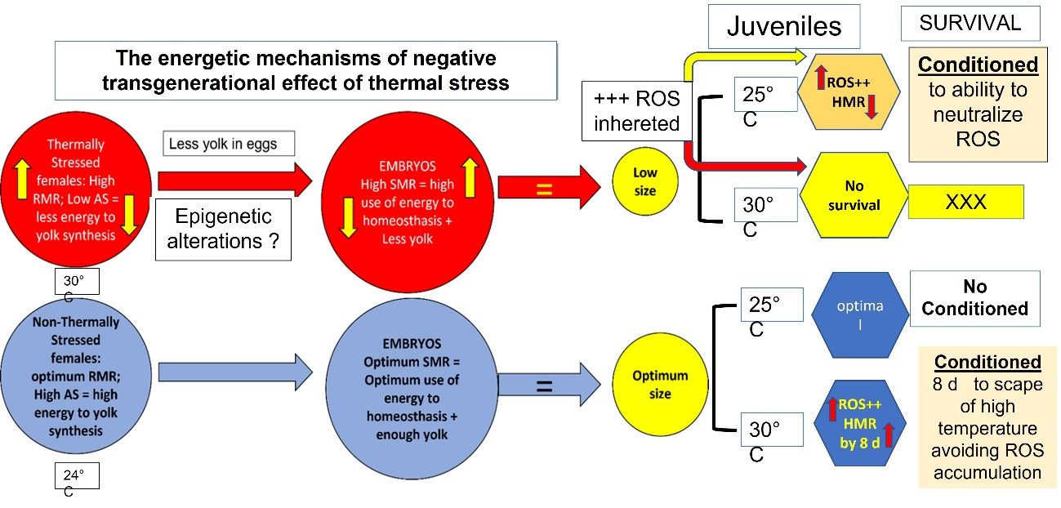
Fig. 6 The flow diagram shows the hypothesis to explain the negative transgenerational effect of maternal thermal stress in Octopus maya embryos and juveniles. Less yolk in embryos, high metabolic rates, and high reactive oxygen species (ROS) levels were inherited to juveniles of thermally stressed females. Juveniles with inherited high ROS levels were not able to neutralize them when exposed at 30°C. Those juveniles died at day 15. Juveniles from thermally stressed females and maintained at 25°C had also high ROS levels too compromise their performance, reducing their metabolism presumably to neutralize ROS excess. AS = Aerobic scope, SMR = Standard metabolic rate

5. Conclusion
The results obtained so far show that O. maya has a thermal history linked to the environmental conditions in which it lives, with all phases of the life cycle occurring in a temperature range from 24 to 26°C (Enriquez et al. 2013). Thus, the results obtained in this study not only show once again the thermal sensitivity of the species but also highlight the fact that females exposed to a temperature beyond the natural range can produce progenies with physiological alterations that limit their metabolic performance and probably their growth and survival. Until now, the temperature of the northern coast of the Yucatán peninsula is regulated by upwelling. However, other sites on the Yucatán continental shelf are not thermally regulated and can experience temperatures far from the thermal tolerance of O. maya which could affect the structure and abundance of this ecosystem (Juárez et al. 2015).
Therefore, if environmental changes exceed the capacity of octopuses to respond via phenotypic plasticity (migration to coolest environments, increase in oxygen consumption, alteration of critical temperature limits, etc.), organisms would be exposed to damage that could be irreversible, affecting the species survival in the coastal environment of the Yucatán Peninsula where thousands of families depend of this valuable marine resource.
6. Statements and Declarations.
6.1. This work was supported by Consejo Nacional de Ciencia y Tecnología for funding the project CONACYT 61503 and PAPIIT IN203022 to CR; D. Fischer provided English Edition. Vargas-Abúndez JA was supported by “Programa de becas posdoctorales en la UNAM” (DGAPA), UNAM. Plata-Díaz A (PCMyL-UNAM) was supported by CONACyT scholarship.
.
6.2. The authors declare that no funds, grants, or other support were received during the preparation of this manuscript
6.3. Competing interests: No Competing interest declared in consequence, the authors have no relevant financial or non-financial interests to disclose.
6.4. Author contribution
APD, CCM, and CR conducted the experiments and make the preliminary analysis of data and the write the draft of the manuscript
MM and GRF make the analysis of the data and wrote the manuscript
CCM, provided the octopus juveniles, and pictures for the elaboration of the figure, and contributed to the writing of the manuscript
  - FD and CR contributed to the design of experiments, the writing of the final version of the manuscript, and to administrate the project.

6.5. Data availability
The datasets generated during and/or analysed during the current study are available in the ZENODO repository, “Data of the study of Maternal temperature stress modulates acclimation and thermal biology in Octopus maya (Cephalopoda: Octopodidae) juvenile progeny | Zenodo”

6.6. Ethics approval
This study was performed following the European directive related to the use of cephalopods as experimental organisms (DIRECTIVA 2010/63/UE) and approved by the Bioethical Commission at UNAM (Universidad Nacional Autónoma de México) Faculty of Sciences (CEARC/Bioética/25102021).

Literature Cited
Anderson MJ (2001) A new method for non-parametric multivariate analysis of variance. Austral Ecol 26, 32–46. https://doi.org/10.1111/j.1442-9993.2001.01070.pp.x
Anderson MJ (2017) Permutational multivariate analysis of variance (PERMANOVA). Wiley StatsRef Stat Ref Online, Major Reference Works. https://doi.org/10.1002/9781118445112.stat07841
Angeles-Gonzalez LE, Calva R, Santos-Valencia J, Avila-Poveda OH, Olivares A, Díaz F, Rosas C (2017) Temperature modulates spatio-temporal variability of the functional reproductive maturation of Octopus maya (Cephalopoda) on the shelf of the Yucatan Peninsula, Mexico. J of Mollusc Stud in press: https://doi.org/10.1093/mollus/eyx013, 1-9
Ángeles-González LE, Lima FD, Caamal-Monsreal C, Díaz F, Rosas C (2020) Exploring the effects of warming seas by using the optimal and pejus temperatures of the embryo of three Octopoda species in the Gulf of Mexico. J Therm Biol 94. https://doi.org/10.1016/j.jtherbio.2020.102753
Ángeles-González LE, Martínez-Meyer E, Rosas C, Guarneros-Narváez PV, López-Rocha JA, Escamilla-Aké Á, Osorio-Olvera L, Yáñez-Arena C (2021a) Long-term environmental data explain better the abundance of the red octopus (Octopus maya) when testing the niche centroid hypothesis. J Exp Mar Bio Ecol 544, 151609. https://doi.org/https://doi.org/10.1016/j.jembe.2021.151609
Ángeles-González LE, Martínez-Meyer E, Yañez-Arenas C, Velázquez-Abunader I, López-Rocha J, Torrejón-Magallanes J, Rosas C (2021b) Climate change effect on Octopus maya (Voss and Solís-Ramírez, 1966) suitability and distribution in the Yucatan Peninsula, Gulf of Mexico: A correlative and mechanistic approach. Estuar Coast and Shelf Sci, 107502. https://doi.org/ 107510.101016/j.ecss.102021.107502
Avendaño O, Velázquez-Abunder I, Fernández-Jardón CM, Ángeles-González LE, Hernández-Flores A, Guerra A (2019) Biomass and distribution of the red octopus (Octopus maya) in the north-east of the Campeche Bank. J Mar Biol Ass UK, 1–7. https://doi.org/10.1017/S0025315419000419
Baker, M.A., Cerniglia, G.J., Zaman, A., 1990. Microtiter plate assay for the measurement of glutathione and glutathione disulfide in large numbers of biological samples. Anal Biochem 190, 360–365. https://doi.org/10.1016/0003-2697(90)90208-Q
Beckman KB, Ames BN (1998) The free radical theory of aging matures. Physiol Rev 78, 547–581. https://doi.org/10.1152/physrev.1998.78.2.547
Bradford MM (1976) A rapid and sensitive method for the quantitation of microgram quantities of protein utilizing the principle of protein-dye binding. Anal Biochem 72, 248–254. https://doi.org/10.1016/0003-2697(76)90527-3
Brown JH, Gillooly JF, Allen AP, Savage VM, West GB (2004) Toward a metabolic theory of ecology. Ecol 85, 1771–1789. https://doi.org/10.1890/03-9000
Byrne M, Foo SA, Ross PM, Putnam HM (2020) Limitations of cross- and multigenerational plasticity for marine invertebrates faced with global climate change. Glob Chang Biol 26, 80–102. https://doi.org/10.1111/gcb.14882
Caamal-Monsreal C, Uriarte I, Farias A, Díaz F, Sánchez A, Re D, Rosas C (2016) Effects of temperature on embryo development and metabolism of O. maya. Aquacul 451, 156–162. https://doi.org/10.1016/j.aquaculture.2015.09.011
Cadenas E (1989) Biochemistry of oxygen toxicity. Annu Rev Biochem 58, 79–110. https://doi.org/10.1146/annurev.bi.58.070189.000455
Cheung WWL, Close C, Lam V, Watson R, Pauly D (2008) Application of macroecological theory to predict effects of climate change on global fisheries potential. Mar Ecol Prog Ser 365, 187–197. https://doi.org/10.3354/meps07414
Di Giulio RT, Washburn PC, Wenning RJ, Winston GW, Jewell CS (1989) Biochemical responses in aquatic animals: A review of determinants of oxidative stress. Environ Toxicol Chem 8, 1103–1123. https://doi.org/10.1002/etc.5620081203
Dominguez-Castanedo O, Palomino-Cruz D, Mascaró M, Rodíguez-Fuentes G, Juárez O, Galind-Sánchez CE, Caamal-Monsreal C, Galindo-Torres P, Díaz F, Rosas C (2022) Trans-generational physiological condition of embryos is conditioned by maternal 2 thermal stress in Octopus maya. BioRxiv https://doi.org/10.1101/2022.05.12.491712
Dupont S, Dorey N, Stumpp M, Melzner F, Thorndyke M (2013) Long-term and trans-life-cycle effects of exposure to ocean acidification in the green sea urchin Strongylocentrotus droebachiensis. Mar Biol 160, 1835–1843. https://doi.org/10.1007/s00227-012-1921-x
Eirin-Lopez JM, Putnam H (2021) Marine Environmental Epigenetics. Front Mar Sci 8. https://doi.org/10.3389/fmars.2021.685075
Ellman GL, Courtney KD, Andres V, Featherstone RM (1961) A new and rapid colorimetric determination of acetylcholinesterase activity. Biochem Pharmacol 7, 88–95. https://doi.org/10.1016/0006-2952(61)90145-9
Enriquez C, Mariño-Tapia I, Jeronimo G, Capurro-Filograsso L (2013) Thermohaline processes in a tropical coastal zone. Cont Shelf Res 69, 101–109. https://doi.org/10.1016/j.csr.2013.08.018
Fassiano AV, Ortiz N, Ríos de Molina MC (2017) Reproductive status, antioxidant defences and lipid peroxidation in Octopus tehuelchus (Cephalopoda: Octopodidae) females. J Nat Hist 51, 2645-2660: https://doi.org/1080/00222933.00222017.01329460
Feidantsis K, Georgoulis I, Giantsis IA, Michaelidis B (2021) Treatment with ascorbic acid normalizes the aerobic capacity, antioxidant defence, and cell death pathways in thermally stressed Mytilus galloprovincialis. Comp Biochem Physiol Part B Biochem Mol Biol 255, 110611. https://doi.org/10.1016/j.cbpb.2021.110611
Fellous A, Favrel P, Riviere G (2015) Temperature influences histone methylation and mRNA expression of the Jmj-C histone-demethylase orthologues during the early development of the oyster Crassostrea gigas. Mar Genomics 19, 23–30. https://doi.org/10.1016/j.margen.2014.09.002
Fellous A, Wegner KM, John U, Mark FC, Shama LNS (2022) Windows of opportunity: Ocean warming shapes temperature-sensitive epigenetic reprogramming and gene expression across gametogenesis and embryogenesis in marine stickleback. Glob Chang Biol 28, 54–71. https://doi.org/10.1111/gcb.15942
Fridovich I (1986) Biological effects of the superoxide radical. Arch Biochem Biophys 247, 1–11. https://doi.org/10.1016/0003-9861(86)90526-6Gardiner NM, Munday PL, Nilsson GE (2010) Counter-gradient variation in respiratory performance of coral reef fishes at elevated temperatures. Plos One 5(10), e13299. https://doi.org/ 10.11371/journal.pone.0013299
Grune T, Shringarpure R, Sitte N, Davies K (2001) Age-related changes in protein oxidation and proteolysis in mammalian cells. J Gerontol Ser A 56, B459–B467. https://doi.org/10.1093/gerona/56.11.B459
Halliwell B (2013) The antioxidant paradox: less paradoxical now? Br J Clin Pharmacol 75, 637–644. https://doi.org/10.1111/j.1365-2125.2012.04272.x
Harman D (1956) Aging: a theory based on free radical and radiation chemistry. J Gerontol 11, 298–300. https://doi.org/10.1093/geronj/11.3.298
Hendry AP, Farrugia TJ, Kinnison MT (2008) Human influences on rates of phenotypic change in wild animal populations. Mol Ecol 17, 20–29. https://doi.org/10.1111/j.1365-294X.2007.03428.x
Hermes-Lima M, Storey KB (1998) Role of antioxidant defenses in the tolerance of severe dehydration by anurans. The case of the leopard frog Rana pipiens. Mol Cell Biochem 189, 79–89. https://doi.org/ 10.1023/A:1006868208476
Hosokawa M, Satoh T (2001) Measurement of carboxylesterase (CES) activities. Curr Protoc Toxicol 10, 4.7.1-4.7.14. https://doi.org/10.1002/0471140856.tx0407s10
Hulbert AJ, Pamplona R, Buffenstein R, Buttemer WA (2007) Life and death: metabolic rate, membrane composition, and life span of animals. Physiol Rev 87, 1175–1213. https://doi.org/10.1152/physrev.00047.2006
Johnstone J, Nash S, Hernandez E, Rahman MS (2019) Effects of elevated temperature on gonadal functions, cellular apoptosis, and oxidative stress in Atlantic sea urchin Arbacia punculata. Mar Environ Res 149, 40–49. https://doi.org/10.1016/j.marenvres.2019.05.017
Juárez OE, Galindo-Sánchez CE, Díaz F, Re D, Sánchez-García AM, Camaal-Monsreal C, Rosas C (2015) Is temperature conditioning Octopus maya fitness? J Exp Mar Bio Ecol 467, 71–76. https://doi.org/10.1016/j.jembe.2015.02.020
Juárez OE, Hau V, Caamal-Monsreal C, Galindo-Sánchez CE, Díaz F, Re D, Rosas C (2016) Effect of maternal temperature stress before spawning over the energetic balance of Octopus maya juveniles exposed to a gradual temperature change. J Exp Mar Bio Ecol 474, 39–45. https://doi.org/10.1016/j.jembe.2015.10.002Juárez OE, Enriquez L,
Camarena F, Arena L, Galindo-Sánchez C, Lafarga-De la Cruz F, López-Galindo L, Nambo K, Rosas C (2018) Genetic monitoring of the Mexican four-eyed octopus Octopus maya population: New insights and perspectives for the fishery management. Fish Res 206, 109-114, https://doi.org/110.1016/j.fishres.2018.1005.1002
Juárez OE, López-Galindo L, Pérez-Carrasco L, Lago-Lestón A, Rosas C, Cosmo AD, Galindo-Sánchez CE (2019) Octopus maya white body show sex-specific transcriptomic profiles during the reproductive phase, with high differentiation in signaling pathways. PLoS One 14, 1–29. https://doi.org/10.1371/journal.pone.0216982
Lefevre S (2016) Are global warming and ocean acidification conspiring against marine ectotherms? A meta-analysis of the respiratory effects of elevated temperature, high CO2 and their interaction. Conserv Physiol 4, cow009. https://doi.org/10.1093/conphys/cow009
Lin D, Han F, Xuan S, Chen X (2019) Fatty acid composition and the evidence for mixed income–capital breeding in female Argentinean short-fin squid Illex argentinus. Mar Biol 166, 90. https://doi.org/10.1007/s00227-019-3534-0
López-Galindo L, Galindo-Sánchez C, Olivares A, Avila-Poveda OH, Díaz F, Juárez OE, Lafarga F, Pantoja-Pérez J, Caamal-Monsreal C, Rosas C (2019) Reproductive performance of Octopus maya males conditioned by thermal stress. Ecol Indic 96, 437–447. https://doi.org/10.1016/j.ecolind.2018.09.036
Madeira D, Costa PM, Vinagre C, Diniz MS (2016) When warming hits harder: survival, cellular stress and thermal limits of Sparus aurata larvae under global change. Mar Biol 163, 91. https://doi.org/10.1007/s00227-016-2856-4
Maharaj RR, Lam VWY, Pauly D, Cheung WWL (2018) Regional variability in the sensitivity of Caribbean reef fish assemblages to ocean warming. Mar Ecol Prog Ser 590, 201–209. https://doi.org/10.3354/meps12462Markaida U,
Méndez-Loeza I, Rosales-Raya M (2016) Seasonal and spatial trends of Mayan Octopus, Octopus maya, population dynamics from Campeche, México. J Mar Biol Ass U.K. 97, 1663-1673. https://doi.org/ 1610.1017/S0025315416001132
Martínez R, Gallardo P, Pascual C, Navarro J, Sánchez A, Caamal-Monsreal C, Rosas C (2014) Growth, survival and physiological condition of Octopus maya when fed a successful formulated diet. Aquacul 426–427, 310–317. https://doi.org/10.1016/j.aquaculture.2014.02.005Massamba-N´Siala G,
Prevedelli D, Simonini R (2014) Trans-generational plasticity in physiology thermal tolerance is modulated by maternal pre-reproductive environment in the polychaete Ophryotrocha labronica. J Exp Biol 217, 2004-2012. https://doi.org/2010.1242/jeb.094474
Melzner F, Mark FC, Pörtner HO (2007) Role of blood-oxygen transport in thermal tolerance of the cuttlefish, Sepia officinalis. Integr and Compar Biol 47 645–655. https://doi.org/610.1093/icb/icm1074
Mesquita CS, Oliveira R, Bento F, Geraldo D, Rodrigues JV, Marcos JC (2014) Simplified 2,4-dinitrophenylhydrazine spectrophotometric assay for quantification of carbonyls in oxidized proteins. Anal Biochem 458, 69–71. https://doi.org/10.1016/j.ab.2014.04.034
Meza-Buendía AK, Trejo-Escamilla I, Piu M, Caamal-Monsreal C, Rodríguez-Fuentes G, Diaz F, Re D, Galindo-Sánchez CE, Rosas C (2021) Why high temperatures limit reproduction in cephalopods? The case of Octopus maya. Aquac Res 00. https://doi.org/10.1111/are.15387
Moguel C, Mascaró M, Avila-Poveda OH, Caamal-Monsreal C, Sanchez A, Pascual C, Rosas C (2010) Morphological, physiological and behavioral changes during post-hatching development of Octopus maya (Mollusca: Cephalopoda) with special focus on the digestive system. Aquat Biol 9, 35–48. https://doi.org/10.3354/ab00234
Moreira DS, Venancio LPR, Sabino MACT, Hermes-Lima M (2016) How widespread is preparation for oxidative stress in the animal kingdom? Comp Biochem Physiol 200 A, 64–78. https://doi.org/10.1016/j.cbpa.2016.1001.1023
Nilsson GE, Crawley N, IGL, Munday PL (2009) Elevated temperature reduces the respiratory scope of coral reef fishes. Glob Chan Biol 15, 1405–1412
Noyola J, Caamal-Monsreal C, Díaz F, Re D, Sánchez A, Rosas C (2013a) Thermopreference, tolerance and metabolic rate of early stages juvenile Octopus maya acclimated to different temperatures. J Therm Biol 38, 14–19. https://doi.org/10.1016/j.jtherbio.2012.09.001
Noyola J, Mascaró M, Caamal C, Noreña-Barroso E, Díaz F, Re AD, Sanchez A, Rosas C (2013b) Effect of temperature on energetic balance and fatty acid composition of early juveniles of Octopus maya. J Exp Mar Biol Ecol 445, 156-165
Olivares A, Rodríguez-Fuentes G, Mascaró M, Arteaga AS, Ortega K, Monsreal CC, Tremblay N, Rosas C (2019) Maturation trade-offs in octopus females and their progeny: energy, digestion and defence indicators. PeerJ 7. https://doi.org/10.7717/peerj.6618
Ortiz-Rodríguez R, Son Dao T, Wiegand C (2012) Transgenerational effects of microcystin-LR on Daphnia magna. J Exp Biol 215, 2795–2805. https://doi.org/10.1242/jeb.069211
Parmesan C (2006) Ecological and evolutionary responses to recent climate change. Annu Rev Ecol Evol Syst 37, 637–669. https://doi.org/10.1146/annurev.ecolsys.37.091305.110100
Paschke K, Agüero J, Gebauer P, Díaz F, Mascaró M, López-Ripoll E, Re D, Caamal-Monsreal C, Tremblay N, Pörtner H-O, Rosas C (2018) Comparison of aerobic scope for metabolic activity in aquatic ectotherms with temperature related metabolic stimulation: A novel approach for aerobic power budget. Front Physiol 9. https://doi.org/10.3389/fphys.2018.01438
Passos JF, Von Zglinicki T (2006) Oxygen free radicals in cell senescence: Are they signal transducers? Free Radic Res 40, 1277–1283. https://doi.org/10.1080/10715760600917151Pörtner HO (2001) Climate change and temperature-dependent biogeography: oxygen limitation of thermal tolerance in animals. Naturwissenschaften 88, 137-146.
Pörtner HO, Knust R (2007) Climate change affects marine fishes through the oxygen limitation of thermal tolerance. Science 315, 95-97
Pörtner H-O (2010) Oxygen- and capacity-limitation of thermal tolerance: a matrix for integrating climate-related stressor effects in marine ecosystems. J Exp Biol 213, 881–893. https://doi.org/10.1242/jeb.037523
Pörtner HO, Bock C, Mark FC (2017) Oxygen- & capacity-limited thermal tolerance: Bridging ecology & physiology. J Exp Biol 220, 2685–2696. https://doi.org/10.1242/jeb.134585
R Core Team (2022) R: a language and environment for statistical computing (Version 4.0.4)
Rahal A, Kumar A, Singh V, Yadav B, Tiwari R, Chakraborty S, Dhama K (2014) Oxidative stress, prooxidants, and antioxidants: the interplay. Biomed Res Int 2014, 761264. https://doi.org/10.1155/2014/761264
Regoli F, Giuliani ME (2014) Oxidative pathways of chemical toxicity and oxidative stress biomarkers in marine organisms. Mar Env Res 93, 106-117
Rodríguez-Fuentes G, Armstrong J, Schlenk D (2008) Characterization of muscle cholinesterases from two demersal flatfish collected near a municipal wastewater outfall in Southern California. Ecotoxicol Environ Saf 69, 466–471. https://doi.org/10.1016/j.ecoenv.2007.06.008
Rodríguez-Fuentes G, Murúa-Castillo M, Díaz F, Rosas C, Caamal-Monsreal C, Sánchez A, Paschke K, Pascual C (2017) Ecophysiological biomarkers defining the thermal biology of the Caribbean lobster Panulirus argus. Ecol Indic 78, 192–204. https://doi.org/10.1016/j.ecolind.2017.03.011
Roumbedakis K, Mascaró M, Martins ML, Gallardo P, Rosas C, Pascual C (2018) Health status of post-spawning Octopus maya (Cephalopoda: Octopodidae) females from Yucatan Peninsula, Mexico. Hydrobiologia 808, 23–34. https://doi.org/10.1007/s10750-017-3340-y
Salinas S, Munch SB (2012) Thermal legacies: transgenerational effects of temperature on growth in a vertebrate. Ecol Lett 15, 159–163. https://doi.org/10.1111/j.1461-0248.2011.01721.x
Steffensen JF (1989) Some errors in respirometry of aquatic breathers: How to avoid and correct for them. Fish Physiol Biochem 6, 49–59. https://doi.org/10.1007/BF02995809
Storey KB (1996) Oxidative stress: animal adaptations in nature. Brazil Med J Biol Res 29, 1715–1733
Svendsen MBS, Bushnell PG, Steffensen JF (2016) Design and setup of intermittent-flow respirometry system for aquatic organisms. J Fish Biol 88, 26–50. https://doi.org/10.1111/jfb.12797
Tercero JF, Rosas C, Mascaro M, Poot G, Domingues P, Noreña E, Caamal-Monsreal C, Pascual C, Estefanell J, Gallardo P (2015) Effects of parental diets supplemented with different lipid sources on Octopus maya embryo and hatching quality. Aquacul 448, 234–242. https://doi.org/10.1016/j.aquaculture.2015.05.023
Thomas J, David AC (2001) Translating the Histone Code. Science (80). 293, 1074–1080. https://doi.org/10.1126/science.1063127
Waite HR, Sorte CJB (2022) Negative carry-over effects on larval thermal tolerances across a natural thermal gradient. Ecol 103, e03565. https://doi.org/10.1002/ecy.3565
Zuur A, Leno E, Smith G (2007) Analyzing Ecological Data. Springer-Verlag New York, USA. https://doi.org/10.1007/978-0-387-45972-1

S Table 1. Effect of the female thermal stress on the routine metabolic rate (RMR) of O. maya juveniles exposed to optimum (25°C) and pejus (30°C) temperatures and measured at different sampling times. Data as mean + SD.
Females temperature | Juveniles temperature | Sampling time, d | n | RMR, mgO2/h/g | SD
24 | 25 | 0 | 7 | 0.57 | 0.22
 |  | 4 | 7 | 0.85 | 0.15
 |  | 8 | 8 | 1.17 | 0.16
 |  | 12 | 7 | 0.55 | 0.14
 |  | 20 | 6 | 0.59 | 0.14
 | 30 | 0 | 8 | 0.47 | 0.21
 |  | 4 | 6 | 0.49 | 0.29
 |  | 8 | 7 | 0.67 | 0.22
 |  | 12 | 8 | 0.97 | 0.21
 |  | 20 | 8 | 0.65 | 0.14
30 | 25 | 0 | 6 | 0.26 | 0.14
 |  | 5 | 8 | 0.41 | 0.22
 |  | 15 | 8 | 0.39 | 0.14
 |  | 30 | 5 | 0.31 | 0.09
30 | 30 | 0 | 8 | 0.27 | 0.07
 |  | 5 | 8 | 0.38 | 0.16
 |  | 15 | 8 | 0.53 | 0.14

S Table 2. Effect of the female thermal stress on the high metabolic rate (HMR) of O. maya juveniles exposed to optimum (25°C) and pejus (30°C) temperatures and measured at different sampling times. Data as mean + SD.
Females Temperature °C | Juveniles Temperature °C | Sampling time, d | n | HMR, mgO2/h/g | SD
24 | 25 | 0 | 5 | 0.65 | 0.14
 |  | 4 | 4 | 0.42 | 0.12
 |  | 8 | 5 | 0.68 | 0.49
 |  | 12 | 5 | 0.57 | 0.24
 |  | 20 | 4 | 0.51 | 0.24
24 | 30 | 0 | 4 | 0.83 | 0.41
 |  | 4 | 4 | 0.77 | 0.41
 |  | 8 | 4 | 1.03 | 0.30
 |  | 12 | 5 | 0.61 | 0.45
 |  | 20 | 6 | 0.62 | 0.24
30 | 25 | 0 | 2 | 0.23 | 0.01
 |  | 5 | 4 | 0.26 | 0.16
 |  | 15 | 4 | 0.63 | 0.31
 |  | 30 | 5 | 0.29 | 0.16
30 | 30 | 0 | 4 | 0.36 | 0.19
 |  | 5 | 3 | 0.21 | 0.08
 |  | 15 | 3 | 0.62 | 0.05

Table S3. Permanova analysis of Antioxidant defence mechanisms and oxidative damage of Octopus maya juveniles from thermally stressed females (30°C) and exposed for 15 d at 25 and 30°C. Numbers in bold indicate weigth of the eigenvectors into each PCA or statistical differences between compared groups.
Eigenvalues
Axis | Eigenvalue | Individual% | Cumulative%
1 | 64.3 | 29.9 | 29.9
2 | 52.4 | 24.4 | 54.3
3 | 37.3 | 17.3 | 71.6
4 | 30.7 | 14.3 | 85.9
5 | 30.3 | 14.1 | 100.0
Eigenvectors
 | SOD | GST | LPO | PO | GSH
PCO1 | 0.58 | 0.23 | 0.69 | -0.42 | -0.67
PCO2 | -0.15 | 0.78 | -0.23 | -0.66 | 0.32
PCO3 | -0.76 | -0.21 | 0.35 | -0.29 | -0.19
PCO4 | -0.22 | 0.35 | -0.34 | 0.29 | -0.59
PCO5 | 0.13 | -0.42 | -0.49 | -0.47 | -0.24
PERMANOVA
Permutational MANOVA
Resemblance worksheet
Name: Resem1
Data type: Distance
Selection: All
Transform: Log(X+1)
Normalise
Resemblance: D1 Euclidean distance
Sums of squares type: Type I (sequential)
Fixed effects sum to zero for mixed terms
Permutation method: Permutation of residuals under a reduced model
Number of permutations: 999
Factors
Name | Abbrev. | Type | Levels
Juvenile temp | Ju | Fixed | 2
Day | Da | Fixed | 4
PERMANOVA table of results
Source | df | SS | MS | Pseudo-F | P(perm)
(A) Ju T, °C | 1 | 10.79 | 10.79 | 2.51 | 0.024
(B) Day | 3 | 28.98 | 9.66 | 2.25 | 0.011
A x B | 2 | 16.38 | 8.19 | 1.91 | 0.034
Res | 37 | 158.86 | 4.29
Total | 43 | 215
PAIR-WISE TESTS
Term A x B for pairs of levels of factor 'Juvenile temp'
a long sampling time
Within level '0' of factor 'Day'
 |  |  | Unique
Groups | t | P(perm) | perms
25, 30 | 1.075 | 0.346 | 771
Denominators
Groups | Denominator | Den.df
25, 30 | 1*Res | 11
Average Distance between/within groups
 | 25 | 30
25 | 2.0128
30 | 2.7356 | 3.2253
Within level '5' of factor 'Day'
 |  |  | Unique
Groups | t | P(perm) | perms
25, 30 | 1.3339 | 0.127 | 918
Denominators
Groups | Denominator | Den.df
25, 30 | 1*Res | 13
Average Distance between/within groups
 | 25 | 30
25 | 3.0177
30 | 2.6767 | 1.9422
Within level '15' of factor 'Day'
 |  |  | Unique
Groups | t | P(perm) | perms
25, 30 | 1.7119 | 0.022 | 759
Denominators
Groups | Denominator | Den.df
25, 30 | 1*Res | 11
Average Distance between/within groups
 | 25 | 30
25 | 2.547
30 | 3.300 | 3.205

Table S4. Permanova analysis of Antioxidant defence mechanisms and oxidative damage of Octopus maya juveniles from non-thermally stressed females (25°C) and exposed for 15 d at 25 and 30°C. Numbers in bold indicate weigth of the eigenvectors into each PCA or statistical differences between compared groups.
Eigenvalues
Axis | Eigenvalue | Individual% | Cumulative%
1 | 141.18 | 31.73 | 31.73
2 | 107.97 | 24.26 | 55.99
3 | 94.43 | 21.22 | 77.21
4 | 57.67 | 12.96 | 90.17
5 | 43.748 | 9.83 | 100
Eigenvectors
 | SOD | GST | LPO | PO | GSH
PCO1 | 0.190139 | -0.14617 | -0.76911 | -0.45752 | 0.853169
PCO2 | -0.40421 | -0.66552 | -0.31354 | 0.709313 | 0.073791
PCO3 | 0.811359 | -0.58564 | 0.236993 | 0.023359 | -0.05499
PCO4 | 0.369672 | 0.4373 | -0.21918 | 0.51659 | 0.071978
PCO5 | 0.074156 | -0.03884 | -0.45382 | -0.1419 | -0.50838
PERMANOVA
Permutational MANOVA
Resemblance worksheet
Name: Resem1
Data type: Distance
Selection: All
Transform: Log(X+1)
Normalise
Resemblance: D1 Euclidean distance
Sums of squares type: Type I (sequential)
Fixed effects sum to zero for mixed terms
Permutation method: Permutation of residuals under a reduced model
Number of permutations: 999
Factors
Name | Abbrev. | Type | Levels
Juvenile temp | Ju | Fixed | 2
Day | Da | Fixed | 5
PERMANOVA table of results
Source | df | SS | MS | Pseudo-F | P(perm)
Ju | 1 | 1.5582 | 1.5582 | 0.40257 | 0.844
Da | 4 | 99.476 | 24.869 | 6.4251 | 0.001
JuxDa | 4 | 34.318 | 8.5795 | 2.2166 | 0.005
Res | 80 | 309.65 | 3.8706
Total | 89 | 445
Details of the expected mean squares (EMS) for the model
Source | EMS
Ju | 1*V(Res) + 44.978*S(Ju)
Da | 1*V(Res) + 17.958*S(Da)
JuxDa | 1*V(Res) + 8.9701*S(JuxDa)
Res | 1*V(Res)
PAIR-WISE TESTS
Term 'JuxDa' for pairs of levels of factor 'Juvenile temp'
Within level '0' of factor 'Day'
 |  |  | Unique
Groups | t | P(perm) | perms
25, 30 | 1.1304 | 0.271 | 978
Denominators
Groups | Denominator | Den.df
25, 30 | 1*Res | 16
Average Distance between/within groups
 | 25 | 30
25 | 2.1506
30 | 2.1057 | 2.1063
Within level '4' of factor 'Day'
 |  |  | Unique
Groups | t | P(perm) | perms
25, 30 | 1.1172 | 0.29 | 974
Denominators
Groups | Denominator | Den.df
25, 30 | 1*Res | 15
Average Distance between/within groups
 | 25 | 30
25 | 2.0791
30 | 2.7214 | 3.2138
Within level '8' of factor 'Day'
 |  |  | Unique
Groups | t | P(perm) | perms
25, 30 | 1.9846 | 0.007 | 982
Denominators
Groups | Denominator | Den.df
25, 30 | 1*Res | 16
Average Distance between/within groups
 | 25 | 30
25 | 2.7185
30 | 2.8355 | 2.0849
Within level '12' of factor 'Day'
 |  |  | Unique
Groups | t | P(perm) | perms
25, 30 | 1.0039 | 0.432 | 937
Denominators
Groups | Denominator | Den.df
25, 30 | 1*Res | 14
Average Distance between/within groups
 | 25 | 30
25 | 2.9988
30 | 2.7829 | 2.5305
Within level '20' of factor 'Day'
 |  |  | Unique
Groups | t | P(perm) | perms
25, 30 | 1.426 | 0.099 | 996
Denominators
Groups | Denominator | Den.df
25, 30 | 1*Res | 19
Average Distance between/within groups
 | 25 | 30
25 | 2.8819
30 | 3.1203 | 3.1288

Table S5. Permanova analysis of AChE and CbE of Octopus maya juveniles from thermally stressed females (30°C) and exposed for 15 d at 25 and 30°C. Numbers in bold indicate weigth of the eigenvectors into each PCA or statistical differences between compared groups.
Eigenvalues
Axis | Eigenvalue | Individual% | Cumulative%
1 | 75.298 | 87.56 | 87.56
2 | 10.702 | 12.44 | 100
Eigenvectors
PCO1 | 0.935715 | 0.935715
PCO2 | -0.35276 | 0.352757
PERMANOVA
Permutational MANOVA
Resemblance worksheet
Name: Resem1
Data type: Distance
Selection: All
Transform: Log(X+1)
Normalise
Resemblance: D1 Euclidean distance
Sums of squares type: Type I (sequential)
Fixed effects sum to zero for mixed terms
Permutation method: Permutation of residuals under a reduced model
Number of permutations: 999
Factors
Name | Abbrev. | Type | Levels
Juvenile temp | Ju | Fixed | 2
Day | Da | Fixed | 4
PERMANOVA table of results
 |  |  |  |  |  | Unique
Source | df | SS | MS | Pseudo-F | P(perm) | perms
Ju | 1 | 0.65163 | 0.65163 | 0.31835 | 0.64 | 998
Da | 3 | 8.3193 | 2.7731 | 1.3548 | 0.28 | 998
JuxDa** | 2 | 1.2931 | 0.64654 | 0.31586 | 0.818 | 999
Res | 37 | 75.736 | 2.0469
Total | 43 | 86

Table S6. Permanova analysis of AChE and CbE of Octopus maya juveniles from non-thermally stressed females (25°C) and exposed for 15 d at 25 and 30°C. Numbers in bold indicate weigth of the eigenvectors into each PCA or statistical differences between compared groups.
Eigenvalues
Axis | Eigenvalue | Individual% | Cumulative%
1 | 163.29 | 91.74 | 91.74
2 | 14.705 | 8.26 | 100
 | Eigenvectors
PCO1 | 0.957803 | 0.957803
PCO2 | -0.28743 | 0.287427
PERMANOVA
Permutational MANOVA
Resemblance worksheet
Name: Resem1
Data type: Distance
Selection: All
Transform: Log(X+1)
Normalise
Resemblance: D1 Euclidean distance
Sums of squares type: Type I (sequential)
Fixed effects sum to zero for mixed terms
Permutation method: Permutation of residuals under a reduced model
Number of permutations: 999
Factors
Name | Abbrev. | Type | Levels
Juvenile temp | Ju | Fixed | 2
Day | Da | Fixed | 5
PERMANOVA table of results
 |  |  |  |  |  | Unique
Source | df | SS | MS | Pseudo-F | P(perm) | perms
Ju | 1 | 1.9867 | 1.9867 | 1.0463 | 0.324 | 999
Da | 4 | 4.221 | 1.0553 | 0.55574 | 0.746 | 999
JuxDa | 4 | 19.885 | 4.9713 | 2.6181 | 0.042 | 999
Res | 80 | 151.91 | 1.8988
Total | 89 | 178
