Table 1 | Homogeneous catalytic ethanol upgrading to secondary alcohols and 2-butenes/butane
Entry | Catalyst  (ppm) | Time  [h] | Conversion  [%]ª | Yields from liquid phase [%]ª
 |  |  |  | 1° alcohols |  | 2° alcohols
 |  |  |  | 1  (TON) | Selectivity [%]  (1° vs 2° alcohol) | 2a | 2b | Total 2^{b}  (TON) | Selectivity [%]  (2° vs 1° alcohol)
1 | Ru-1 (1000) | 96 | 57 | 3 (30) | 5 (11) | 12 | 6 | 22 (220) | 39 (89)
2 | Ru-1 (830) | 96 | 61 | 3 (36) | 5 (19) | 9 | 2 | 13 (157) | 21 (81)
3 | Ru-1 (250) | 96 | 57 | 3 (120) | 5 (14) | 10 | 4 | 17 (680) | 30 (86)
4^{c} | Ru-1 (250) | 96 | 60 | 3 (120) | 5 (23) | 6 | 2 | 10 (400) | 17 (77)
5 | Ru-2 (830) | 48 | 38 | 2 (24) | 5 (14) | 8 | 2 | 12 (145) | 32 (86)
6 | Ru-2 (420) | 48 | 42 | 3 (71) | 7 (21) | 7 | 2 | 11 (262) | 26 (79)
7 | Ru-2 (420) | 96 | 50 | 3 (71) | 6 (19) | 10 | 3 | 15 (357) | 26 (81)
8 | Ru-2 (250) | 96 | 55 | 3 (120) | 5 (13) | 12 | 4 | 18 (720) | 33 (87)
9^{c} | Ru-2 (250) | 96 | 68 | 3 (120) | 4 (21) | 7 | 1 | 10 (400) | 15 (79)
10 | Ru-2  (83) | 96 | 24 | 3 (362) | 13 (28) | 5 | 2 | 8 (964) | 33 (72)
11 | Ru-3 (250) | 96 | 27 | 5 (200) | 19 (50) | 3 | 1 | 5 (200) | 19 (50)
12 | Ru-4 (250) | 96 | 26 | 5 (200) | 19 (45) | 4 | 2 | 6 (240) | 23 (55)
13 | Ru-5 (250) | 96 | 42 | 13 (520) | 31 (>99) | <1 | <1 | <1 | <1 (<1)
14^{c} | Ru-5 (250) | 24 | 33 | 18 (720) | 55 (>99) | <1 | <1 | <1 | <1 (<1)
15^{c} | Ru-5 (250) | 96 | 49 | 22 (880) | 45 (96) | 1 | <1 | 1 (40) | 2 (4)
ª Only yields from the liquid phase are shown. Determined by NMR (liquid phase products), GC-FID (liquid phase products), and GC-MS (liquid phase products).
^{b} Total yield of secondary alcohols (C3-C7).
^{c} Reaction at 130 °C.
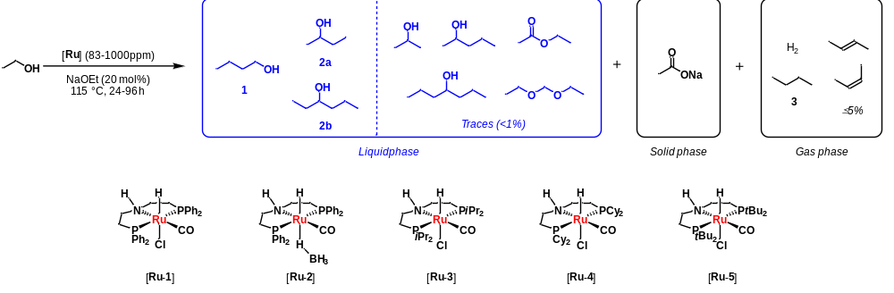

Table 2 | Homogeneous catalytic ethanol upgrading to secondary alcohols and 2-butenes/butane
Entry | Catalyst  (ppm) | Time  [h] | Conversion  [%]ª | Yields from solid and gas phases [%]ª
 |  |  |  | Solid phase |  | Gas phase
 |  |  |  | NaOAc  (TON) | Selectivity  [%] | H₂ | 3  (TON) | Selectivity [%] (of 3)
1 | Ru-1 (250) | 96 | 57 | ^{d} | - |  |  | -
2^{c} | Ru-2 (250) | 96 | 68 | 16 (640) | 24 | 26 | 3 (120) | 4
3 | Ru-2 (250) | 96 | 55 | 11 (440) | 20 | 25 |  | -
4 | Ru-2  (83) | 96 | 24 | 8 (964) | 33 | 20 |  | -
5 | Ru-3 (250) | 96 | 27 | 4 (160) | 15 | 18 |  | -
6 | Ru-4 (250) | 96 | 26 | 9 (360) | 35 | 22 |  | -
7^{c} | Ru-5 (250) | 24 | 33 | 5 (200) | 15 | 13 | 2 (80) | 6
ª Only yields from solid and gas phases are shown. Determined by NMR (NaOAc), GC-TCD (H₂), GC-MS (organic gases), and Micro-GC (H₂ and organic gases).
^{b} Total yield of secondary alcohols (C3-C7).
^{c} Reaction runs at 130 °C.
^{d} Blank refers to not determined.
