Supporting Information

Low-temperature selective ethanol upgrading to primary or secondary alcohols by homogeneous catalysis
Zhenwei Ni, Rosa Padilla, Lucas dos Santos Mello & Martin Nielsen*
Technical University of Denmark (DTU), Department of Chemistry, 2800 Kgs. Lyngby, Denmark; marnie@kemi.dtu.dk.

Table of contents

1. General information
2. Experimental section
3. Butenes, butane, and nitrogen calibration curves, and reactor standard curve
4. Scope of the reactions for the ethanol upgrading
5. Reaction pathways of each product
6. GC-TCD reports of inorganic gas
7. GC-FID reports of liquid products
8. GC-MS (liquid phase) reports of products
9. GC-MS (gas phase) reports of products
10. Micro-GC reports of inorganic and organic gas
11. A typical NMR spectrum of 2-butanol
12. A typical NMR spectrum of sodium acetate quantification
13. Pressure change studies
14. Mechanistic study
15. References

1. General information
Neat ethanol (purity 99.99%), NaOtBu (purity 97%), NaOEt (purity 95%), and precatalysts Ru-1 to Ru-5 are commercially available and used without further purification. N₂ gas (H₂O ≤ 3 ppm; O₂ ≤ 2 ppm) 1-butene (purity 98%), cis-2-butene (purity 99%), and trans-2-butene (purity 99%), butane (purity 99.5%), NH₄Cl (purity ≥99.5%), 4-hydroxy-2-butanone (purity 95%), tridecane (100 uL, purity ≥99.0%), decane (purity 99.0%), dimethyl sulfoxide (purity 99.9%), dichloromethane (purity 100%) were purchased from a commercial supplier as well. All chemicals used for calibration curves were analytical standards. All reactions dealing with air or moisture-sensitive compounds were performed using standard Schlenk techniques or in an argon-filled glovebox. ¹H NMR and ¹³C NMR spectra were recorded on a Bruker Avance III 400 MHz spectrometer and were referenced on the deuterated solvent peak.
All of the starting materials and dehydrogenation products are literature-known compounds, and the experimental data fit with those reported.

Supplementary Table S1 | Properties of gasoline, ethanol, 1-butanol, and 2-butanol¹
Properties | gasoline | ethanol | 1-butanol | 2-butanol
Boiling point | 200 | 78 | 117 | 100
Flashpoint | -43 | 13 | 34 | 31
Research octane number (RON) | 91 - 99 | 120 - 135 | 94 - 96 | 101
Motor octane number (MON) | 81 - 89 | 100 - 106 | 78 - 81 | 91
Energy Density [MJ/L] | 32 | 21 | 29.2 | 32
Self-ignition temperature [°C] | 247 - 280 | 365 - 423 | 343 | 380 - 406
Explosive limits [%] | 1.4 - 7.6 | 4 - 19 | 1.4 - 11.2 | 1.7 - 9.8
Solubility in water [wt%] | Not soluble | Fully miscible | 7.7 | 12.5

Supplementary Figure 1 | Reported catalytic systems for ethanol upgrading to 1-butanol and/or other longer-chain primary alcohols based on the Guerbet reaction².

Supplementary Figure 2 | Typical Guerbet reaction sequence for ethanol upgrading.

2. Experimental section
General instrumentation.
NMR (Bruker Avance III 400 MHz spectrometer), GC-MS (Agilent Technologies 6890 Network GC System and Agilent Technologies 7890A Network GC System), GC-FID (Agilent Technologies 6890N Network GC System), GC-TCD (Agilent Technologies 6890N Network GC System), Micro-GC (Agilent Technologies 490 Network GC System).
General information of the two reactors.
Reactor A (stainless steel, inner diameter 25.0 mm, reactor capacity: 22.8 mL; Teflon cup volume: 13.0 mL). The pressure record is non-electronic and subject to error.
Reactor B (2550 flat gasket microvessel, Alloy 600, 5.0 mL; reactor capacity: 16.0 mL; Teflon cup volume: 6.0 mL). The electronic dashboard records pressure with accurate data.

Supplementary Table 2 | Control experiments and model reaction for the ethanol upgrading
Entry | Catalyst (ppm) | NaOtBu [mol%] | EtOH [mL] | T  [ºC] | Time  [h] | Conversion [%] | Yield [%]ª
 |  |  |  |  |  |  | 2-propanol | 2-butanol | EtOAc | H₂
1 | - | 10 | 2.5 | 105 | 1 | 0 | - | - | - | -
2 | Ru-1 (500) | / | 2.5 | 105 | 1 | 0 | - | - | - | -
3 | Ru-1 (500) | 10 | 5 | 105 | 1 | 3 | 0.2 | 0.9 | - | -
4 | Ru-2 (250) | / | 5 | 115 | 24 | 16 | - | - | 5.4 | 1.6
Reaction conditions: 2.5-5.0 mL EtOH, 250-500 ppm catalyst, 10 mol% NaOtBu, 105-115 ºC, 1-24 h, in reactor A and 600 rpm.
ª Determined by GC-FID (liquid phase products), GC-MS (liquid phase products), and Micro-GC (H₂).

3. Butenes, butane, and nitrogen calibration curves, and reactor standard curve
Commercially available butenes (cis- and trans-2-butene) and butane standards were used for the analysis of the gas phase by GC-MS. Gas/air sampling bags were evacuated with the vacuum/N₂ before use and different volumes of the standard gases were loaded at 2, 4, 6, 8, 10, 20, and 30 μL, respectively. A calibration curve was performed employing the mentioned gas volumes against the observed area (abundance).
The gas volume contained in the headspace of the reactor was determined with a collection of blank tests with the same reaction mixture in the pressure reactor, loading 5.0, 7.5, and 10 bar N₂, respectively. The released gas volume was quantified using the water displacement method.
To experimentally determine the composition of the gas produced in the upgrading experiments, a sampling bag was attached to the pressure reactor at 25 ºC. The product identification was performed using GC-MS analysis and the above standard curves by direct injection of 20 μL (three times) of the gas mixture using a high-precision syringe (100 μL) and known standards.
4. Scope of the reactions for the ethanol upgrading
Supplementary Tables 3–5 provided the information on all the detected products. Among them, NaOAc was quantified by NMR, liquid products were quantified by GC-FID, organic gases were quantified by GC-MS, and H₂ was quantified by Micro-GC.

Supplementary Table 3 | Experiments for the ethanol upgrading with Ru-1
Entry | Ru-1 [ppm] | Base  (%) | T  [℃] | Time  [h] | Conversion [(%]ª | Yield [%]ª
 |  |  |  |  |  | 2c | 2a | 2d | 2b | 2e | Total 2 | 1 | 4 | 5 | H₂ | Pressure (bar)^{e}
1 | 500 | NaOtBu  (10) | 105 | 1 | 3 | 0.2 | 0.9 | 0 | 0 | 0 | 1.1 | 0.3 | 0.7 | 0.16 | ^{b} | 5
2 | 1000 | NaOtBu  (20) | 115 | 4 | 23 | 1.3 | 5.3 | 0.4 | 1.2 | trace^{c} | 8.2 | 1.9 | trace | 0.25 |  | 15
3 | 1000 | NaOtBu  (20) | 115 | 19 | 40 | 0.8 | 7.5 | 0.4 | 3.0 | 0.1 | 11.8 | 2.7 | trace | trace |  | 36
4 | 1000 | NaOtBu  (20) | 115 | 48 | 43 | 1.6 | 7.5 | 0.9 | 2.6 | trace | 12.6 | 1.9 | trace | 0.09 |  | 32
5 | 1000 | NaOtBu  (20) | 115 | 72 | 57 | 2.3 | 10.3 | 1.5 | 4.6 | 0.2 | 18.9 | 2.4 | trace | 0.08 |  | 21
6 | 1000 | NaOtBu  (20) | 115 | 96 | 57 | 2.7 | 11.5 | 2.0 | 5.8 | 0.3 | 22.3 | 3.0 | trace | 0.16 |  | 18
7 | 910 | NaOEt  (10) | 105 | 72 | 50 | 1.0 | 5.3 | 0.2 | 0.6 | trace | 7.1 | 1.1 | 0.2 | 0.09 |  | 12
8 | 420 | NaOEt  (20) | 105 | 72 | 36 | 1.4 | 7.5 | 0.6 | 2.0 | trace | 11.5 | 2.3 | trace | trace |  | 18
9 | 830 | NaOEt  (20) | 105 | 72 | 27 | 0.6 | 5.4 | 0.3 | 1.0 | trace | 7.3 | 1.4 | trace | 0.21 |  | 27
10^{d} | 830 | NaOEt  (20) | 115 | 96 | 61 | 1.5 | 8.6 | 0.8 | 2.4 | trace | 13.3 | 2.6 | trace | trace | 21.5 | 37
11 | 250 | NaOEt  (20) | 115 | 96 | 57 | 2.0 | 9.6 | 1.3 | 3.6 | 0.1 | 16.6 | 3.0 | 0.8 | trace |  | 12
12 | 1000 | NaOtBu  (25) | 115 | 24 | 53 | 0.9 | 5.4 | 0.7 | 2.3 | trace | 9.3 | 1.6 | trace | trace |  | 23
13 | 250 | NaOEt  (20) | 160 | 96 | 60 | 1.2 | 5.8 | 0.7 | 2.0 | trace | 9.7 | 3.0 | trace | trace | 22.2 | 34.9  (27.7)
Reaction conditions: 5.0 mL EtOH in reactor A at 105 and 115 ºC and 2.5 mL EtOH in reactor B at 160 ºC, 250-1000 ppm Ru-1, 10-25 mol% base, 1-96 h, 600 rpm.
ª Determined by NMR (NaOAc), GC-TCD (H₂), GC-FID (liquid phase products), GC-MS (liquid phase products, organic gases), and Micro-GC (H₂ and organic gases).
^{b} Blank entry refers to not determined.
^{c} Trace refers to yield < 0.1%.
^{d} Mixture of trans, cis-2-butene and butane, ≤ 5% in the gas phase.
^{e} The pressure outside the brackets indicates the reaction pressure before cooling. The pressure in parentheses is after cooling down.

Supplementary Table 4 | Experiments for the ethanol upgrading with Ru-2.
Entry | Ru-2 [ppm] | Base  (%) | T  [℃] | Time  [h] | Conv. [%]ª | Yield [%]ª |  |  |  |  |  |  |  |  |  |  |  | Pressure (bar)^{f}
 |  |  |  |  |  | 2c | 2a | 2d | 2b | 2e | Total 2 | 1 | 4 | 5 | H₂ | NaOAc | 3 | Pressure (bar)^{f}
1 | 250 | NaOEt  (20) | 115 | 4 | 16 | trace^{b} | 2.4 | 0.2 | 0.5 | trace | 3.1 | 1.2 | trace | trace | ^{c} |  |  | 18
2^{d} | 250 | NaOEt  (20) | 115 | 24 | 40 | 1.2 | 5.8 | 0.5 | 1.5 | trace | 9 | 2.1 | trace | 0.15 | 15.6 |  |  | 33  (27)
3^{d} | 250 | NaOEt  (20) | 115 | 48 | 41 | 1.3 | 6.7 | 0.5 | 1.7 | trace | 10.2 | 1.9 | trace | 0.12 | 18.7 |  |  | 33  (28)
4^{d} | 420 | NaOEt  (20) | 115 | 48 | 42 | 1.3 | 7.2 | 0.7 | 1.8 | trace | 11 | 2.5 | trace | trace | 17.2 |  |  | 31  (26)
5^{d} | 420 | NaOEt  (20) | 115 | 96 | 50 | 1.8 | 9.6 | 1.0 | 2.8 | trace | 15.2 | 2.7 | trace | trace | 19.1 |  |  | 33  (27)
6^{d} | 830 | NaOEt  (20) | 115 | 48 | 38 | 1.3 | 7.7 | 0.7 | 2.2 | trace | 11.9 | 2.3 | trace | trace | 14.9 |  |  | 31  (26)
7 | 250 | NaOEt  (20) | 115 | 72 | 44 | 2.0 | 11.1 | 1.3 | 4.2 | 0.1 | 18.7 | 2.8 | trace | trace |  |  |  | 15
8^{d} | 250 | NaOEt  (20) | 115 | 96 | 55 | 0.6 | 12.3 | 1.4 | 3.9 | trace | 18.2 | 2.5 | trace | trace | 25.1 | 10.6 |  | 41  (35)
9 | 270 | NaOEt  (10) | 115 | 72 | 28 | 1.2 | 8.0 | 0.4 | 1.1 | trace | 10.7 | 1.8 | trace | trace |  |  |  | 16
10 | 250 | NaOEt  (20) | 85 | 72 | 29 | 0.4 | 2.0 | 0.1 | 0.2 | trace | 2.7 | 0.8 | trace | trace |  |  |  | 9
11^{d} | 83 | NaOEt  (20) | 115 | 96 | 24 | 0.9 | 4.6 | 0.4 | 1.6 | trace | 7.5 | 3.1 | trace | trace | 20.1 | 8.4 |  | 37  (30)
12 | 500 | NaOtBu  (10) | 105 | 48 | 22 | 1.1 | 5.8 | 0.2 | 0.5 | trace | 7.6 | 0.9 | 0.2 | 0.13 |  |  |  | 11
13 | 500 | NaOtBu  (20) | 115 | 4 | 26 | 0.6 | 4.6 | 0.3 | 0.8 | trace | 6.3 | 1.3 | trace | 0.26 |  |  |  | 16
14 | 500 | NaOtBu  (20) | 105 | 96 | 37 | 1.5 | 8.5 | 0.9 | 2.9 | trace | 13.8 | 2.0 | trace | 0.19 |  |  |  | 30
15 | 1000 | NaOtBu  (20) | 115 | 48 | 50 | 1.7 | 8.0 | 1.1 | 3.4 | 0.1 | 14.3 | 2.3 | trace | 0.10 |  |  |  | 23
16 | 1000 | NaOtBu  (25) | 105 | 18 | 59 | 1.2 | 5.4 | 0.7 | 2.7 | 0.1 | 10.1 | 2.1 | trace | 0.19 |  |  |  | 16
17 | 1000 | NaOtBu  (25) | 105 | 48 | 66 | 0.9 | 5.7 | 1.0 | 4.1 | 0.3 | 12 | 2.1 | trace | 0.11 |  |  |  | 20
18^{d,e} | 250 | NaOEt  (20) | 115 | 96 | 73 | 1.9 | 9.7 | 0.9 | 2.8 | trace | 15.3 | 3.2 | trace | trace | 15.2 |  |  | 26  (21)
19 | 250 | NaOEt  (20) | 160 | 96 | 86 | 0.9 | 4.1 | 0.8 | 2.3 | trace | 8.1 | 4.1 | trace | trace | 31.1 |  | 4.7 | 37.4  (28.7)
20 | 250 | NaOEt  (20) | 130 | 96 | 68 | 1.4 | 7.1 | 0.3 | 1.2 | trace | 10.0 | 2.6 | trace | trace | 26.0 | 15.9 | 2.7 | 35.9  (29.4)
21 | 8.3 | NaOEt  (20) | 130 | 168 | 32 | 0.3 | 0.8 | 0.2 | 0.4 | trace | 1.7 | 7.8 | trace | trace | 11.5 | 4.6 |  | 20.1  (15.7)
Reaction conditions: 5 mL EtOH in a reactor A at 85, 105, 115 ºC and 2.5 mL EtOH in reactor B at 130 and 160 ºC, 83-1000 ppm Ru-2, 10-25 mol% base, 4-168 h, 600 rpm.
ª Determined by NMR (NaOAc), GC-TCD (H₂), GC-FID (liquid phase products), GC-MS (liquid phase products, organic gases), and Micro-GC (H₂ and organic gases).
^{b} Trace refers to yield < 0.1%.
^{c} Blank entry refers to not determined.
^{d} Mixture of trans, cis-2-butene and butane, ≤ 5% in the gas phase.
^{e} 3.5 mL ethanol.
^{f} The pressure outside the brackets indicates the reaction pressure before cooling. The pressure in parentheses is after cooling down.
Supplementary Table 5 | Experiments for ethanol conversion with Ru-3 - Ru-5.
Entry | Catalyst (250 ppm) | T [℃] | t [h] | Conv. [%]ª | Yield [%]ª |  |  |  |  |  |  |  |  |  |  |  | Pressure (bar)^{g}
 |  |  |  |  | 2c | 2a | 2d | 2b | 2e | Total 2 | 1 | 4 | 5 | H₂ | NaOAc | 3 | Pressure (bar)^{g}
1 | Ru-3 | 115 | 96 | 27 | 0.6 | 3.0 | 0.3 | 1.0 | trace^{b} | 4.9 | 5.2 | trace | trace | 17.5 | 4.0 | ^{c} | 31  (26)
2 | Ru-4 | 115 | 96 | 26 | 0.7 | 3.8 | 0.4 | 1.5 | trace | 6.4 | 5.3 | trace | trace | 22.3 | 8.9 |  | 37  (30)
3^{d} | Ru-5 | 115 | 96 | 42 | trace | trace | trace | trace | trace | trace | 12.9 | trace | trace | 12.8 |  |  | 24  (20)
4e | Ru-5 | 130 | 24 | 33 | trace | 0.9 | trace | trace | trace | 0.9 | 17.6 | trace | trace | 12.5 | 5.2 | 2.4 | 17.4  (14.3)
5^{f} | Ru-5 | 130 | 96 | 49 | trace | 1.0 | trace | trace | trace | 1 | 22.1 | trace | trace | 20.4 |  |  | 27.4  (21.5)
Reaction conditions: 5 mL EtOH in reactor A at 115 ºC and 2.5 mL EtOH in reactor B at 130 ºC, 250 ppm catalyst, 20 mol% NaOEt, 24-96 h, 600 rpm.
ª Determined by NMR (NaOAc), GC-TCD (H₂), GC-FID (liquid phase products), GC-MS (liquid phase products, organic gases), and Micro-GC (H₂ and organic gases).
^{c} Blank entry refers to not determined.
^{b} Trace refers to yield < 0.1%.
^{d} 0.4 % of 2-ethyl-1-butanol and 0.9 % of 1-hexanol were also determined.
^{e} 0.6 % of 2-ethyl-1-butanol and 2.2 % of 1-hexanol were also determined.
^{f} 0.9 % of 2-ethyl-1-butanol and 3.0 % of 1-hexanol were also determined.
^{g} The pressure outside the brackets indicates the reaction pressure before cooling. The pressure in parentheses is after cooling down.

5. Reaction pathways of each product
Supplementary Figure 3 | Reaction pathways of liquid- gas- and solid products.

6. GC-TCD reports of inorganic gas
a) Example: Supplementary Table 4, Entry 12.
Reaction conditions: 5.0 mL EtOH, Ru-2 (500 ppm, 25.1 mg), 48 h, 105 ºC, NaOtBu (10 mol%, 823 mg) in reactor A and 600 rpm.
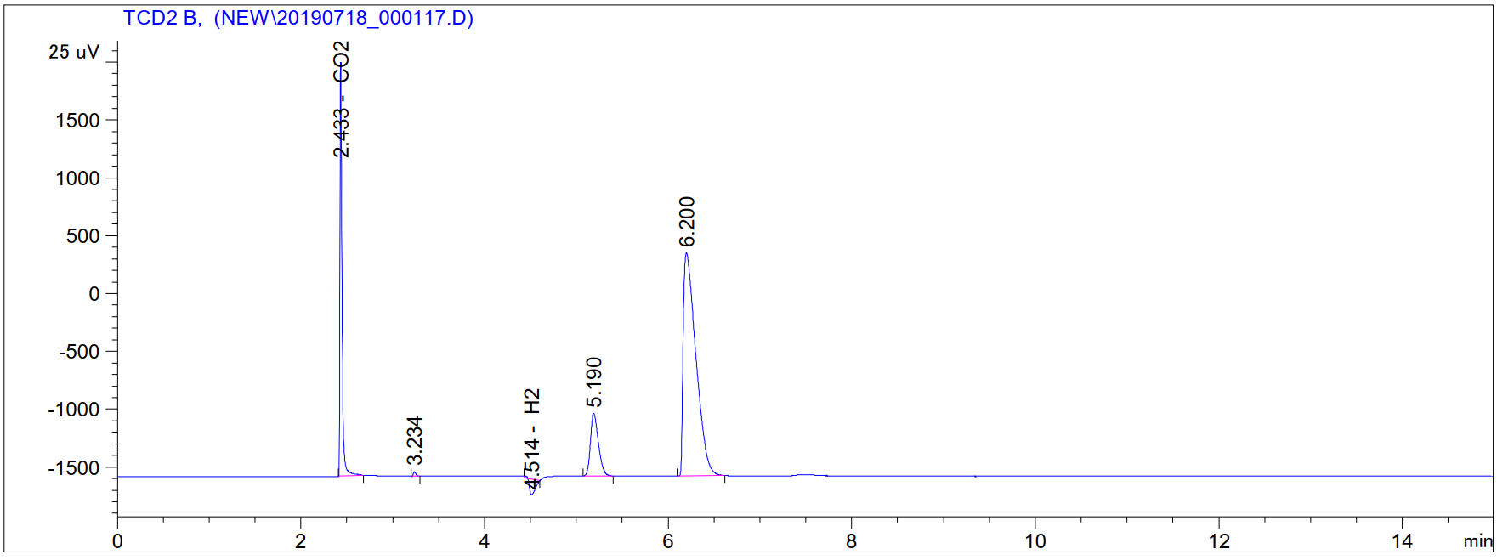
Supplementary Table 6 | Information of products from GC-TCDª
Retention time | Compound
2.433 | CO₂
4.514 | H₂
5.190 | O₂
6.200 | N₂
ª GC-TCD is responsible for qualitative studies only, and the area is not positively correlated with the concentration.

b) Reaction conditions: 5.0 mL EtOH, Ru-4 (250 ppm, 16.2 mg), 41 h, 115 ºC, NaOEt (20 mol%, 1166 mg) in reactor A and 600 rpm.
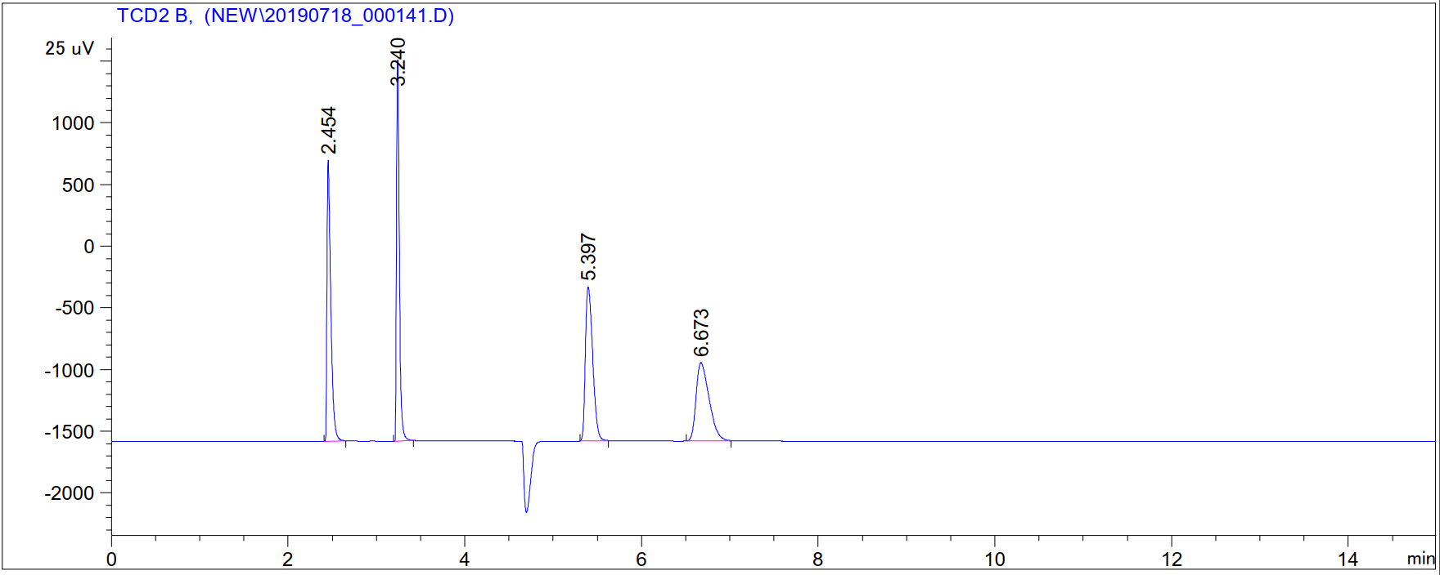
Supplementary Table 7 | Information of products from GC-TCDª
Retention time | Compound
2.454 | CO₂
4.747 | H₂
5.397 | O₂
6.673 | N₂
ª GC-TCD is responsible for qualitative studies only, and the area is not positively correlated with the concentration.

c) Reaction conditions: 5.0 mL EtOH, Ru-5 (250 ppm, 13.5 mg), 41 h, 115 ºC, NaOEt (20 mol%, 1166 mg) in reactor A and 600 rpm.
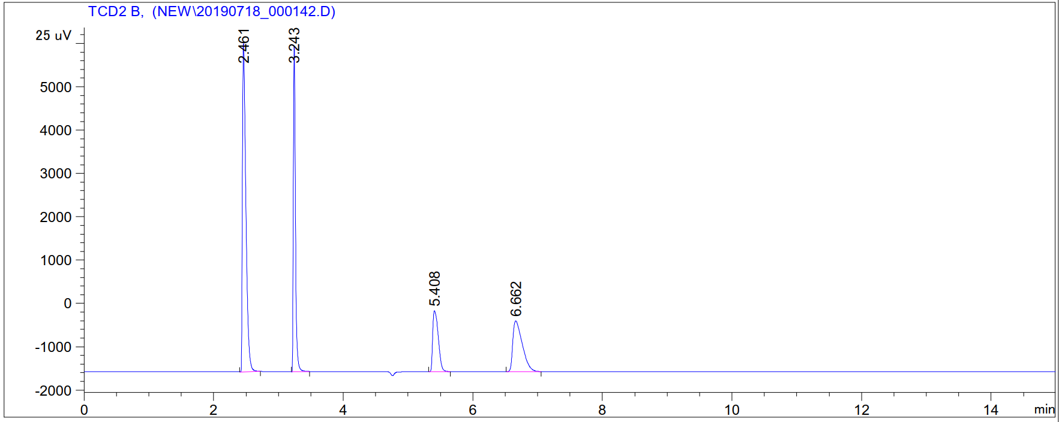
Supplementary Table 8 | Information of products from GC-TCDª
Retention time | Compound
2.461 | CO₂
4.747 | H₂
5.408 | O₂
6.662 | N₂
ª GC-TCD is responsible for qualitative studies only, and the area is not positively correlated with the concentration.

7. GC-FID reports of liquid products
a) Example: Supplementary Table 3, Entry 10.
Reaction conditions: 5.0 mL EtOH, Ru-1 (830 ppm, 51.8 mg), 96 h, 115 ºC, NaOEt (20 mol%, 1166 mg) in reactor A and 600 rpm.
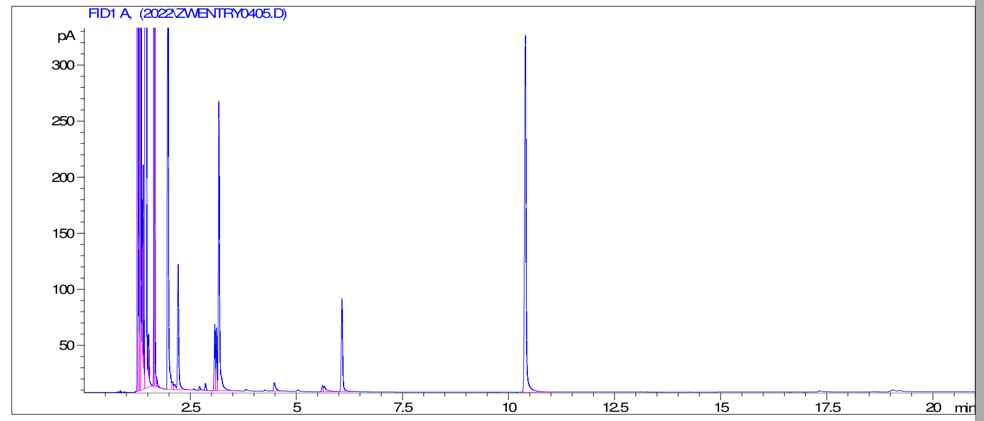
Supplementary Table 9 | Information of products from GC-FID
Retention time | Compound | Area | Area [%] | Conversion / Yield [%]ª
1.335 | ethanol | 8293.04492 | 6.14711 | 61
1.393 | 2-propanol | 168.33704 | 0.12478 | 1.5
1.434 | dichloromethane | 10174.5 | 75.41698 | /
1.647 | ethyl acetate | 964.02954 | 0.71457 | trace
1.662 | 2-butanol | 1569.88892 | 1.16366 | 8.6
1.980 | 1-butanol | 869.32996 | 0.64438 | 2.6
2.077 | diethoxymethane | 16.39939 | 0.01216 | trace
2.217 | 2-pentanol | 227.67053 | 0.16876 | 0.8
3.174 | 3-hexanol | 515.06836 | 0.38179 | 2.4
6. 072 | decane | 197.88586 | 0.14668 | /
10.394 | tridecane | 866.97992 | 0.64264 | /
ª mol% conversion and yield.

b) Example: Supplementary Table 4, Entry 8.
Reaction conditions: 5.0 mL EtOH, Ru-2 (250 ppm, 15.1 mg), 96 h, 115 ºC, NaOEt (20 mol%, 1166 mg) in reactor A and 600 rpm.
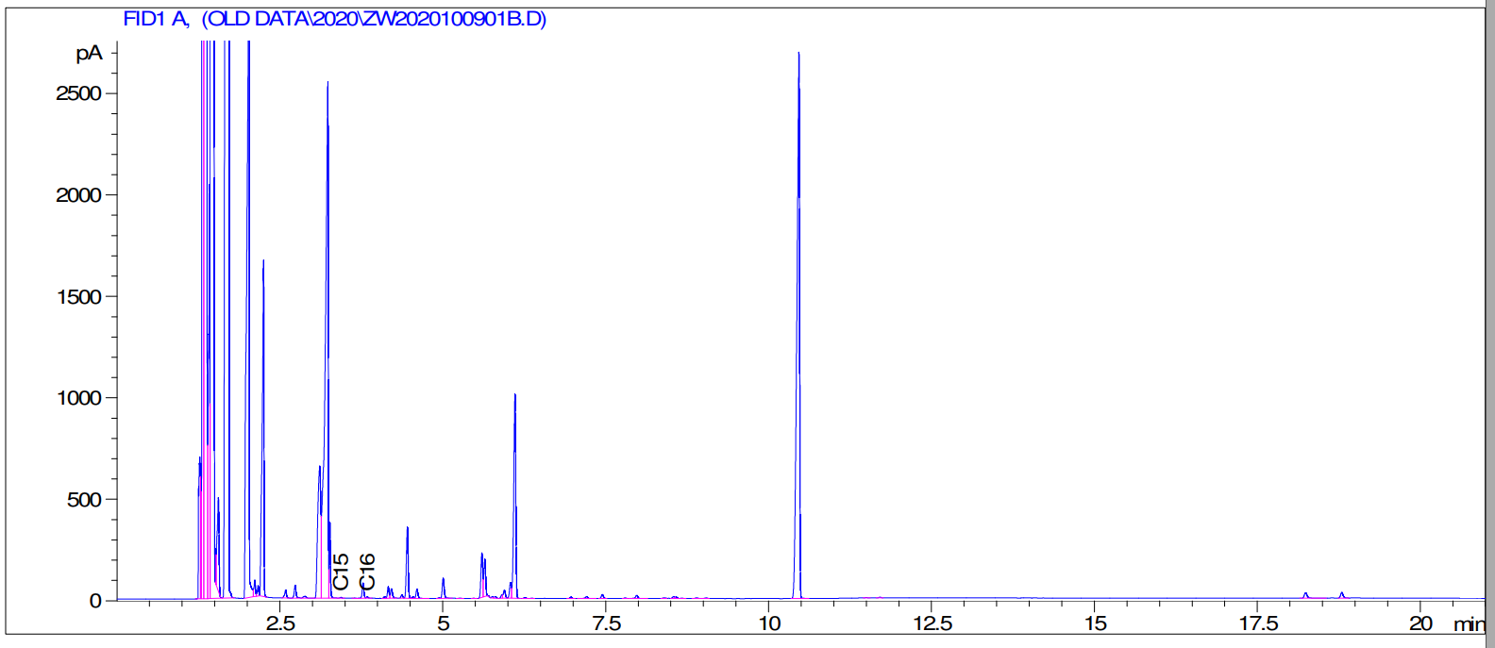
Supplementary Table 10 | Information of products from GC-FID
Retention time | Compound | Area | Area [%] | Conversion / Yield [%]ª
1.381 | ethanol | 90797.9 | 30.86938 | 55
1.424 | 2-propanol | 2897.57007 | 0.98511 | 0.6
1.438 | dichloromethane | 98131.8 | 33.36273 | /
1.718 | 2-butanol | 29429.3 | 10.00533 | 12.3
2.029 | 1-butanol | 8425.74414 | 2.86458 | 2.5
2.118 | diethoxymethane | 134.34705 | 0.04568 | trace
2.252 | 2-pentanol | 3115.85864 | 1.05933 | 1.4
3.234 | 3-hexanol | 8092.85254 | 2.75140 | 3.9
4.455 | 4-heptanol | 660.98340 | 0.22472 | trace
6.105 | decane | 2189.15063 | 0.74427 | /
10.463 | tridecane | 7827.92480 | 2.66133 | /
ª mol% conversion and yield.

c) Example: Supplementary Table 5, Entry 1.
Reaction conditions: 5 mL EtOH, Ru-3 (250 ppm, 12.1 mg), 96 h, 115 ºC, NaOEt (20 mol%, 583 mg) in reactor A and 600 rpm.
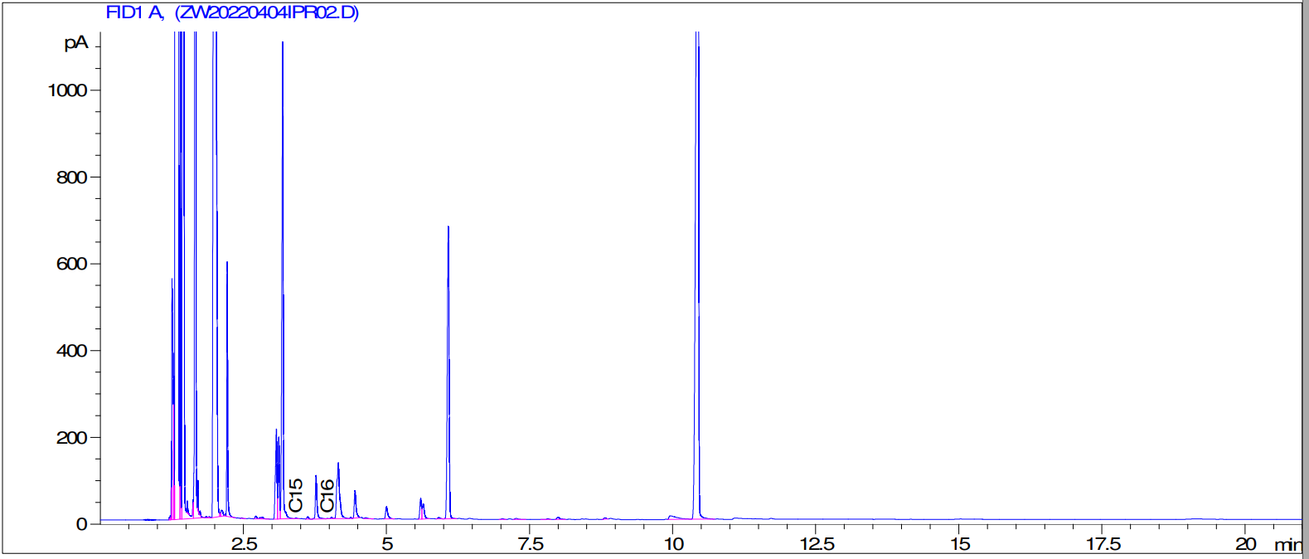
Supplementary Table 11 | Information of products from GC-FID
Retention time | Compound | Area | Area [%] | Conversion / Yield [%]ª
1.369 | ethanol | 109729.5 | 47.35016 | 27
1.404 | 2-propanol | 724.32721 | 0.31256 | 0.6
1.433 | dichloromethane | 86245.6 | 37.21646 | /
1.623 | ethyl acetate | 8.94422 | 0.00386 | trace
1.670 | 2-butanol | 6602.84082 | 2.84924 | 3.0
2.027 | 1-butanol | 14326.2 | 6.18201 | 5.2
2.098 | diethoxymethane | 8.79898 | 0.00380 | trace
2.221 | 2-pentanol | 617.71112 | 0.26655 | 0.3
3.186 | 3-hexanol | 1816.89905 | 0.78402 | 1.0
4.448 | 4-heptanol | 138.97281 | 0.05997 | trace
6.079 | decane | 1456.10242 | 0.62833 | /
10.437 | tridecane | 7004.85645 | 3.02272 | /
ª mol% conversion and yield.

d) Example: Supplementary Table 5, Entry 2.
Reaction conditions: 5 mL EtOH, Ru-4 (250 ppm, 16.2 mg), 96 h, 115 ºC, NaOEt (20 mol%, 583 mg) in reactor A and 600 rpm.
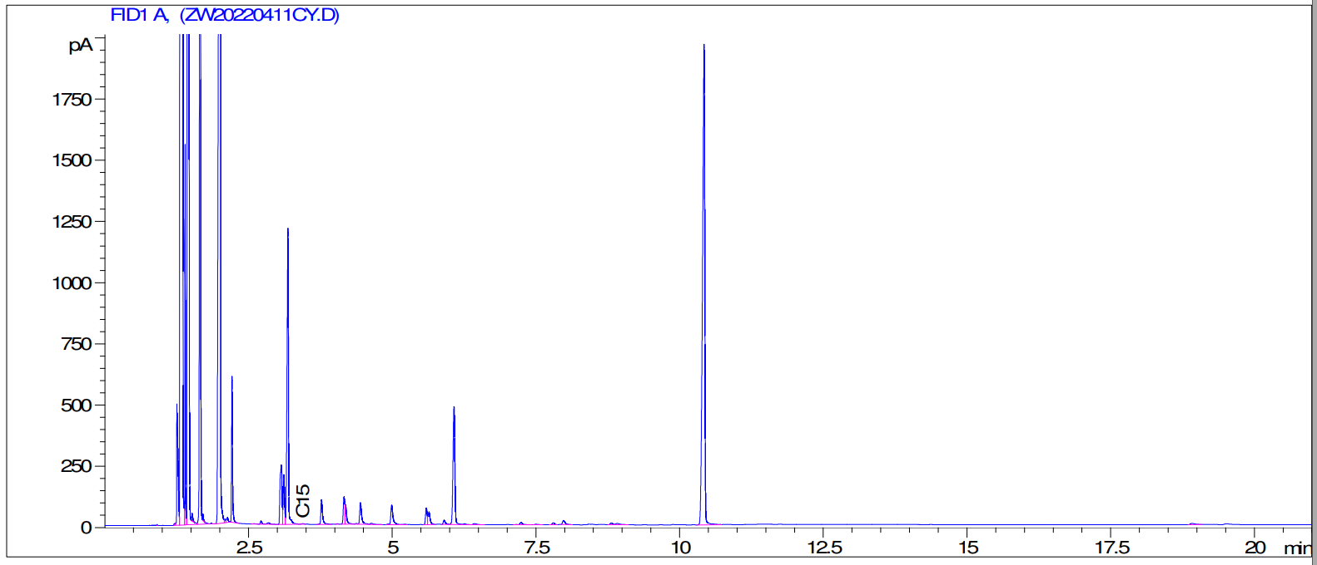
Supplementary Table 12 | Information of products from GC-FID
Retention time | Compound | Area | Area [%] | Conversion / Yield [%]ª
1.359 | ethanol | 84510.3 | 38.87546 | 26
1.400 | 2-propanol | 741.91418 | 0.34129 | 0.7
1.434 | dichloromethane | 101392.7 | 46.64151 | /
1.665 | 2-butanol | 6692.29688 | 3.07851 | 3.8
2.016 | 1-butanol | 11309.6 | 5.20252 | 6.4
2.092 | diethoxymethane | 19.78473 | 0.00910 | trace
2.215 | 2-pentanol | 666.55798 | 0.30662 | 0.4
3.184 | 3-hexanol | 2086.07300 | 0.95961 | 1.5
4.444 | 4-heptanol | 208.58214 | 0.09595 | trace
6.072 | decane | 1088.52576 | 0.50073 | /
10.423 | tridecane | 5422.88037 | 2.49457 | /
ª mol% conversion and yield.

e) Example: Supplementary Table 5, Entry 5.
Reaction conditions: 2.5 mL EtOH, Ru-5 (250 ppm, 6.8 mg), 96 h, 130 ºC, NaOEt (20 mol%, 583 mg) in reactor B and 600 rpm.
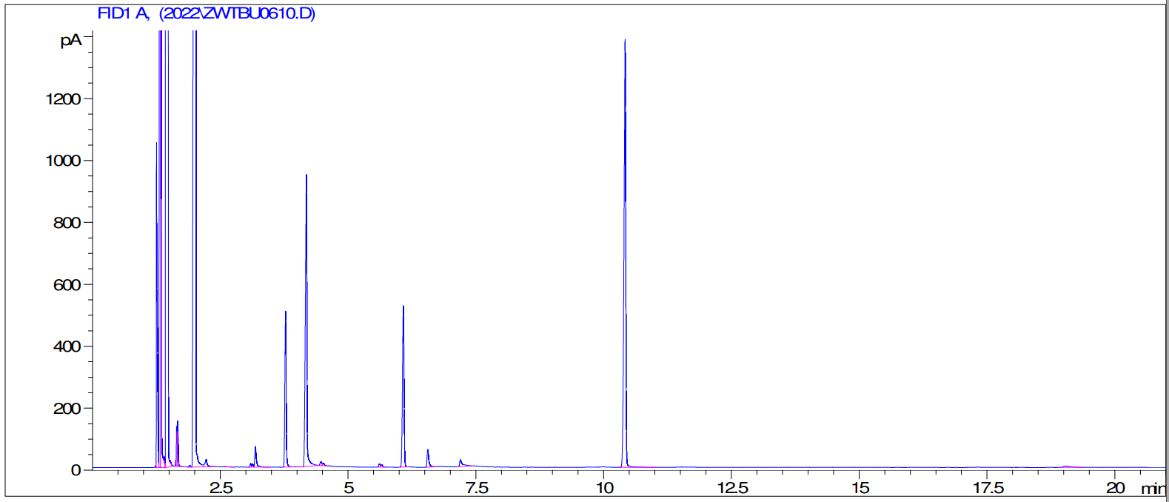
Supplementary Table 13 | Information of products from GC-FID
Retention time | Compound | Area | Area [%] | Conversion / Yield [%]ª
1.317 | ethanol | 12013.5 | 6.10001 | 49
1.433 | dichloromethane | 14745.9 | 74.87437 | /
1.666 | 2-butanol | 207.80112 | 0.10551 | 1.0
2.024 | 1-butanol | 14908.8 | 7.57001 | 22.1
3.776 | 2-ethyl-1-butanol | 900.70880 | 0.45735 | 0.9
4.184 | 1-hexanol | 2093.11304 | 1.06280 | 3.0
6.558 | decane | 144.53439 | 0.07339 | /
10.418 | tridecane | 3444.03467 | 1.74875 | /
ª mol% conversion and yield.

8. GC-MS (liquid phase) reports of products
a) Example: Supplementary Table 3, Entry 6.
Reaction conditions: 5.0 mL EtOH, Ru-1 (1000 ppm, 52 mg), 96 h, 115 ºC, NaOtBu (20 mol%, 1646 mg) in reactor A and 600 rpm.
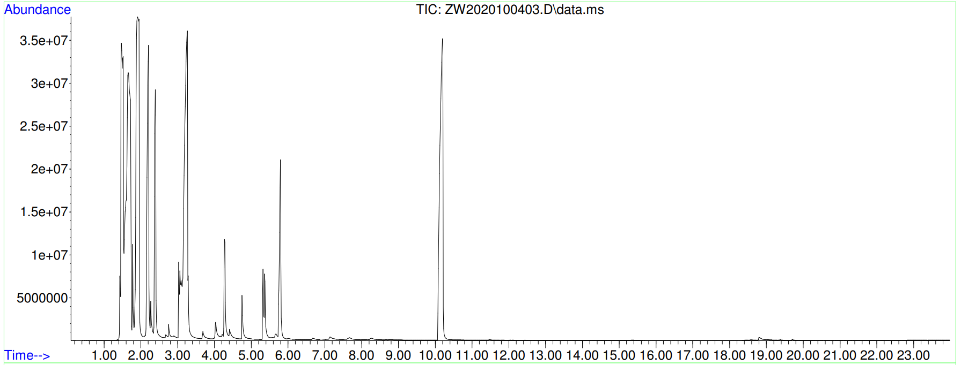
Supplementary Table 14 | Information of products from GC-MS
Retention time | Compound | Corr.area | Corr. % max. | % of total (mol%) | Conversion / Yield [%]ª
1.480 | ethanol | 863227873 | 32.50 | 5.693 | 57
1.513 | ethanol | 635973656 | 23.94 | 4.195 | 57
1.663 | dichloromethane | 2656087416 | 100 | 17.518 | /
1.917 | 2-butanol | 2227223903 | 83.85 | 14.690 | 11.5
2.205 | 1-butanol | 1123128824 | 42.29 | 7.408 | 3.0
2.397 | 2-pentanol | 781939039 | 29.44 | 5.157 | 2.0
3.260 | 3-hexanol | 2266166719 | 85.32 | 14.946 | 5.8
4.282 | 4-heptanol | 304316668 | 11.46 | 2.007 | 0.3
5.795 | decane | 581154003 | 21.88 | 3.833 | /
10.199 | tridecane | 2103928204 | 79.21 | 13.876 | /
ª mol% conversion and yield.

b) Example: Supplementary Table 4, Entry 8.
Reaction conditions: 5.0 mL EtOH, Ru-2 (250 ppm, 15.1 mg), 96 h, 115 ºC, NaOEt (20 mol%, 1166 mg) in reactor A and 600 rpm.
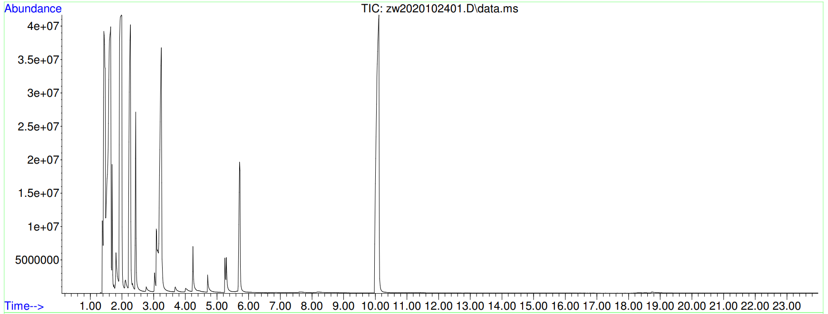
Supplementary Table 15 | Information of products from GC-MS
Retention time | Compound | Corr.area | Corr. % max. | % of total (mol%) | Conversion / Yield [%]ª
1.447 | ethanol | 2026304360 | 100.00 | 23.464 | 55
1.582 | dichloromethane | 1086549541 | 53.62 | 12.582 | /
1.846 | 2-butanol | 1196213678 | 59.03 | 13.852 | 12.3
2.139 | 1-butanol | 1128952416 | 55.71 | 13.073 | 2.5
2.319 | 2-pentanol | 244070235 | 12.05 | 2.826 | 1.4
3.121 | 3-hexanol | 694041934 | 34.25 | 8.037 | 3.9
4.191 | 4-heptanol | 110495747 | 5.45 | 1.280 | trace
5.703 | decane | 437082455 | 21.57 | 5.061 | /
10.057 | tridecane | 1298317982 | 64.07 | 15.034 | /
ª mol% conversion and yield.
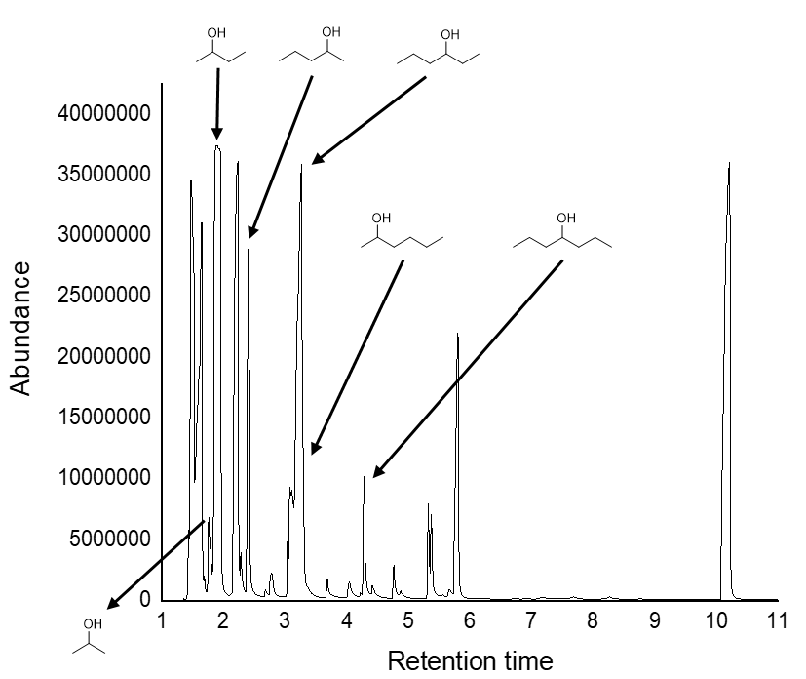
Supplementary Figure 4 | A typical MS spectrum of a reaction mixture. (Supplementary Table 4, Entry 8.)

MW 60.1 g/mol
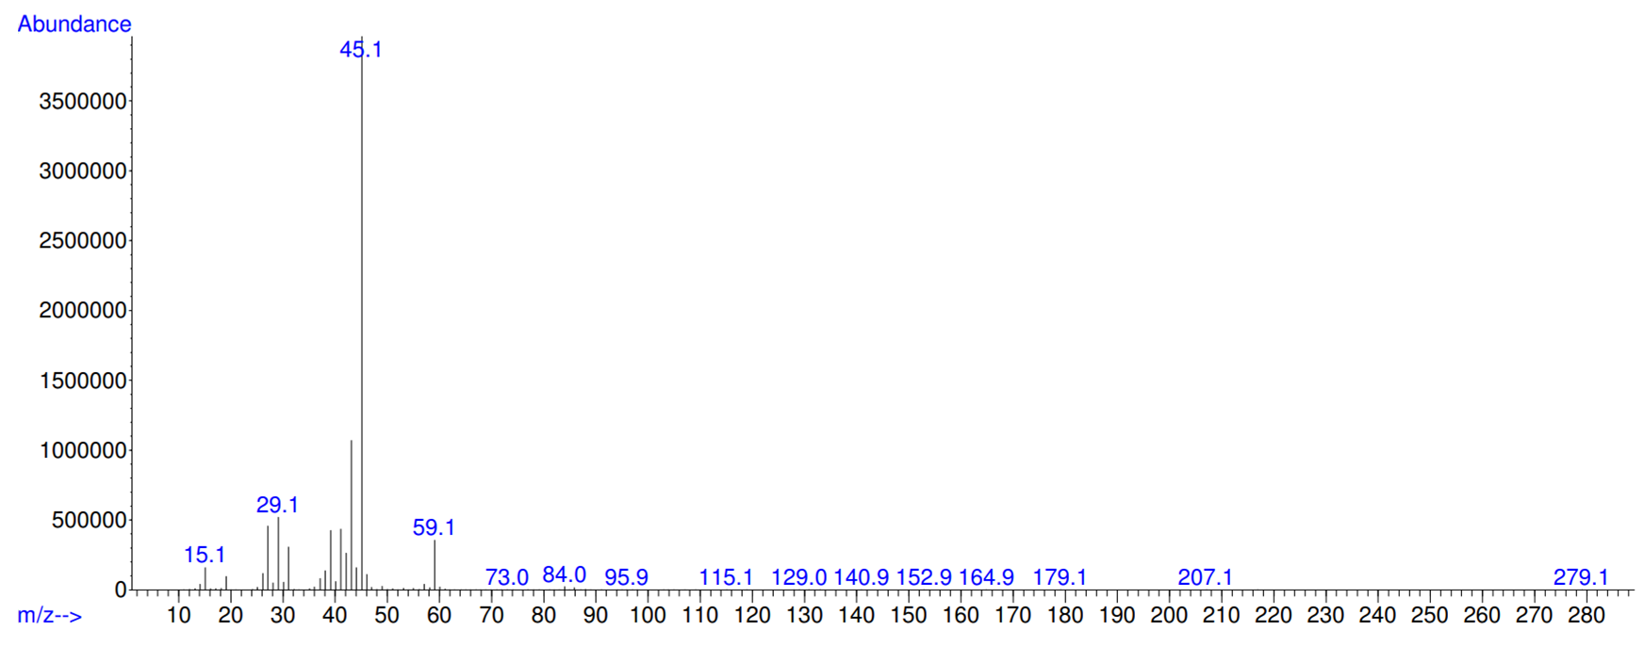
Supplementary Figure 4.1 | A MS spectrum of 2-propanol. (Supplementary Table 4, Entry 8.)

MW 74.12 g/mol
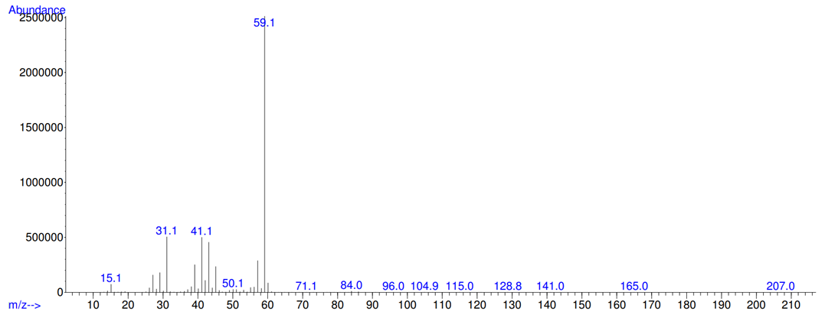
Supplementary Figure 4.2 | A MS spectrum of tert-butanol. (Supplementary Table 4, Entry 8.)

MW 60.0952 g/mol
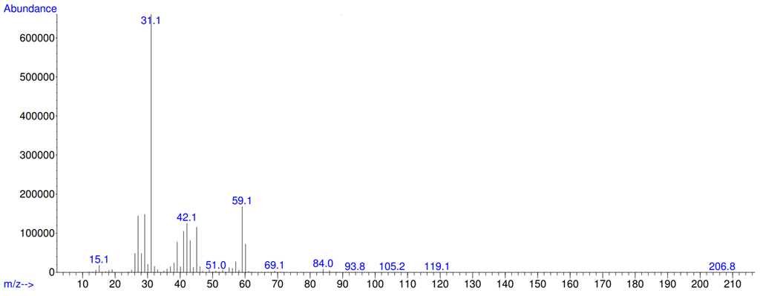
Supplementary Figure 4.3 | A MS spectrum of 1-propanol. (Supplementary Table 4, Entry 8.)

MW 72.11 g/mol
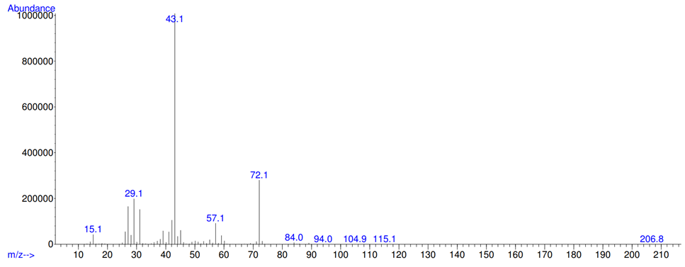
Supplementary Figure 4.4 | A MS spectrum of 2-butanone. (Supplementary Table 4, Entry 8.)
MW 74.122 g/mol
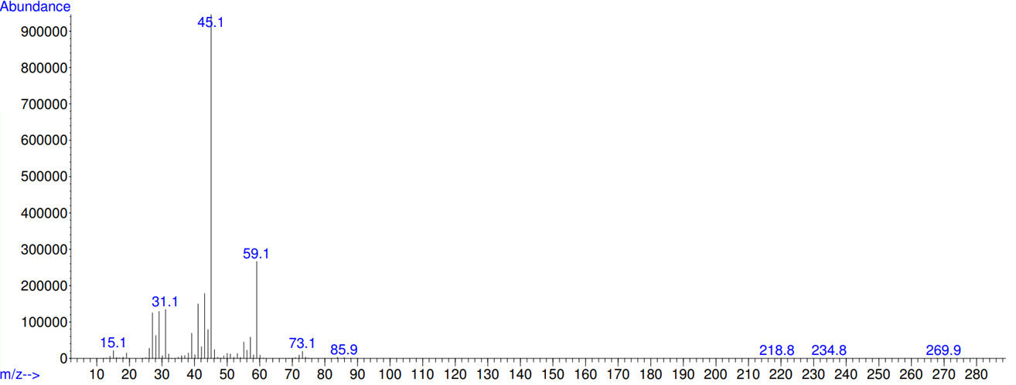
Supplementary Figure 4.5 | A MS spectrum of 2-butanol. (Supplementary Table 4, Entry 8.)

MW 88.11 g/mol
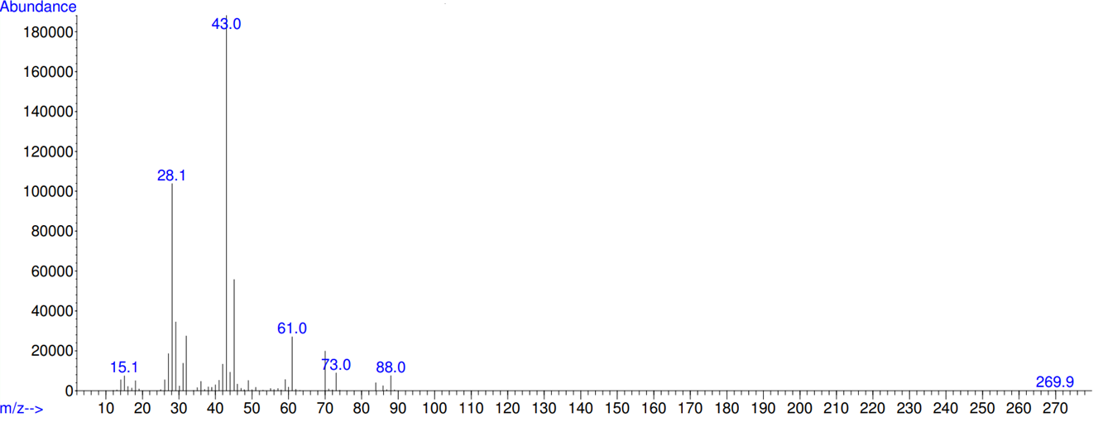
Supplementary Figure 4.6 | A MS spectrum of ethyl acetate. (Supplementary Table 4, Entry 8.)

MW 74.121 g/mol
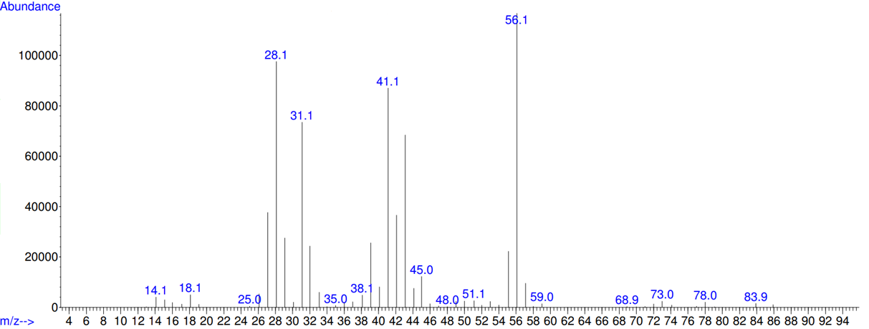
Supplementary Figure 4.7 | A MS spectrum of 1-butanol. (Supplementary Table 4, Entry 8.)
MW 104.15 g/mol
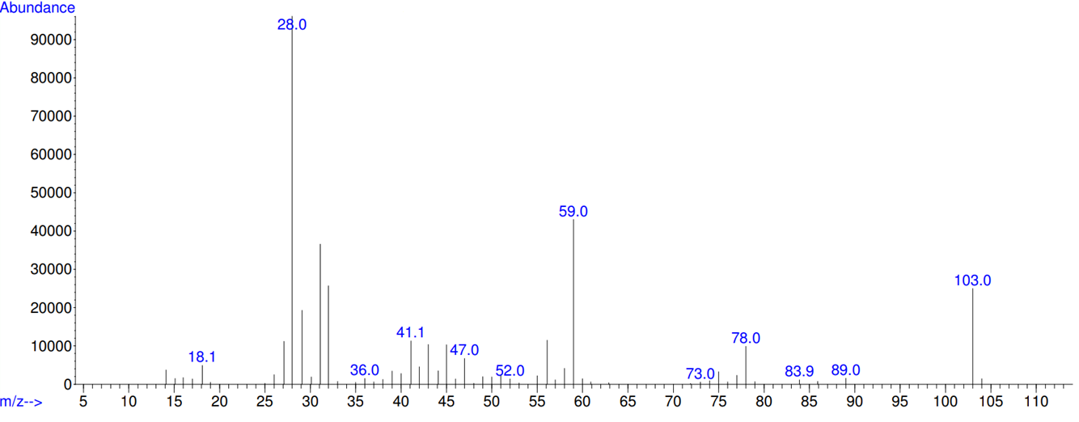
Supplementary Figure 4.8 | A MS spectrum of diethoxymethane. (Supplementary Table 4, Entry 8.)

MW 88.148 g/mol
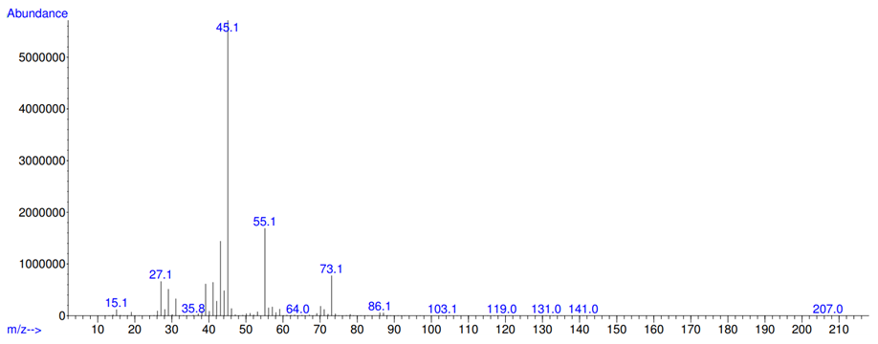
Supplementary Figure 4.9 | A MS spectrum of 2-pentanol. (Supplementary Table 4, Entry 8.)

MW 100.1589 g/mol 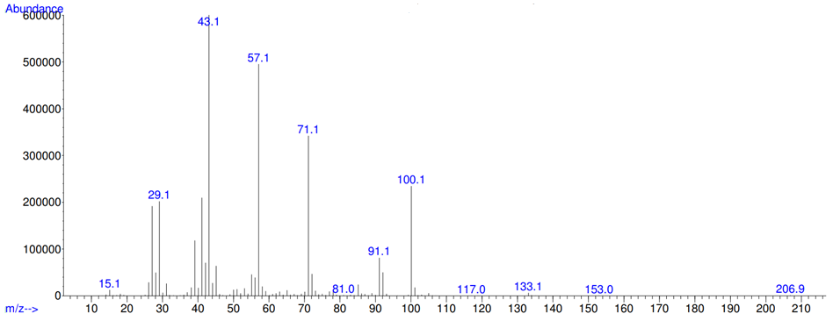
Supplementary Figure 4.10 | A MS spectrum of 3-hexanone. (Supplementary Table 4, Entry 8.)
MW 102.174 g/mol
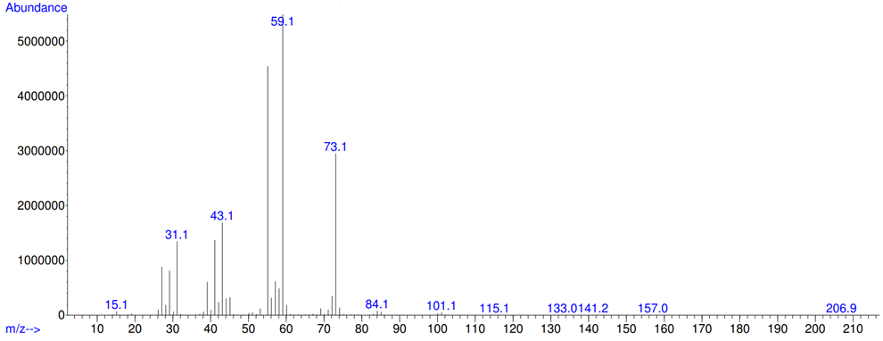
Supplementary Figure 4.11 | A MS spectrum of 3-hexanol. (Supplementary Table 4, Entry 8.)

MW 116.2 g/mol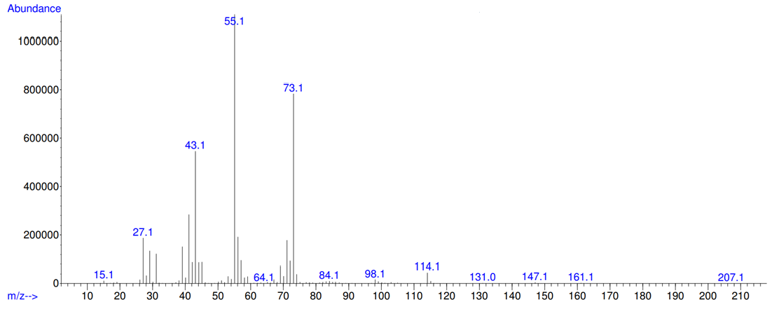
Supplementary Figure 4.12 | A MS spectrum of 4-heptanol. (Supplementary Table 4, Entry 8.)

9. GC-MS (gas phase) reports of products
a) Example: Supplementary Table 4, Entry 20.
Reaction conditions: 2.5 mL EtOH, Ru-2 (250 ppm, 7.6 mg), 96 h, 130 ºC, NaOEt (20 mol%, 583 mg) in reactor B and 600 rpm.
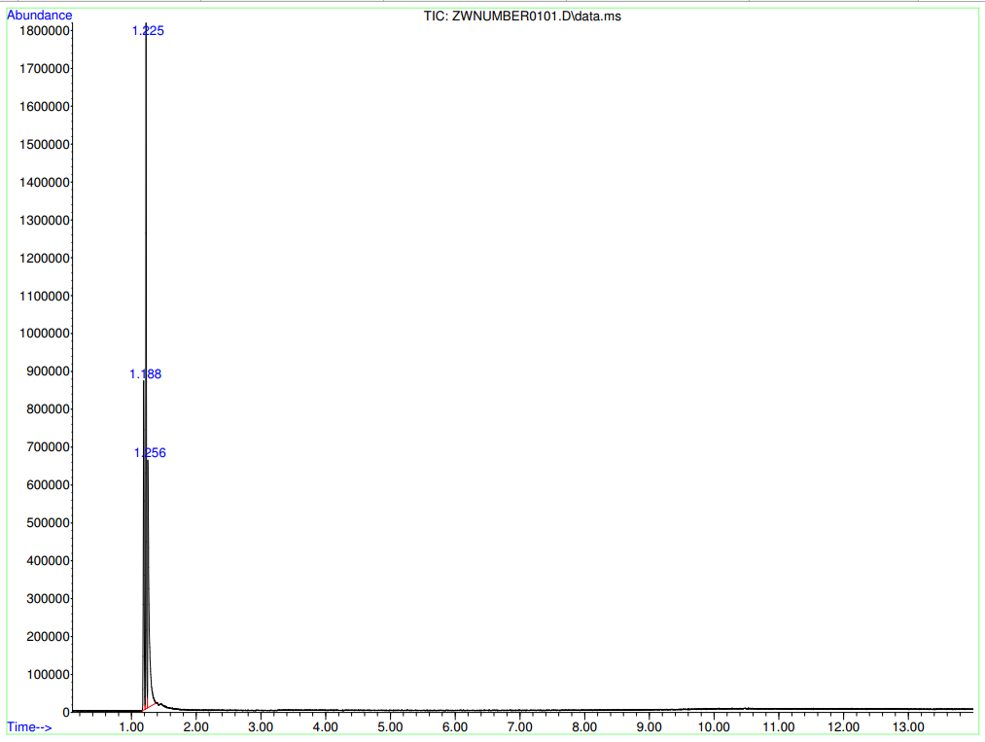
Supplementary Table 16 | Information of products from GC-MS
Retention time | Compound | Corr.area | Corr. % max. | % of total | Yield [%]ª
1.188 | N₂ | 7614491 | 61.75 | 25.817 | /
1.225 | butane | 12331117 | 100.00 | 41.809 | 2.7
1.256 | ethanol | 9548633 | 77.44 | 32.375 | /
ª mol% yield.

MW 56.11 g/mol
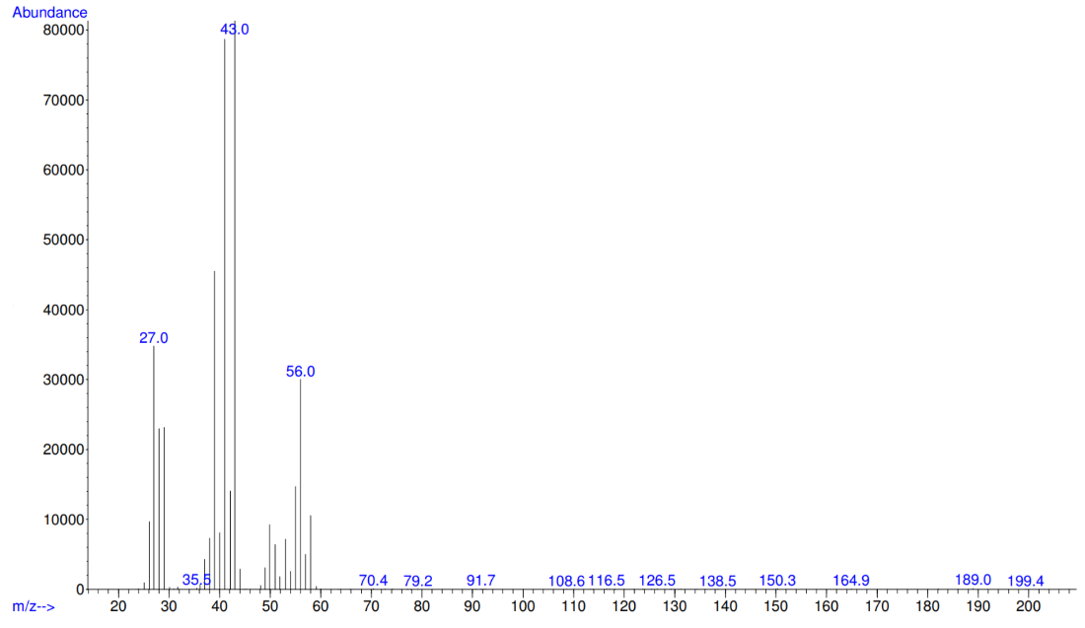
Supplementary Figure 5 | A MS spectrum of 2-butenes. (Supplementary Table 4, Entry 8.)

MW 58.12 g/mol
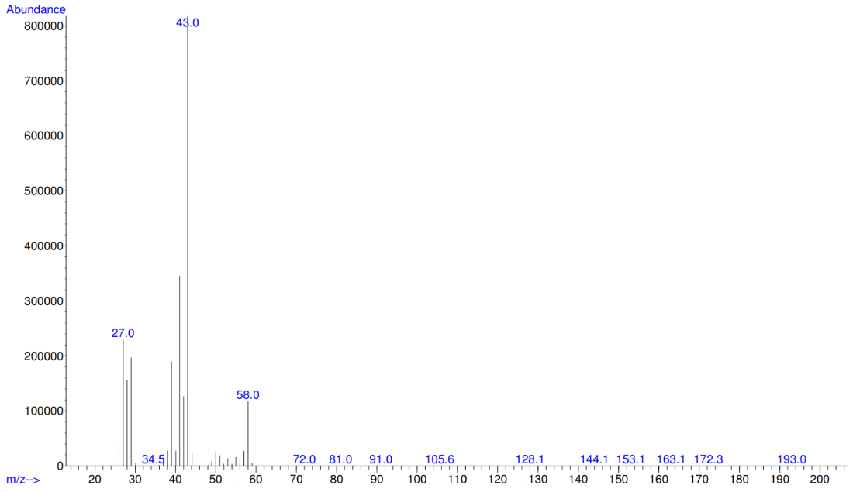
Supplementary Figure 6 | A MS spectrum of butane. (Supplementary Table 4, Entry 20.)

b) Example: Supplementary Table 4, Entry 21.
Reaction conditions: 2.5 mL EtOH, Ru-2 (8.3 ppm, 0.0025 mg), 168 h, 130 ºC, NaOEt (20 mol%, 583 mg) in reactor B and 600 rpm.
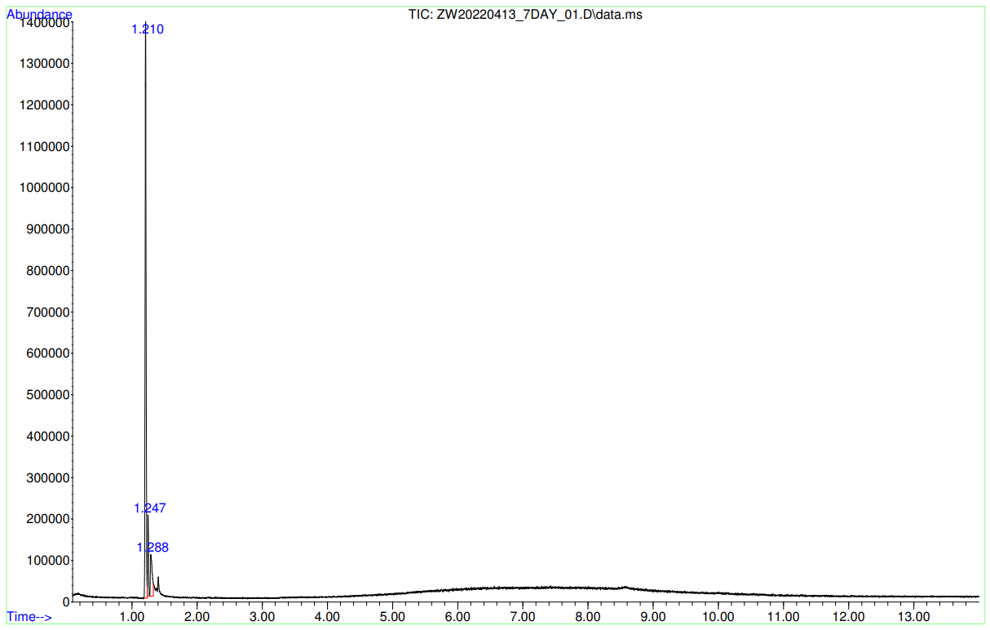
Supplementary Table 17 | Information of products from GC-MS
Retention time | Compound | Corr.area | Corr. % max. | % of total
1.210 | N₂ | 1514805 | 100.00 | 80.205
1.247 | hexane (partially stays in the gas phase) | 174901 | 11.55 | 9.261
1.288 | ethanol | 198958 | 13.13 | 10.534

MW: 86.18 g/mol
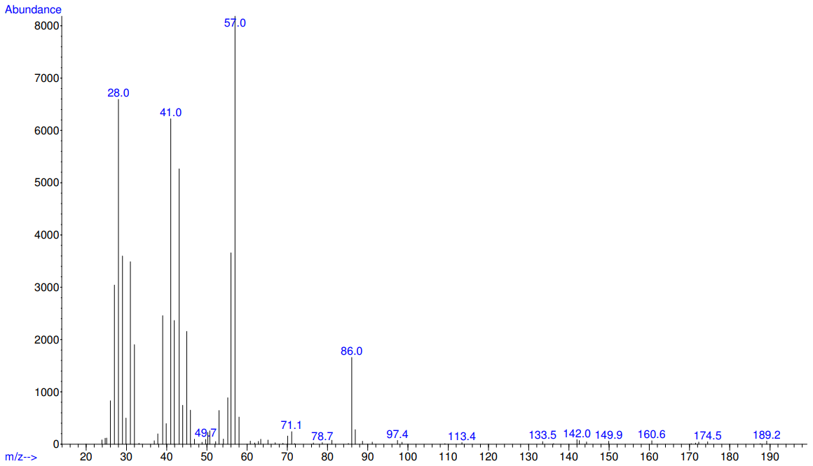
Supplementary Figure 7 | A MS spectrum of hexane. (Supplementary Table 4, Entry 21.)

10. Micro-GC reports of inorganic and organic gas
Example: Supplementary Table 4, Entry 2.
Reaction conditions: 5.0 mL EtOH, Ru-2 (250 ppm, 15.1 mg), 24 h, 115 ºC, NaOEt (20 mol%, 1166 mg) in reactor A and 600 rpm.
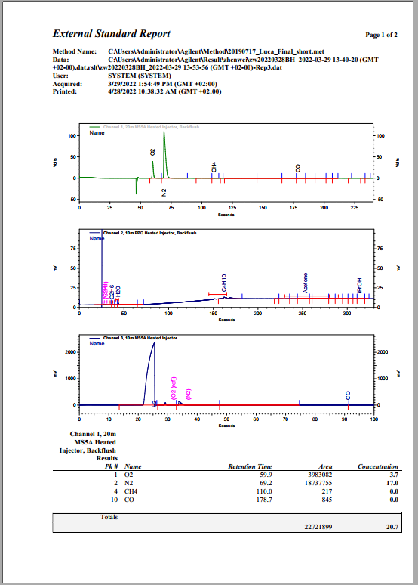
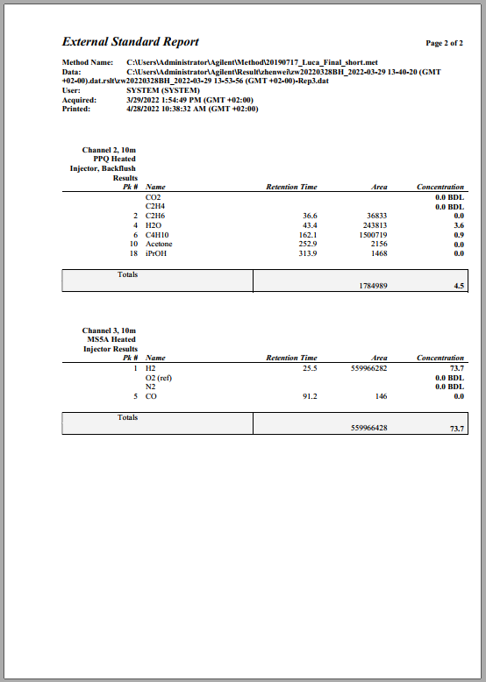

11. A typical NMR spectrum of 2-butanol
-CH₃
-CH₂
-CH
-CH₃
Supplementary Figure 8 | ¹H NMR of the reaction mixture (400 MHz, CDCl₃ at 25 ºC). Reaction conditions: 5.0 mL ethanol, Ru-2 (250 ppm), 96 h, 115 ºC, NaOEt (20 mol%) in reactor A and 600 rpm. (Supplementary Table 4, Entry 8.)
.
-CH₃
-CH₂
-CH
-CH₃
Supplementary Figure 9 | ¹³C NMR of the reaction mixture (100.62 MHz, CDCl₃ at 25 ºC). Reaction conditions: 5.0 mL ethanol, Ru-2 (250 ppm), 96 h, 115 ºC, NaOEt (20 mol%) in reactor A and 600 rpm. (Supplementary Table 4, Entry 8.)

12. A typical NMR spectrum of sodium acetate quantification
-CH₃
DMSO
Supplementary Figure 10 | ¹H NMR of sodium acetate quantification (DMSO as internal standard, 400 MHz, D₂O at 25 ºC). Reaction conditions: 2.5 mL ethanol, Ru-2 (250 ppm), 96 h, 130 ºC, NaOEt (20 mol%), in reactor B and 600 rpm. (Supplementary Table 4, Entry 20.)

-CH₃
-C_{q}
Supplementary Figure 11 | ¹³C NMR of sodium acetate quantification (100.62 MHz, D₂O at 25 ºC). Reaction conditions: 2.5 mL ethanol, Ru-2 (250 ppm), 96 h, 130 ºC, NaOEt (20 mol%) in reactor B and 600 rpm. (Supplementary Table 4, Entry 20.)
.

13. Pressure change studies

Supplementary Figure 12 | Pressure changes over time observed by Parr system digital recording. Reaction conditions: 2.5 mL ethanol, Ru-2 (250 ppm), 96 h, 130 ºC, NaOEt (20 mol%) in reactor B and 600 rpm. (Supplementary Table 4, Entry 20.)

14. Mechanistic study
Supplementary Table 18 | Mechanistic tests with 4-hydroxy-2-butanone as substrate
Entry | Additive (mol%) | 4-hydroxy-2-butanone [mL / mmol] | H₂ [mmol] | GC-MS observed productsª
 |  |  |  | acetone | methyl vinyl ketone | 2-butanone | 2-butanol | 1,3-butanediol | Butenes
1 | / | 5.0 / 58 | 22 | √ | √ | √ | √ | × | ×
2 | / | 2.5 / 29 | 22 | × | × | × | √ | √ | √
3 | NaOAc (20) | 2.5 / 29 | 22 | √ | × | √ | √ | × | ×
Reaction conditions: 2.5-5.0 mL 4-hydroxy-2-butanone (29-58 mmol), 22 bar H₂ (22 mmol) 250 ppm Ru-2, with or without 20 mol% NaOAc, 115 ºC, 24 h in reactor A and 600 rpm.
ª Determined by GC-MS. See the reports for more products.

Example: Supplementary Table 18, Entry 1.
Reaction conditions: 5.0 mL 4-hydroxy-2-butanone, Ru-2 (250 ppm, 8.5 mg), 24 h, 115 ºC, 22 bar H₂ in reactor A and 600 rpm.
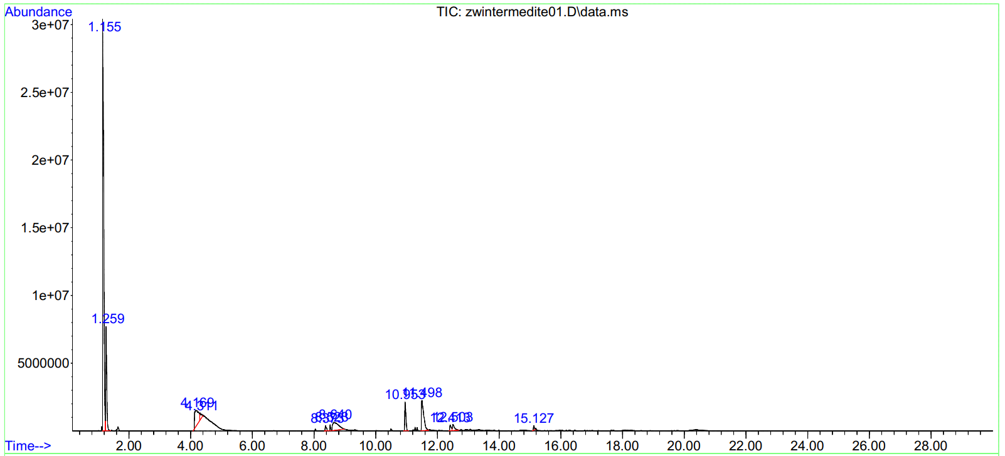
Supplementary Table 19 | Information of products from GC-MS
Retention time | Compound | Corr.area | Corr. % max. | % of total (mol%)
1.113 | acetone | - | - | -
1.155 | dichloromethane | 754615915 | 100.00 | 55.583
1.259 | methyl vinyl ketone | 182087021 | 24.13 | 13.412
1.281 | 2-butanone | - | - | -
1.655 | 2-butanol | - | - | -
4.169 | 4-hydroxyl-2-butanone | 96419728 | 12.78 | 7.102
4.311 | 4-hydroxyl-2-butanone | 16803779 | 2.23 | 1.238

MW: 58.08 g/mol
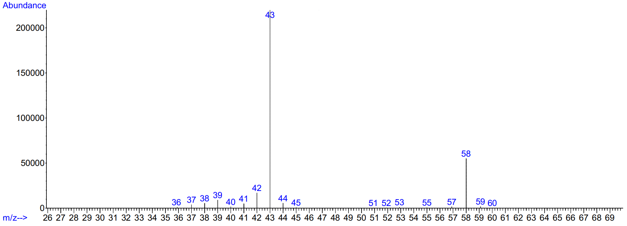
Supplementary Figure 13 | A MS spectrum of acetone. (Supplementary Table 18, Entry 1.)

MW: 70.09 g/mol
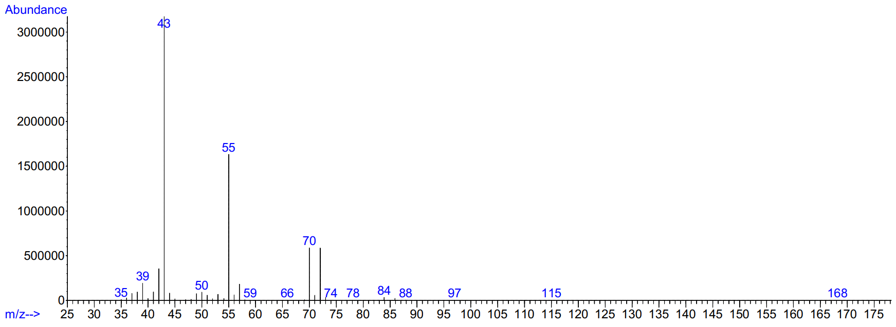
Supplementary Figure 14 | A MS spectrum of methyl vinyl ketone. (Table Supplementary Table 18, Entry 1.)

Example: Supplementary Table 18, Entry 2. (liquid phase)
Reaction conditions: 2.5 mL 4-hydroxy-2-butanone, Ru-2 (250 ppm, 4.3 mg), 24 h, 115 ºC, 22 bar H₂, in reactor A and 600 rpm.
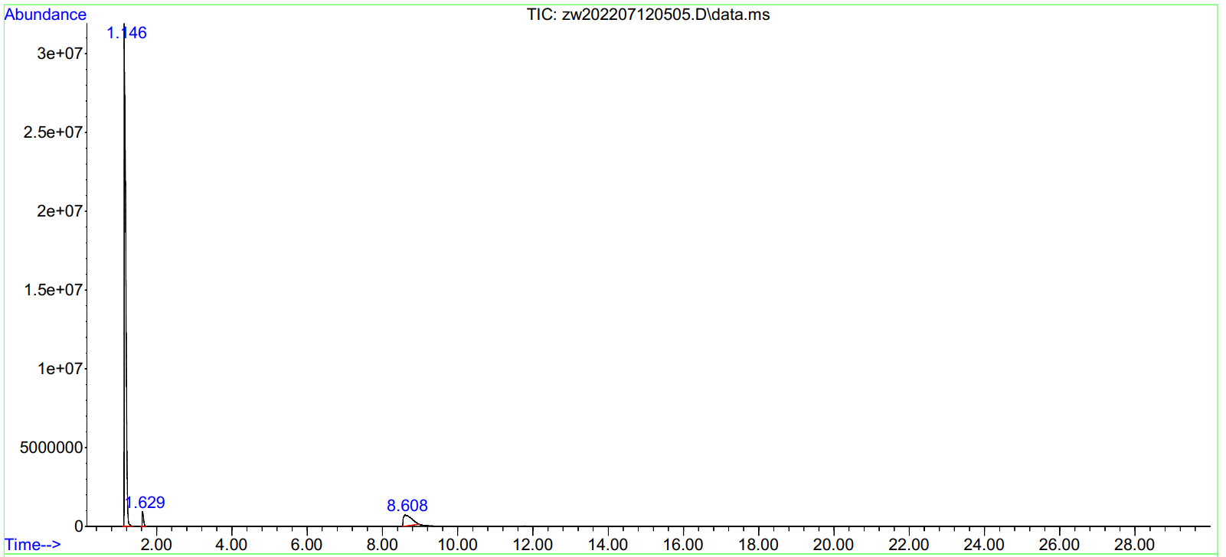
Supplementary Table 20 | Information of products from GC-MS
Retention time | Compound | Corr.area | Corr. % max. | % of total (mol%)
1.146 | dichloromethane | 946790132 | 100.00 | 88.245
1.629 | 2-butanol | 22370046 | 2.36 | 2.085
8.608 | 1,3-butanediol | 103752503 | 10.96 | 9.670

MW: 90.122 g/mol
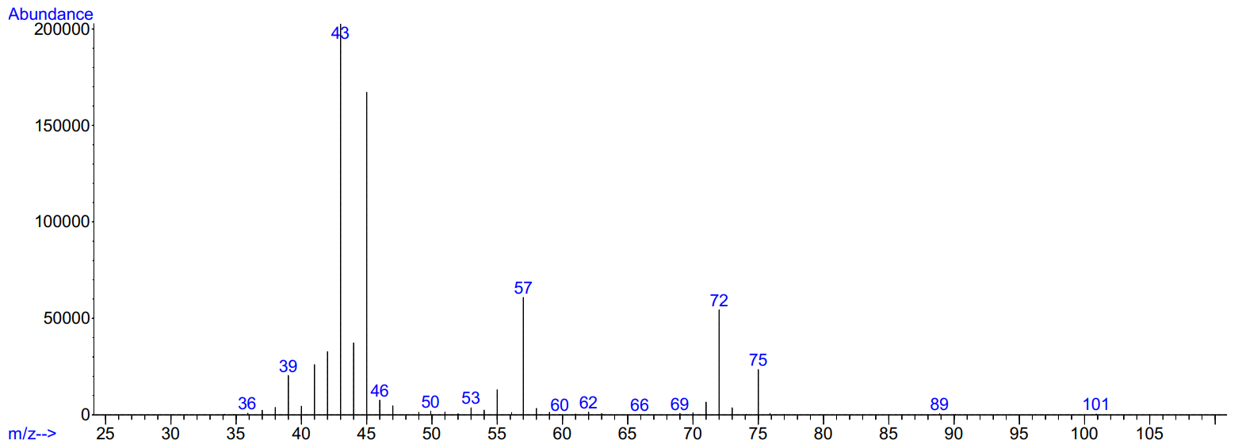
Supplementary Figure 15 | A MS spectrum of 1,3-butanediol. (Supplementary Table S18, Entry 2.)
Example: Supplementary Table 18, Entry 2. (gas phase)
Reaction conditions: 2.5 mL 4-hydroxy-2-butanone, Ru-2 (250 ppm, 4,3 mg), 24 h, 115 ºC, 22 bar H₂, in reactor A and 600 rpm.
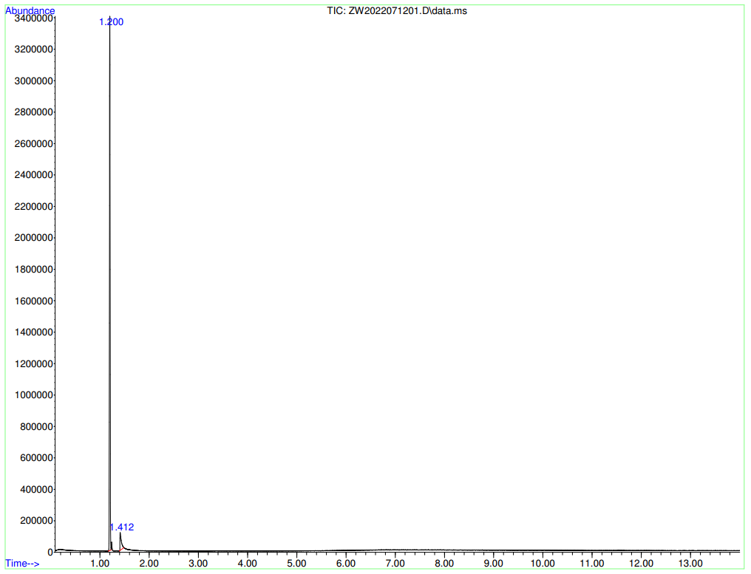
Supplementary Table 21 | Information of products from GC-MS
Retention time | Compound | Corr.area | Corr. % max. | % of total (mol%)
1.200 | N₂ | 33682013 | 100.00 | 93.887
1.412 | butenes | 2193061 | 6.51 | 6.113

Example: Supplementary Table 18, Entry 3.
Reaction conditions: 2.5 mL 4-hydroxy-2-butanone, Ru-2 (250 ppm, 4.3 mg), NaOAc (20 mol%, 595 mg), 24 h, 115 ºC, 22 bar H₂, in reactor A and 600 rpm.
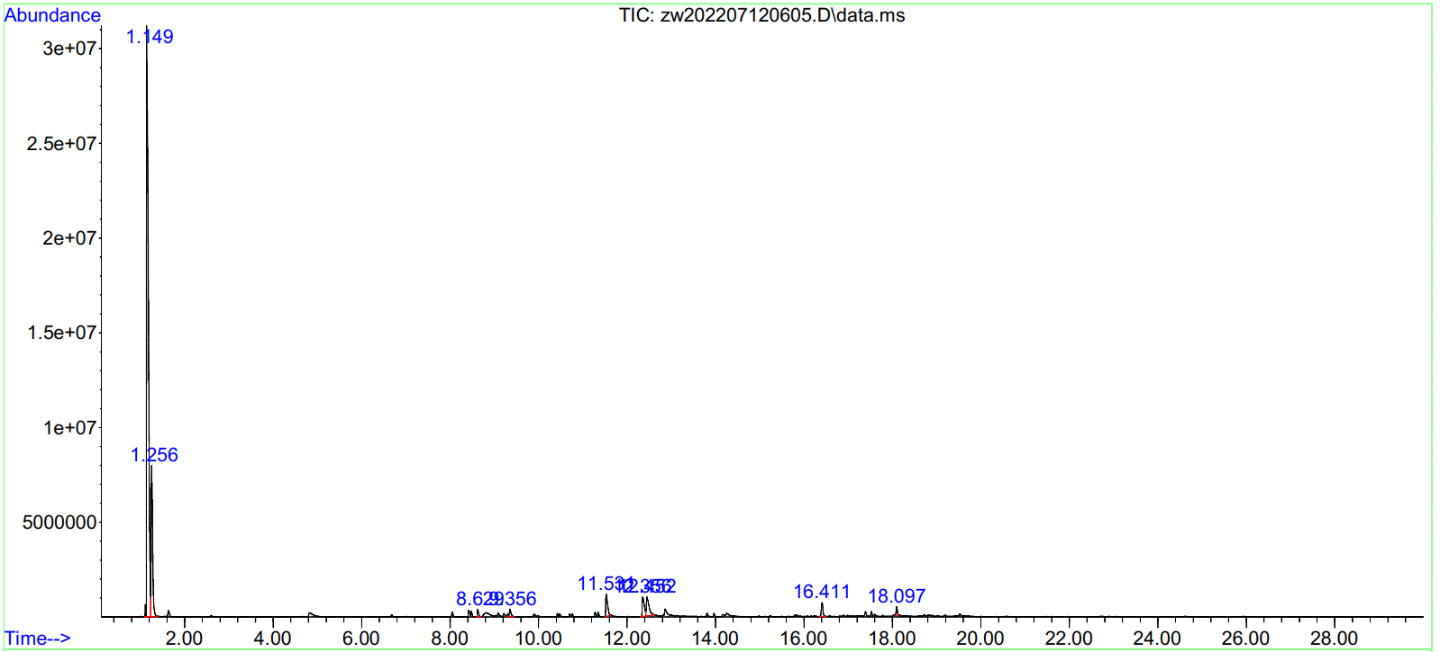
Supplementary Table 22 | Information of products from GC-MS
Retention time | Compound | Corr.area | Corr. % max. | % of total (mol%)
1.109 | acetone | - | - | -
1.149 | dichloromethane | 869114795 | 100.00 | 72.115
1.261 | 2-butanone | - | - | -
1.635 | 2-butanol | - | - | -

MW: 88.11 g/mol
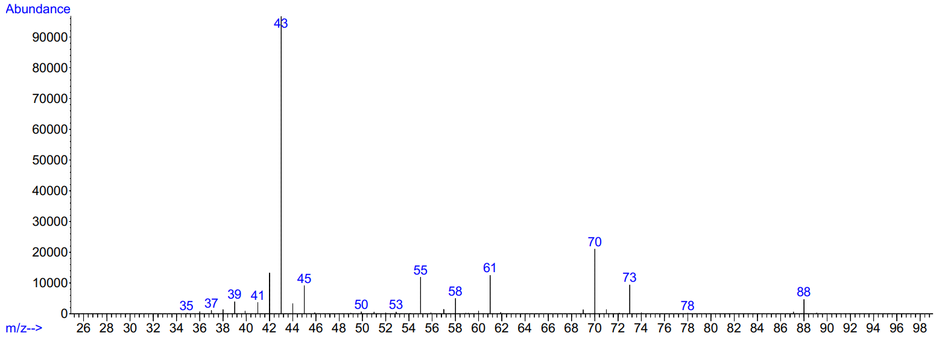
Supplementary Figure 16 | A MS spectrum of 4-hydroxy-2-butanone. (Supplementary Table 18, Entry 3.)

15. References
1. AMF. Iea-amf.org (2022). at <https://iea-amf.org/content/fuel_information/butanol/properties>
2. O’Lenick, A. J. Guerbet Chemistry. J. Surfactants Deterg. 4, 311–315 (2001).

