S1: P. 1
S2: P. 2
S3: P.3-5
S4: P.5 Line 9
S5: P.5-6
S6: P.7
S7: P.5
Line 24
S8: P.6 Line 2
S9: P.6
Line 22
S10: P.6
S11: P.6
S12: P.6
S13: P.6-7
S14: P.6-7
S15: P.7
S16: P.7-11
S17: P.7-11
S18: P.11-13
S19: P.13-14
S20: P.15
S20: P.15
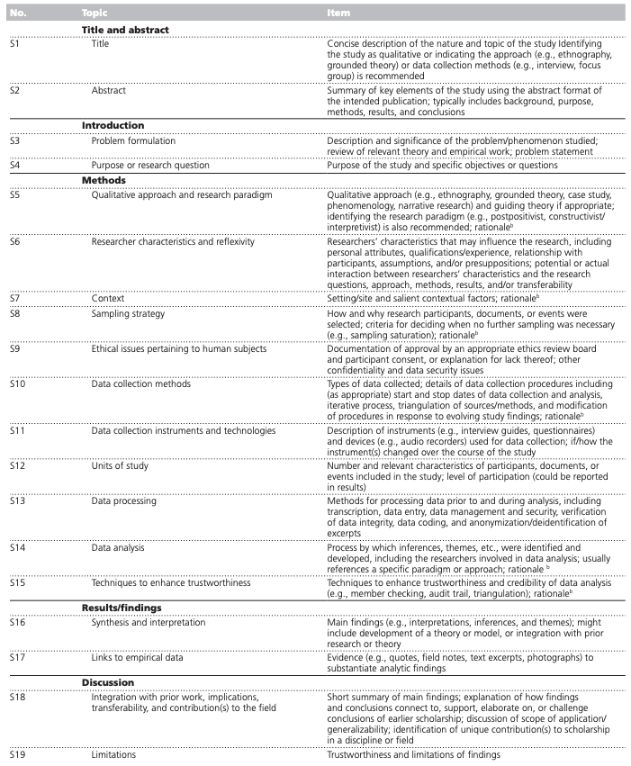
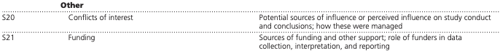
Appendix 1. Checklist for the Standards for Reporting Qualitative Research (SRQR)
References:
O’Brien BC, Harris IB, Beckman TJ, Reed DA, Cook DA. Standards for reporting qualitative research: A synthesis of recommendations. Academic Medicine [Internet]. 2014 [cited 2022 Jul 18];89(9):1245–51. Available from: https://journals.lww.com/academicmedicine/Fulltext/2014/09000/Standards_for_Reporting_Qualitative_Research__A.21.aspx

