Supplementary Information

Chemical composition of the ML deposited at 500 °C
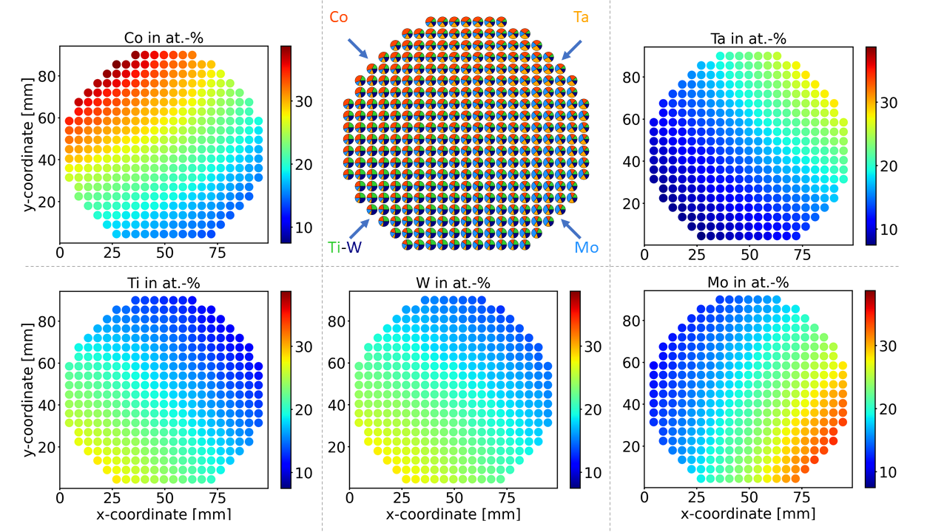
Supplementary Figure 1: EDS composition maps of the ML deposited at 500 °C, normalized to metal elements. All maps use the same color scale ranging from 8 to 40 at.%. The figure in the upper center represents the target positions during co-sputter deposition.

Photos of the MLs after OER measurements
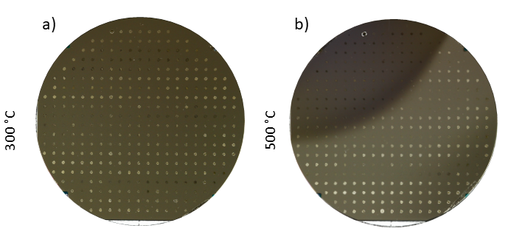
Supplementary Figure 2: Photos of the MLs after one cycle of OER activity measurements. Photos of the MLs deposited at a) 300°C and b) 500°C - both taken after OER activity measurements. The MAs are visible with bare eye, which can be attributed to two things. First: the alteration of the thin film because of oxidazation or second: due to dried electrolyte on the sample. The different appearance linewise can also have different reasons: a different amount of electrolyte stayed on the surface and therefore, the ampunt of dried debris and optical appearance changes, or also the angle of illumination and the direction of the photograph of the MLs. Furthermore, the composition also influences the optical appaerance.

All LSVs
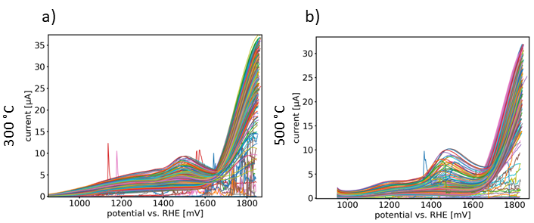
Supplementary Figure 3: All LSVs of the first cycle of OER activity measurements. All LSVs of the ML deposited at a) 300°C and b) 500°C. The measured current is plotted in µA against the potential vs. RHE in mV.

Additional OER measurements
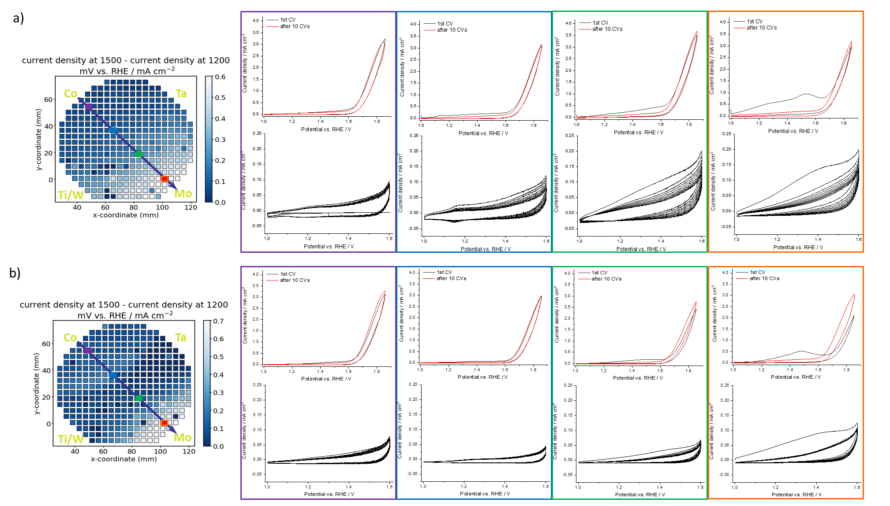
Supplementary Figure 4: OER activity during several cycles of OER activity measurements. For both MLs four MAs located on the line on the pre-oxidation map were chosen for additional measurements. In each of those MAs 2 cyclic voltammograms in the potential range 1-1.85 V vs. RHE were conducted separated by the 10 cycles in the potential range of 1-1.6 V vs. RHE. The oxidation peaks are decreasing with each cycle, suggesting the irreversible oxidation of the thin films.

