Supplementary Information for

Direct observation of bandgap opening at the metasurface of nano-scale highly oriented pyrolytic graphite

Sujinda Chaiyachad¹, Sirisak Singsen¹, Tanachat Eknapakul¹, Warakorn Jindata¹, Chutchawan Jaisuk¹, Patrick Le Fevre², Francois Bertran², Donghui Lu³, Yaobo Huang⁴, Hideki Nakajima⁵, Watchara Liewrian⁶, Ittipon Fongkaew¹ and Worawat Meevasana^{1, *}
¹ School of Physics and Center of Excellence on Advanced Functional Materials, Suranaree University of Technology, Nakhon Ratchasima 30000, Thailand
² Synchrotron SOLEIL, Saint-Aubin, 91192 Gif sur Yvette, France
³ Stanford Synchrotron Radiation Lightsource, SLAC National Accelerator Laboratory, 2575 Sand Hill Road, Menlo Park, California 94025, USA
⁴ Shanghai Advanced Research Institute, Chinese Academy of Sciences No.99 Haike Road, Zhangjiang Hi-Tech Park, Pudong Shanghai, P R China
⁵ Synchrotron Light Research Institute, Nakhon Ratchasima 30000, Thailand
⁶Department of Physics, King Mongkut's University of Technology Thonburi, Bangkok 10140, Thailand
*Correspondence: Assoc. Prof. Dr. Worawat Meevasana
School of Physics, Suranaree University of Technology,
111 University Ave.
Nakhon Ratchasima 30000, Thailand
E-mail: worawat@g.sut.ac.th

Figure S1 shows the symmetrized EDC of ARPES spectra across k_{F} of HOPG surface that were performed at beamline 09U1 of the Shanghai Synchrotron Radiation Facility, China. This ARPES data were measured by using 95 eV of photon energy. This figure clarifies where the nano HOPG is located in the experiment section. Each position of ARPES measurements in the 300 x 300 μm² array with a step size of 100 μm in x and y directions (i.e., 3 × 3 grid). The nano-HOPGs are located at positions (i), (ii), and (iv).
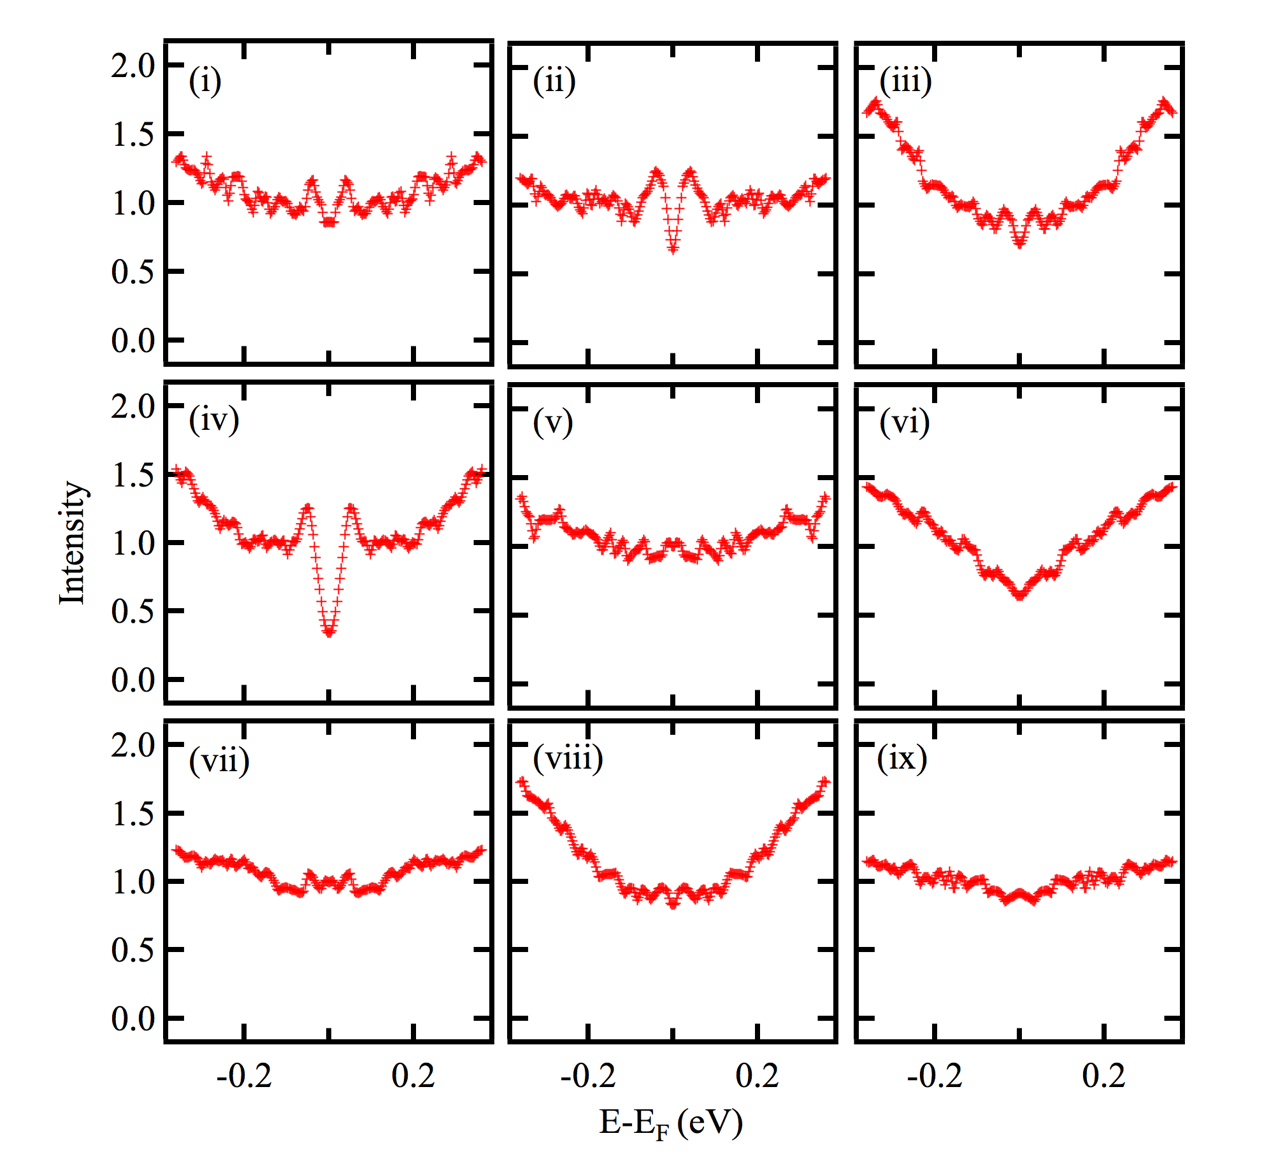
FIG S1 (i)-(ix) Symmetrized EDC spectra across k_{F} of each position of ARPES measurements in the 300 x 300 μm² array with a step size of 100 μm in x and y directions (i.e., 3 × 3 grid).

Figure S2 illustrate the symmetrized EDC of ARPES spectra across k_{F} of nano-HOPG(i), HOPG surface(ii), and Au(iii). This data were measured by using 60 eV of photon energy at the beamline 5-4, Stanford Synchrotron Radiation Lightsource, in the USA.
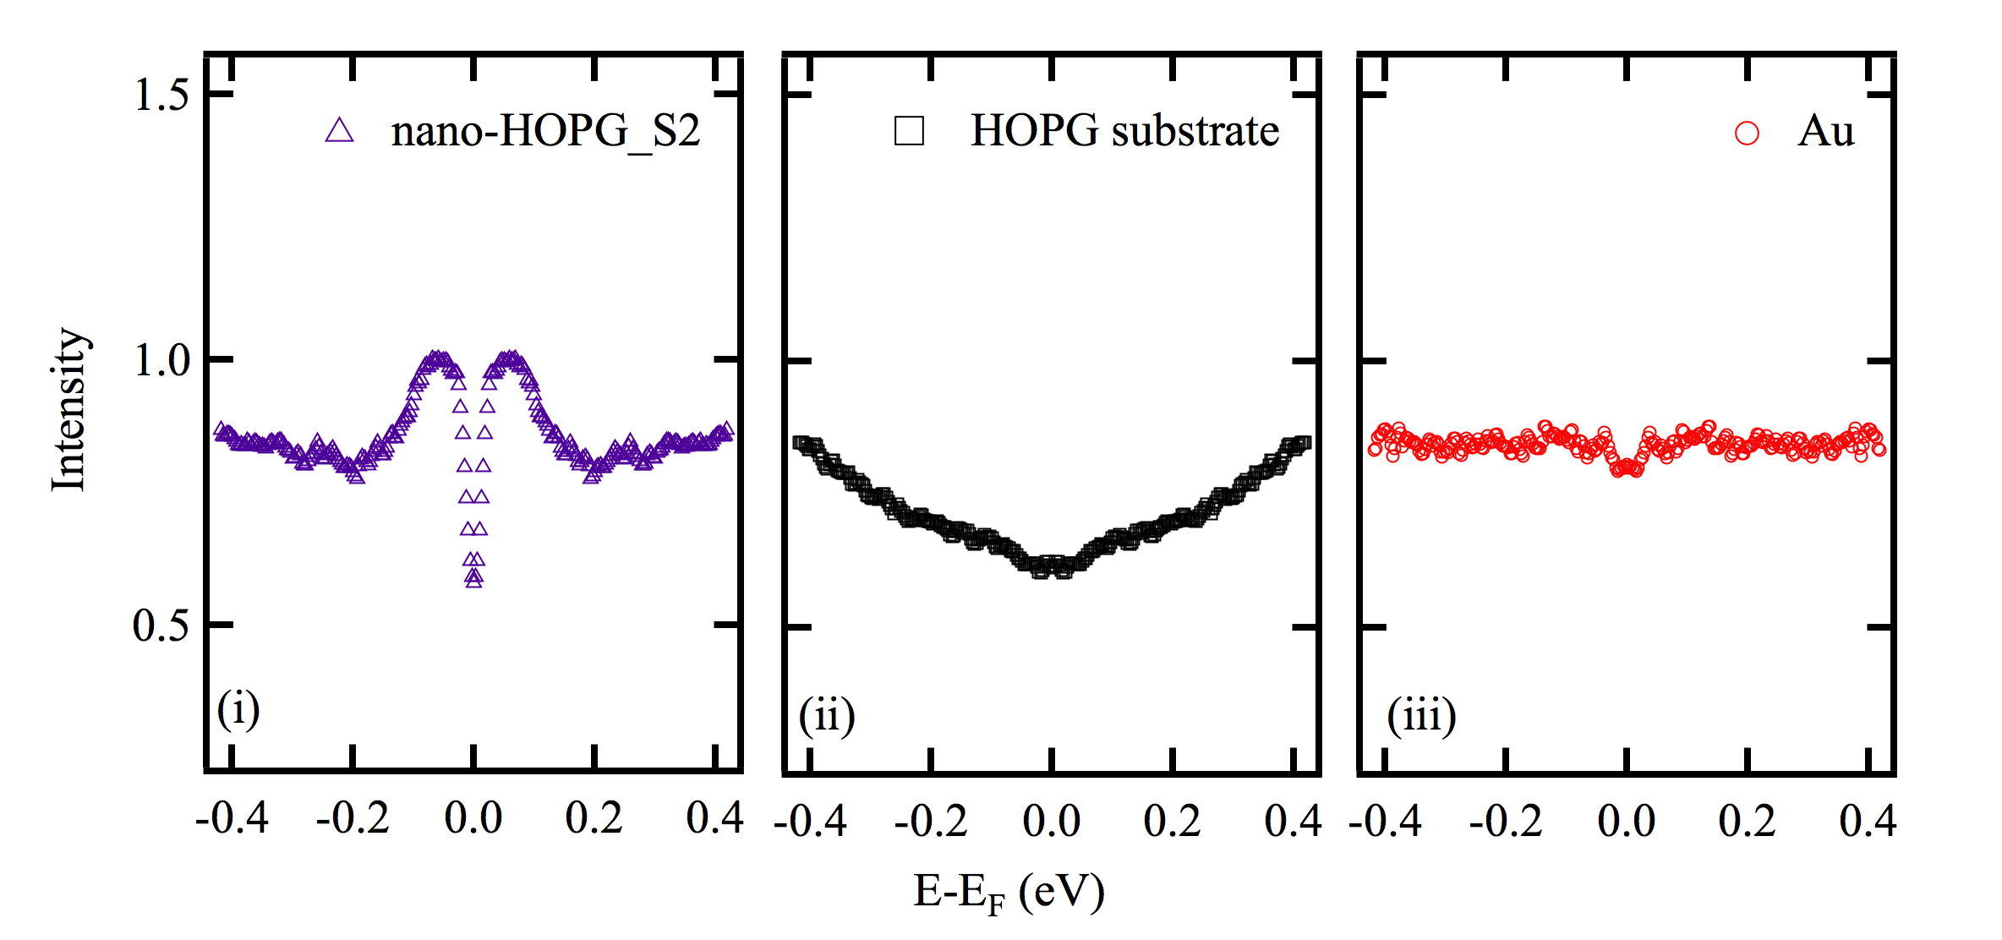
FIG S2 ARPES measurements at Stanford Synchrotron Radiation Lightsource, beamline 5-4, (i)-(iii) symmetrized EDC spectra across k_{F} of ARPES spectra of nano-HOPG, HOPG substrate, and Au respectively.

From ARPES measurement, we have observed the gap opening using different photon energies (i.e. at different k_{z}) as shown in Figure S3 below 60 eV (FIGs S3a–S3d) and 95 eV (FIGs S3e–S3h). By using DFT to calculate the band along k_{z} direction of the 1.1% biaxial tensile strain on three layers of graphene (see Figure S4), the dispersion clearly shows no gap closing at all k points. From the ARPES data at different k_{z} and the DFT calculation, it suggests that the observed gap opening happens through the Brillouin zone along kz. Note that the same behavior along k_{z} is also observed in the similar system MoS₂ ¹.
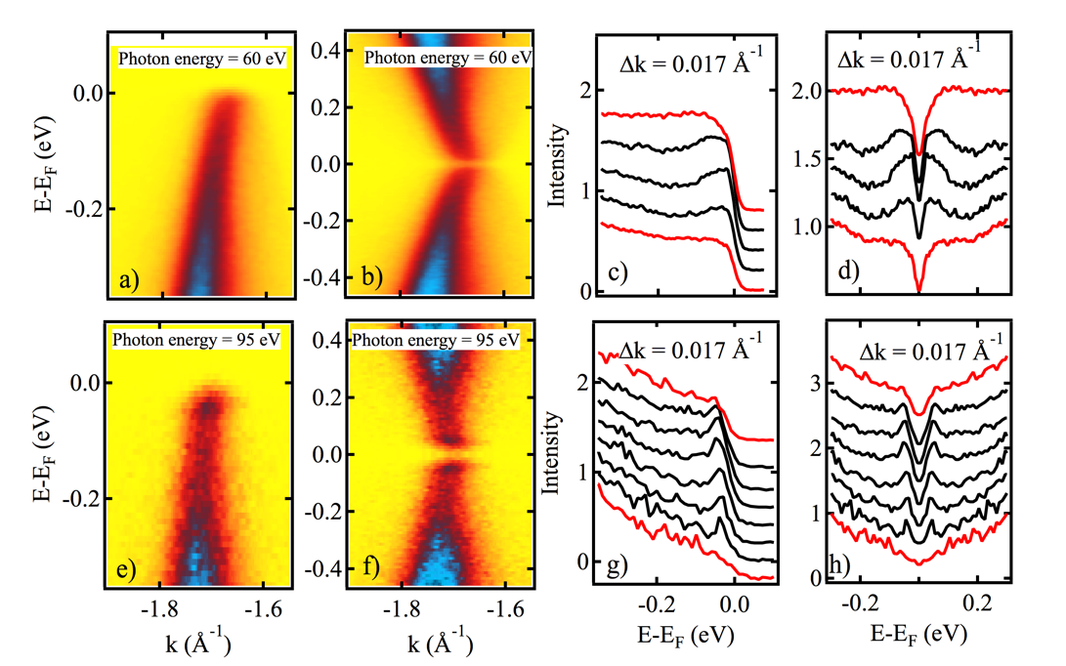
FIG S3 ARPES spectra of nano HOPG that was measured at 60 eV (a) and 95 eV (e). The symmetrized ARPES spectra of (a) and (e) are shown in (b) and (f), respectively. EDC spectra near kF of (a) and (e) in (c) and (g), respectively. EDC spectra near kF of (b) and (f) are shown in (d) and (h), respectively.
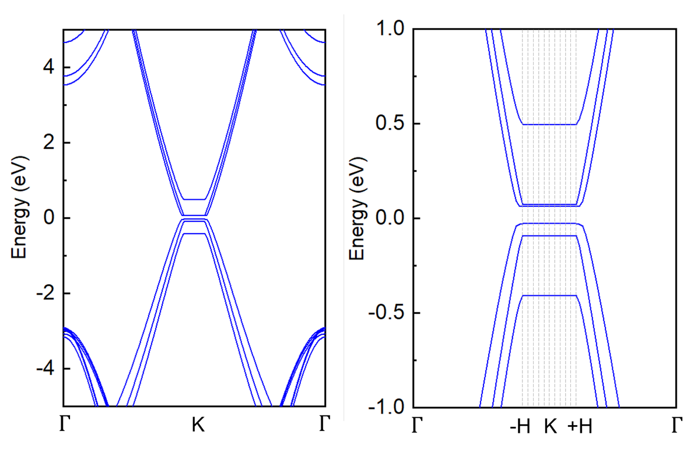
FIG S4 Band structure of three layers graphene with 1.1 % of biaxial tensile strain

Reference:
1. Kim, B. S.; Rhim, J. W.; Kim, B.; Kim, C.; and Park, S. R. Determination of the band parameters of bulk 2H-MX₂ (M= Mo, W; X= S, Se) by angle-resolved photoemission spectroscopy. Scientific Reports 6, 1-7 (2016)

