Genomic adaptation to extreme climate conditions in beef cattle as a consequence of cross-breeding program

Rugang Tian^{1*†}, Hojjat Asadollahpour Nanaie^{2†}, Xiao Wang¹, Meng Zhao¹, Fenf Wang¹, Hui Li¹，Ding Yang¹, Hao Zhang¹, SuFan Li¹, Yuan Li¹, Tu Luan³
¹Institute of Animal Husbandry, Inner Mongolia Academy of Agricultural & Animal Husbandry Sciences, Hohhot, 010031, China
²Key Laboratory of Animal Genetics, Breeding and Reproduction of Shaanxi Province, College of Animal Science and Technology, Northwest A&F University, Yangling 712100, China
³Faculty of Biosciences, Norwegian University of Life Sciences
†These authors contributed equally to this work.
*Corresponding author:
Prof. Rugang Tian
E-mail: tiannky@163.com
Phone: +86 15124784023

Fig. S1: Cattle breeds used in this study. The figure was designed by the first author.

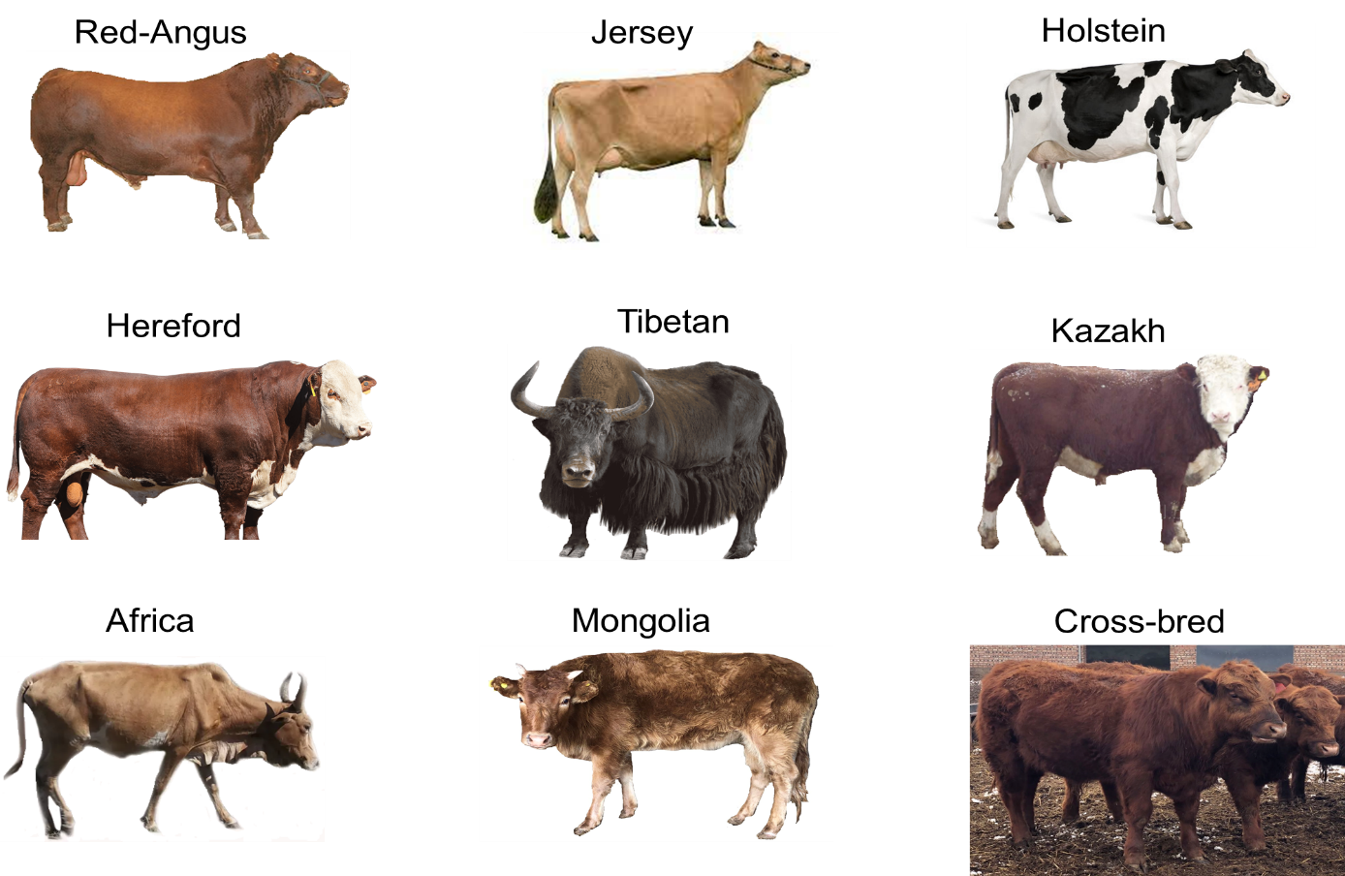

Fig. S2: Cross validation error (CV) plot from ADMIXTURE.
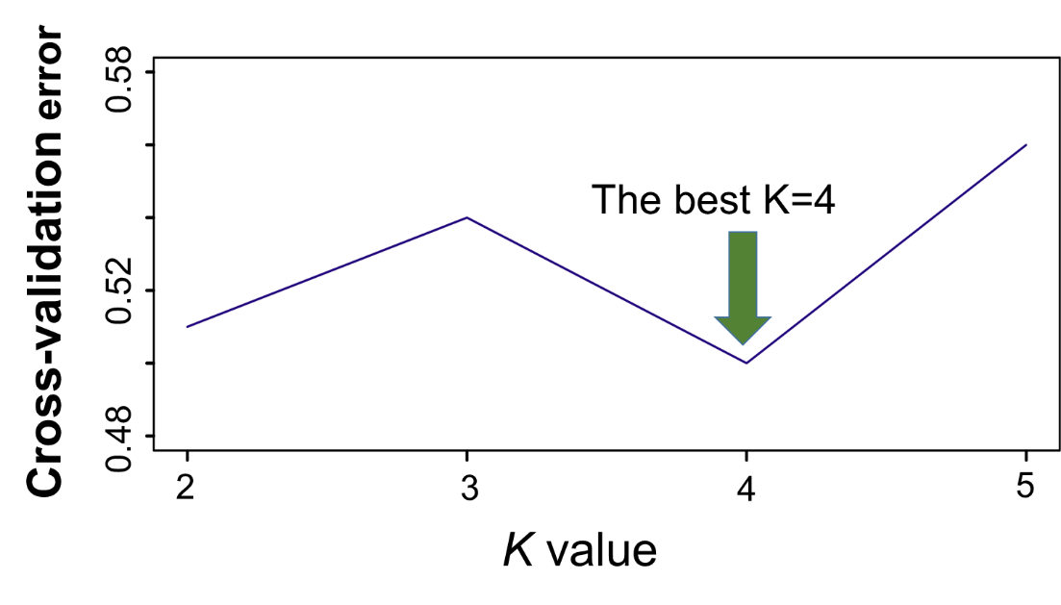
Fig. S3. The heat map of ChromoPainter’s coancestry matrix. The African individuals (red box) show lower haplotype sharing with other world-wide cattle groups.

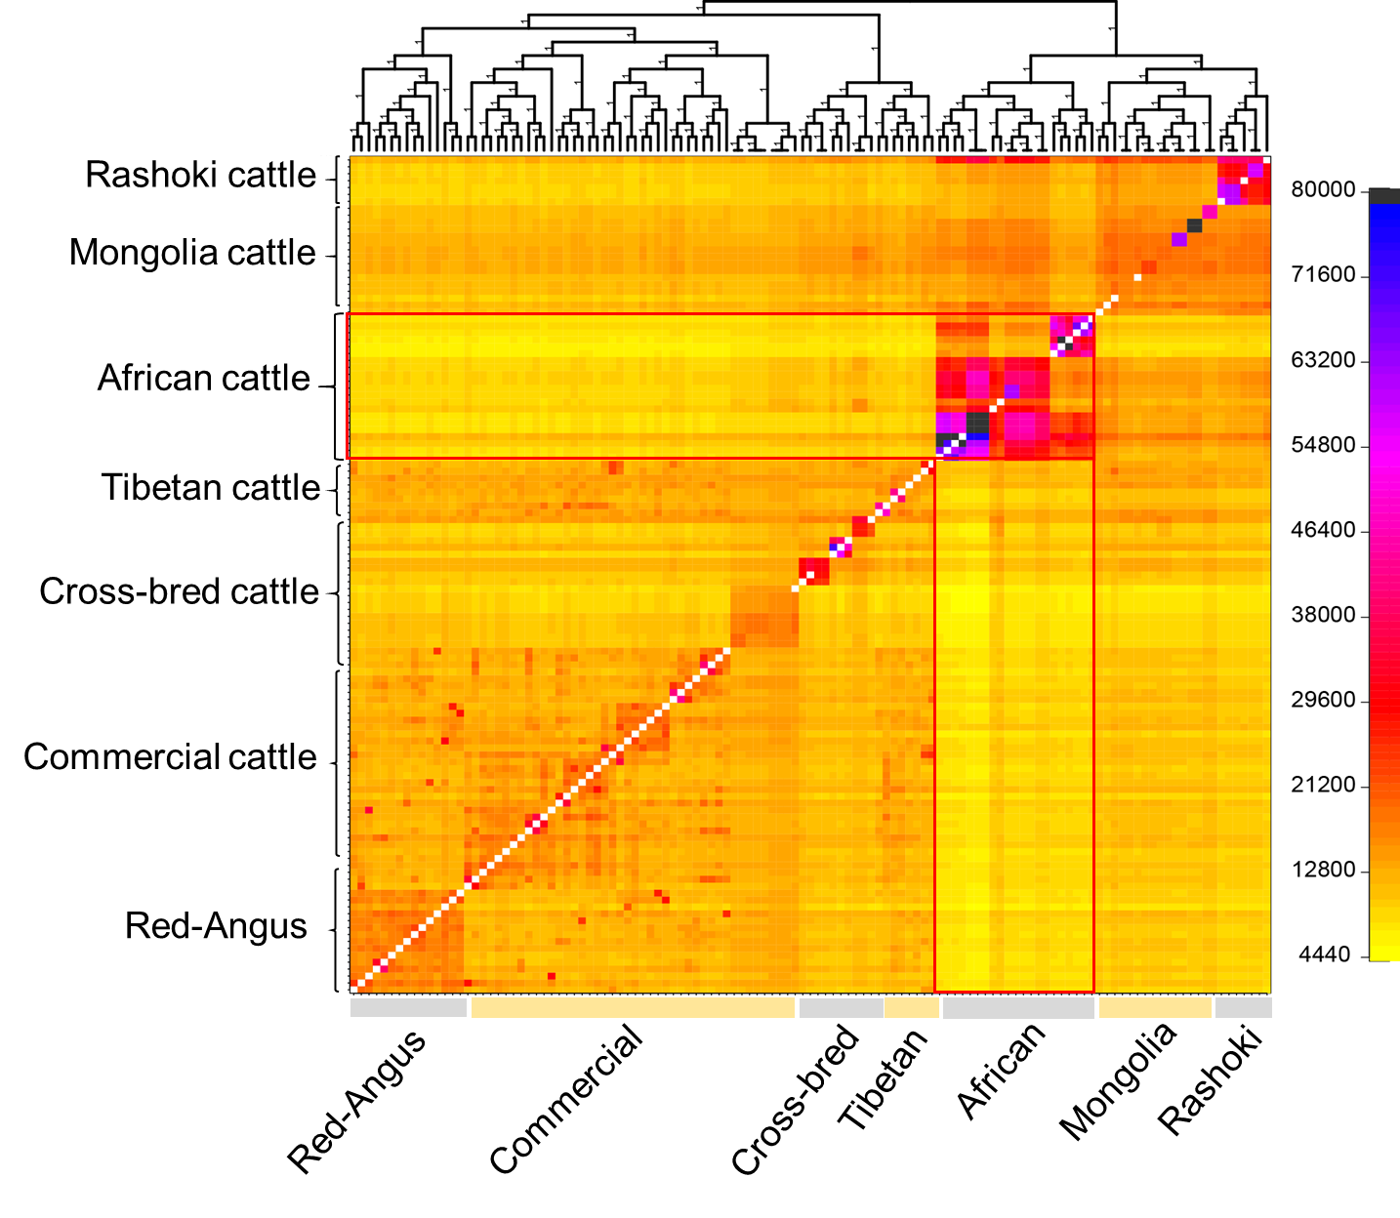

Fig. S4. The decay of linkage disequilibrium (LD) estimated as the squared correlation coefficient by pairwise physical distance in cattle populations.

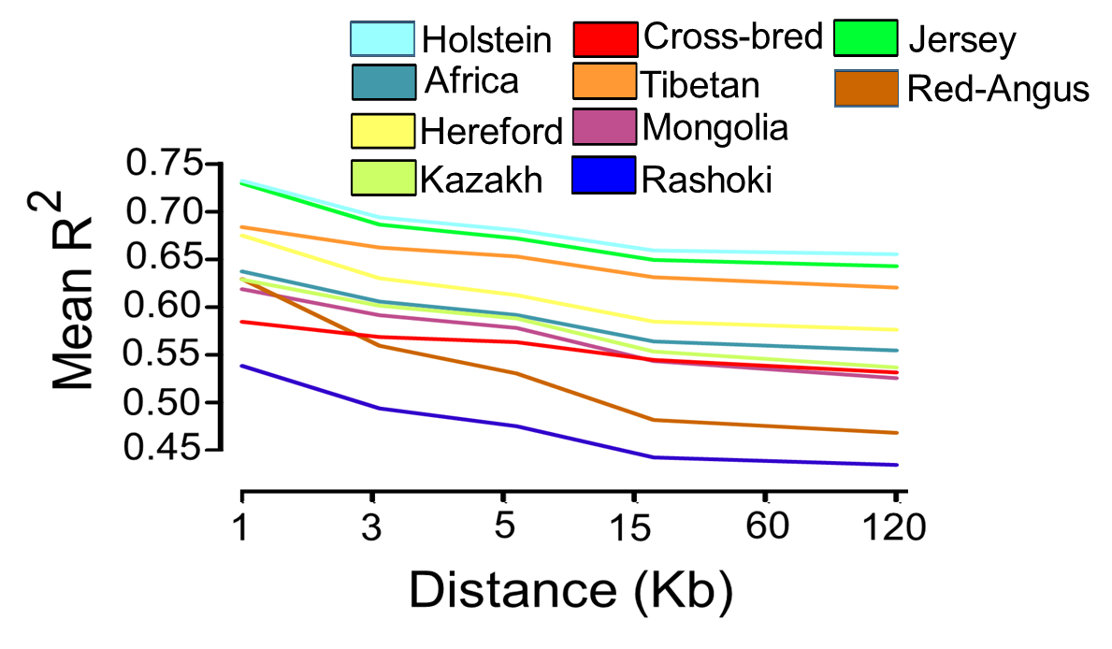

Fig. S5. Inbreeding coefficient (F) for different cattle populations in this study.
