Dopamine-Modified Hyaluronic Acid (DA-HA) As A Novel Dopamine-Mimetics With Minimal Autoxidation And Cytotoxicity

Sunpil Kim^{1,2,†}, Ye-Ji Kim^{3,4,†}, Kyoung Hwan Park^{5,6}, Kang Moo Huh⁵, Sun-Woong Kang^{3,6}, C. Justin Lee^{1,2,*}, Dong Ho Woo^{3,4,*}

¹ KU-KIST Graduate School of Converging Science and Technology, Korea University, Seoul 02841, South Korea, ² Center for Cognition and Sociality, Cognitive Glioscience Group, Institute for Basic Science, Daejeon 34126, South Korea,³ Human and Environmental Toxicology, University of Science and Technology, Daejeon 34114, South Korea,⁴ Department of Advanced Toxicology Research, Korea Institute of Toxicology, KRICT, Daejeon 34114, South Korea, ⁵ De partment of Polymer Science and Engineering, Chungnam National University, Daejeon 34134, South Korea,⁶ Research Group for Biomimetic Advanced Technology, Korea Institute of Toxicology (KIT), KRICT, Daejeon 34114, South Korea

Keywords: Dopamine-Modified Hyaluronic Acid (DA-HA), dopamine (DA), DA-induced cytotoxicity, autoxidation, and 6-OHDA-induced mouse model of Parkinson’s disease.
† these are equally contributed
* Correspondence

To whom correspondence should be addressed:
Changjoon Justin Lee, Ph.D.
Center for Cognition and Sociality, Cognitive Glioscience Group,
Institute for Basic Science, Daejeon 34126, South Korea.
TEL: + 82-42-878-9150, FAX: + 82-42-878-9151
E-mail: cjl@ibs.re.kr
Dong Ho Woo, Ph.D.
Department of Advanced Toxicology Research,
Korea Institute of Toxicology, KRICT, Daejeon 34114, South Korea.
TEL: +82-42-610-8243, FAX: +82-42-610-8252
E-mail: dongho.woo@kitox.re.kr

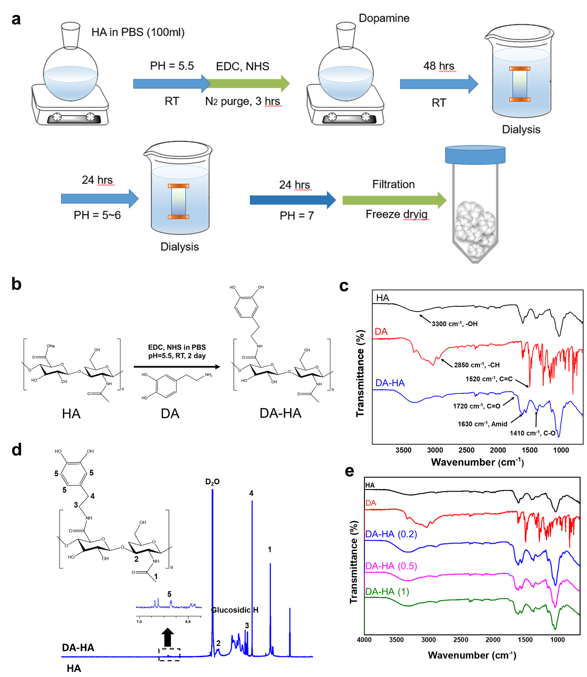
Fig. S1 The process of synthesis and characterization of DA-HA. a The process of synthesis of DA-HA. b Schematic representation of DA-HA. c Protein conformation of HA (black), DA (red), and DA-HA (blue) is analyzed by ATR-FTIR spectra. d The structures of HA and DA-HA were analyzed by H-NMR spectra. e ATR-FTIR spectra of HA, DA, 0.2 DA-HA, 0.5 DA-HA, and 1 DA-HA.

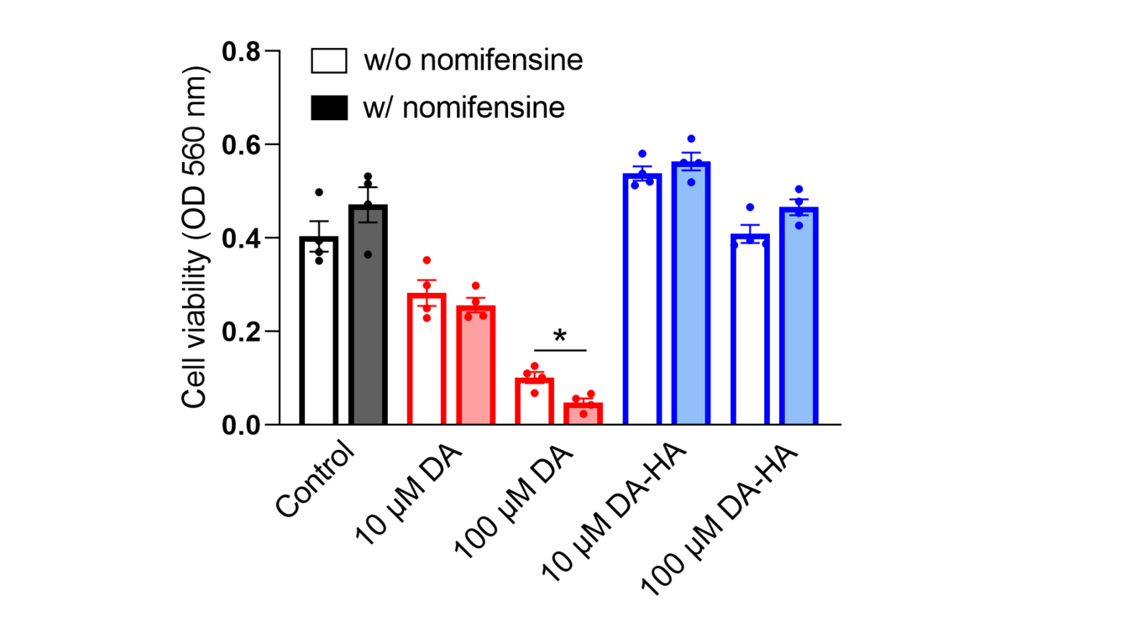
Fig. S2 Intracellular ROS does not contribute to DA-induced neurotoxicity. Summary bar graph of cell viability with and without 10 µM nomifensine, a DA transporter (DAT) inhibitor, in the presence of 10 µM DA, 100 µM DA, 10 µM DA-HA, and 100 µM DA-HA for 7 days. At 10 µM DA, nomifensine shows no neurotoxic effect. At 100 µM DA, nomifensine even exacerbates neurotoxicity, indicating that intracellular ROS does not contribute to DA-induced neurotoxicity. Paired t-test. *p < 0.05.
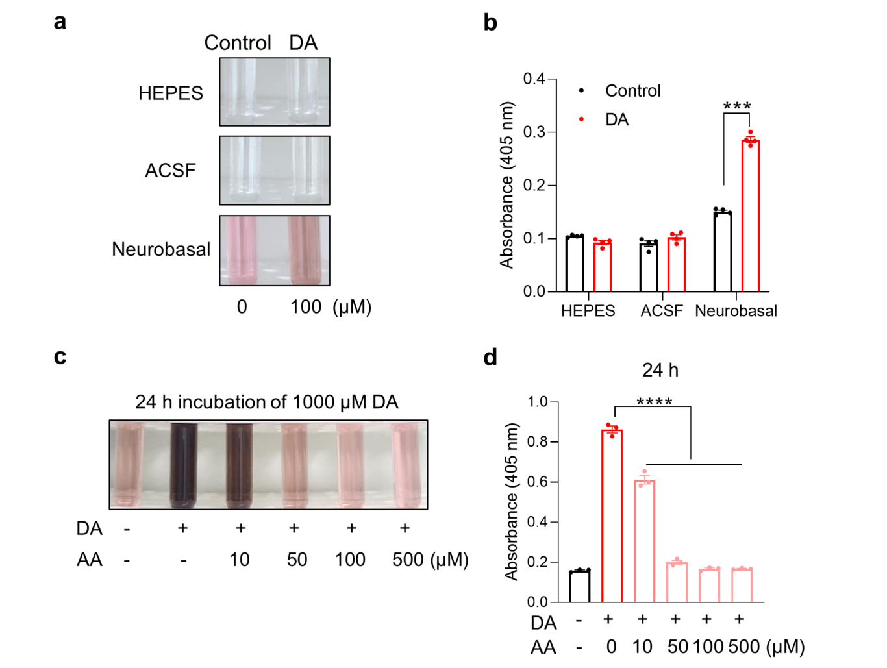
Fig. S3 Detection of ascorbic acid-sensitive autoxidation in culture media. a Photopraph of DA autoxidation in various media. Neurobasal media was suitable for visualizing the autoxidation level of 100 µM DA. b Summary bar graph of the level of DA autoxidation in HEPES, ACSF buffer, and neurobasal media (n = 4 for each condition). Unpaired t-test. Control vs DA in neurobasal condition, ***p < 0.001. c Representative photographs of dose-dependency of ascorbic acid (AA) on the autoxidation of 1000 µM DA. d Autoxidation of 1000 µM DA with a dose-dependency of AA for 24-h incubation (n = 3 for each condition). One-way ANOVA, F(5, 12) = 601.6, p < 0.0001; 0 vs 10, 0 vs 50, 0 vs 100, and 0 vs 500 µM AA, ****p < 0.0001. Dunnett’s multiple comparisons test for d.

Supplementary figures
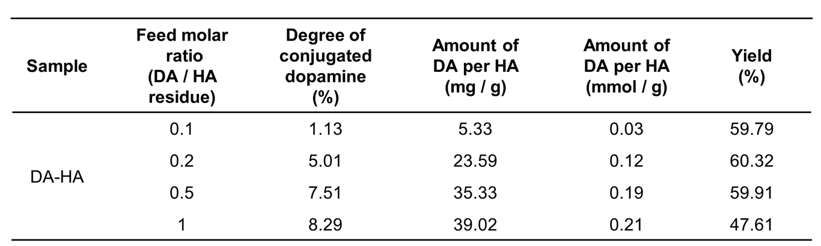
Table. 1 Result of the feed molar ratio DA and HA from the synthesis of DA-HA.

