Supporting information

Optimizing variant-specific therapeutic SARS-CoV-2 decoys using deep-learning-guided molecular dynamic simulations.

Katharina Köchl^{1,2}, Tobias Schopper¹, Vedat Durmaz¹, Lena Parigger¹, Amit Singh^{1,3},
Andreas Krassnigg¹, Marco Cespugli¹, Wei Wu⁴, Xiaoli Yang⁴, Yanchong Zhang⁴,
Welson Wen-Shang Wang⁴, Crystal Selluski⁴, Tiehan Zhao⁴, Xin Zhang⁴, Caihong Bai⁴, Leon Lin⁴, Yuxiang Hu⁴, Zhiwei Xie⁴, Zaihui Zhang⁴, Jun Yan⁴, Kurt Zatloukal⁵, Karl Gruber^{1,3,6},
Georg Steinkellner^{1,3*} & Christian C. Gruber^{1,2,3,6*}

¹Innophore GmbH, 8010, Graz, Austria
²Austrian Centre of Industrial Biotechnology, 8010, Graz, Austria
³Institute of Molecular Bioscience, University of Graz, 8010, Graz, Austria
⁴SignalChem Lifesciences Corp., 110-13120 Vanier Place, Richmond, BC V6V 2J2, Canada
⁵Diagnostic- and Research Center for Molecular Biomedicine, Institute of Pathology, Medical University of Graz, 8010, Graz, Austria
⁶Field of Excellence BioHealth - University of Graz, 8010, Graz, Austria
*Correspondence should be addressed to (christian.gruber@innophore.com or georg.steinkellner@innophore.com)

Artificial Neural Network.
Motivation.
We employed the ANN to predict new viable hACE2 candidates. Since randomly searching through the entire mutation landscape using molecular-dynamics simulations is computationally infeasible, the binding affinities of all possible single-point mutants of the wildtype-hACE2 were predicted by the ANN, of which the most promising candidates were then analyzed via the empirical scoring function.
Training the ANN for hACE2 candidate pre-selection.
The validation set for the experiments was chosen to be any combination containing hACE2 variants with the amino-acid exchanges T27Y and L79T. This results in a set of 70 combinations, and includes the three best-performing samples, which contain the two highest-affinity hACE2 variants “T27Y, L79T, N330Y, K31W” and “T27Y, L79T, K31W”, leaving the lowest ΔG values in the training set at -67.1 kJ/mol. Using this validation set to learn how the ANN behaves when shown out-of-distribution values of ΔG, the model training was stopped when the validation loss was minimal, under the requirement that all high-performers were assigned ΔG values lower than -60 kJ/mol.
This approach was chosen since this way the network was trained so that it would have been able to predict the current highest-affinity hACE2 mutation without having seen them during training.
Results
Out of all single-point hACE2 mutants, the ANN only found five values with ΔG values lower than -60 kJ/mol. For ΔG values lower than -59 kJ/mol it found nine, for ΔG values lower than -58 kJ/mol, 18 candidates were found. The candidates with ΔG values < -60 kJ/mol successfully gave three new hACE2 mutations with values < -63 kJ/mol, one of which (K31E) even reached state-of-the art performance of -71 kJ/mol. Note that the previous highest-affinity hACE2 mutant was built using four amino-acid exchanges, versus just a single one in this case.
Fig. S1 shows the distribution of the obtained MD results in dependence of the ANN prediction, and shows a clear trend towards higher MD affinities for higher predictions.
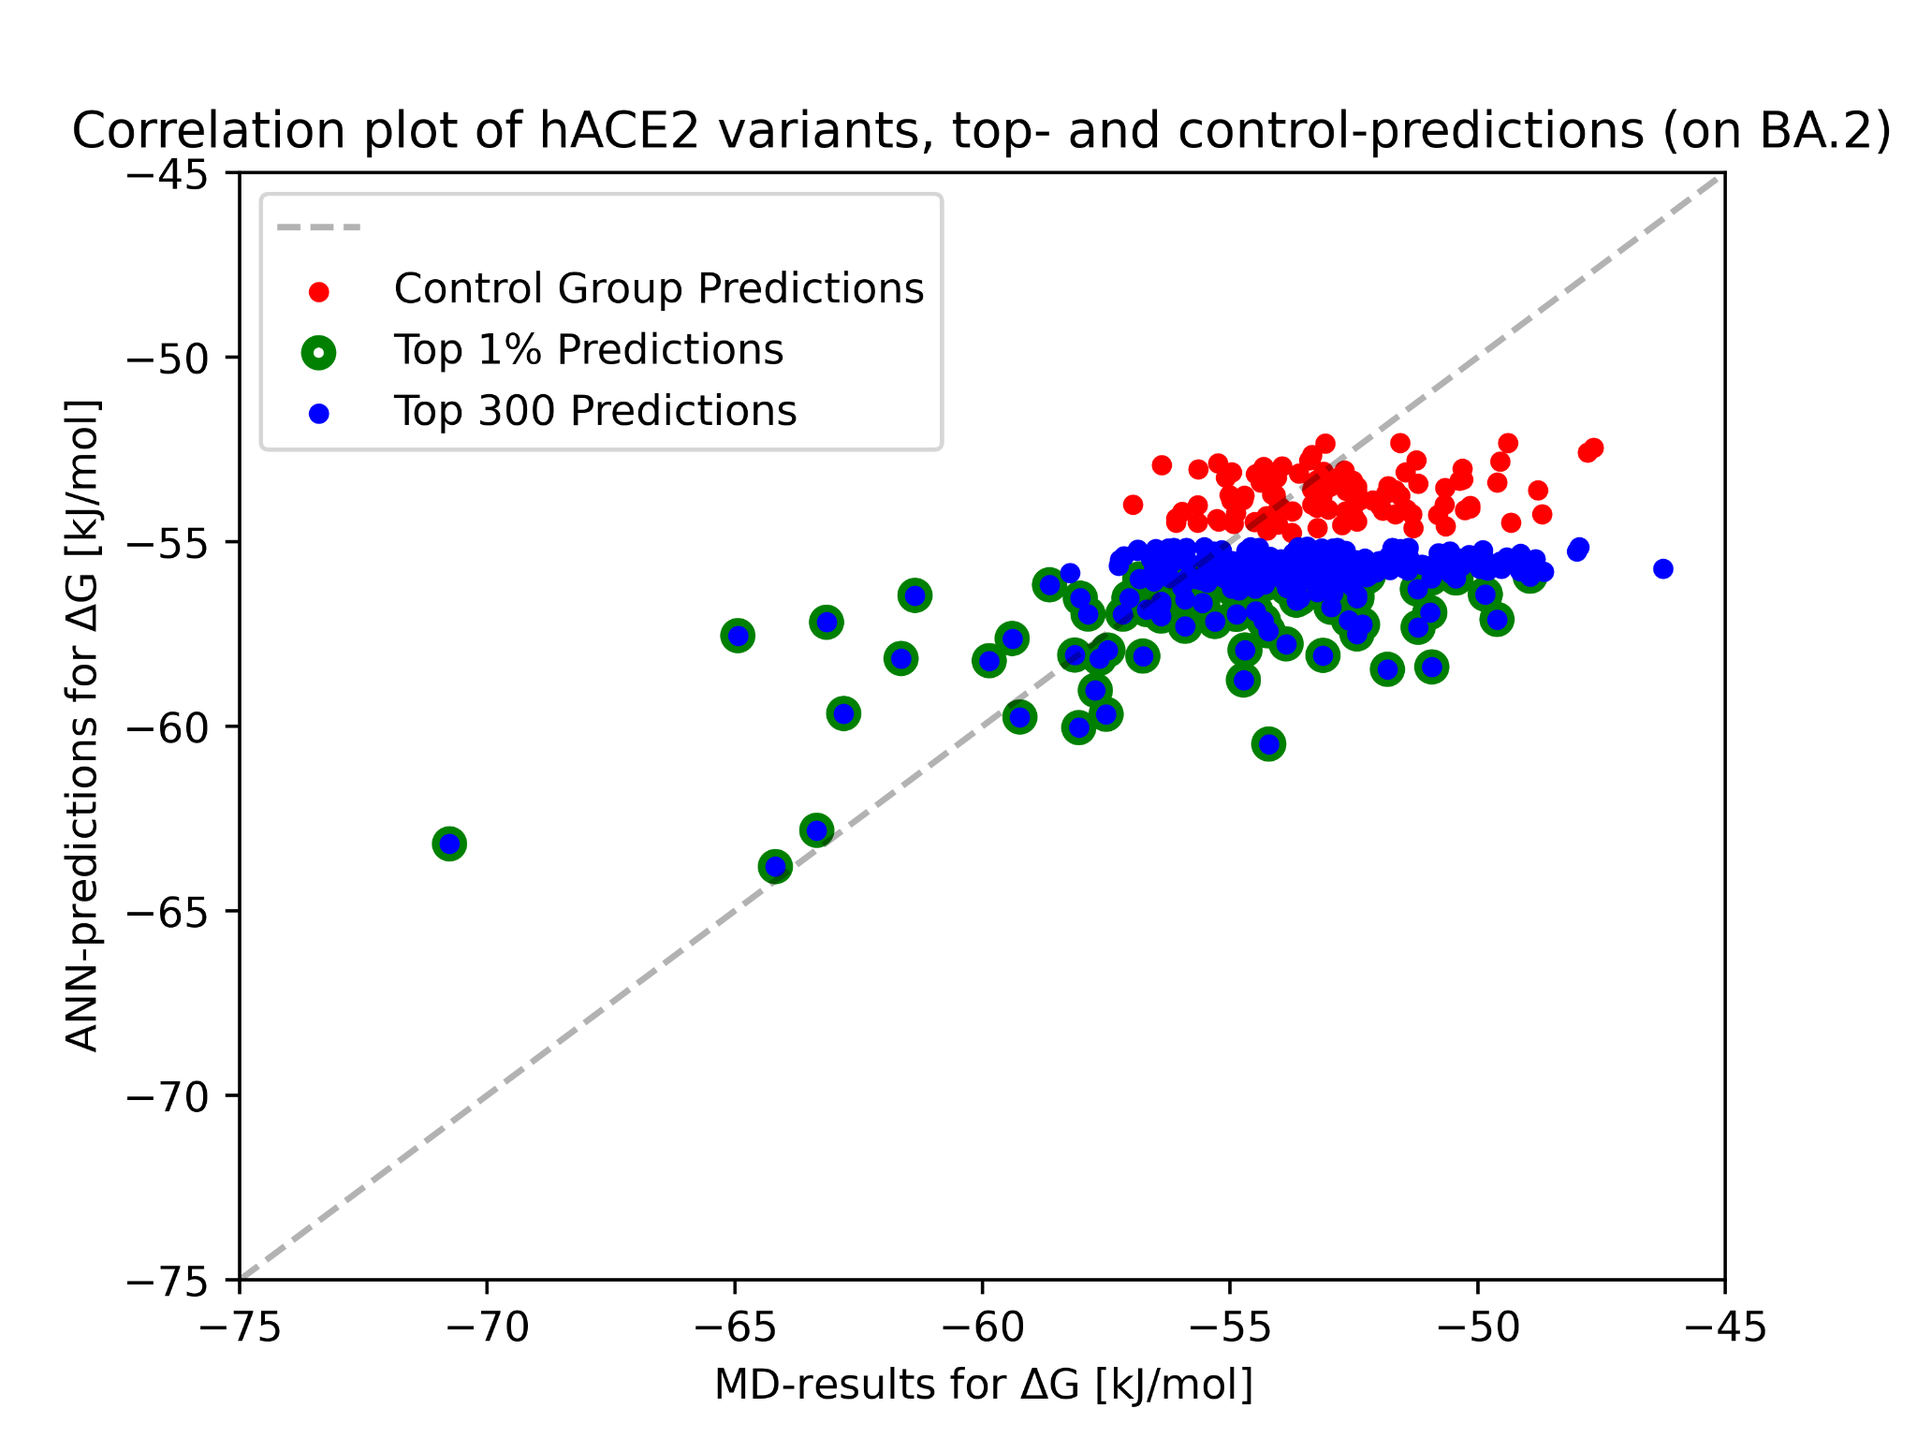
Fig. S1 | Correlation-plot between ANN predictions and MD-results for single-point hACE2 mutants. The control group shows 100 randomly sampled single-point amino-acid exchanges from all possible single-point mutations. Blue points indicate the 300 highest affinities predicted by the ANN from all single-point variants, green outlines indicate that points belong to the top 1% (110) of ANN predictions.

Table S1 | Detailed composition of the initial artificial neural network training-set.
 | RBD Mutations | Count | ACE2 Mutations | Count
 | 0-5 Mutations | 621 | 1 Mutation | 120
 | 6-10 Mutations | 187 | 2 Mutations | 15
 | 10-15 Mutations | 176 | 3 Mutations | 30
 | 15 - 20 Mutations | 64 | 4 Mutations | 35
 | 28 Mutations | 1 | 5 Mutations | 5
 | —- | —- | Wild type | 844

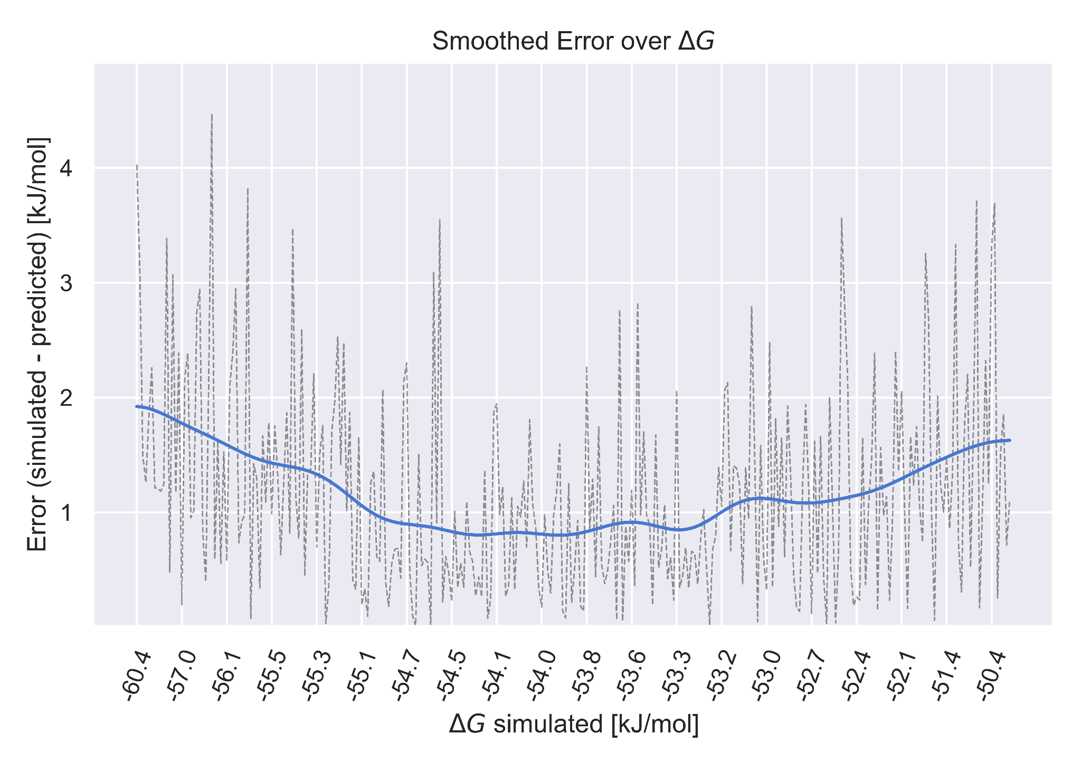
Fig. S2 | Qualitative representation of model error dependence on Gibbs free-energy values (ΔG) from the MD simulations.
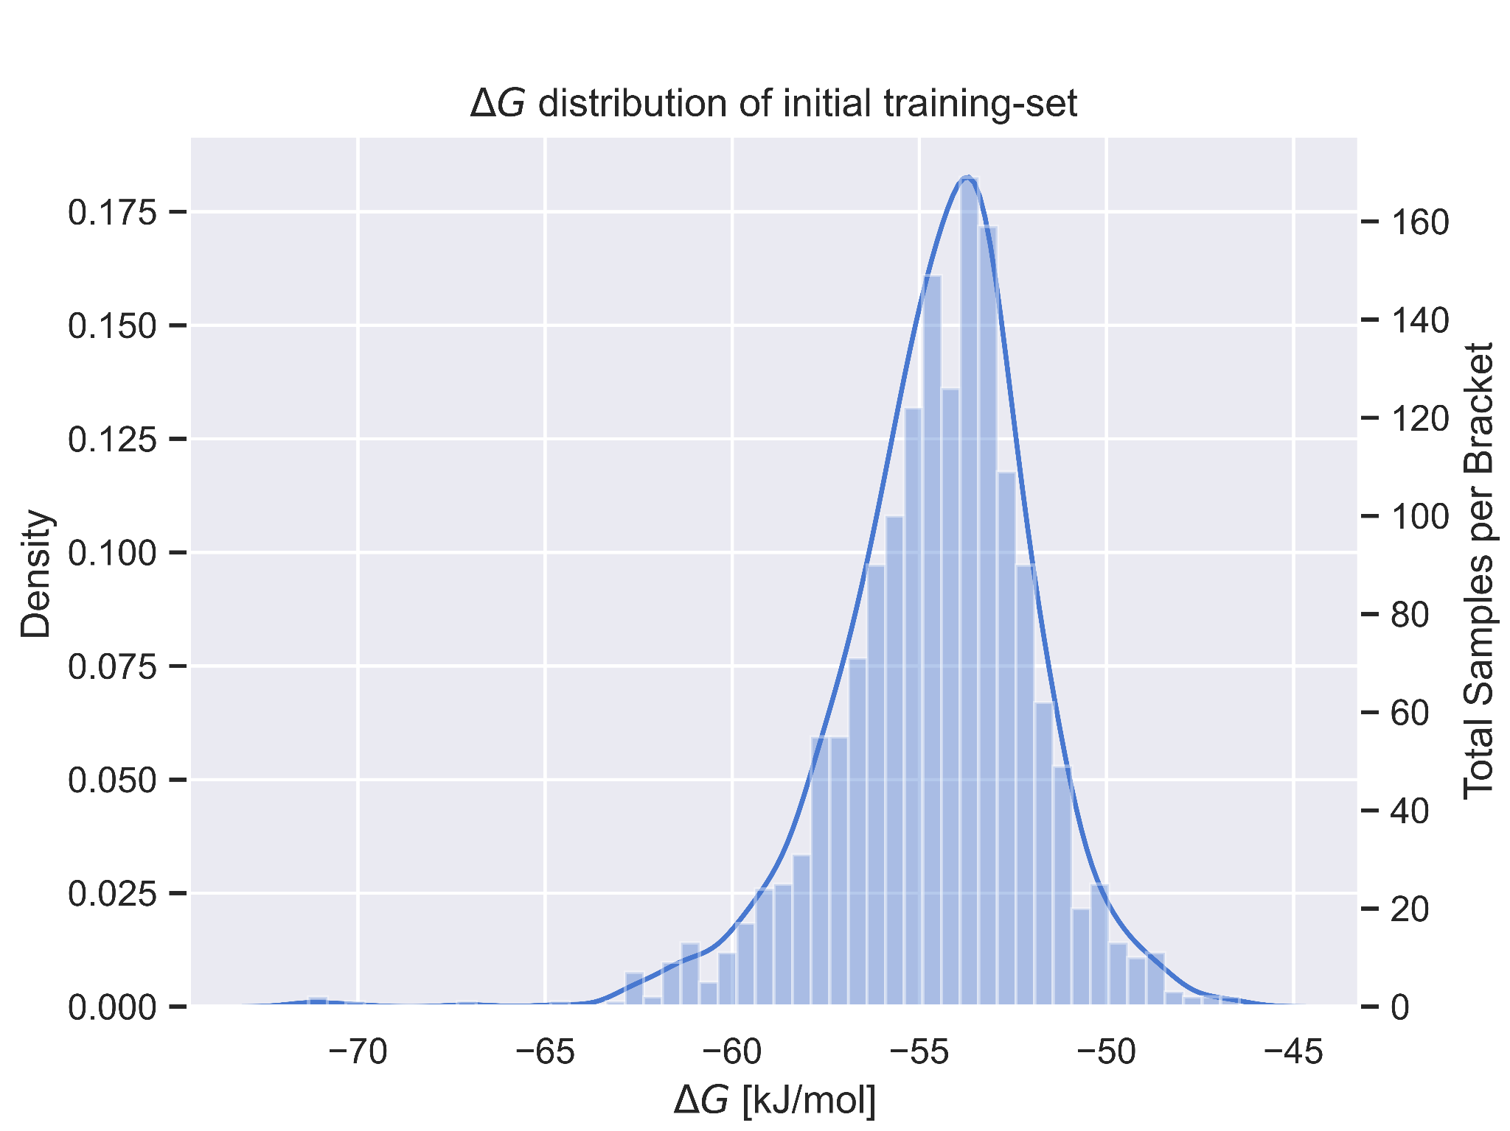
Fig. S3 | Gibbs free-energy value (ΔG) distribution of the entire training set. Strong binders with energies <-65 kJ/mol and weak binders with energies >-45 kJ/mol are severely underrepresented, yet the model still produces accurate predictions.

Network Input Data.
The input channels were decided on to be the following set of properties:
- “e” representing the electric field
- “A” : representing the force-field experienced by aromatics
- “HP” : The hydrophobicity-field
- “HD” : Hydrogen-bond donor field
- “d” : Desolvation field
- "I" : Iodine field
- “BF”: Flexibility field
- “NA”: Nitrogen as H-bond acceptor field
Halos only depend on surface geometry and are independent of the exact underlying structure of their respective proteins, which allows the ANN to be agnostic to the protein-structure. Fig. S4 shows an example set of Halos. To see their relation to the protein structure, we refer to Fig. 2.
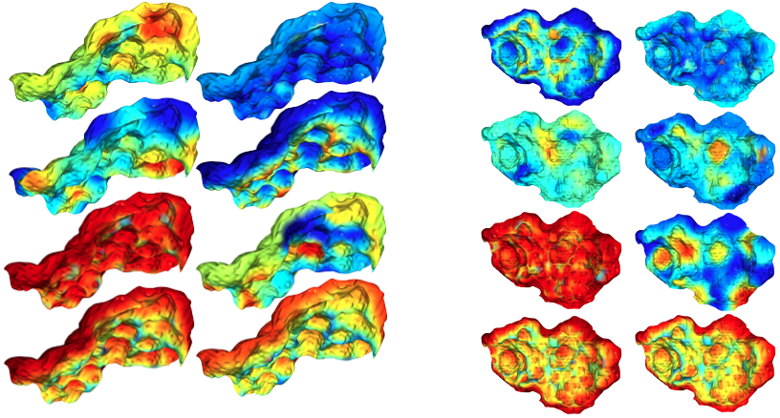
Fig. S4 | Example Halos of the eight input-channels for hACE2 (left) and RBD (right) rendered in Open3D. First column, from top to bottom: electrostatics (e), hydrophobicity (HP), hydrogen-bond donor (HD), nitrogen as hydrogen-bond acceptor (NA). Second column, from top to bottom: Iodine (I), desolvation field (d), flexibility/uncertainty field (BF), aromaticity (A).

This decision was made by correlation studies independent from the present work, deciding on this set of eight largely uncorrelated features. Preliminary ablation studies have shown that, if each property is used separately one by one, the hydrophobicity field has the strongest predictive power, outperforming all others by 0.1 to 0.15 kJ/mol validation error. On the other hand, all of the eight channels alone are sufficient to produce meaningful predictions, with the “nitrogen as H-bond acceptor” field, which for hACE2 and RBD Halos seems to correlate mainly with their depth-profile perpendicular to the attachment plane, exhibiting unstable and slow training as well as worse convergence on validation metrics, suggesting that the surface geometry alone is important but not sufficient. The best performing combination of fields evaluated for the prediction of new hACE2 variants has been determined to be, in descending order of importance:
- Hydrophobicity field
- Hydrogen-bond donor field
- Aromatic field
- Electric field
The voxelized Halos were padded to a size of 36x38x33 voxels, at a grid spacing of 1.4 Å between neighboring voxels. A visualization of the Halos for the properties listed above is shown in Fig. S4.

Network Regularization and Augmentation.
No explicit techniques for regularization were employed, only the implicit mechanisms induced by separated convolutions on the input Halos, as well as a channel-wise bottleneck in the last convolutional layer.
The data labels were augmented with an additive Gaussian-noise term with mean zero and variance 0.6 kJ/mol, which amounts to half of the uncertainty of the MD simulation itself. Furthermore, the MSE loss was again squared, leading to a stronger emphasis on rare outlier samples. This strategy was chosen over under- or oversampling to avoid memorizing outliers, as well as to keep retraining the network with the bulk of noisy samples, which adds an additional stochastic element to the loss landscape, avoiding the overfitting of common samples. Loss values under 0.5 kJ/mol were set to zero, as these deviations were not considered physically meaningful and did not need to be emphasized further during training.

MD-simulation.
Table S2 | Binding activities of wild-type hACE2-Fc and hACE2-Fc variants with immobilized recombinant SARS-CoV-2 spike protein RBD in the ELISA binding affinity assay and predicted Gibbs free binding energies (ΔG_{pred}) from the MD simulations. Binding half maximal effective concentration (EC₅₀) values were calculated using GraphPad prism. ΔG_{pred} values were predicted using the empirical scoring function (ESF).
 | hACE2 mutation | EC₅₀ (nM) | ΔG_{pred} (kJ/mol)
 | WT | 0.89 | -51.22
 | K31W | 0.16 | -58.01
 | N330Y | 0.24 | -54.08
 | T27Y, L79T, E35D | 0.14 | -59.43
 | T27Y, L79T, K31W | 0.11 | -60.32
 | T27Y, L79T, N330Y, E35D | 0.18 | -57.41
 | T27Y, L79T, N330Y, K31W | 0.12 | -55.91
 | T27Y, L79T, N330Y, N90E | 0.08 | -58.77
 | T27Y, L79T, N330Y, T92C | 0.12 | -59.61
 | T27Y, L79T, N330Y, T92C, E35D | 0.18 | -58.12
 | T27Y, L79T, N330Y, T92S | 0.14 | -61.06
 | T27Y, L79T, N90E | 0.17 | -57.35
 | T27Y, L79T, T92C | 0.15 | -57.20
 | T27Y, L79T, T92C, E35D | 0.11 | -57.53
 | T27Y, L79T, T92S | 0.22 | -55.72
 | T27Y, N330Y, A386L | 0.20 | -62.22
 | T92C, K31W | 0.30 | -57.12
 | L79R, Q24E | 2.04 | -51.66
 | N330R | 2.39 | -52.62
 | R393E | 0.78 | -56.18
 | L79Y | 0.62 | -54.67
 | T27Y, L79T, N330Y, A386L | 0.24 | -61.50
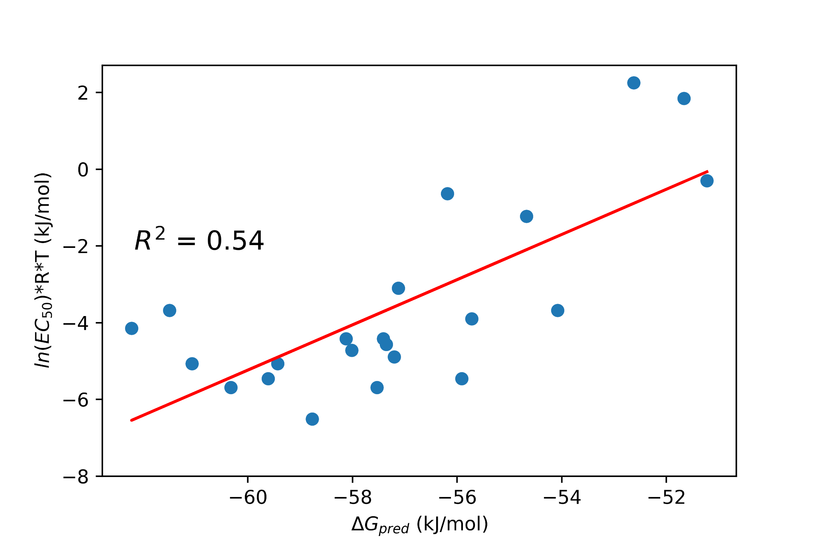
Fig. S5 | Validation of the empirical scoring function (ESF) results using an experimental half maximal effective concentration (EC₅₀) test set. To calculate the correlation between Gibbs free binding energies (ΔG_{pred}) and EC₅₀ values, logarithmic EC₅₀ values were adjusted under consideration of temperature (T) and the gas constant R.

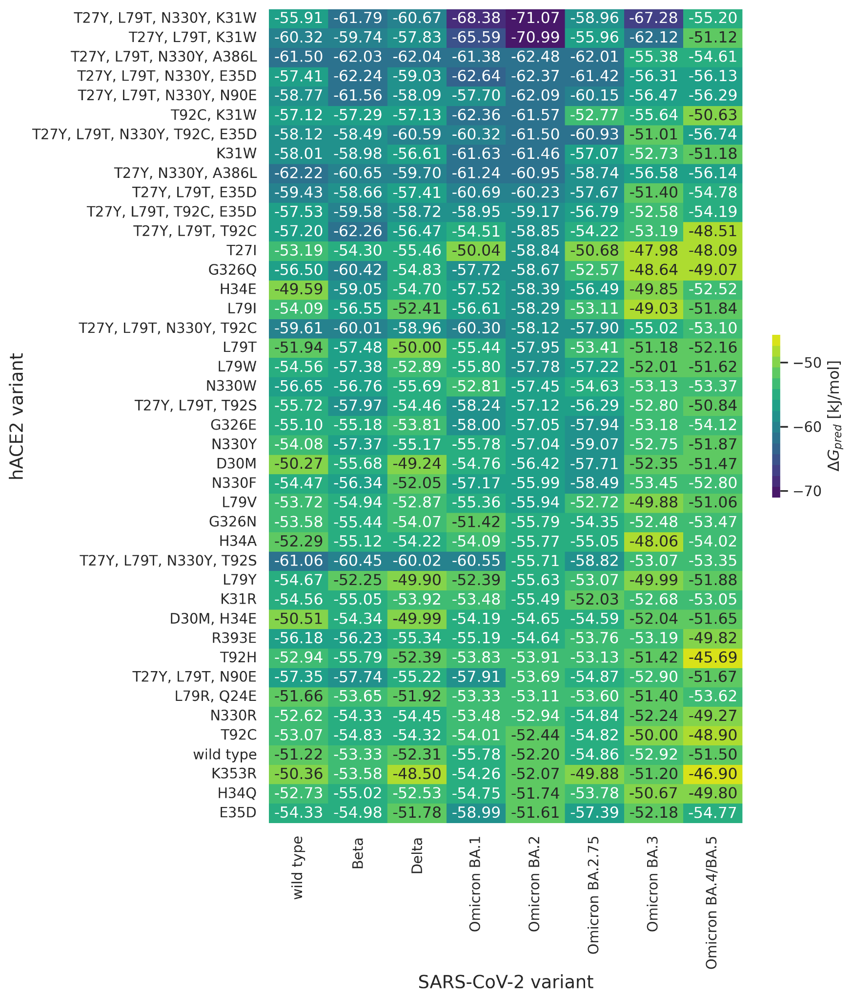
Fig. S6 | Preselection of hACE2 variants with Gibbs free energy predictions. hACE2 variants selected either by visual inspection, literature research or a combination of both with the goal to enhance the binding affinity between SARS-CoV-2 RBD and hACE2. Van der Waals (vdw) and electrostatic (elec) energies from the MD simulation in combination with optimal fitted weights (𝜔^{elec} = 0.024, 𝜔^{vdw} = 0.765) from the training set resulted in predicted Gibbs free energies (ΔG_{pred}).

SARS-CoV-2 neutralization assay.
a b c
SARS-CoV-2 wild type
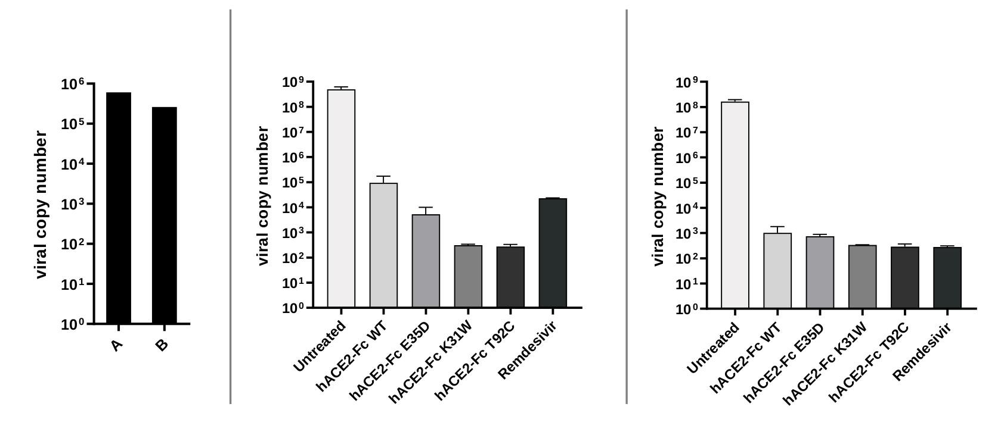

d e f
SARS-CoV-2 Beta
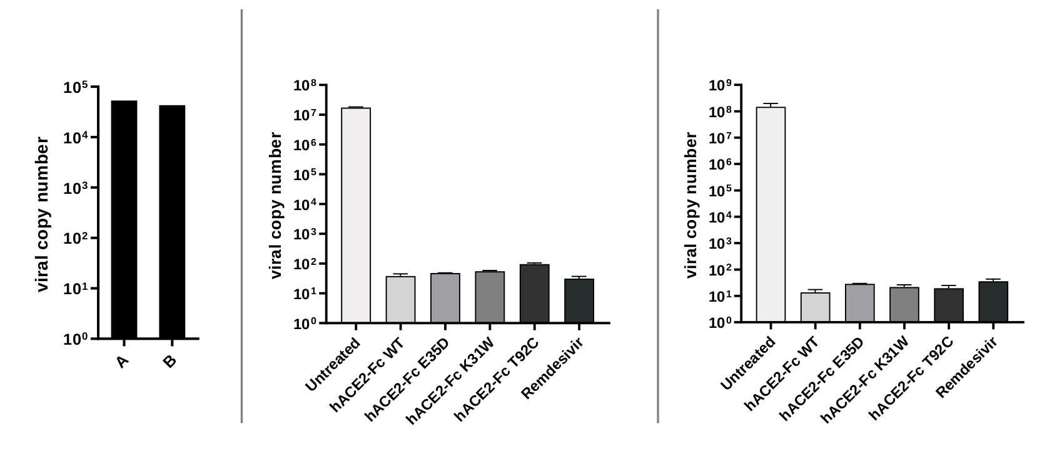
Fig. S7 | Inhibiting effect of hACE2-Fc wild type (hACE2-Fc WT) and three hACE2-Fc variants on SARS-CoV-2 (wild-type and Beta variant) infection. Each hACE2-Fc variant (25 μg/mL) was preincubated with SARS-CoV-2 (MOI: 0.0003) and then added to VeroE6 cells. Remdesivir (10 μM) treatment and infections without treatment (“Untreated”) served as controls. Supernatants (SN) were collected 48 h post-infection and RNA levels were analyzed by qRT-PCR. a, SARS-CoV-2 wild-type virus inputs for two independent experimental series, which led to the viral titers shown in b and c. SARS-CoV-2 Beta virus inputs for two independent experimental series are shown in d. The associated SN contained viral titres illustrated in e and f. qRT-PCR data are mean ± SEM of three replicates per tested condition.

