Supplemental Material:

Figure S1. Direct NK cell cytotoxicity of two deceased patients at the deterioration phase. Natural cytotoxicity is represented by the different E:T ratios of P1 and P2.

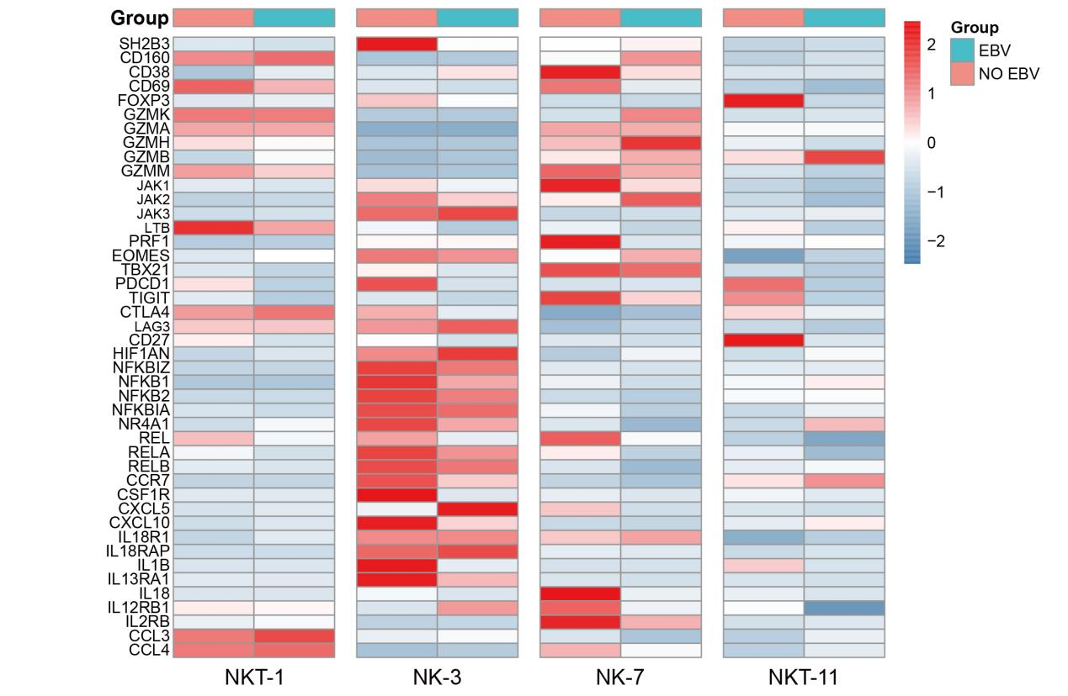
Figure S2. Comparison of the functionality and cytokines between EBV infected and noninfected cells through high-throughput single-cell RNA-seq. Expression of selected genes between EBV infected and noninfected NKT-1, NK-3, NK-7, and NKT-11 clusters.

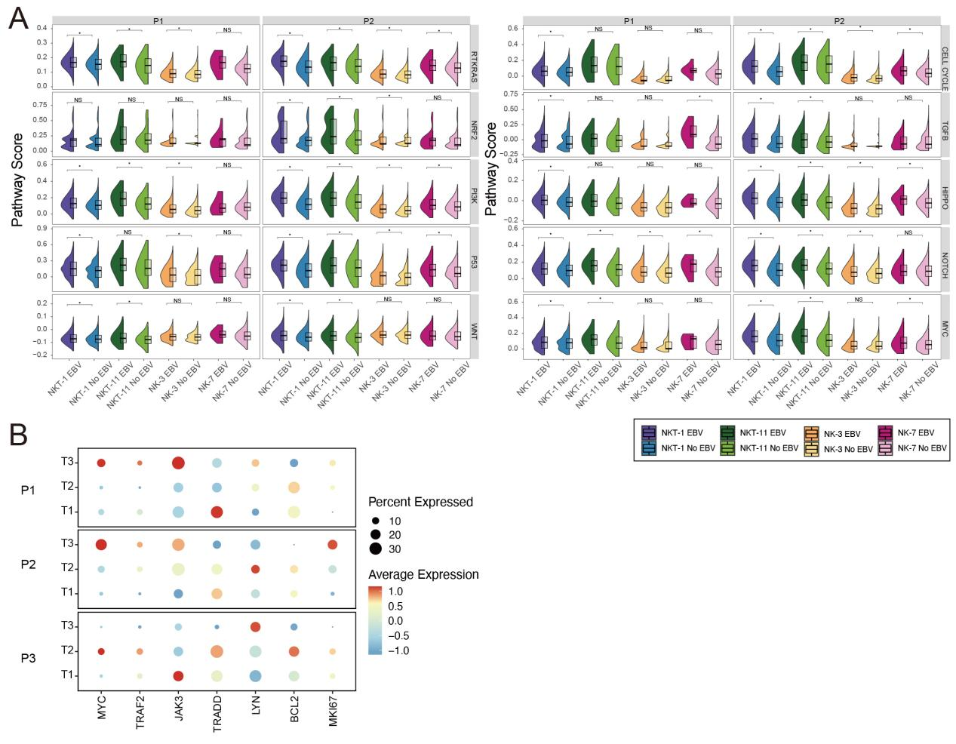
Figure S3. Single-cell RNA-seq identifies oncogenesis of EBV-infected NK and NKT cells of EBV-HLH patients.
A. Comparison of the enrichment of ten canonical pathways, including cell cycle, Hippo signaling, Myc signaling, Notch signaling, oxidative stress response/Nrf2, PI-3-Kinase signaling, receptor-tyrosine kinase (RTK)/RAS/MAP-Kinase signaling, TGFβ signaling, p53, and β-catenin/Wnt signaling, between EBV-infected and non-EBV-infected cells of P1 and P2.
B. Expression of selected genes representing proto-oncogenes, proliferation and EBV-viral carcinogenesis for EBV infected versus non-EBV clusters of three EBV-HLH patients. ns, not significant; *P < 0.05.

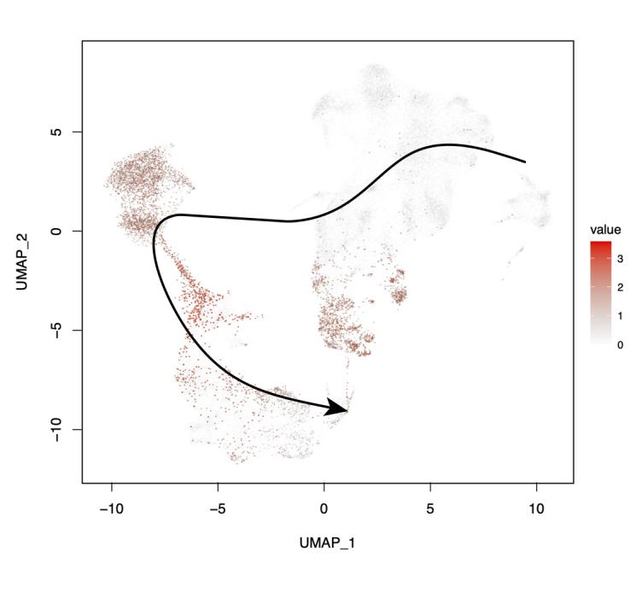
Figure S4. Pseudotime trajectory analysis traces the differentiation of CD56 positive cells. Calculated pseudotime trajectory analysis based on CD56 expression in T, NKT, and NKT cells. The arrow is drawn according to the computed pseudotime coordinate, with lighter cells denoting earlier timepoints in the trajectory and dark cells denoting later timepoints.

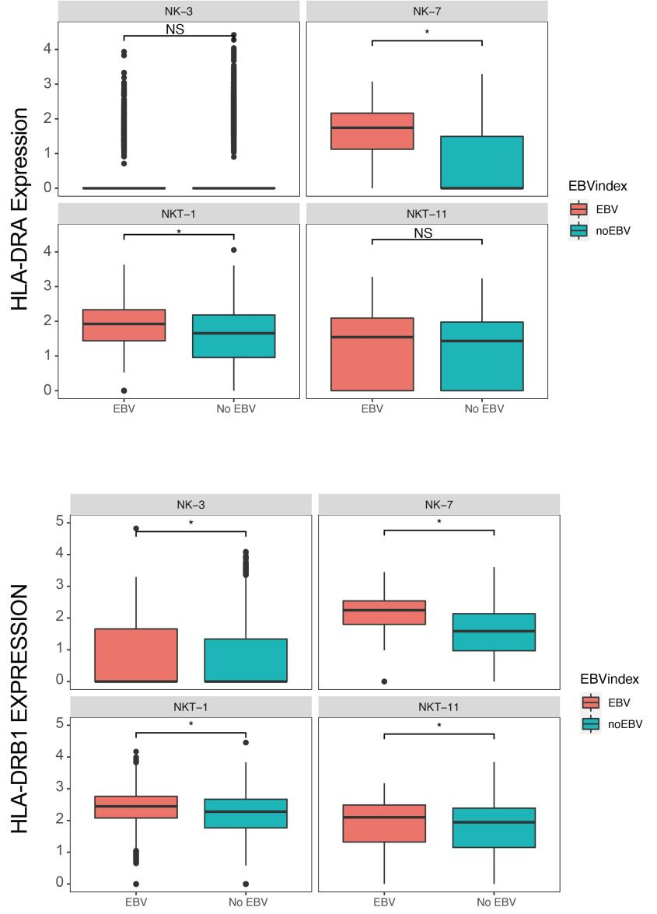
A
B
Figure S5. Expression of HLA-DR in EBV-infected and EBV-noninfected cells by scRNA-seq. A. Comparison of HLA-DRA gene expression between EBV infected and non-EBV infected NKT-1, NK-3, NK-7, and NKT-11 clusters.
B. Expression of HLA-DRB1 gene in EBV infected and non-EBV infected NKT-1, NK-3, NK-7, and NKT-11 clusters. ns, not significant; *P < 0.05.

