Sup.Fig.1 (a) Absorption spectrum of biofunctionalized Cu₂O NPs (b) Tauc plot of biofunctionalized Cu₂O NPs
Sup.Fig.2 SEM and EDAX analysis report for biofunctionalized Cu₂O NPs
Sup.Fig.3 FT-IR spectrum of (a) purified Cu₂O NPs (b) at various stages of nanoparticles synthesis reaction

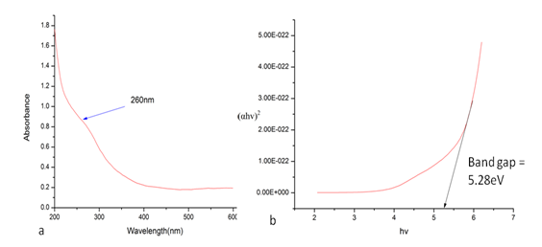
Sup.Fig.1
Sup.Fig.2

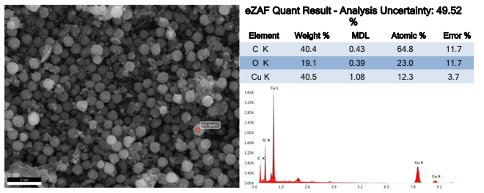
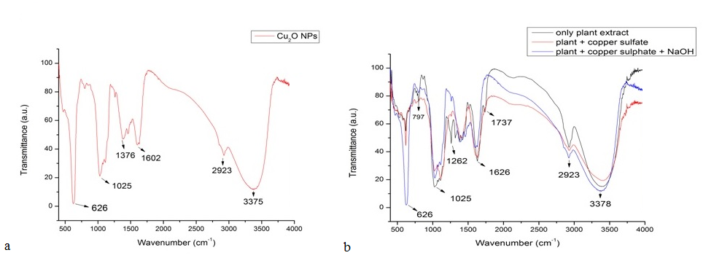
Sup. Fig.3

