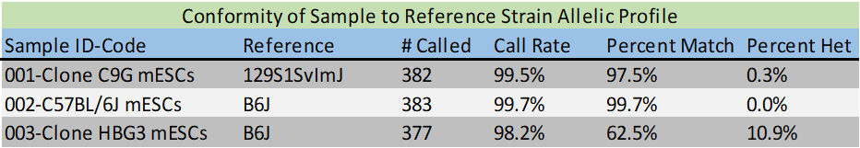
Supplementary Table 1. Single Nucleotide Polymorphism (SNP) analysis of Clone #C9G and control mESC lines to confirm genetic background strain. SNP analysis confirmed that mESC Clone #C9G, used for engraftment studies, originated from a different genetic background compared to host mice (C57Bl/6J background strain). C57BL/6J mESCs and HBG3 mESCs were included as controls.

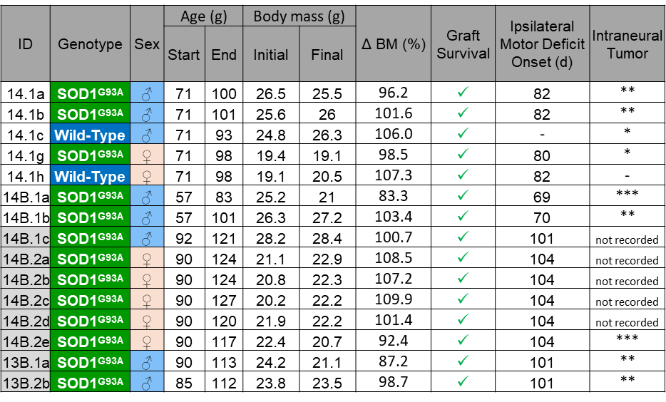
Supplementary Table 2. Summary of ChR2+ motor neuron engraftment experiments with FK506 immunosuppression. List of experimental mice, including genotype, ages at start and end of experiment, initial and final (and % change) body mass. Engrafted ChR2⁺ motor neurons were histologically determined to be present in all animals. Age at which ipsilateral hindlimb motor deficits were initially observed in vivo and post-mortem observation of intraneural tumour formation: *, **, and *** denotes small, medium and large tumor size, respectively (see Supplementary Fig. 2e).

