Supplementary information for

Neural replacement and optogenetics can prevent muscle atrophy and paralysis in an aggressive mouse model of ALS

J. Barney Bryson^{1,2}*, Alexandra Kourgiantaki^{1,2}, Dai Jiang³, Andreas Demosthenous³ and Linda Greensmith^{1,2}*

*Corresponding authors: email barney.bryson@ucl.ac.uk and l.greensmith@ucl.ac.uk

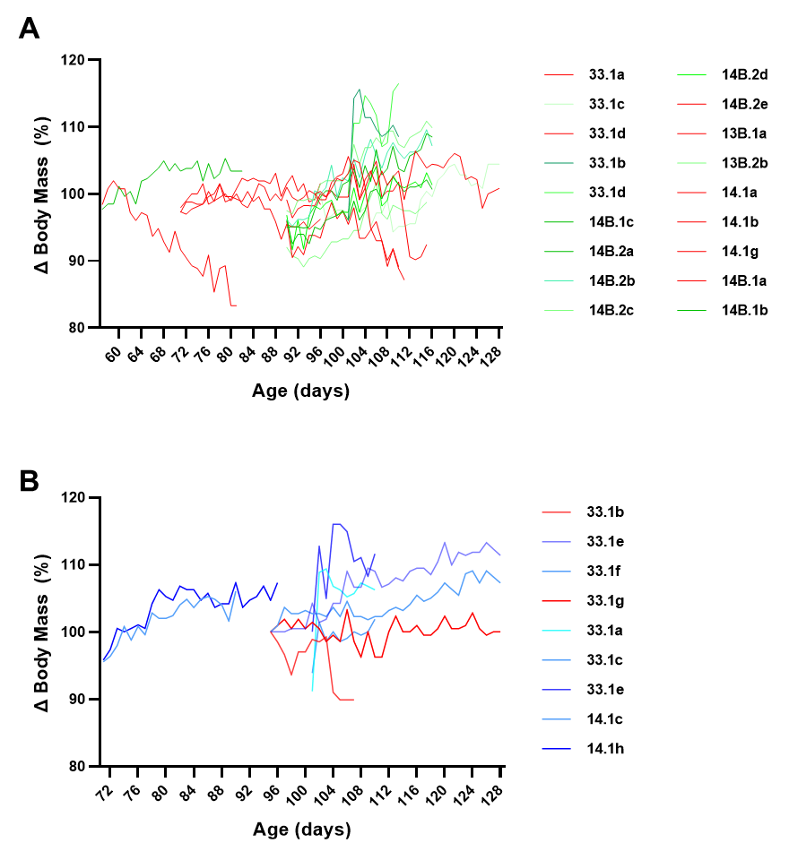

Supplementary Fig. 1 FK506 severely affects body mass in most SOD1^{G93A} but not wild-type mice. Longitudinal body mass analysis of individual SOD1^{G93A} mice (n = 18) treated with FK506 (5mg/Kg/d), spanning different age ranges (A), reveals that FK506 prevents body mass increase in the majority of SOD1^{G93A} mice and causes body mass decline (highlighted in red) that precedes normal disease phenotype. Body mass of most (77.8%; 7/9) wild-type mice treated with FK506 continued to increase throughout the study period (B).

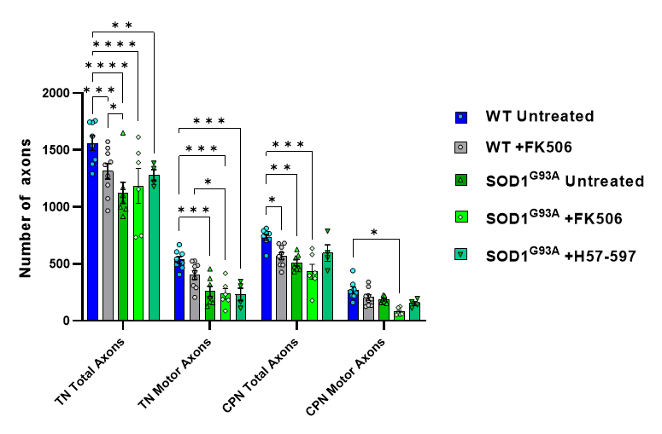
Supplementary Fig. 2 FK506 moderately reduces total sciatic nerve axon counts in wild-type mice but loss of total and motor axons is not observed in SOD1^{G93A} mice when all axon calibers are grouped. Automated analysis of total (ie. sensory and motor) axon numbers reveals that daily treatment with FK506 causes a significant reduction total axon counts in wild-type tibial nerve (TN) and common peroneal nerve (CPN) nerve branches; when all axonal calibers are grouped, the deleterious effect of FK506 on motor axon loss is not observed, suggesting that specific calibers may be preferentially vulnerable and the expected axonal loss in SOD1^{G93A} mice does not appear to be exacerbated by FK506 treatment in terms of overall numbers. Data shown as mean; error bars = SEM; two-way ANOVA; *denotes p = ≤ 0.05; ** denotes p = ≤0.0002; *** denotes p = ≤0.002; **** denotes p = ≤0.00002.

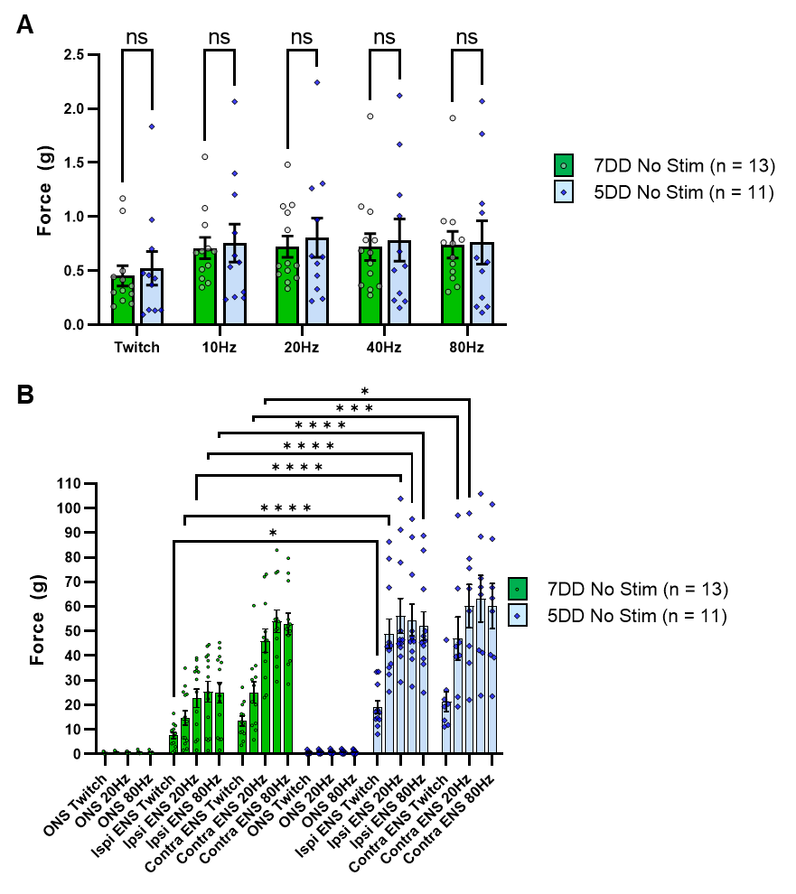
Supplementary Fig. 3 Subtype identity of engrafted ChR2+ motor neurons does not affect the maximum contractile response of the targeted muscle to acute optical stimulation in SOD1^{G93A} mice. (A) Fast-firing or slow-firing ChR2+ motor neurons were engrafted in age matched SOD1^{G93A} mice and the maximum contractile response elicited by acute optical stimulation (at (133.9 ±7.2 days versus 133 ±6.9 days, respectively) was determined using isometric muscle tension analysis; optical nerve stimulation (ONS) was delivered at the indicated frequencies to fully interrogate the muscle response. (B) Electrical nerve stimulation (ENS) of the ipsilateral and contralateral triceps surae muscles were also determined for reference, using stimulation frequencies designed to mirror the ONS patterns; ONS responses included for scale. Data shown as mean; error bars = SEM; multiple unpaired t tests with Tukey post hoc correction (A) or two-way ANOVA (B) *denotes p = ≤ 0.05; ** denotes p = ≤0.0002; *** denotes p = ≤0.002; **** denotes p = ≤0.00002.
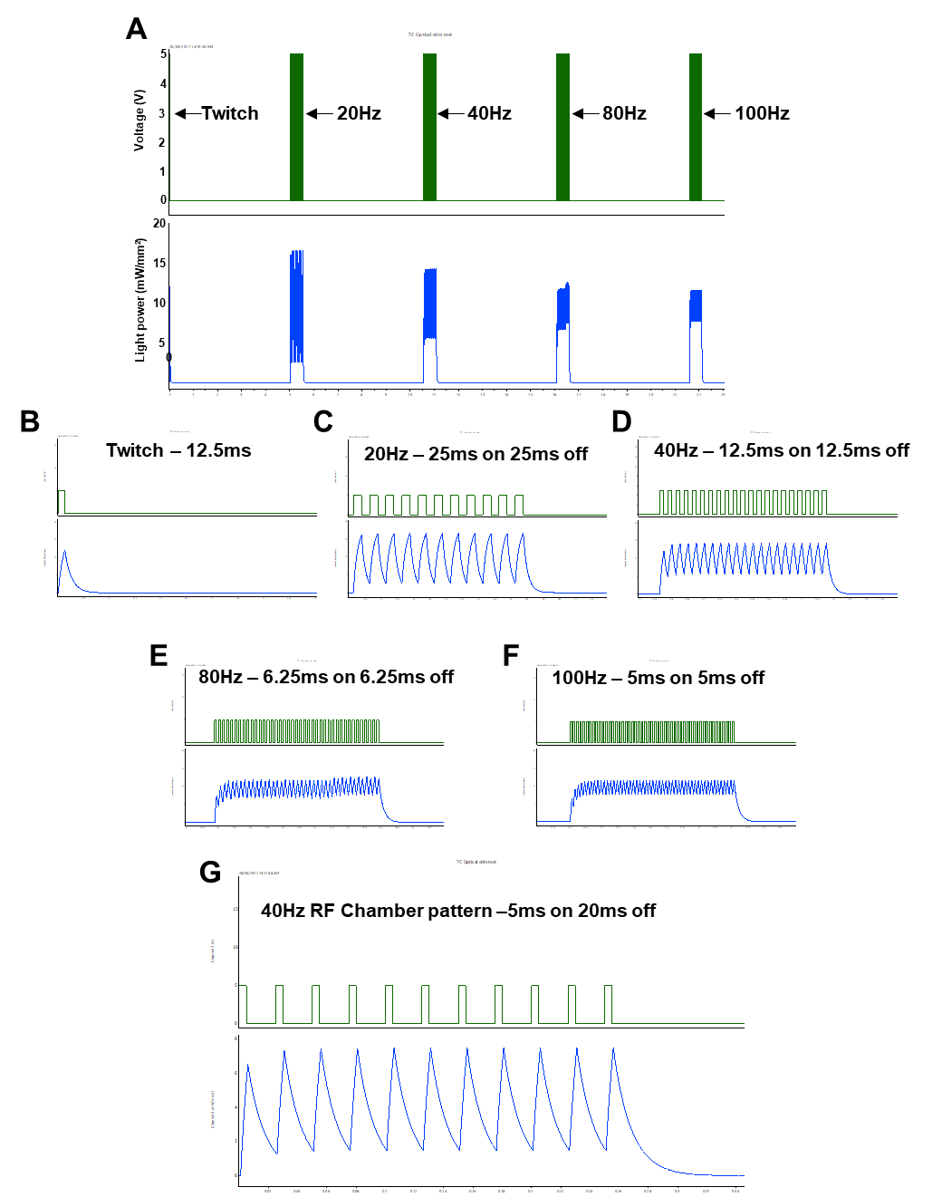

Supplementary Fig. 4 Light power recording and stimulation pattern recordings used to elicit acute optical nerve stimulation (ONS) throughout study. (A) Low temporal resolution recording show electrical TTL trigger pulses (green; top), used to activate an LED stimulator, and light power recordings measured using a digital light meter; note: LED liquid light guide was positioned an equivalent distance (1cm) from the light meter, compared to the nerve for ONS studies. (B-F) Higher temporal resolution images of the same pulse patterns; (G) recording of the optimized pulse pattern that induced maximal tetanic contraction and was subsequently used for long term optical stimulation training.
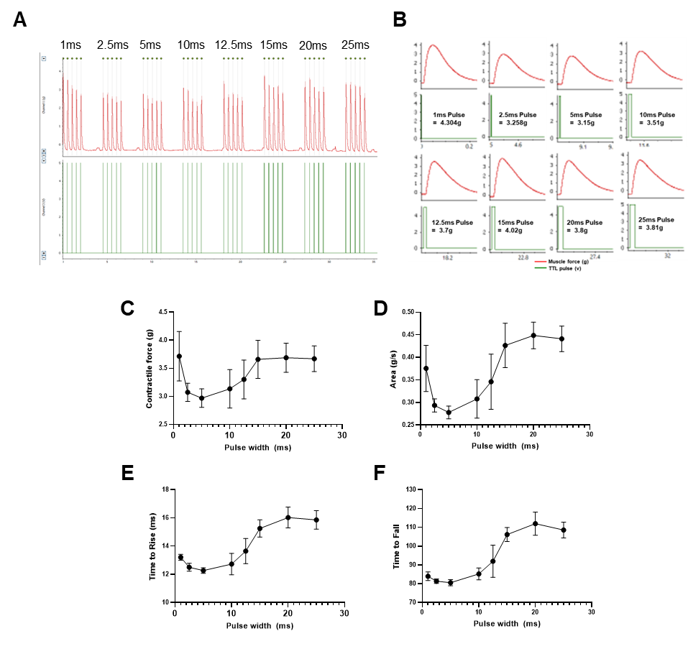

Supplementary Fig. 5 Optimization of optical nerve stimulation (ONS) pulse width to evoke maximum twitch contractile force. Isometric muscle tension force was recorded in response to 5 repeated ONS pulses, with varying pulse width from 1ms – 25ms (A); higher temporal resolution images of ONS evoked muscle twitch contractions (B) show electrical TTL trigger pulses, which activate the LED stimulator, in relation to twitch contractions. Automated analysis of ONS evoked contractile responses shows the relationship between pulse duration and contractile force (C), area under the curve (D), time take for force to rise from baseline to 5% of maximum (E) and time taken for force to fall back to below 10% of maximum response (F). Note: the shortest 1ms pulse induces maximal contractile force, with a rapid rise and fall time, whereas longer pulses (>15ms) can induce similar contractile force but at the cost of delayed muscle relaxation. Data shown as mean; error bars = st dev.
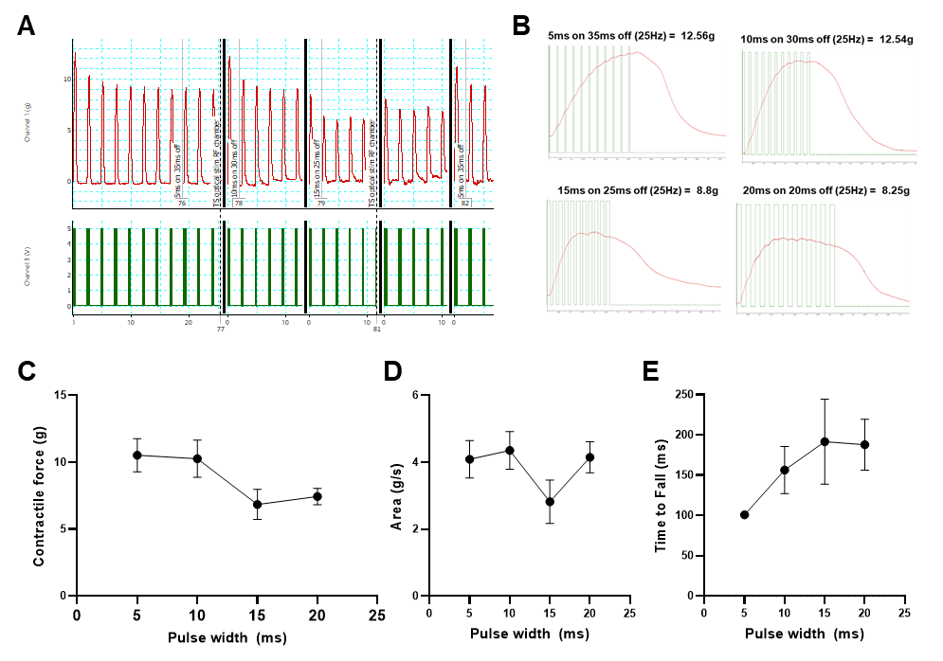

Supplementary Fig. 6 Optimization of optical nerve stimulation (ONS) pulse pattern to evoke maximum tetanic contractile force. Repetitive tetanic contractions following delivery of custom designed 25Hz ONS pulse patterns, in a ChR2+ motor neuron engrafted SOD1^{G93A} mouse; pulse width varied from 5-20ms and pulse interval varied from 35-20ms (A); individual tetanic contractions for each of the four tested pulse patterns are shown at higher resolution, with overlayed TTL pulses to indicate when LED is activated (B). Automated quantification of 5 tetanic contractions per pulse pattern revealed important contractile characteristics of maximal contractile force (C), area under curve (D) and time for contractile force to fall to 80% of peak value (E). Note: electrical TTL trigger pulses <5ms frequently failed to activate the LED stimulator, therefore 5ms was the shortest pulse duration tested and incorporated into the optical stimulation training (OST) program. Data shown as mean; error bars = st dev.

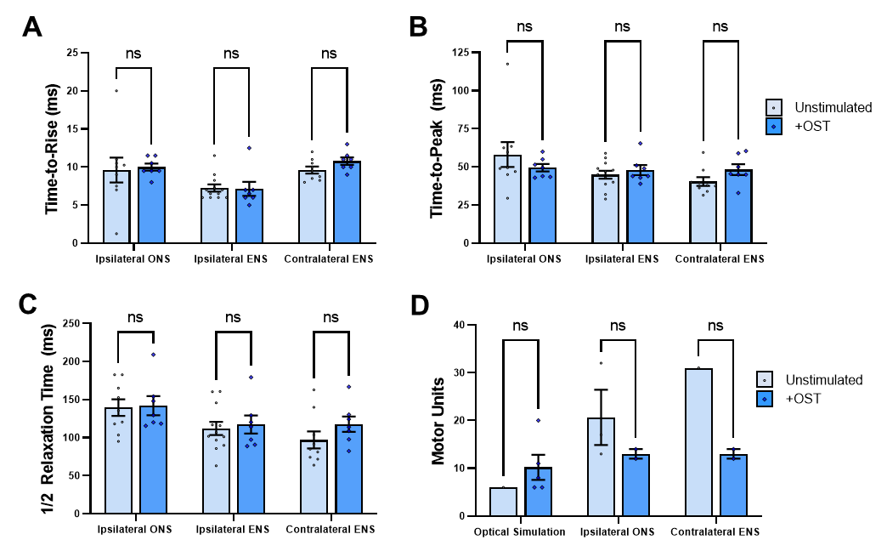

Supplementary Fig. 7 Daily optical stimulation training (OST) in SOD1^{G93A} mice does not affect muscle contractile characteristics in response to acute optical nerve stimulation (ONS). Automated peak analysis of brief twitch contractions revealed that OST did not significantly alter any of the following muscle characteristics compared to untrained SOD1^{G93A} mice: (A) time taken for muscle contractile force to rise above 5% of baseline value from onset of ONS pulse (Time to Rise); (B) time between initial contraction and peak force generation (Time to Peak); or (C) time taken to relax to 50% of peak force (1/2 Relaxation Time). Motor unit number estimates (MUNE) were difficult to obtain in untrained SOD1^{G93A} mice in response to ONS, but greater contractile force of twitch contractions in mice that underwent OST enabled MUNE values to be determined. Data shown as mean; error bars = SEM; multiple unpaired t tests with Tukey post hoc correction; ns = not significant.

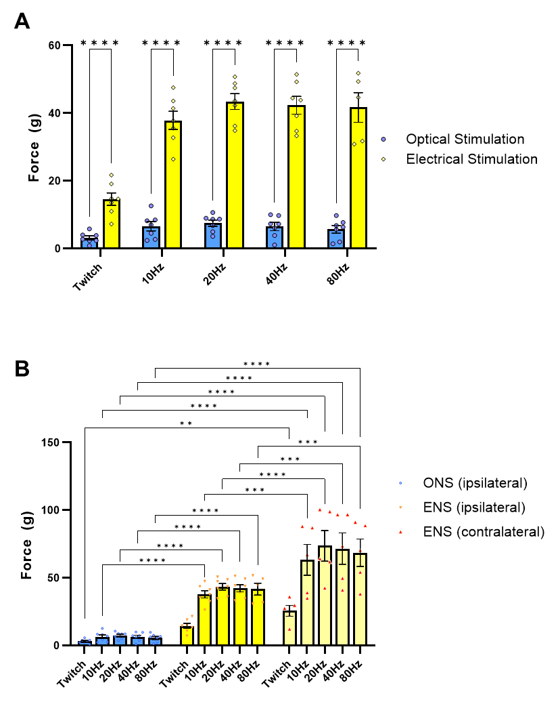

Supplementary Fig. 8 Comparison of optical nerve stimulation (ONS) versus electrical nerve stimulation (ENS) in late-stage SOD1^{G93A} mice shows that supramaximal ENS still induces stronger contractile force, even after optical stimulation training (OST). (A) Comparison of maximal twitch and tetanic force values, acquired from the same TS muscle in each animal in response to either supramaximal ONS or ENS stimuli delivered at specified pulse patterns; (B) maximal twitch and tetanic recordings from the ipsilateral and contralateral TS muscle in response to ONS and ENS stimuli. Data shown as mean; error bars = SEM; multiple unpaired t tests with Tukey post hoc correction (A) or two-way ANOVA (B) *denotes p = ≤ 0.05; ** denotes p = ≤0.0002; *** denotes p = ≤0.002; **** denotes p = ≤0.00002.
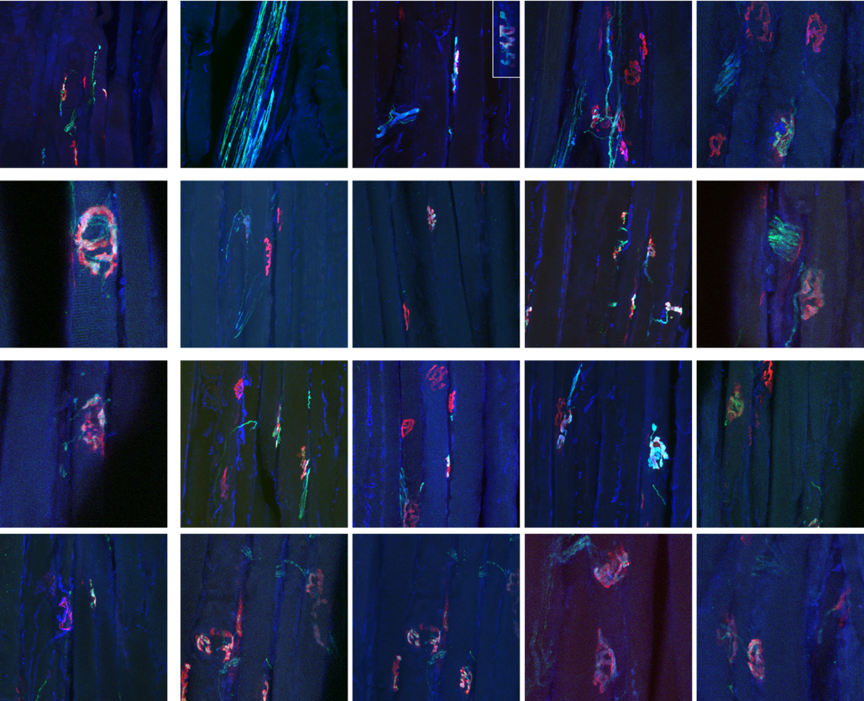

Supplementary Fig. 9 Daily optical stimulation training (OST) appears to enhance the extent of innervation of endplates by engrafted ChR2+ motor neurons. Confocal images showing examples of intramuscular nerves and endplates, within the triceps surae muscle, innervated by engrafted ChR2⁺ motor neurons in late-stage SOD1^{G93A} mice (n = 3) that had undergone OST. This sampling of NMJs provides an indication of the high-level of occupancy of innervated endplates; many of these images were extracted from confocal z-stacks of regions of interest (ROIs) used for digital Cross-sectional area Analysis of Longitudinal Muscle Sections (dCALMS) analysis ( shown in Fig. 7).

