Electronic Data Repository
A Novel Method to Calculate Compliance and Airway Resistance During Mechanical Ventilation

Guillermo Gutierrez, MD, PhD
Professor Emeritus Medicine, Anesthesiology and Engineering
The George Washington University
Washington, DC

Correspondence:
Guillermo Gutierrez, MD, PhD
700 New Hampshire Ave, NW
Suite 510
Washington, DC 20037
gutier@gwu.edu

1e. Database description.
The database used in the present study was collected between March 2011 and February 2012 as part of research on respiratory rate variability (Gutierrez et al, Intensive Care Med. 2013; 39:1359–1367). That study was approved by The George Washington University IRB (IRB No. 110910) that allowed use of the deidentified data in further studies.
The database contains information from 176 patients on positive pressure invasive ventilation with acute respiratory failure of various kinds enrolled within 24 hours of intubation and monitored during the entirety of their ventilatory support. In addition to deidentified demographic information, the database contains flow and pressure signals sampled continuously at 0.032 second intervals (32.25 Hz) from the data-port of the mechanical ventilator (Servo I or Servo S ventilators, Getinge, Solna, Sweden), and saved as contiguous 131.1 seconds long epochs containing 4096 samples of each signal.
The database contains approximately half-million epochs stored according to study number. Each patient folder is divided into several folders, each containing specific information, such as the flow and pressure signals, ventilator settings, etc. Each of these folders in turn contains files where data have been saved as 131.1 second longs epochs, with one folder for every 24 hours of monitoring. For example, “Breath” files hold data derived from the flow and pressure signals.
The dataset is available from the author upon reasonable request.
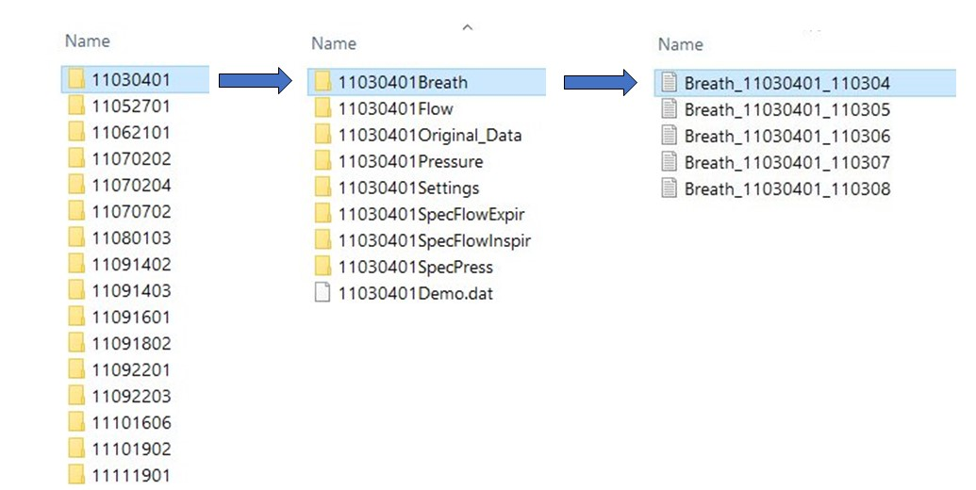
The first line in a Breath file contains demographic information. Subsequent lines hold values for different calculated variables, such as respiratory rate variability (lines 3,4 and 5 for the inspired flow, expired flow and pressure signals, respectively); FIO₂ (line 7); respiratory rate (line 8); tidal volumes (line 9), mean pressure (line 10); peak pressures (line 11), etc. Each column contains the average values pertaining to a single epoch. There are as many columns as epochs recorded in a 24-hour period, usually in the neighborhood of 570 epochs.
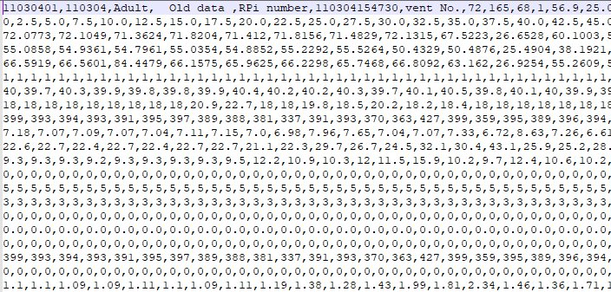
The Flow files contain the sampled flow data.
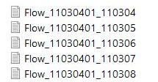
Each line represents one epoch and encompasses 4096 points sampled at 30.25 Hz.
Col 1 = Study number, Col 3 = Epoch time, 4 = Date and time data acquired.
Data begins in column 5, one point every 32 ms for a total of 4096 points.
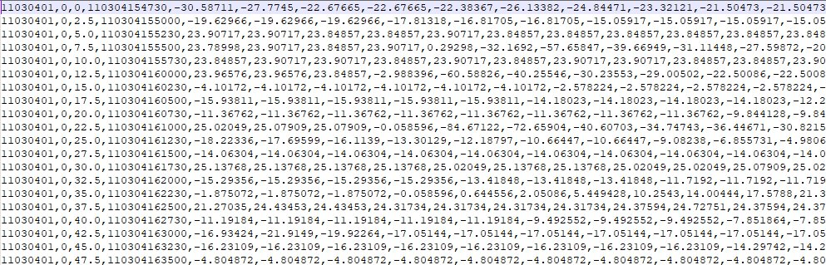
Similarly, the Press files contain the sampled airway pressure data.
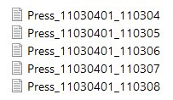
Each line represents one epoch and encompasses 4096 points sampled every 32 ms.
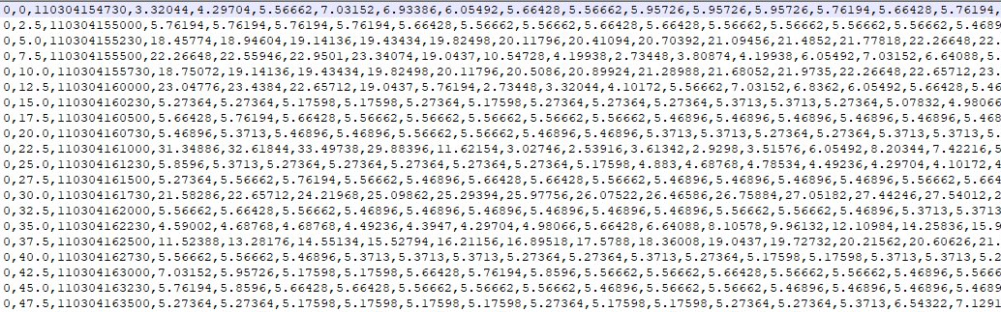
These data are shown graphically in Figure 1e, illustrating the airway flow and pressure signals stored for a single epoch:
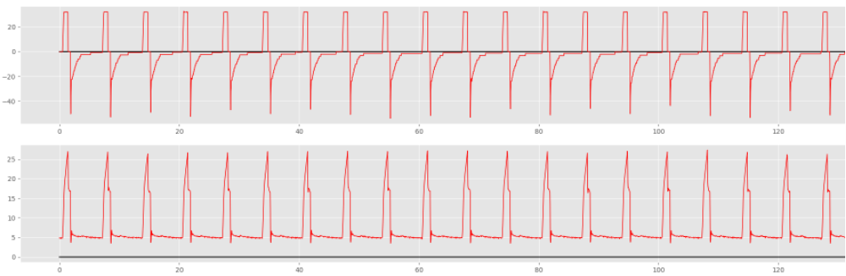
Figure 1e

2e. Example of epoch and individual breath inclusion in the study.
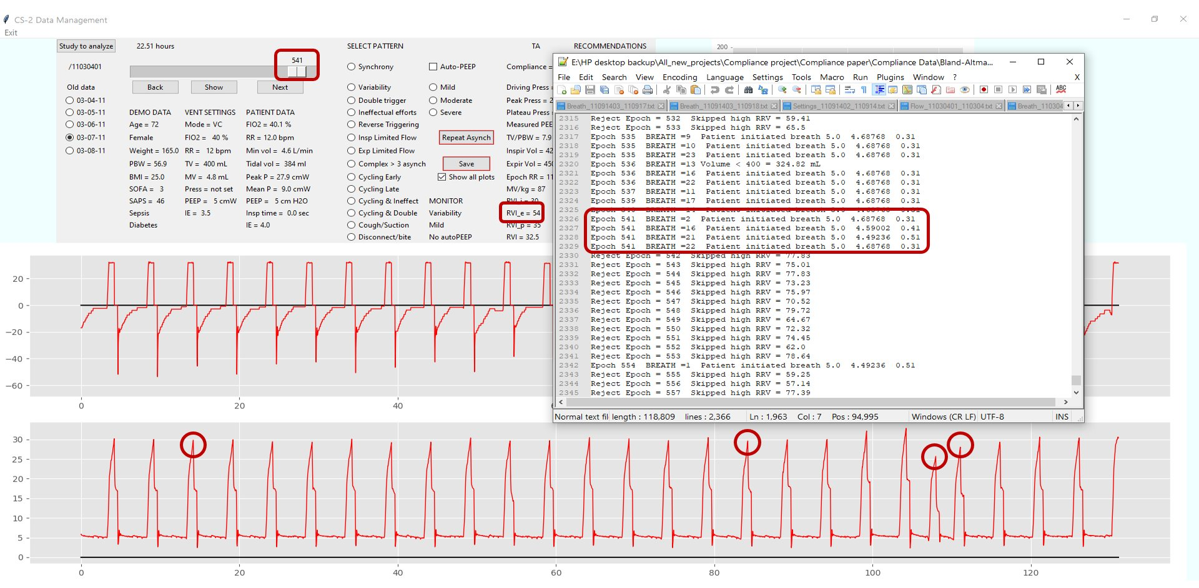
Epoch #541 was acquired at 22:51 hours of the fifth monitoring day, March 7, 2011. The epoch was included in the analysis since RVI ≤ 55% (in this case 54%). The first breath is always rejected to avoid analysis of an incomplete breath. Breaths 2, 16, 21 and 22 were rejected (red circles) based on possible patient-initiation
Breath 1 2 3 4 5 6 7 8 9 10 11 12 13 14 15 16 17 18 19 20 21 22 23 24
Figure 2e

3e. Numerical application of the method to calculate C_{rs} and R_{rs}.
Software (Python 3.8) was written to identify epochs in the database on volume-controlled ventilation and RRV < 55%. Once an epoch is identified, the software calculates C_{rs} and R_{rs} by both static and dynamic methods on all breaths meeting selection criteria. Mean epoch values for C_{rs} and R_{rs} are reported.
For the static method, the software calculates C_{rs} = V_{tidal} /(P_{plateau} - PEEP_{a}), where V_{tidal} = tidal volume, P_{plateau} = breath-hold P_{aw}, and PEEP_{a} = applied positive end expiratory pressure. Similarly, R_{rs} = (P_{peak} - P_{plateau})/F_{aw}, where P_{peak} = peak inspiratory pressure and F_{aw} is airway flow measured just prior to breath-holding.
For the dynamic method, P_{aw}(t) solution matrices are generated for each set of F_{aw}(t_{k}), ΔV(t_{k}) and PEEP_{a} measurements obtained at 0.032 second intervals during insufflation from ΔV(t) ≥ ΔV(t)_{open} = 200 mL , to end-inspiration (t_{end-insp}) with the latter identified by a decrease in F_{aw} > 5 L·min⁻¹. P_{aw}(t) solution matrices are developed by sequentially applying to Eqt. 2 a range of C_{rs} values from 0.05 to 200 cmH₂O·mL⁻¹ at intervals of 0.05 cmH₂O·mL⁻¹ and R_{rs} of 0.005 to 50.0 cmH₂O·s·L⁻¹ at intervals of 0.005 cmH₂O·s·L⁻¹.
A C_{rs}-R_{rs} function is then calculated for each P_{aw}(t) solution matrix developed from t_{open} to t_{end-insp} by identifying values for C_{rs} and R_{rs} where the solution matrix P_{aw}(t) = measured P_{aw}(t_{k}). The mean (μC_{rs}) and standard deviation (σC_{rs}) of all generated C_{rs}-R_{rs} functions are determined and R_{rs} for the breath is identified by the position along the R_{rs} axis corresponding to the smallest σC_{rs} whereas dynamic C_{rs} = μC_{rs}.
4e.Fitting double exponential – Excel notebook
Excel spreadsheet containing the airway pressure plateau region for the 15 study patients. Also shown are the results of a double exponential y = Ae(-mt) + Be(-nt) fitted to the mean plateau Paw data. Extrapolating the plateau region from 0.4 to 1.0 seconds predicts a decrease in Paw of only 0.8 cmH₂O (from 17.8 to 17.0 cmH₂O).
Although dynamic method bias was minimal for both C_{rs} and R_{rs}, the possibility of introducing an error when calculating the “gold standards” C_{rs} and R_{rs} by the static method should be acknowledged. The cessation of gas flow during the end-inspiratory hold produces a rapid decline in P_{aw} from P_{peak} to P₁, followed by a slow decay to a plateau P₂ . The timing of the (t_{hold}) is an important source of error since a short t_{hold} may affect P₁ by the persistence of airflow during inspiratory valve closure or it may prematurely shorten the decay of P_{aw} to P₂. Conversely, an extended t_{hold} may allow for voluntary respiratory muscle activity to occur, also distorting P₂ . All analyzed breaths in the study were ventilator triggered with no evidence of respiratory muscle activity, including the time spent in the end-inspiratory hold. t_{hold} for the cohort was 0.4 [0.4,0.4](range 0.3 to 0.7) seconds (Table 1e, Online Supplementary Information). This t_{hold} allowed ample time for inspiratory valve closing and placed P₂ firmly on the flat portion of the plateau, as evidenced by the small decline in P_{aw} (< 1.0 cmH₂O) predicted by decreasing exponentials fitted to the data (R² = 0.96) and extrapolated from 0.4 to 1.0 seconds.

5e. Raw data individual and aggregate – Excel notebook
Contains the Model Results Derived from the 3174 Chosen Epochs.

6e. Experimental data results – Excel notebook
Contains data obtained from the 1 liter test lung ventilated with tidal volumes of 300 and 400 mL and three levels of applied PEEP, 0, 5 and 10 cmH2O.

7e. Fifty Randomly Chosen Epochs from a Database of 3174 Epochs (example).
The criteria used to select the epochs and individual breaths used in the study resulted in epochs displaying regular, steady breathing patterns with low respiratory rates. To further explore this issue, 50 epochs were drawn randomly among the 3171 analyzed epochs (Section 1e, Online Supplementary Information). All breaths within these epochs were uniform in shape, ventilator triggered and displayed no asynchronies, including reverse triggering , findings lending support to the assumption of absent voluntary respiratory muscle activity in the analyzed breaths.
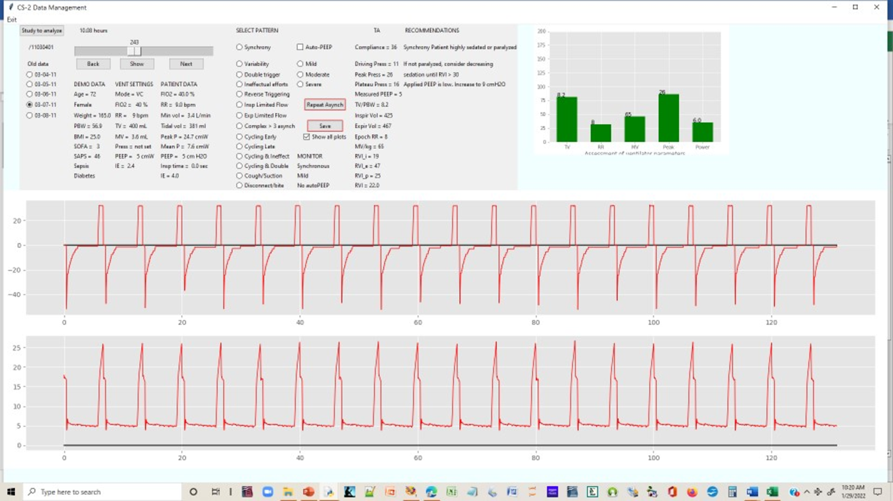
Table 1e
Demographic and ICU Admission Data, Diagnoses, and ICU Admission Chest X Rays for Study Patients.
Patient | Gender | Age | PBW | BMI | SAPS II | P/F | Diagnosis | LLL PNA
_______________________________________________________________________________________________
1 | F | 72 | 57 | 25 | 46 | 370 | Smoke inhalation | Bilateral effusions
2 | F | 81 | 63 | 45 | 49 | 236 | Pneumonia | Rib fractures
3 | M | 22 | 80 | 22 | 45 | 268 | Trauma | Clear
4 | M | 33 | 52 | 20 | 17 | 553 | Post-operative | Atelectasis
5 | M | 30 | 52 | 29 | 38 | 337 | Post-operative | Pulmonary edema
6 | M | 58 | 80 | 35 | 28 | 215 | Post-operative | Clear
7 | F | 54 | 61 | 22 | 43 | 586 | Cardiac arrest | Clear
8 | F | 42 | 73 | 30 | 32 | 383 | Cardiac arrest | Clear
9 | F | 88 | 54 | 19 | 41 | 298 | Intracranial bleed | Clear
10 | M | 31 | 75 | 19 | 36 | 486 | Sepsis | Atelectasis
11 | M | 51 | 73 | 21 | 33 | 224 | Overdose | Clear
12 | F | 56 | 66 | 18 | 34 | 400 | Intracranial bleed | Clear
13 | M | 37 | 71 | 31 | 19 | 335 | Trauma | Bilateral PNA
14 | F | 75 | 66 | 29 | 62 | 275 | Renal failure | LLL PNA
15 | M | 58 | 78 | 22 | 32 | 458 | Post-operative | LLL PNA
Median |  | 54 | 66 | 22 | 36 | 337
IQR |  | [35,65] | [59,74] | [21,30] | [32,44] | [272,429]

Table 2e
Average Ventilatory Parameters Computed from All Epochs Used in Method Comparison.
Patient | Epochs  (3274) | FIO2 (%) | Respiratory  Rate  (bpm) | Tidal Volume  (mL/PBW) | Peak  Pressure  (cmH₂O) | Mean  Pressure  (cmH₂O) | Plateau  Pressure  (cmH₂O) | Driving  Pressure  (cmH₂O) | Flow  (L·min⁻¹) | RRV  (%)
______________________________________________________________________________________________________
1 | 293 | 40 | 10 | 8.0 | 29 | 9 | 17 | 12 | 32 | 45
2 | 119 | 100 | 19 | 8.5 | 36 | 14 | 25 | 20 | 40 | 45
3 | 127 | 50 | 11 | 7.8 | 25 | 9 | 15 | 10 | 42 | 36
4 | 385 | 40 | 11 | 10.4 | 33 | 10 | 21 | 15 | 37 | 40
5 | 15 | 60 | 14 | 10.1 | 24 | 9 | 14 | 8 | 36 | 46
6 | 38 | 40 | 13 | 6.8 | 26 | 10 | 18 | 12 | 40 | 45
7 | 399 | 50 | 14 | 8.5 | 29 | 10 | 19 | 13 | 39 | 40
8 | 881 | 40 | 11 | 9.4 | 31 | 10 | 17 | 12 | 49 | 52
9 | 72 | 60 | 11 | 8.9 | 20 | 4 | 10 | 10 | 34 | 51
10 | 27 | 30 | 11 | 6.3 | 28 | 9 | 17 | 12 | 37 | 50
11 | 38 | 50 | 14 | 8.1 | 26 | 9 | 17 | 12 | 42 | 41
12 | 26 | 40 | 10 | 8.6 | 23 | 8 | 15 | 10 | 38 | 41
13 | 248 | 40 | 14 | 7.5 | 35 | 12 | 22 | 17 | 42 | 33
14 | 476 | 40 | 14 | 8.2 | 32 | 11 | 21 | 16 | 39 | 39
15 | 30 | 40 | 10 | 8.1 | 23 | 8 | 14 | 9 | 41 | 45
Median | 119 | 40 | 11 | 8.2 | 28 | 9 | 17 | 12 | 37 | 45
IQR | [34,339] | [40,50] | [11,14] | [7.9,8.8] | [24,31] | [9,10] | [15,20] | [10,14] | [39,41] | [40,46]
Applied PEEP was 5 cmH₂O for all epochs.
FIO₂ = Fractional Inspired O₂ concentration; RRV = Respiratory rate variability; IQR = Interquartile range.

Table 3e
Comparison of bias ± Limits of Agreement (LOA) for C_{rs} and R_{rs} calculated From Individual Patient Data by the Dynamic, Least Square Fitting (LSF) and Expiratory Time Constant (τ_{E}) Methods .

Method | C_{rs} bias ± LOA  (cmH₂O·mL⁻¹) | R_{rs} bias ± LOA  (cmH₂O·s· L⁻¹)
Dynamic (n = 15; s = 3174) | 0.6 ± 0.9 | - 0.1 ± 0.8
LSF (n = 1; s = 11) | 1.5 ± 3.0 | 4.9 ± 10.2
τ_{E} (n = 24; s = 24) | 2.0 ± 4.5 | - 1.3 ± 2.2

n = number of patients in the study; s = number of independent samples.

Mergoni M, Volpi A, Bricchi C, Rossi A. (2001) Lower inflection point and recruitment with PEEP in ventilated patients with acute respiratory failure. J Appl Physiol (1985) 91:441-450. doi: 10.1152/jappl.2001.91.1.441. PMID: 11408462.
Matamis D, Lemaire F, Harf A, Brun-Buisson C, Ansquer JC, Atlan G. (1984) Total respiratory pressure-volume curves in the adult respiratory distress syndrome. Chest 86:58-66. doi:10.1378/chest.86.1.58
Bates JH, Baconnier P, Milic-Emili J.(1985) A theoretical analysis of interrupter technique for measuring respiratory mechanics. J Appl Physiol 1988;64:2204-2214. doi: 10.1152/jappl.1988.64.5.2204. PMID: 3391919.
Bates JH, Hunter IW, Sly PD, Okubo S, Filiatrault S, Milic-Emili J. (1987) Effect of valve closure time on the determination of respiratory resistance by flow interruption. Med Biol Eng Comput 25:136-140. doi: 10.1007/BF02442841. PMID: 3695616.
Akoumianaki E, Lyazidi A, Rey N, Matamis D, Perez-Martinez N, Giraud R, Mancebo J, Brochard L, Richard JCM. (2013) Mechanical ventilation-induced reverse-triggered breaths: a frequently unrecognized form of neuromechanical coupling. Chest 143:927–938. doi:10.1378/chest.12-1817
Iotti GA, Braschi A, Brunner JX, Smits T, Olivei M, Palo A, Veronesi R. (1995) Respiratory mechanics by least squares fitting in mechanically ventilated patients: applications during paralysis and during pressure support ventilation. Intensive Care Med. 21:406-413. doi: 10.1007/BF01707409. PMID: 7665750.
Al-Rawas N, Banner MJ, Euliano NR, Tams CG, Brown J, Martin AD, Gabrielli A. (2013) Expiratory time constant for determinations of plateau pressure, respiratory system compliance, and total resistance. Crit Care 17:R23. doi: 10.1186/cc12500. PMID: 23384402; PMCID: PMC4056774.

