Unique insertion/deletion polymorphisms within histidine-rich region of histidine-rich glycoprotein in Thoroughbred horses

Ryo Muko¹, Tomoya Sunouchi¹, Shuntaro Urayama², Yuko Toishi³, Kanichi Kusano², Hiroaki Sato⁴, Masanori Muranaka², Taekyun Shin⁵, Masa-aki Oikawa⁶, Yoshinobu Ojima¹, Mohammad Ali⁶, Yoshihiro Nomura⁷, Hiroshi Matsuda¹ and Akane Tanaka^{1, 8 *}

¹ Laboratory of Comparative Animal Medicine, Division of Animal Life Science, Faculty of Agriculture, Tokyo University of Agriculture and Technology, Tokyo, Japan.
² Race Horse Clinic, Ritto Training Center, Japan Racing Association, Shiga, Japan.
³ Shadai Stallion Station, Shadai Corporation, Hokkaido, Japan.
⁴ Race Integrity Section, Stewards Department, Japan Racing Association, Tokyo, Japan
⁵ Department of Veterinary Anatomy, College of Veterinary Medicine and Veterinary Medical Research Institute, Jeju National University, Jeju, South Korea.
⁶ Diagnostic Laboratory, Equine Veterinary Medical Center, Education City, Doha, Qatar.
⁷ Scleroprotein and Leather Research Institute, Faculty of Agriculture, Tokyo University of Agriculture and Technology, Tokyo, Japan.
⁸ Cooperative Major in Advanced Health Science, Graduate School of Bio-Applications and System Engineering, Tokyo University of Agriculture and Technology, Tokyo, Japan.
*Correspondence and requests for materials should be addressed to Akane Tanaka, Laboratory of Comparative Animal Medicine, Division of Animal Life Science, Faculty of Agriculture, Tokyo University of Agriculture and Technology, 3-5-8 Saiwai-cho, Fuchu, Tokyo 183-8509, Japan.
email address: akane@cc.tuat.ac.jp (A. Tanaka).
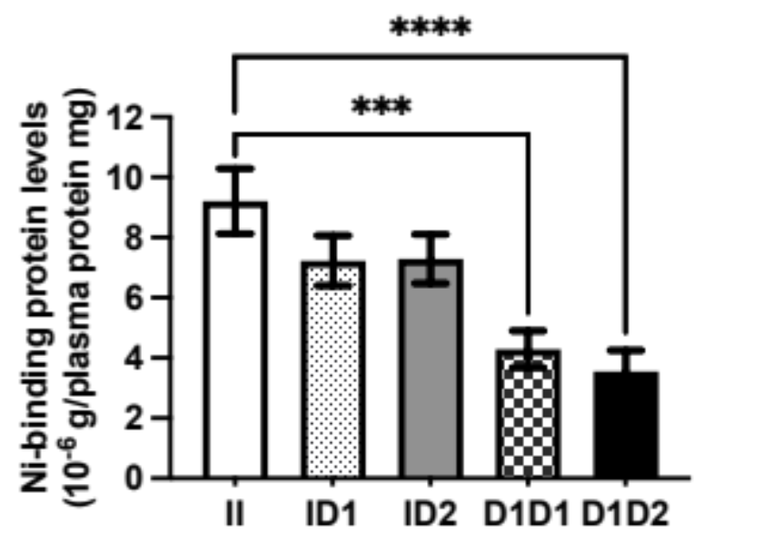
Figure S1
Amount of Ni-sepharose binding protein in the plasma of horses with each genotype. Ni-binding protein was expressed as weight per mg of total plasma protein. Each column of the graph shows the mean ± standard error. N = 10 in each group. ***p < 0.0005, ****p < 0.0001. II: Insertion/insertion, ID1: insertion/ 45 bp deletion, ID2: insertion/ 90 bp deletion, D1/D1: 45 bp deletion/45 bp deletion, D1D2: 45 bp deletion/ 90 bp deletion.

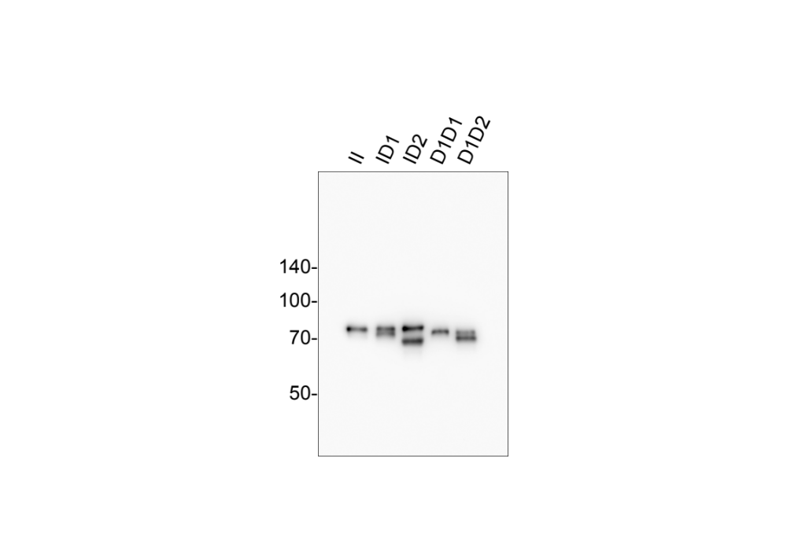
Figure S2
The full-length blot of anti- HRG western blotting analysis using plasma collected from horses with each genotype. Photo represents five independent experiments. The numbers on the left are molecular weight markers. II: Insertion/insertion, ID1: insertion/ 45 bp deletion, ID2: insertion/ 90 bp deletion, D1/D1: 45 bp deletion/45 bp deletion, D1D2: 45 bp deletion/ 90 bp deletion. The sectioning photo was used in Figure 4.

