ADDITIONAL FILES

Additional file 1. Hospital peer-groups definition

Teaching | Hospitals with full membership to the Association of Canadian Academic Healthcare Organizations (ACAHO) or teaching hospitals according to the Association québécoise des établissements en santé et services sociaux (AQESS)
Community - Large | 2 of the following 3 criteria:  - ≥ 8000 inpatient cases  - ≥ 10 000 weighted cases  - ≥ 50 000 inpatient days
Community - Medium | Do not meet large-community group criteria  ≥ 2000 weighted cases (approximately ≥ 50 beds)
Community - Small | Do not meet large-community group criteria  < 2000 weighted cases (approximately < 50 beds)
Reproduced from : CIHI. Hospital Standardized Mortality Ratio (HSMR): Technical Notes. Public Release. Ottawa, February 2012.

Additional file 2. List of the Diagnosis Groups (n=37) of the International Classification of Diseases (10th version) included in the ED-HSMR

A41 | Sepsis
E11 | Diabetes Mellitus type 2
E86 | Volume depletion
E87 | Other disorders of fluid, electrolyte and acid-base balance
F05 | Delirium, not induced by alcohol and other psychoactive substances
G93 | Other disorders of brain
I21 | Acute Myocardial Infarction (AMI)
I24 | Other acute ischemic heart disease
I26 | Pulmonary embolism
I46 | Cardiac arrest
I50 | Heart failure
I60 | Subarachnoid haemorrhage
I61 | Intracerebral haemorrhage
I62 | Other non traumatic intracranial haemorrhage
I63 | Cerebral infarction
I64 | Stroke, not specified as haemorrhage or infarction
I71 | Aortic aneurism and dissection
J18 | Pneumonia
J44 | Other chronic obstructive pulmonary disease
J69 | Pneumonitis due to solids and liquids
J80 | Adult respiratory distress syndrome
J96 | Respiratory failure, not elsewhere classified
K26 | Duodenal ulcer
K55 | Vascular disorders of intestine
K56 | Paralytic ileus and intestinal obstruction without hernia
K57 | Diverticular disease of intestine
K65 | Peritonitis
K72 | Hepatic failure
K85 | Acute pancreatitis
K92 | Other diseases of digestive system
L03 | Cellulitis
N17 | Acute renal failure
R57 | Shock, not elsewhere classified
S06 | Intracranial injury
S32 | Fracture of lumbar spine and pelvis
S72 | Fracture of femur
T82 | Complications of cardiac and vascular prosthetic devices, implants and grafts

Additional file 3. Charlson index score groups

Charlson Group | Charlson score
 | Outside Québec | In Québec
0 | 0 | 0 and 1
1 | 1 and 2 | 2, 3 and 4
2 | ≥ 3 | ≥ 5
Reproduced from : CIHI. Hospital Standardized Mortality Ratio (HSMR): Technical Notes. Public Release. Ottawa, February 2012.

Additional file 4. Distribution of ED-HSMRs of all eligible institutions (n=294) in 2010-11
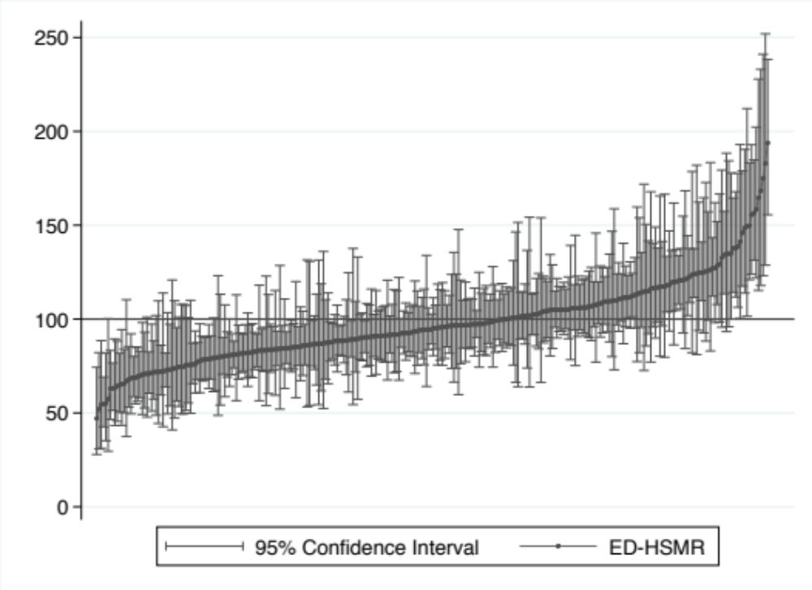

Additional file 5. Caterpillar plots of ED-HSMRs by peer-group

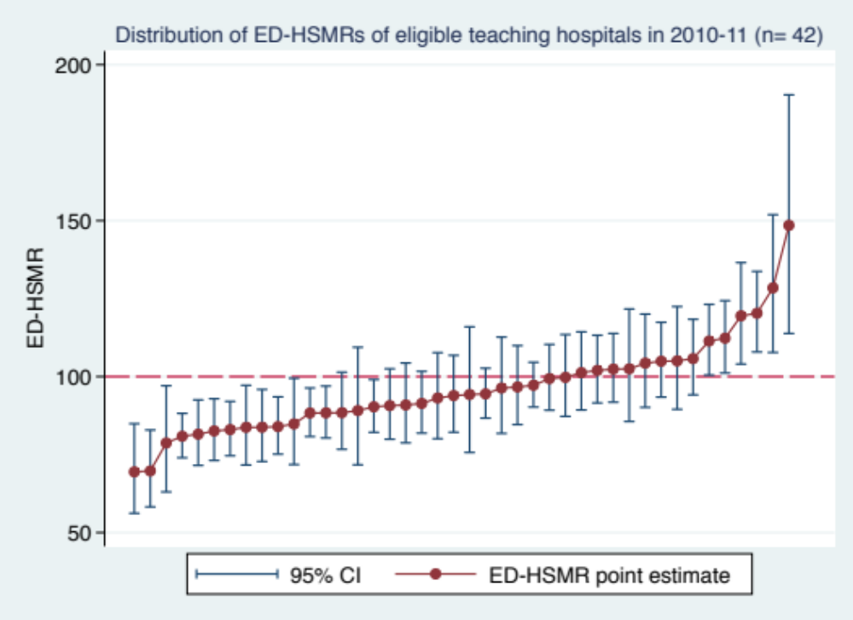

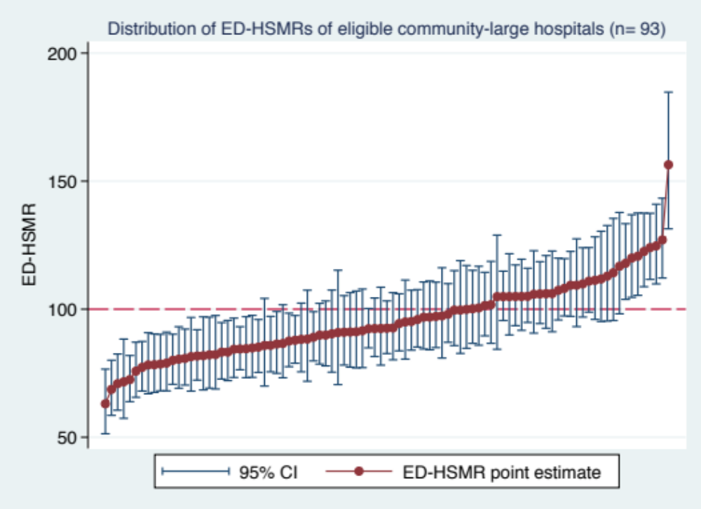

Additional file 5. (Continued)

