Supplementary Table S1. The geography and vegetation of each pocosin peat site based on different fire histories at PLNWR NC, USA.
Sites | Pungo North | Pungo South | 2 year post fire | 5 year post fire | DNL
Fire stage | UD,15d,71d | UD,15d,71d | 2y | 5y | 30y
Fire intensity | Low-intensity | Low-intensity | Low-intensity | High-intensity | High-intensity
Latitude (°N) | 35.68882°N | 35.67348° N | 35.68450°N | 35.68900°N | 35.69078°N
Longitude (°W) | 76.56437°W | 76.55810° W | 76.56152°W | 76.53074°W | 76.52856°W
Dominant Species | Ilex nigra (85%)  Pinus taeda  Liquidambar styraciflua  Woodwardia virginica | Ilex nigra  Morella cerifera  Persea palustris  Rhus copallinum  Woodwardia virginica | Ilex nigra  Pinus taeda  Woodwardia virginica | Ilex nigra  Ilex coriacea  Persea palustris  Smilax laurifolia  Vaccinium  Woodwardia | Ilex nigra  Vaccinium formosum  Lyonia lucida  Woodwardia virginica  Andropogon virginicus  Pinus serotina  Pinus taeda
MAT | 16.8︒C
MAP | 1,230 mm

UD: undisturbed sample; 15d: 15 days post-fire; 71d: 71 days post-fire; 2y: 2 years post-fire; 5y: 5 years post-fire; 30y: 30 years post-fire; MAT: mean annual temperature; MAP: mean annual precipitation

Supplementary Table S2. Results of linear mixed-effects models for the fire stage on fungal diversity, fungal copy number, relative abundances of fungal guilds and soil properties with site as a random factor under low-intensity fire and high-intensity fire. Significant P values are in bold.
 | 0-5cm |  |  | 6-10cm |  |  | 11-15cm |  |  | 16-20cm
 | P | R_{m}² | R_{c}² | P | R_{m}² | R_{c}² | P | R_{m}² | R_{c}² | P | R_{m}² | R_{c}²
Low-intensity fire
Phenolics | 0.03 (Q) | 0.19 | 0.32 | 0.00(Q) | 0.42 | 0.81 | 0.24 | 0.07 | 0.25 | 0.64 | 0.01 | 0.29
pH | 0.00 (Q) | 0.23 | 0.73 | 0.00 (Q) | 0.40 | 0.71 | 0.00 (Q) | 0.38 | 0.78 | 0.00 (Q) | 0.35 | 0.55
NH₄-N | 0.08 | 0.10 | 0.58 | 0.09 | 0.11 | 0.43 | 0.17 | 0.09 | 0.37 | 0.51 | 0.02 | 0.55
DOC | 0.32 | 0.05 | 0.05 | 0.29 | 0.05 | 0.05 | 0.08 | 0.13 | 0.20 | 0.00(Q) | 0.39 | 0.83
TC | 0.15 | 0.1 | 0.23 | 0.04 | 0.18 | 0.21 | 0.17 | 0.08 | 0.12 | 0.26 | 0.06 | 0.27
High-intensity fire
Phenolics | 0.09 | 0.31 | 0.37 | 0.00(L) | 0.66 | 0.86 | 0.01 (Q) | 0.31 | 0.76 | 0.00 (Q) | 0.48 | 0.89
pH | 0.05 (Q) | 0.19 | 0.42 | 0.02(L) | 0.45 | 0.65 | 0.01(Q) | 0.51 | 0.69 | 0.00 (Q) | 0.58 | 0.84
NH₄-N | 0.78 | 0.008 | 0.12 | 0.87 | 0.004 | 0.38 | 0.65 | 0.03 | 0.28 | 0.25 | 0.26 | 0.93
DOC | 0.67 | 0.02 | 0.68 | 0.94 | 0.02 | 0.25 | 0.78 | 0.01 | 0.52 | 0.59 | 0.07 | 0.89
TC | 0.55 | 0.06 | 0.57 | 0.05(L) | 0.26 | 0.31 | 0.11 | 0.04 | 0.62 | 0.80 | 0.01 | 0.78
The letter in parentheses indicated the best fitted model. R_{m}², the variance explained by fixed effects; R_{c}², the variance explained by both fixed and random effects. TC: Total Carbon; DOC: Dissolve Organic Carbon; NH₄-N: ammonia; Q: Quadratic fit; L: Linear fit.
Supplementary Figure S1. Photographs of sampling sites before and after burns at PLNWR, NC, USA.
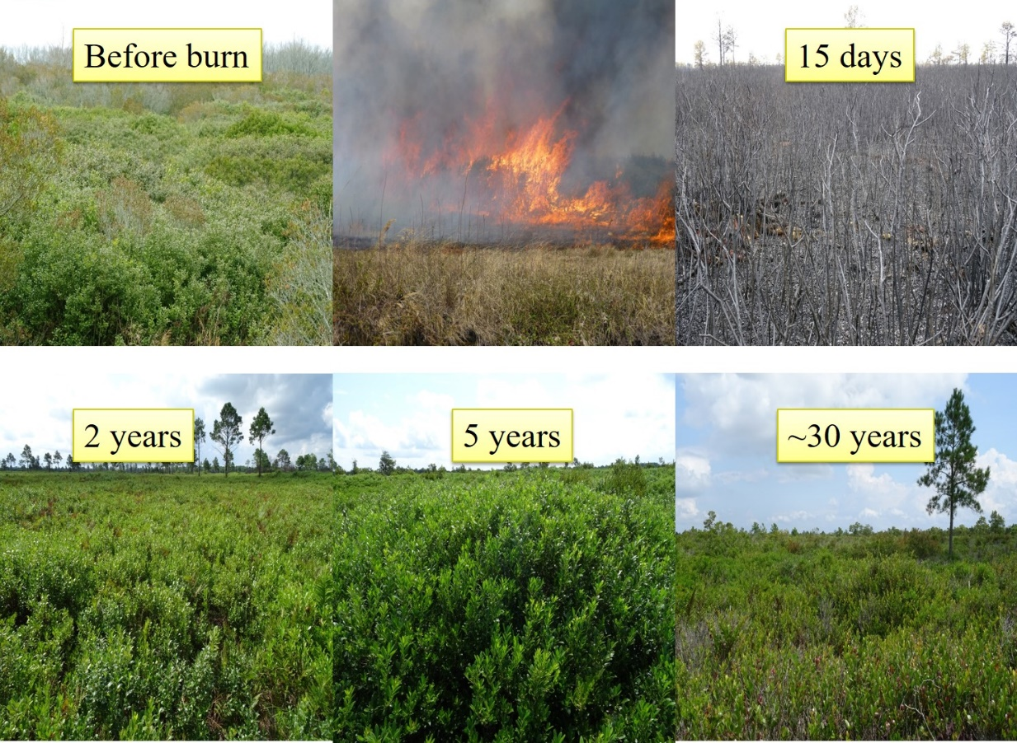

Supplementary Figure S2. Principal coordinate analysis (PCoA) ordinations of Bray-Curtis similarities calculated based on relative OTU abundances. Variance explained by each PCoA axis is given in parentheses. (A and B) ITS1F primer; (C and D) ITS4 primer. Fire stage: 30 years post-fire (30y); 5 years post-fire (5y); 2 years post-fire (2y); 15 days post-fire (15d); 71 days post-fire (71d); undisturbed (UD).
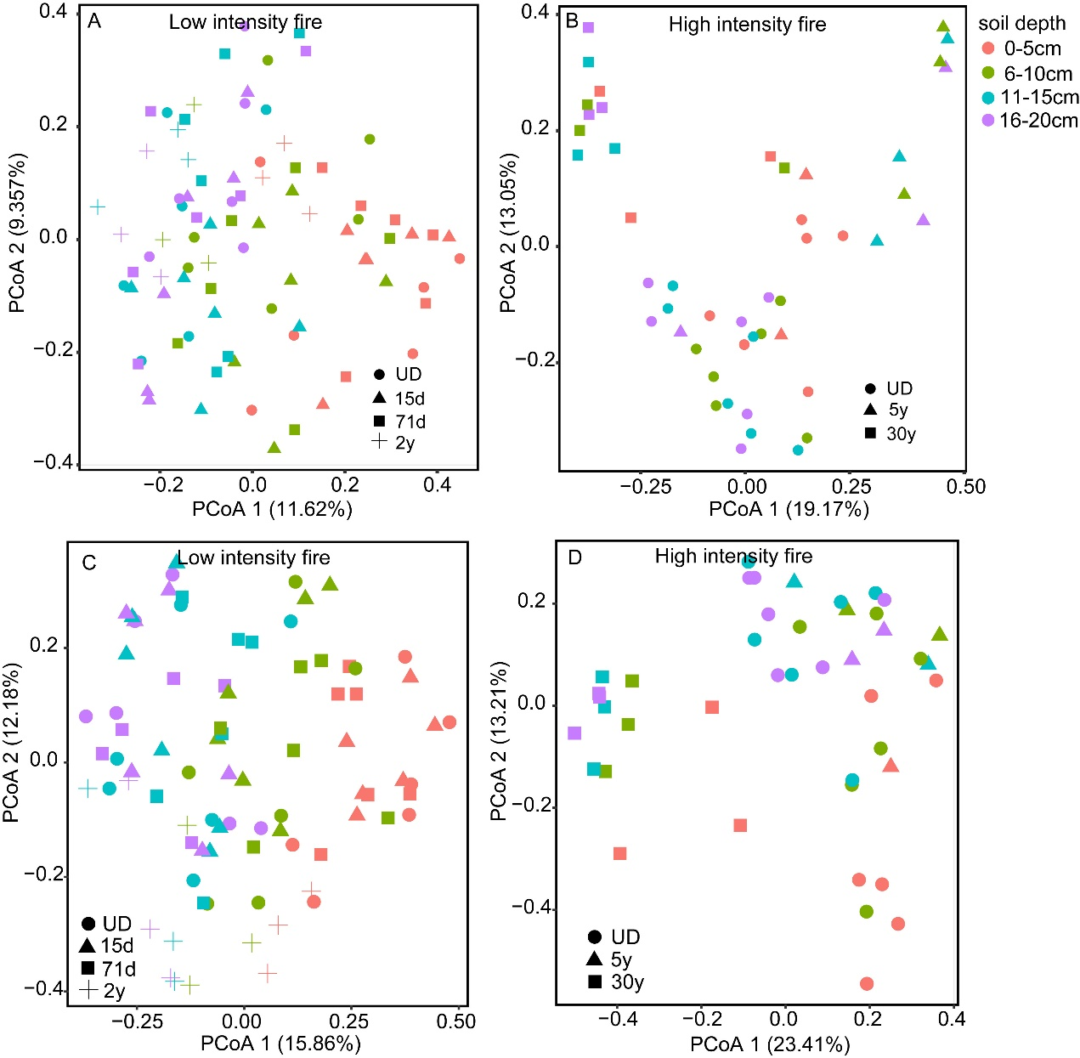

Supplementary Figure S3. The variation of soil physiochemical properties under low-intensity fire along time since fire, as revealed by the marginal effects in linear mixed-effects models. Only the significant relationships are shown. The gray shaded areas show the 95% confidence interval of the fit. The details are summarized in Supplementary Table S1.
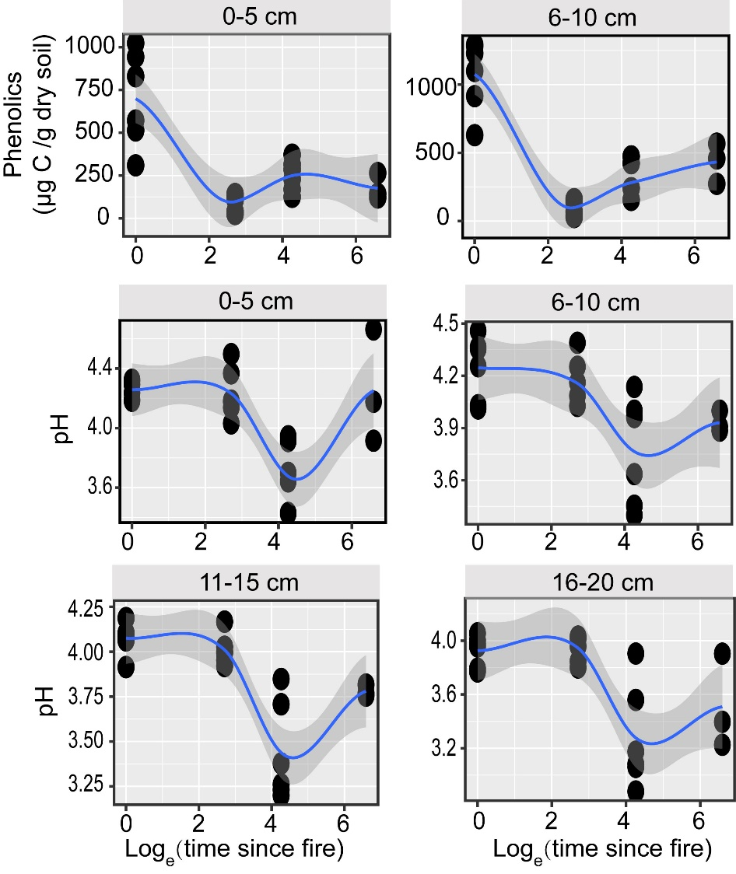

Supplementary Figure S4. The variation of soil physiochemical properties under high-intensity fire along time since fire, as revealed by the marginal effects in linear mixed-effects models. Only the significant relationships are shown. The gray shaded areas show the 95% confidence interval of the fit. The details, including parameters, are summarized in Supplementary Table S1.
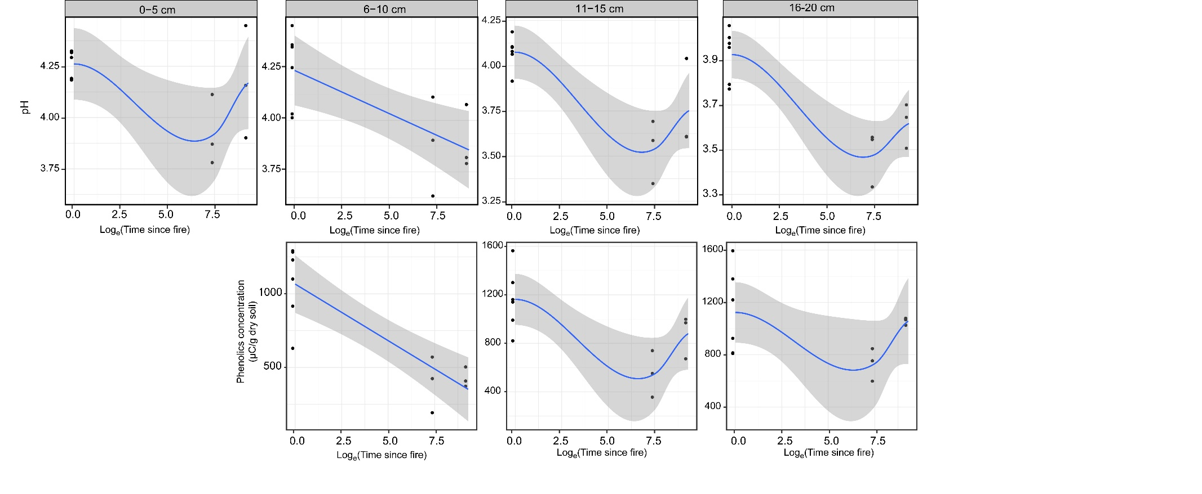

Supplementary Figure S5. Relationships between fungal ITS copy numbers (in logarithmic scale) and environmental factors. Solid line indicates linear fit. (A) Fungal ITS copy number vs. total carbon; (B) Fungal ITS copy number vs. ammonia concentration; (C) Fungal ITS copy number vs. dissolved soil carbon; (D) Fungal ITS copy number vs. pH value. Blue circles indicate samples from low-intensity fire; Red circles indicate amples from high-intensity fire.

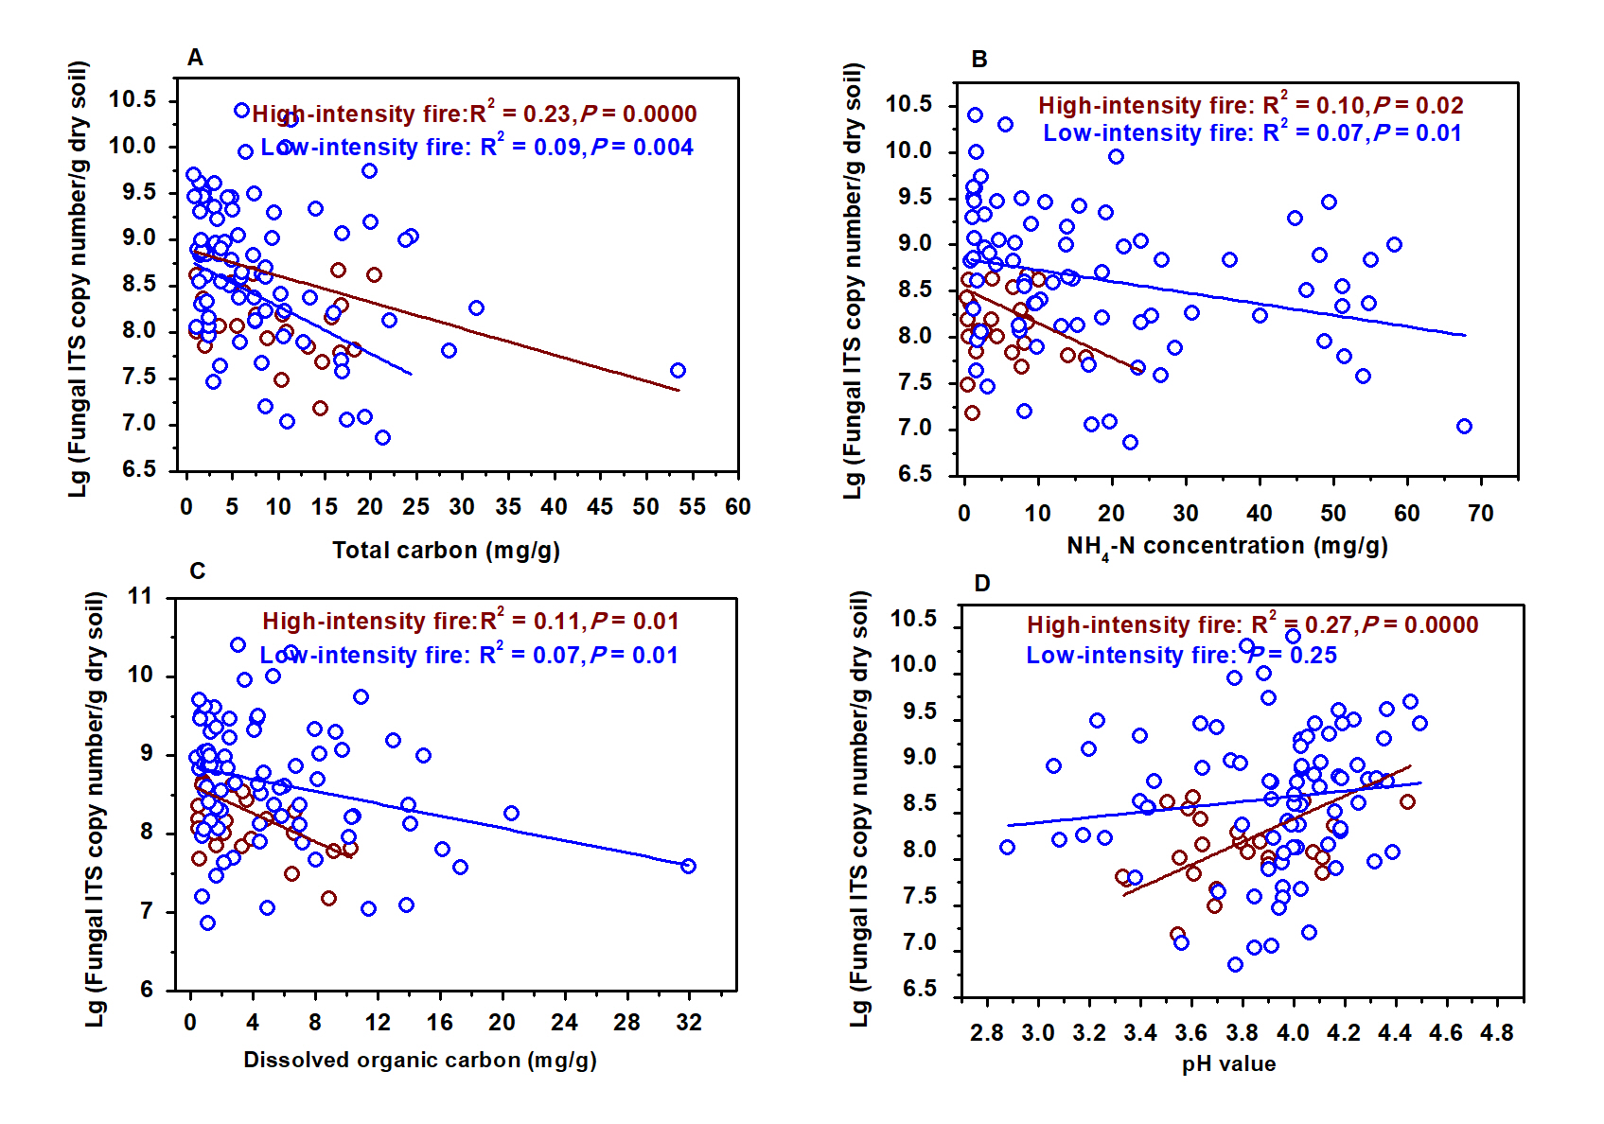

Supplementary Figure S6. Distance decay relationships of fungal community. (A) Low-intensity fire; (B) High-intensity fire.
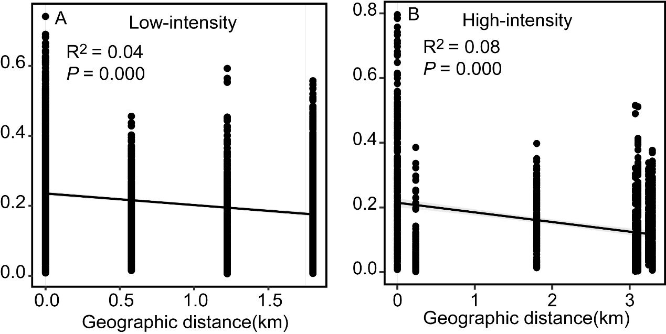

Supplementary Figure S7. The variation of relative abundance in fungal guilds and class along time since fire after low-intensity fire. A–B: Archaeorhizomycetes; C–D: Saprotrophs. Statistical significance effect of time since fire was determined using a linear mixed-effects model (where sampling sites as random factors). Only the significant relationships are shown. Marginal R² (R_{m}²) represents the variance explained by fixed effects. Significant differences are reported as *, P < 0.05; **, P < 0.01; ***, P < 0.001. The relative abundance for each fire stage at each soil layer is also given as the mean ± SE derived from 3 or 6 replicate measurements. Bars with the same letter were not significantly different in Tukey’s HSD test reported from one-way ANOVA. Fire stage: 2 years post-fire (2y); 15 days post-fire (15d); 71 days post-fire (71d); undisturbed (UD).

