Graphical abstract

Effect of different synthesis routes on the morphology, optical, colorimetric, and photocatalytic properties of β-Ag₂MoO₄ microcrystals
F.H.P. Lopesª, L.F.G. Noleto^{b}, V.E.M. Vieira^{b}, P.B. de Sousa^{c}, A.C.S. Jucáª, Y.L. Oliveira^{c}, K.R.B.S. Costa^{c}, M.A.P. Almeida^{d}, A.F. Gouveia^{e}, L.S. Cavalcante^{a,c*}
ªGERATEC-CETEM-PPGQ, Universidade Estadual do Piauí, Rua: João Cabral, N. 2231, P.O. Box 381, 64002150, Teresina-PI, Brazil
^{b}Programa de Pós-Graduação em Química–PPGQ, Universidade Federal do Piauí, Teresina–PI, 64049-550, Brazil
^{c}Programa de Pós-Graduação em Ciências e Engenharia dos Materiais-PPGCEM, Universidade Federal do Piauí, Teresina-Pi, 64049-550, Brazil
^{d}PPGQ, PPGAero, Centro de Ciências Exatas e Tecnologia, Universidade Federal do Maranhão-CCET, 65085–580, São Luís–MA, Brazil
^{e}Department of Analytical and Physical Chemistry, University Jaume I, Castelló, 12071, Spain
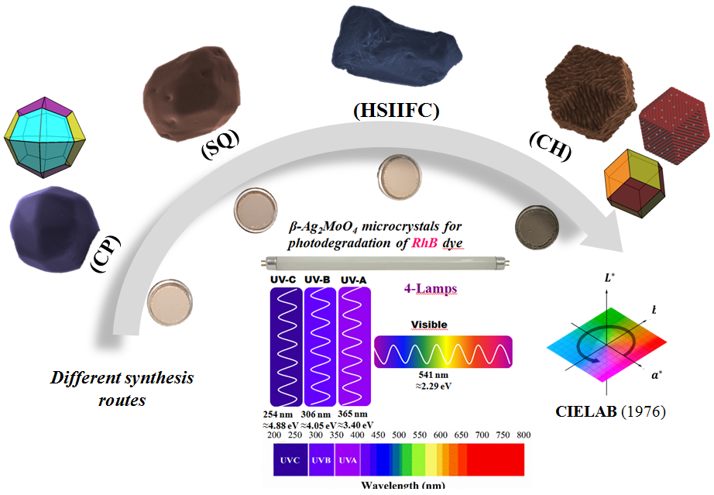
Highlights

• Structural, optical, colorimetric, and morphological studies of β-Ag₂MoO₄ microcrystals by four different chemical synthesis
• New observations and interpretations for photocatalysis properties at β-Ag₂MoO₄ microcrystals with specific sphapes and faced {112} exposed
• Photocatalytic tests were performed using four lamps: UV-C, UV-B, UV-A, and visible light

