Figure S1. Risk of bias of included randomized controlled trials (a, b) and cohort studies (c, d)
(a) Risk of bias graph of randomized controlled trials: review authors' judgements about each risk of bias item presented as percentages across all included studies
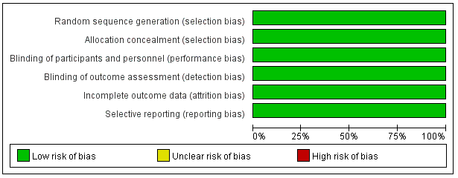

(b) Risk of bias graph of randomized controlled trials: review authors' judgements about each risk of bias item for each included study

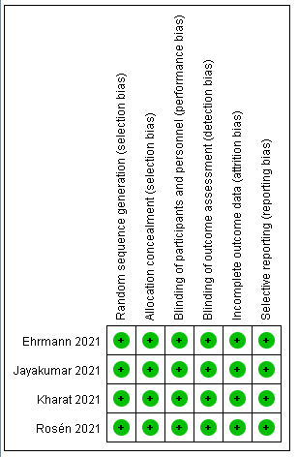

(c) Risk of bias graph of cohort studies: review authors' judgements about each risk of bias item presented as percentages across all included studies
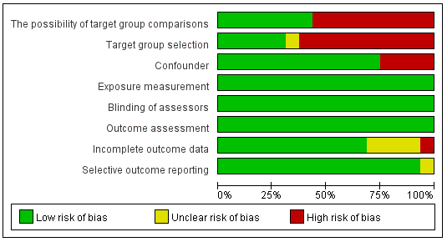

(d) Risk of bias graph of cohort studies: review authors' judgements about each risk of bias item for each included study
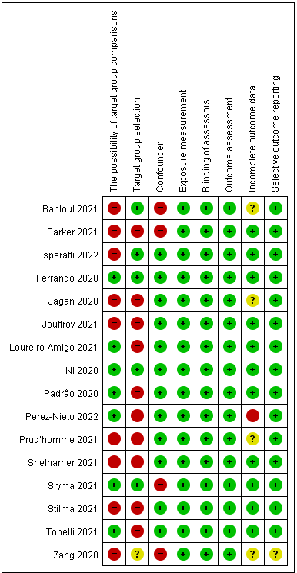

Figure S2. Subgroup analysis of mortality by oxygen delivery methods in non-intubated patients of cohort studies
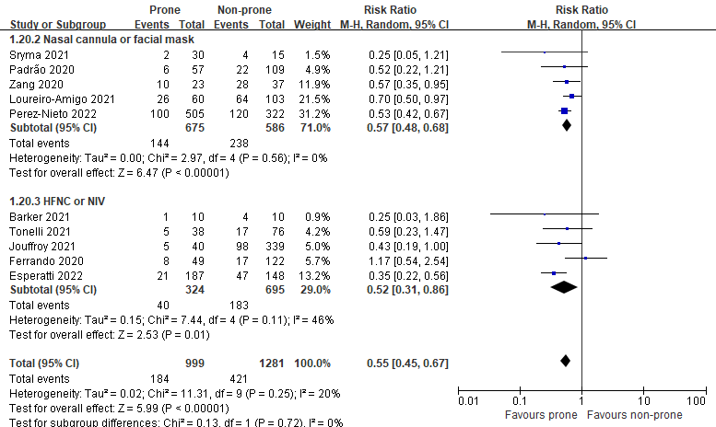

Figure S3. Contour-enhanced funnel plot for mortality in cohort studies
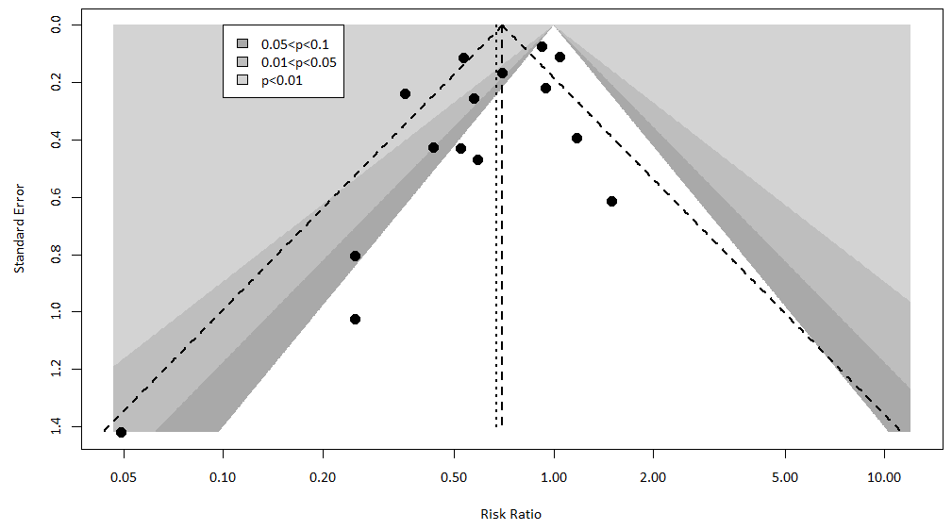

Figure S4. Subgroup analysis of intubation rate by oxygen delivery methods in non-intubated patients of cohort studies
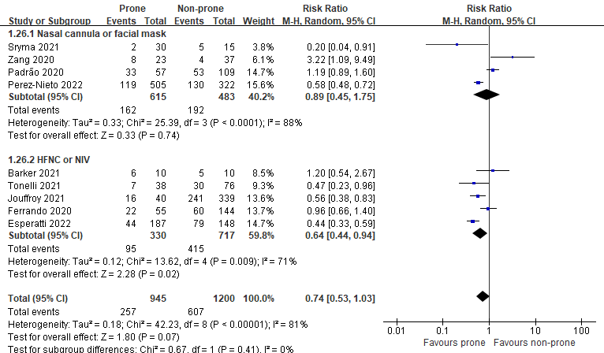

Figure S5. Contour-enhanced funnel plot for intubation rate in cohort studies
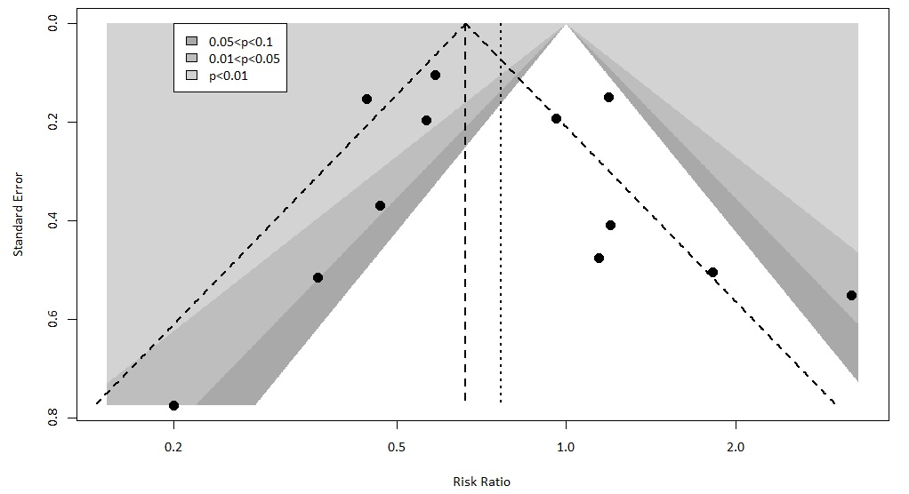

Figure S6. Adverse events in randomized controlled trials
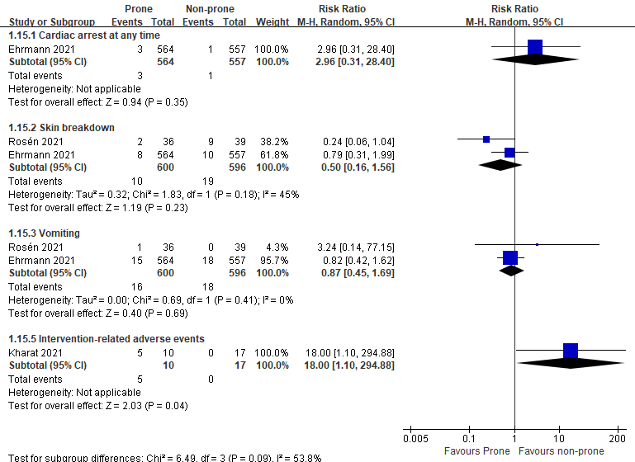

Table S1. Adverse events in cohort studies
Adverse events | Cases in the prone group | References
Desaturation or hemodynamic worsening | 0/30 | Sryma et al. (2021) [24]
Back pain | 2/30 | Sryma et al. (2021) [24]
Back pain | 3/57 | Padrão et al. (2020) [28]
Bloating sensation | 2/30 | Sryma et al. (2021) [24]
Endotracheal tube dislocation | 0/62 | Shelhamer et al. (2021) [9]
Peripheral line removal | 2/62 | Shelhamer et al. (2021) [9]
Peripheral line removal | 2/57 | Padrão et al. (2020) [28]
Major adverse events | 0/48 | Prud’homme et al. (2021) [30]
Overall adverse events | 0/17 | Ni et al. (2020) [5]
Overall adverse events | 0/38 | Tonelli et al. (2021) [32]

Figure S7. Length of stay in intensive care units in randomized controlled trials
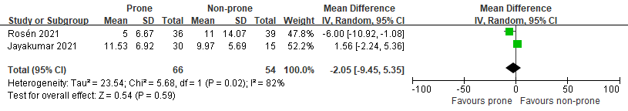

Figure S8. Length of stay in intensive care units in cohort studies

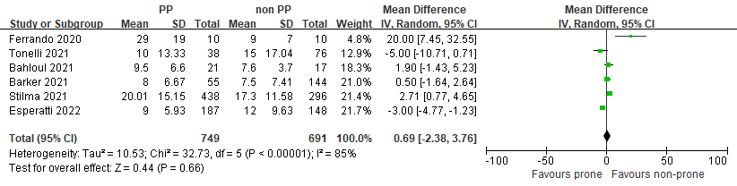

Figure S9. Length of stay in hospital in randomized controlled trials
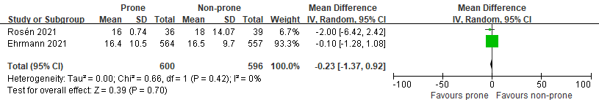

Figure S10. Length of stay in hospital in cohort studies
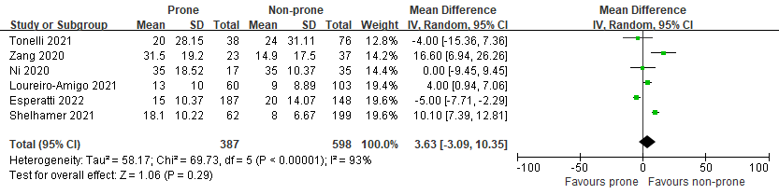

Figure S11. Ventilator-free days in cohort studies
