Nitrogen Transformation Processes in Manure Microbiomes of Earthen Pit and Concrete Storages on Commercial Dairy Farms
Supplementary File 1
Bela Haifa Khairunisa¹, Usha Loganathan², Jactone A. Ogejo^{3#}, Biswarup Mukhopadhyay^{1,2#*}

¹Genetics, Bioinformatics, and Computational Biology Ph.D. Program, Virginia Tech, Blacksburg, VA 24061, USA
²Department of Biochemistry, Virginia Tech, Blacksburg, VA 24061, USA
³Department of Biological System Engineering, VA 24061, USA

#Correspondence should be addressed to Jactone A. Ogejo (arogo@vt.edu) and Biswarup Mukhopadhyay (biswarup@vt.edu).
*Review contact corresponding author: Biswarup Mukhopadhyay; biswarup@vt.edu

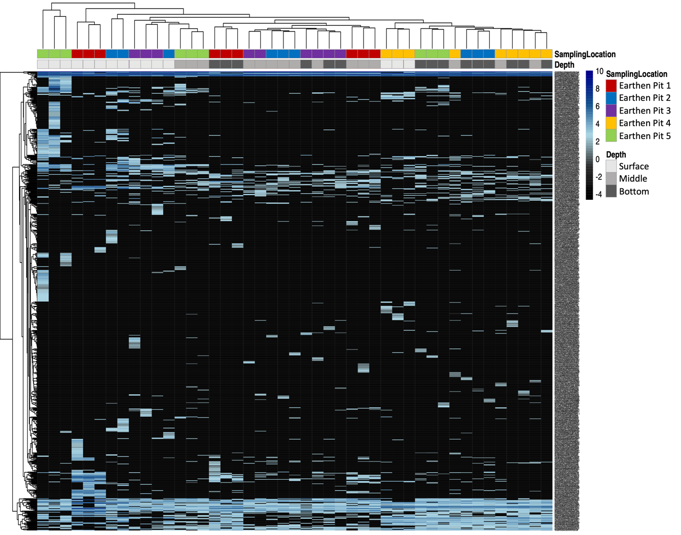
Figure S1. Site-specific enrichment of OTUs assigned to nitrogen transformation process in the earthen pit storage (EP). VST-transformed values of 740 OTUs that are potentially involved in nitrogen transformation during manure storage are presented as heat map, using the scale as shown on the right of the figure. Sampling location and depths, as defined in Fig. 2, are shown on the X-axis and Y-axis presents the OTU ids.
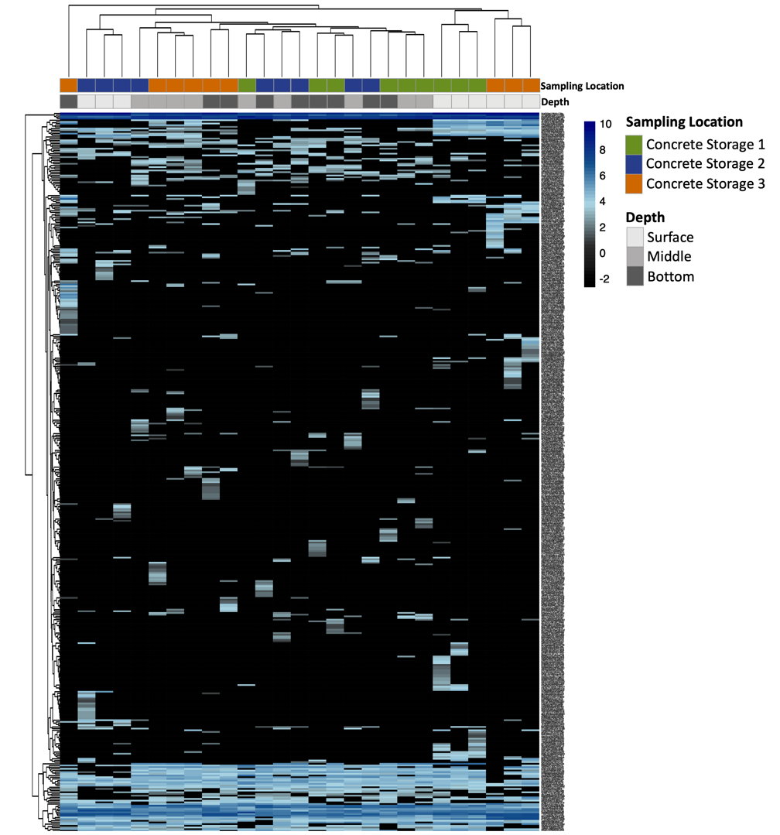
Figure S2. Site-specific enrichment of OTUs assigned to nitrogen transformation process in the concrete storage (CS). VST-transformed values of 270 OTUs that are potentially involved in nitrogen transformation during manure storage are presented as heat map, using the scale as shown on the right of the figure. Sampling location and depths, as defined in Fig. 2, are shown on the X-axis and Y-axis presents the OTU ids.

Supplementary Method

Method S1. DNA extraction
In brief, 200 mg of a manure sample was mixed with 1 ml of inhibitEX buffer (cat. no. 19593, Qiagen, Germantown, MD) in a 1.5 ml polypropylene microcentrifuge tube and the mixture was vortexed vigorously for one minute using a standard heavy-duty vortex mixer (VWR International, LCC, Radnor, PA) operating at 2,500 rpm. The homogenized sample was incubated at 90°C for 5 minutes, vortexed again for 15 seconds at 2,500 rpm, and centrifuged at 16,000 x g for one minute. The resultant supernatant was transferred into a new microcentrifuge tube and the centrifugation step was repeated twice to minimize solid material carry over. To the clarified supernatant, RNase A (Sigma-Aldrich; cat. no. 9001-99-4) was added to a final concentration of 0.5 mg/ml. The mixture was incubated at 37°C for 3 minutes and then centrifuged for 3 minutes at 16,000 x g. Resulted aqueous phase was transferred to a fresh microcentrifuge tube and mixed with Qiagen Proteinase K to a final concentration of 0.83 mg/ml. Then, an equal volume of Buffer AL (Qiagen) was added to the mixture. The rest of the steps followed the manufacturer’s instruction (Qiagen). Quantification and quality assessment of DNA samples were performed via both agarose gel electrophoresis and Nanodrop measurements (NanoDrop Lite UV-Vis Spectrophotometer; cat. no. ND-LITE; ThermoFisher Scientific, Waltham, MA). In order to determine whether a DNA preparation contained inhibitors that could affect downstream processes, full length 16S rRNA genes were PCR amplified using universal primers 27F and 1525R (3). Samples yielding a full-length product were considered suitable for sequencing.

