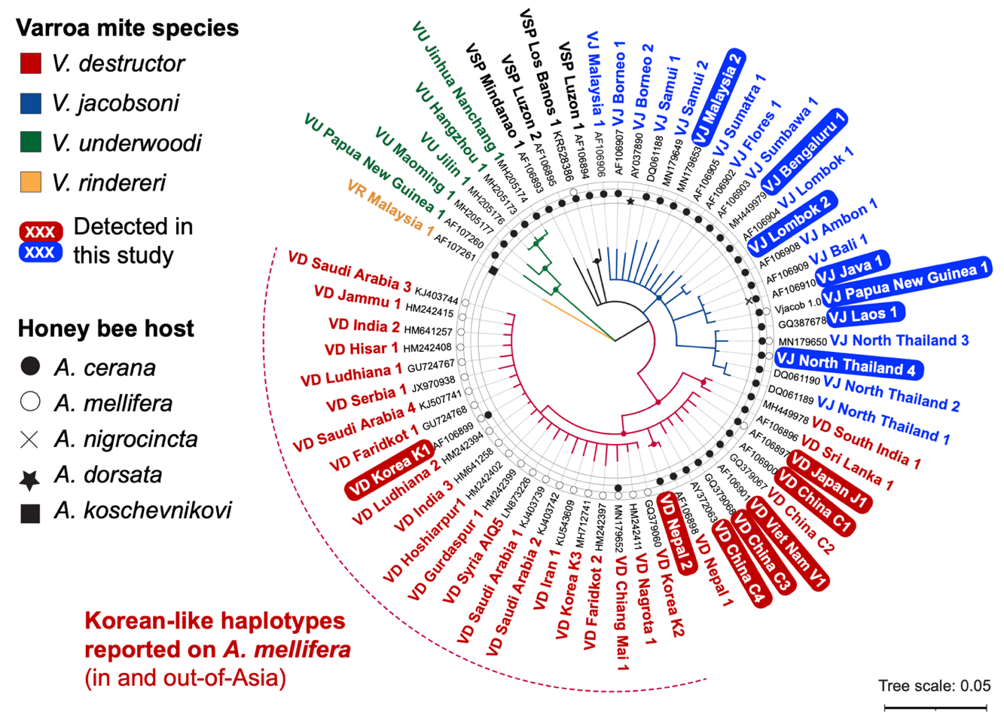

Figure S1: Sequenced V. destructor and V. jacobsoni mites originated from diverse maternal genetic backgrounds (lineages) shown by mtDNA COX1 barcoding. A neighbor-joining tree was built using the Tamura-Nei genetic distance model with 1,000 bootstraps (> 80% are shown as filled circles in the base of each branch). V. rindereri was considered as an outgroup and the host range indicated (D. L. Anderson and Trueman 2000). V. destructor mites collected throughout Asia on their original host belong to seven distinct lineages (see details in Table S2). By contrast, all the host-switched mites across that range belong to the Korean K1 haplotype [AF106899], which is also found worldwide (Traynor et al. 2020). V. jacobsoni mites collected throughout Southeast Asia and Oceania, we identified seven lineages including two newly described: Lombok 2 and North Thailand 4. All mites parasitizing A. mellifera in Papua New Guinea were infested only by the V. jacobsoni Papua New Guinea 1 haplotype. The novel haplotype, North Thailand 4, was found on one A. mellifera colony in the northern limit of V. jacobsoni native range.

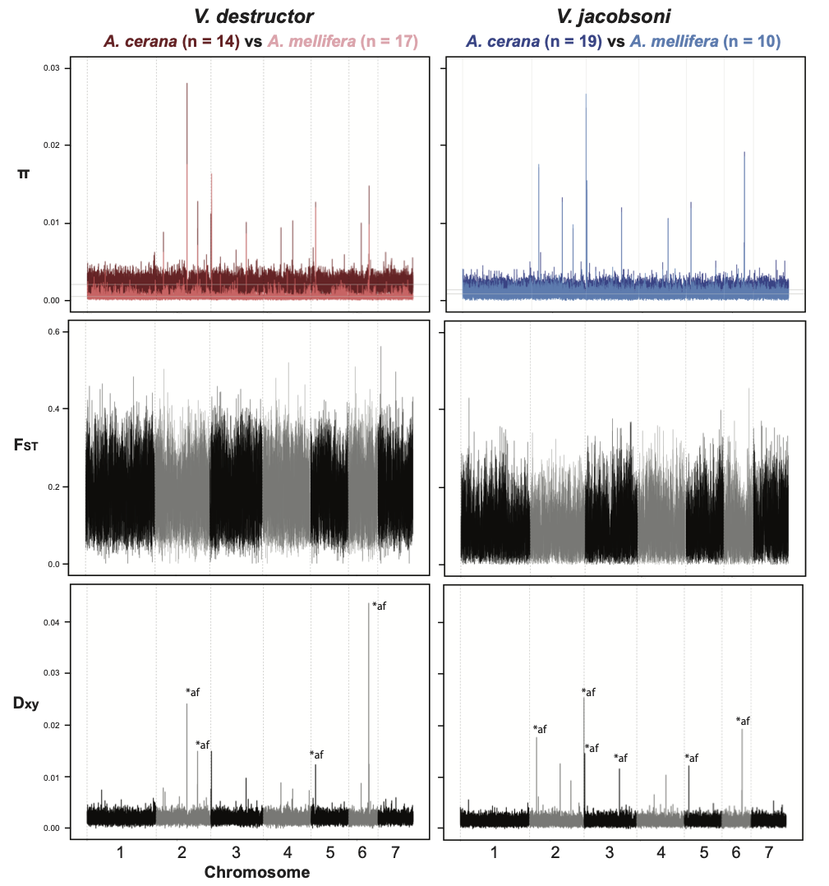
Figure S2: Parallel reduction of genetic diversity and genomic divergence between hosts in V. destructor and V. jacobsoni. First row: Nucleotide diversity in 20kb window along all seven chromosomes with mites parasitizing the same host pooled as one population for each Varroa species. Genetic divergence estimated by pairwise F_{ST} (second row) and absolute divergence using D_{xy} estimate (third row) in 20kb window, show a strong host differentiation all along the genome with few outliers. All sites with D_{xy} value > 0.01 were investigated manually by examining individual genotypes, which showed an excess in heterozygosity levels. These regions were also poorly conserved within species and had BLAST matches elsewhere in the genome, suggesting the presence of sequencing artefacts rather than biological signal (labelled *af on the plots).
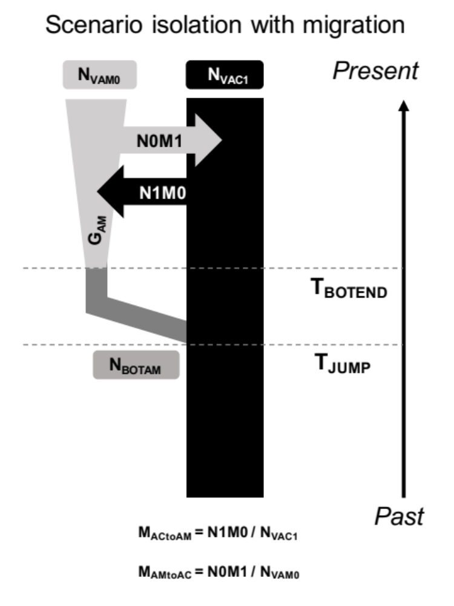
Figure S3 Graphical representation of Varroa host switch demographic scenario designed following population genomics analysis. The model was run independently for each Varroa species but contained the same parameters. N_{VAM0} is the present effective population size on the novel host (A. mellifera) whereas N_{VAC1} is the present population size on the original host (A. cerana). At a time in the past, T_{JUMP}, a founding size of N_{BOTAM} switched durably host from A. cerana to A. mellifera. The founder effect associated with host switch ended at T_{BOTEND} and population on novel host expanded at a growth rate G_{AM}. As both hosts are in artificial sympatry with evidence of gene flow, migration rates were estimated for spillover (M_{ACtoAM}) and spillback (M_{AMtoAC}). See Table 2 for parameters prior details.

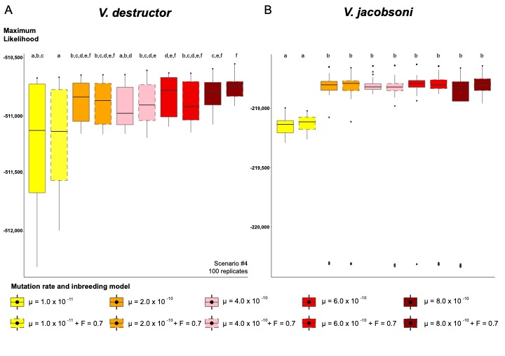

Figure S4 Distribution of the maximum likelihood obtained from the best pseudo-observed SFS generated by demographic inferences across different mutation rates and inbreeding levels in Varroa species. Replicates generated with lower mutation rates than the directly estimated 8.0 x 10⁻¹⁰ were not associated with a better fit to the observed SFS from our genomic data for V. destructor (A) and V. jacobsoni (B). No significant differences were detected in the likelihood variance among different mutation rates. However, pairwise Wilcoxon test significance (letters) after Bonferroni corrections showed that the lower mutation rate differentiated from other rates, especially in V. jacobsoni.

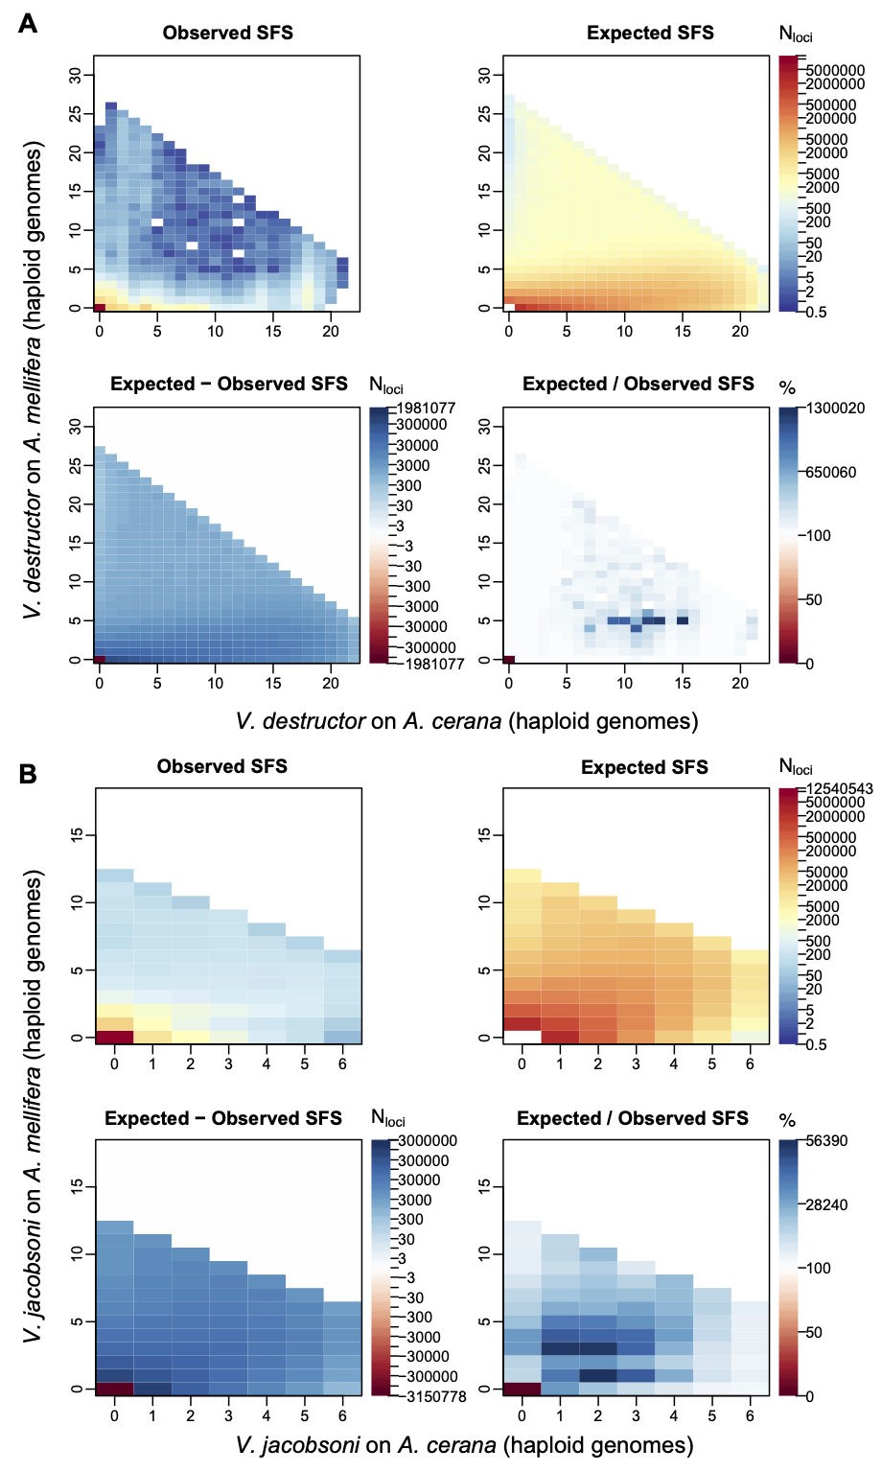
Figure S5: Observed vs expected joint 2D-SFS from the best replicate of the isolation with migration scenario for V. destructor and V. jacobsoni.
Table S1: Detailed sampling information for each of the Varroa mite sequenced for population genomics as well as for estimation of the mutation rate. Sampling details include Varroa species, host identity, country and locality, date and geographical coordinates. Sequencing details include the DRA accession on NCBI, the total number of reads, mapped reads, mapping ratio and mean read depth. Mitochondrial lineages and mitotype identity are also included for each specimen.

Table S2: Repertoire of standard mtDNA markers used to determine mite species and lineages of sequenced specimens. Names given to new mitotype were chosen to follow the revised nomenclature and compared to V. destructor and V. jacobsoni reference sequences (source and sequence accession indicated).

Table S3: Observed (O_{HOM}) and expected (E_{HOM}) homozygosity and inbreeding coefficient (F) values computed for each sequenced mite on N_{SITES} for the population genomics analysis.

Table S4: Pairwise Weir and Cockerham F_{ST} values computed between host-adapted Varroa species and between host-adapted Varroa mtDNA lineages. The color shades indicate relatively high genetic differentiation (in red), moderate (in yellow) to a low one (in green).

Table S5: Number of reads from whole-body Varroa sample mapped against A. mellifera and A. cerana mitochondrial reference genomes. Host metagenomics identity was assigned by the higher number of reads and compared to the field collection information. The proof of concept was confirmed with Mom and Son samples collected while feeding on their A. mellifera host.

