Supplementary materials

Regression models

Regression model for the change in MMSE score over time.
OLS Regression Results
===============================================================================================================
Dep. Variable: MMSE_diff_COVID R-squared: 0.099
Model: OLS Adj. R-squared: 0.063
Method: Least Squares F-statistic: 2.745
Date: Tue, 23 Feb 2020 Prob (F-statistic): 0.00996
Time: 16:45:45 Log-Likelihood: 554.99
No. Observations: 183 AIC: -1094.
Df Residuals: 175 BIC: -1068.
Df Model: 7
Covariance Type: nonrobust
===============================================================================================================
coef std err t P>|t| [0.025 0.975]
---------------------------------------------------------------------------------------------------------------
Intercept -0.0021 0.001 -1.552 0.122 -0.005 0.001
Sex[male] 0.0029 0.002 1.523 0.130 -0.001 0.007
APOE4[true] 0.0006 0.002 0.307 0.759 -0.003 0.004
Takes_anxiety_meds[true] -0.0010 0.003 -0.389 0.698 -0.006 0.004
CDR_cat[impaired] -0.0069 0.002 -3.485 0.001 -0.011 -0.003
Age 0.0002 0.000 0.924 0.357 -0.000 0.001
CDR_cat[impaired]:Age 0.0002 0.000 0.557 0.578 -0.000 0.001
YearsOfEducation -0.0001 0.000 -0.475 0.635 -0.001 0.000 ==============================================================================
Omnibus: 107.531 Durbin-Watson: 2.011
Prob(Omnibus): 0.000 Jarque-Bera (JB): 907.541
Skew: -2.054 Prob(JB): 8.51e-198
Kurtosis: 13.110 Cond. No. 21.0
==============================================================================

Regression model for the change in GAD-7 score.
OLS Regression Results
===============================================================================================================
Dep. Variable: GAD_diff_COVID R-squared: 0.110
Model: OLS Adj. R-squared: 0.075
Method: Least Squares F-statistic: 3.200
Date: Thu, 12 Nov 2020 Prob (F-statistic): 0.00320
Time: 18:39:00 Log-Likelihood: -488.93
No. Observations: 190 AIC: 993.9
Df Residuals: 182 BIC: 1020.
Df Model: 7
Covariance Type: nonrobust
===============================================================================================================
coef std err t P>|t| [0.025 0.975]
---------------------------------------------------------------------------------------------------------------
Intercept 0.0057 0.003 2.076 0.039 0.000 0.011
Sex[male] -0.0029 0.004 -0.771 0.442 -0.010 0.005
APOE4[true] -0.0002 0.004 -0.048 0.962 -0.008 0.008
Takes_anxiety_meds[true] -0.0058 0.006 -1.032 0.303 -0.017 0.005
CDR_cat[impaired] -0.0108 0.004 -2.667 0.008 -0.019 -0.003
Age -0.0002 0.000 -0.423 0.673 -0.001 0.001
CDR_cat[impaired]:Age 0.0016 0.001 2.408 0.017 0.000 0.003
YearsOfEducation 0.0004 0.001 0.702 0.484 -0.001 0.001
==============================================================================
Omnibus: 71.296 Durbin-Watson: 1.735
Prob(Omnibus): 0.000 Jarque-Bera (JB): 1034.901
Skew: -1.056 Prob(JB): 1.88e-225
Kurtosis: 14.830 Cond. No. 20.07
==============================================================================

Regression model for the level of subjective stress directly due to COVID-19 (CovidStress25).
OLS Regression Results
===================================================================================
Dep. Variable: stress_COVID R-squared: 0.079
Model: OLS Adj. R-squared: 0.050
Method: Least Squares F-statistic: 2.735
Date: Thu, 12 Nov 2020 Prob (F-statistic): 0.00963
Time: 18:30:26 Log-Likelihood: -702.44
No. Observations: 231 AIC: 1421.
Df Residuals: 223 BIC: 1448.
Df Model: 7
Covariance Type: nonrobust
===============================================================================================================
coef std err t P>|t| [0.025 0.975]
--------------------------------------------------------------------------------------------------------------
Intercept 0.8226 0.356 2.309 0.022 0.119 1.526
Sex[male] -0.2690 0.502 -0.536 0.593 -1.260 0.722
APOE4[true] -0.4655 0.527 -0.884 0.378 -1.506 0.575
Takes_anxiety_meds[true] -1.1012 0.719 -1.531 0.128 -2.521 0.319
CDR_cat[impaired] -1.4177 0.529 -2.681 0.008 -2.462 -0.373
Age -0.0180 0.050 -0.355 0.723 -0.118 0.082
CDR_cat[impaired]:Age 0.2074 0.086 2.400 0.018 0.037 0.378
YearsOfEducation -0.0037 0.065 -0.056 0.955 -0.132 0.124
==============================================================================
Omnibus: 13.308 Durbin-Watson: 1.902
Prob(Omnibus): 0.001 Jarque-Bera (JB): 24.451
Skew: 0.366 Prob(JB): 4.90e-06
Kurtosis: 4.732 Cond. No. 19.8 ==============================================================================

Regression model for the knowledge on COVID-19 score.
OLS Regression Results
==========================================================================================
Dep. Variable: knowledge_score_COVID R-squared: 0.190
Model: OLS Adj. R-squared: 0.170
Method: Least Squares F-statistic: 9.268
Date: Tue, 01 Dec 2020 Prob (F-statistic): 3.97e-09
Time: 11:30:47 Log-Likelihood: -674.61
No. Observations: 244 AIC: 1363.
Df Residuals: 237 BIC: 1388.
Df Model: 6
Covariance Type: nonrobust
====================================================================================================================
coef std err t P>|t| [0.025 0.975]
--------------------------------------------------------------------------------------------------------------- Intercept 1.6001 0.425 3.769 0.000 0.763 2.437
Sex[male] -1.0663 0.603 -1.768 0.079 -2.255 0.123
APOE4[true] 0.0526 0.621 0.085 0.933 -1.172 1.277
CDR_cat[impaired] -3.3621 0.620 -5.426 0.000 -4.584 -2.140
Age 0.0355 0.055 0.642 0.522 -0.074 0.145
CDR_cat[impaired]:Age 0.1315 0.083 1.576 0.117 -0.033 0.296
YearsOfEducation 0.0553 0.079 0.697 0.487 -0.101 0.212
==============================================================================
Omnibus: 56.433 Durbin-Watson: 1.833
Prob(Omnibus): 0.000 Jarque-Bera (JB): 140.231
Skew: -1.223 Prob(JB): 3.54e-31
Kurtosis: 6.255 Cond. No. 18.2 ==============================================================================

Knowledge of COVID-19
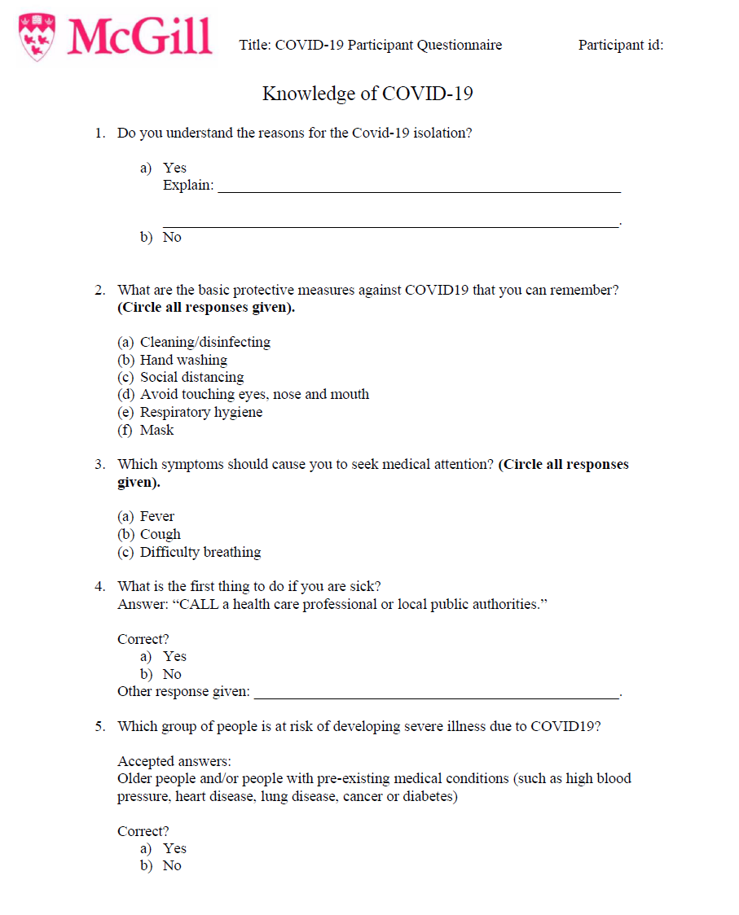

Montreal Assessment of Stress related to COVID-19 (MASC)
