Supplementary material
Aquaculture International
Effects of scallop visceral mass and mantle as dietary supplements on the physiology, immune response and intestinal microflora of sea cucumber Apostichopus japonicus
Yu Yu ¹, Mengshu Wang¹, Yichao Ren ^{1*}, Xin Wang^{1, 2}, Xiangyun Ge ^{1, 2}, Kecheng Li ^{2,3}
1 School of Marine Science and Engineering, Qingdao Agricultural University, Qingdao 266109, China
2 CAS and Shandong Province Key Laboratory of Experimental Marine Biology, Institute of Oceanology, Chinese Academy of Sciences, Qingdao 266071, China
3 Laboratory for Marine Drugs and Bioproducts, Pilot National Laboratory for Marine Science and Technology (Qingdao), Qingdao 266237, China

E-mail addresses of corresponding author: lkc@qdio.ac.cn (K. Li); yichaor@126.com (Y. Ren).

Table S1 Primers for gene expression. The cytb gene was selected as the reference gene
Target genes | Primers | Sequence
cytb | F | TGAGCCGCAACAGTAATC
 | R | AAGGGAAAAGGAAGTGAAAG
TLR3 | F | AAATACGAACACGATGTAGCGA
 | R | TTCTTTTCAATGGACGAGGC
AjToll | F | ACGAAAGCGATTTAGCC
 | R | GAGCCCGTGGTGAGATG
MyD88 | F | TTTAGCCTTAGGACCGACCG
 | R | GCCTCTTTTACTCCCCCAATTA
TRAF6 | F | TGGGAAGCAAATCGCAAA
 | R | CGACTACCACCTTAGGACACGT
p50 | F | TCCTATCGGTCTGAATCTTCCAA
 | R | TTTCTTCCCTTTCTGGCTATGTTC
p105 | F | GCAACACACCCCTCCATCTT
 | R | TCTTCTTCGCTAACGTCACACC
rel | F | TGAAGGTGGTATGCGTCTGG
 | R | TTGGGCTGCTCGGTTATG
MKK36 | F | CCGAGGAGAAAGGATCAAGAGA
 | R | TTATGACAGGGTAGCCACACAA
p38 | F | ACATAGACATAAATCCAATCGGC
 | R | AAGGTGAAAATACATCCAACAGG

Table S2 Amino acid composition in tissue of sea cucumber and feed ingredients (%)
Amino acid | CK | SV | SM | scallop visceral mass | scallop mantal
Asp | 4.38±0.24 | 4.36±0.19 | 4.31±0.14 | 3.61 | 4.28
Thr | 2.16±0.15 | 2.13±0.1 | 2.1±0.09 | 1.51 | 1.93
Ser | 2.18±0.09 | 2.15±0.14 | 2.06±0.15 | 1.26 | 1.47
Glu | 6.81±0.4 | 6.94±0.38 | 6.91±0.14 | 5.11 | 7.58
Gly | 4.64±0.47 | 4.59±0.13 | 4.84±0.16 | 4.25 | 7.39
Ala | 2.39±0.16 | 2.41±0.1 | 2.42±0.15 | 1.94 | 2.81
Cys | 0.24±0.05 | 0.32±0.06 | 0.25±0.08 | 0.62 | 0.2
Val | 1.97±0.12 | 1.97±0.14 | 1.96±0.11 | 1.75 | 2.43
Met | 0.11±0.03 | 0.13±0.05 | 0.2±0.18 | 0.21 | 0.63
Ile | 1.64±0.09 | 1.64±0.13 | 1.65±0.17 | 1.5 | 2.17
Leu | 2.48±0.15 | 2.48±0.17 | 2.4±0.11 | 2.3 | 3.27
Tyr | 0.99±0.14 | 0.67±0.57 | 1.02±0.06 | 0.84 | 1.46
Phe | 1.69±0.08 | 1.93±0.42 | 1.62±0.06 | 1.3 | 1.73
His | 1.62±0.02ª | 1.66±0.12ª | 1.45±0.08^{b} | 1.17 | 1.28
Lys | 2.15±0.07 | 2.2±0.12 | 2.14±0.14 | 2.89 | 3.17
Arg | 3.01±0.17 | 3.04±0.15 | 3.12±0.19 | 1.46 | 1.59
Pro | 2.69±0.27 | 2.76±0.09 | 2.74±0.18 | 1.1 | 2
∑AA | 41.16±2.32 | 41.38±1.99 | 41.19±1.41 | 32.82 | 45.39
∑EAA | 12.2±0.64 | 12.47±0.37 | 12.07±0.52 | 11.46 | 15.34
∑NEAA | 28.95±1.72 | 28.91±1.76 | 29.12±0.96 | 21.36 | 30.05
∑EAA/∑NEAA | 0.42±0.01 | 0.43±0.02 | 0.41±0.01 | 0.54 | 0.51
∑EAA/∑AA | 0.3±0.01 | 0.3±0.01 | 0.29±0.01 | 0.35 | 0.34
AA: amino acid; EAA: essential amino acid; NEAA: non-essential amino acid;

Fig.S1 Composition and relative abundance (%) of microbial communities in each group at (A) Class and (B) Order levels, respectively

Fig. S2 Cladogram of the microbial communities in different dietary supplement groups on days 15 and 40 by linear discriminant analysis (LDA) with a threshold of 3. The color mode means differentially abundant taxa identified as biomarkers in different treatments. The six rings of the cladogram from inner to outside stand for phylum, class, order, family, genus and species
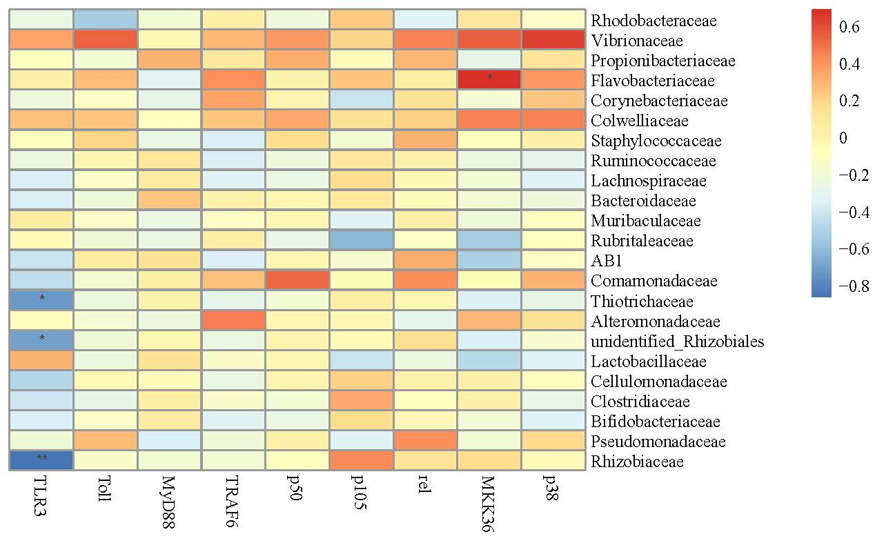
Fig. S3 Correlations between the immune-related genes and top 20 families and major biomarker families of microbial communities in intestine of the A. japonicas. (* P < 0.05, ** P < 0.01)

