Suppl. Figure 1
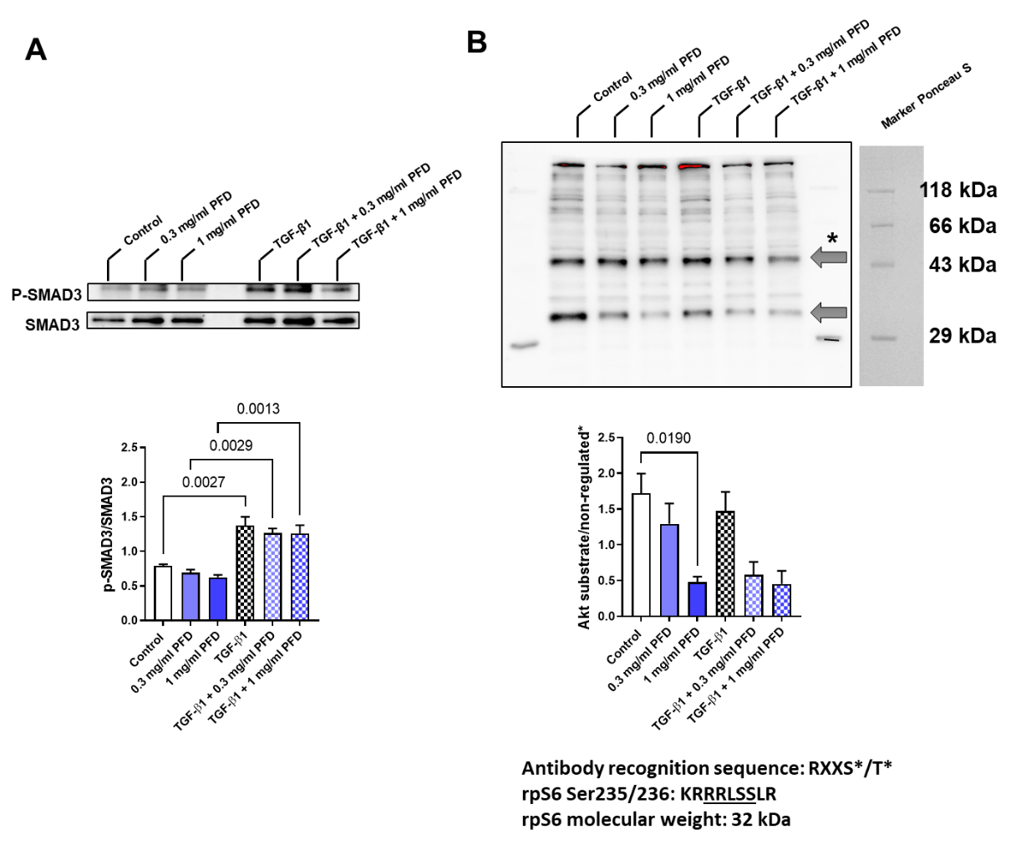
PFD effects on protein phosphorylation in 2D-cultured human CF. A) Human CF were treated with 0, 0.3, or 1.0 mg/ml PFD for 4 h and then 5 ng/ml TGF-β1 was applied for 30 min. Cell lysates were used for immunoblot analysis. A) Shown are representative immunoblots and the analysis of SMAD3 phosphorylation. B) An antibody that recognizes the phosphorylated sequence RXXS*/T* was used for the presented immunoblot and its analysis. The lower band, indicated by an arrow, is supposedly the phosphorylated version of rpS6. The upper indicated band was used for normalization. All results were obtained from 3 independent experiments and shown are the means+SEM with the significant p-values as assessed by 1way-ANOVA with Tukey’s multiple comparison test.

