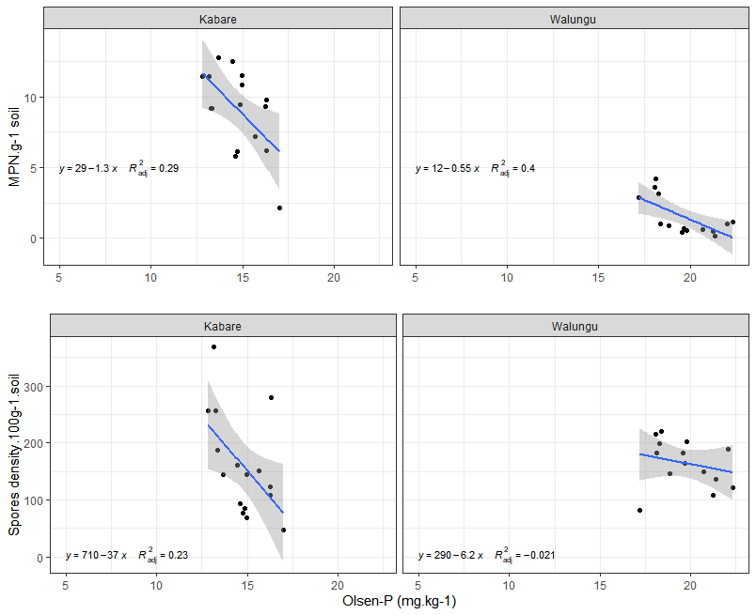
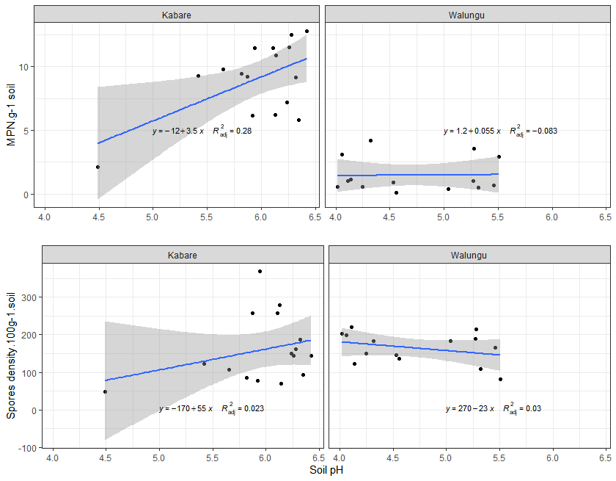
a)
b)
c)
d)

Supplementary figure 1: Linear regression between soil properties and mycorrhizal parameters in Kabare and Walungu territory. Relationship analysis between soil Olsen-P and soil mycorrhizal potential (MPN of AM propagules. g⁻¹ soil): a, and spores density (number of spores. 100 g⁻¹ soil): c. Linear regression analysis between soil soil pH and soil mycorrhizal potential (MPN of AM propagules. g⁻¹ soil): b and spores density (number of spores. 100 g⁻¹ soil): d.

