Sirt6 reprograms myofibers to oxidative type through CREB-dependent Sox6 suppression

Running title: Sirt6 is a molecular switch regulating myofiber composition

Contents
- Supplementary table
- Supplementary figures

Supplementary Table 1
Table S1. Sequences and accession numbers for primers (forward, FOR; reverse, REV) for real-time RT-PCR and PCR analyses
Gene (qPCR) |  | Sequences for primers
Myh7 | FOR: ACAAGCTGCAGCTGAAGGTG
Myh7 | REV: TCATTCAGGCCCTTGGCAC
Myh2 | FOR: CCAGCTGCACCTTCTCGTTTGCCAG
Myh2 | REV: CATGGGGAAGATCTGGTCTTCTT
Tnni1 | FOR: TGAAGCCAAATGCCTCCACAACAC
Tnni1 | REV: ACACCTTGTGCTTAGAGCCCAGTA
Tnnc1 | FOR: AGCTCATGAAGGACGGTGACAAGA
Tnnc1 | REV: AACCGTGCAAGACCAGCATCTACT
Tnnt1 | FOR: AAGGGGAGCGTGTGGATTTTG
Tnnt1 | REV: TCCTCCTTTTTCCGCTGTTCA
Myh4 | FOR: CCTGGAACAGACAGAGAGGAGCAGGAGAG
Myh4 | REV: GTGAGTTCCTTCACTCTGCGCTCGTGC
Myh1 | FOR: TGCAACAGTTCTTCAACCAC
Myh1 | REV: GCCAGGTCCATCCCAAAGT
Tnnt3 | FOR: AACTGGAGACTGACAAATTCGAGT
Tnnt3 | REV: GCTGTGCTTCTGGGTTTGGT
Tnnc2 | FOR: CCATCATCGAGGAGGTGGAC
Tnnc2 | REV: CTTCCCCTTCGCATCCTCTT
Tnni2 | FOR: GCACCTGAAGAGTGTGATGCT
Tnni2 | REV: TCTCCTTCTCAGATTCTCGGC
Ppia | FOR: GCATACGGGTCCTGGCATCTTGTCC
Ppia | REV: ATGGTGATCTTCTTGCTGGTCTTGC
Mb | FOR: CATGGTTGCACCGTGCTCACAG
Mb | REV: GAGCCCATGGCTCAGCCCTG
Sdhb | FOR: CAGAGTCGGCCTGCAGTTTC
Sdhb | REV: GGTCCCATCGGTAAATGGCA
Fndc5 | FOR: TCCTCTTCATGTGGGCAGGT
Fndc5 | REV: GGGCTCGTTGTCCTTGATGATA
Nrf1 | FOR: GGAGCACTTACTGGAGTCC
Nrf1 | REV: CTGTCCGATATCCTGGTGGT
Tfam | FOR: GCAAAGGATGATTCGGCTCAGGGAA
Tfam | REV: CCGGATCGTTTCACACTTCGACGG
Mtco1 | FOR: CTACTATTCGGAGCCTGAGC
Mtco1 | REV: GCATGGGCAGTTACGATAAC
Mtco2 | FOR: AACCATAGGGCACCAATGATAC
Mtco2 | REV: GGATGGCATCAGTTTTAAGTCC
Mcad | FOR: GGTTTGGCTTTTGGACAATG
Mcad | REV: TGACGTGTCCAATCTACCACA
Atp5o | FOR: TCTCGACAGGTTCGGAGCTT
Atp5o | REV: AGAGTACAGGGCGGTTGCATA
Cox5b | FOR: TTCAAGGTTACTTCGCGGAGT
Cox5b | REV: CGGGACTAGATTAGGGTCTTCC
Cycs | FOR: CCAAATCTCCACGGTCTGTTC
Cycs | REV: ATCAGGGTATCCTCTCCCCAG
Ndufs1 | FOR: TGCAAATCCCTCGATTCTGTTAC
Ndufs1 | REV: GCTTTCTCAATCTCTACCAGGC
Ndufv2 | FOR: GCAAGGAATTTGCATAAGACAGC
Ndufv2 | REV: TAGCCATCCATTCTGCCTTTG
Nr4a3 | FOR: TAGCCATCCATTCTGCCTTTG
Nr4a3 | REV: TGGTGTATTCCGAGCCATAAGT
Ppargc1a | FOR: ACGAGGCCAGTCCTTCCTCC
Ppargc1a | REV: AGCTCTGAGCAGGGACGTCT
Nr4a1 | FOR: TGATGTTCCCGCCTTTGC
Nr4a1 | REV: CAATGCGATTCTGCAGCTCTT
Nr4a2 | FOR: TGTCGTAATTCAGCGAAGGA
Nr4a2 | REV: TGAATGAAGAGAGCGGACAA
Sik1 | FOR: CAGGTGCTAGGGATCATGCAG
Sik1 | REV: GGAGGTAGTAAATGGCGGCAA
Atf3 | FOR: GAGGATTTTGCTAACCTGACACC
Atf3 | REV: TTGACGGTAACTGACTCCAGC
Creb1 | FOR: AGCAGCTCATGCAACATCATC
Creb1 | REV: AGTCCTTACAGGAAGACTGAACT
Sox6 | FOR: AATGCACAACAAACCTCACTCT
Sox6 | REV: AGGTAGACGTATTTCGGAAGGA
Cbx1 | FOR: GGTGGAAAAAGTTCTTGATCGGC
Cbx1 | REV: GCTCCCAAGTGTTGTCCTCA
Sp3 | FOR: TGTCCCAACTGTAAAGAAGGTGG
Sp3 | REV: CTCCAGAATGCCAACGCAGATG
Purb | FOR: GATGTGAAGCAGAACGCCAAGG
Purb | REV: GCGTAGTGTTCTATGAAGTCGCC
Gapdh | FOR: GGCATGGACTGTGGTCATGA
Gapdh | REV: TTCACCACCATGGAGAAGGC
Gene (Chip) |  | Sequences for primers
Creb1 Enhancer1 | FOR: ACAGGTTGAGGGAGCAGAGA
Creb1 Enhancer1 | REV: TTGGGTGGAAAGATGTGTCA
Creb1 Enhancer2 | FOR: TGGTGCTAAAGCCAGTGTTG
Creb1 Enhancer2 | REV: CATGCCTTCTCCACCAGTCT
Creb1 Enhancer3 | FOR: AGGTGAAGAACTGGCGGTTA
Creb1 Enhancer3 | REV: AAACAGATCCCCACCCTACC
Creb1 Promoter1 | FOR: GGCGTCTCCAACCTTCCA
Creb1 Promoter1 | REV: GGGGACTTGCTGGAAACC
Creb1 Promoter2 | FOR: GAAGCGGAGTGTTGGTGAGT
Creb1 Promoter2 | REV: GGTACAAGCTCCTCCGTCAC
Myh7 promoter | FOR: GCTCCAGCCCCTTTATATCC
Myh7 promoter | REV: CAGACCTTTCATGGGCAAAC
Sox6 promoter | FOR: CAAGCCCAAGGTTTCGAGG
Sox6 promoter | REV: GAAGCCATTCTCCATCATTGTT

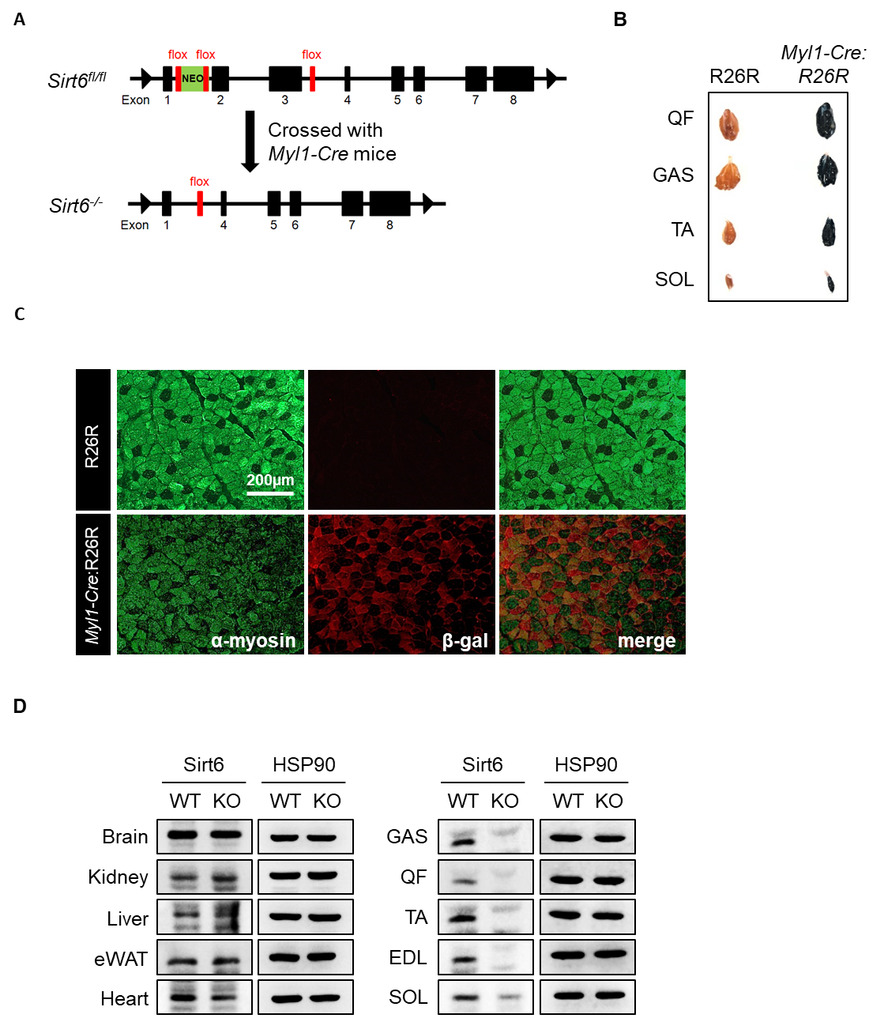
Figure S1. Generation of skeletal muscle-specific Sirt6 KO mice. (A) Schematic diagram illustrating skeletal muscle-specific ablation of Sirt6 using Myl1-Cre. (B) Whole mount X-gal staining of hindlimb muscle tissues from three-month-old Myl1-Cre:R26R mouse after overnight incubation in X-gal staining solution. (C) Immunofluorescence staining for β-gal and α-myosin was performed on serial sections of GAS muscle. (D) Western blot confirmation of Sirt6 ablation in Myl1-Cre:Sirt6^{flox/flox} mice.
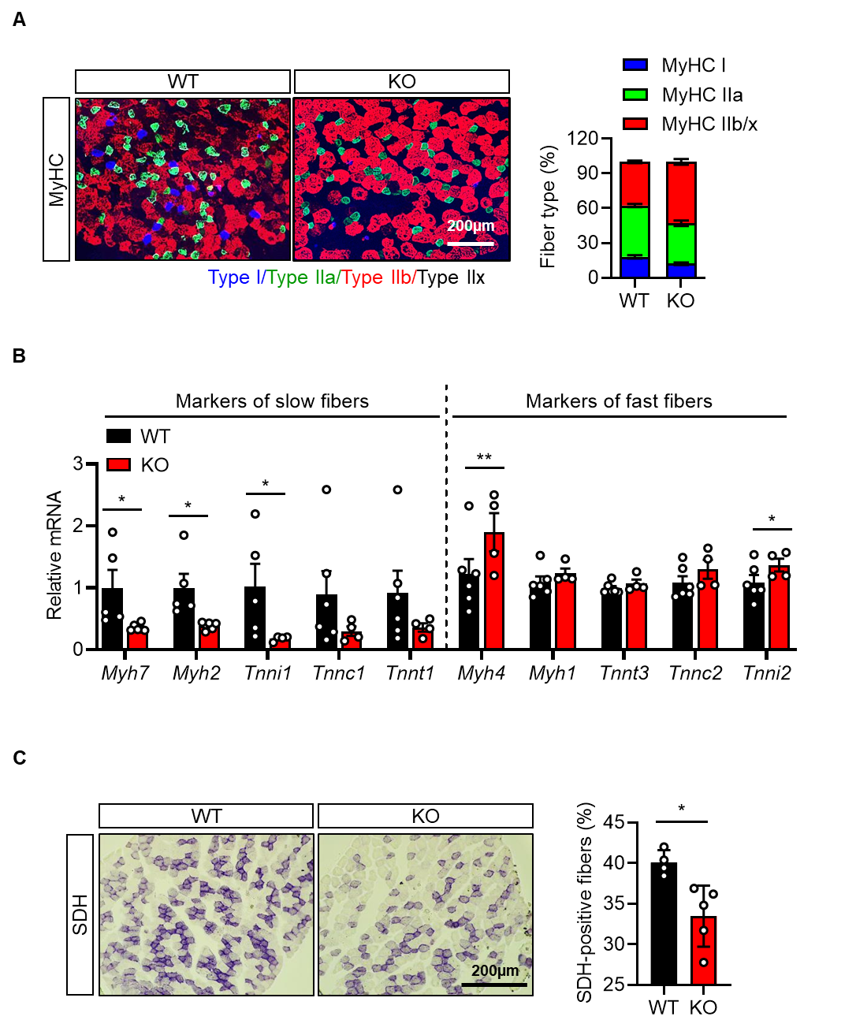
Figure S2. Decrease in oxidative fiber density in the extensor digitorum longus muscle of Sirt6 KO mice. (A) Immunofluorescence staining for MyHC-I, MyHC-IIa, and MyHC-IIb/x (n=6). Composition of each myofiber was quantified. (B) Expression of markers of slow and fast fibers was compared by qPCR. (C) Succinate dehydrogenase (SDH) staining and quantification of SDH-positive fibers. Values are mean ± SEM. *, p<0.05 and **, p<0.01 vs. WT.
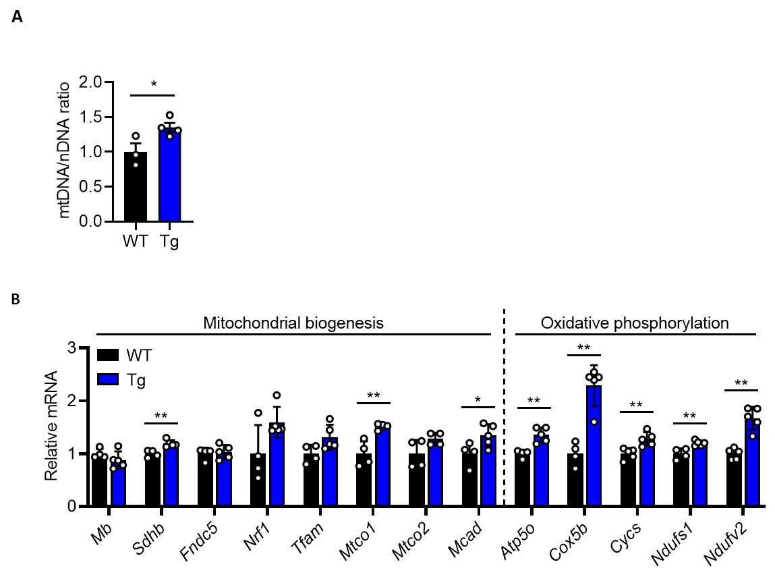
Figure S3. Increase in oxidative fiber density in GAS muscle of Sirt6 Tg mice. (A) Mitochondrial DNA (mtDNA) was quantified by qPCR using nuclear DNA (nDNA) as a standard. (B) Expression of markers of mitochondrial biogenesis and oxidative phosphorylation was compared by qPCR. Values are mean ± SEM. *, p<0.05 and **, p<0.01 vs. WT.

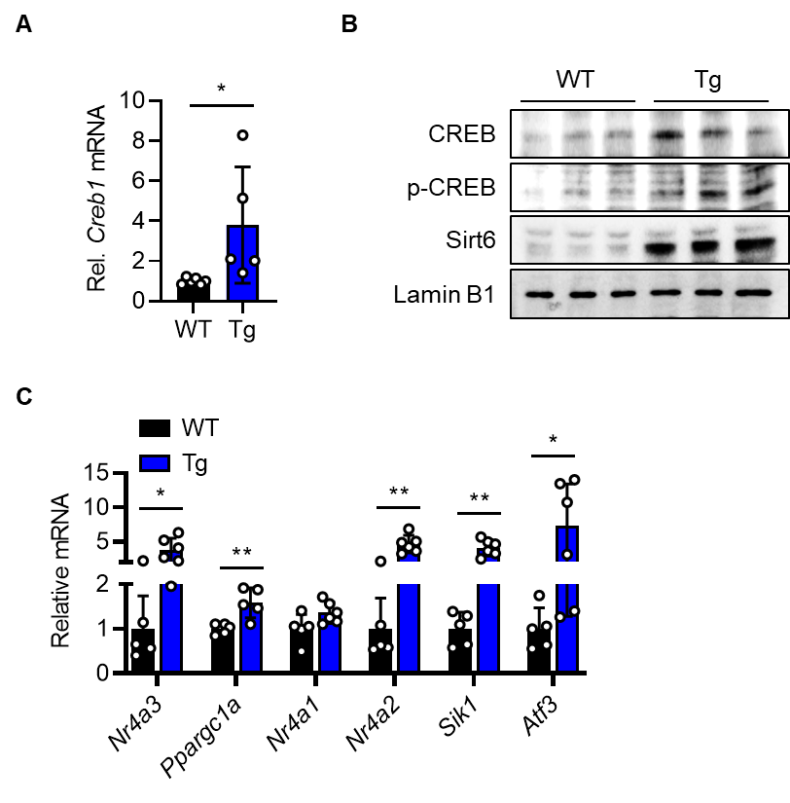
Figure S4. Increased CREB pathway in Sirt6 Tg mice. (A-C) mRNA and protein levels of CREB and its downstream genes in WT and Sirt6 Tg mice were analyzed by qPCR and Western blotting. Values are mean ± SEM. *, p<0.05 and **, p<0.01 vs. WT.

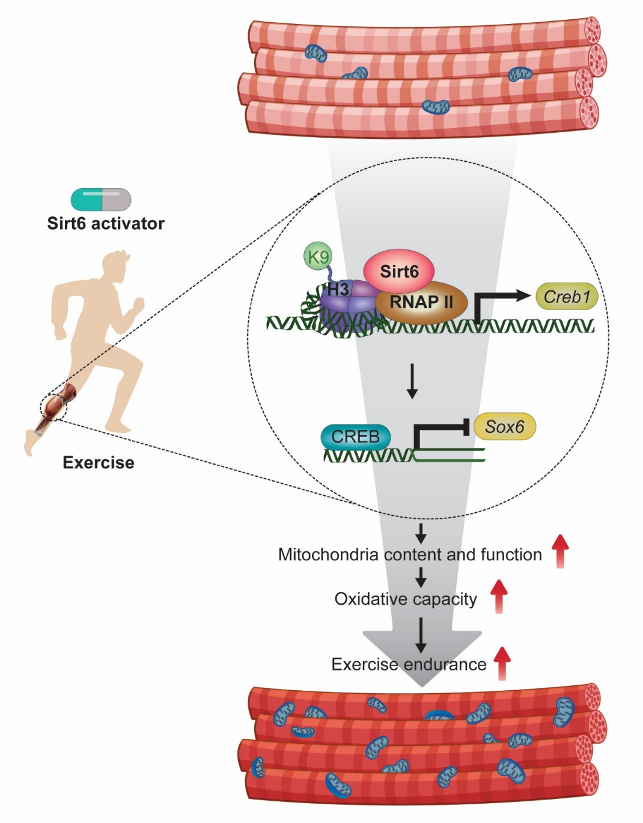
Figure S5. Proposed summary.

