Supplementary Information for
Wake-riding effect inspired opto-hydrodynamic diatombot for non-invasive trapping and removal of nano-biothreats
Jianyun Xiong^{1#}, Yang Shi^{1#}, Ting Pan¹, Dengyun Lu¹, Ziyi He¹, Danning Wang¹, Xing Li¹, Guoshuai Zhu¹, Baojun Li^{1*}, and Hongbao Xin^{1*}
¹Institute of Nanophotonics, Jinan University, Guangzhou 511443, China
#J.X., Y.S. contributed equally to this work
*To whom correspondence may be addressed
Email: baojunli@hnu.edu.cn, hongbaoxin@jnu.edu.cn
Supplementary Section S1. Movies
Movie S1. Optical control of OHD rotation.
Movie S2. Simulation comparation about the removal efficiency of OT and OHD.
Movie S3. Controllable collection and removal of adenoviruses.
Movie S4. Controllable collection and removal of pathogenic bacteria.
Movie S5. Controllable collection and removal of mycoplasmas.
Movie S6. Comparison of the removal efficiency using different OHD arrays.
Supplementary Section S2. PTB characterization
Fig. S1. Size characterization of PTB cells based on over 100 cells repeat. Upper panels: schematic illustration of the PTB structure. Lower panels: histogram of size characterization with Gaussian fit. (a) PTB long axis, the peak value of the length is 7.9 μm. (b) PTB short axis, the peak value of the length is 1.8 μm. (c) PTB arm angle, the peak value of the length is 120°.

Supplementary Section S3. Experimental setup
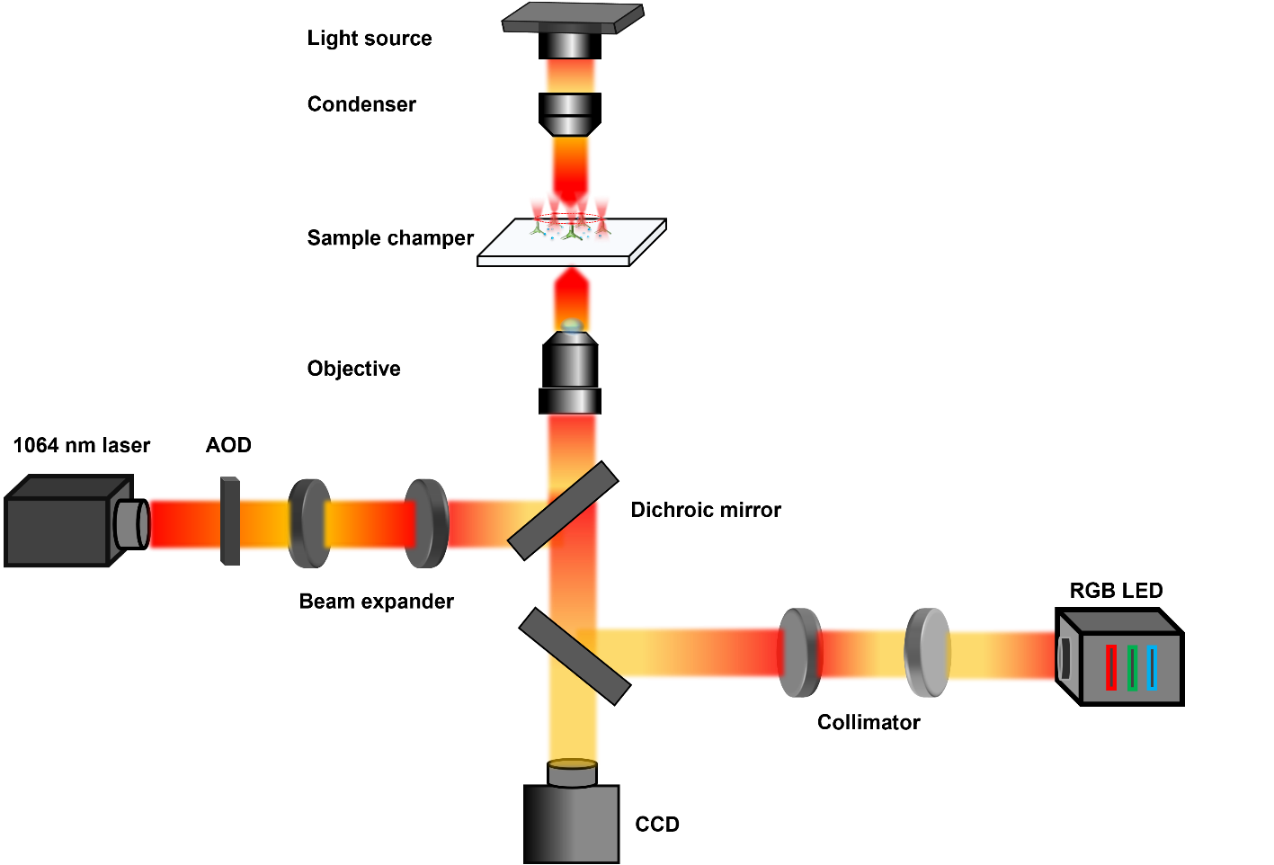
Fig. S2. Schematic illustration of the experimental setup. The experimental setup consists of an inverted microscope (both fluorescence and bright-field) and a scanning optical tweezers system. The laser beam (wavelength: 1064 nm) is output from a continuous-wave solid-state laser source and focused on the sample plane through a 60× water-immersion inverted objective. For bright-field imaging, a halogen light source is used to illuminate the sample from the top. For fluorescence imaging, excitation light generated with an LED transmitted through a dichroic mirror is concentrated by an objective to illuminate the sample. The final experimental process can be captured by a high-speed CCD camera interfaced with a personal computer.

Supplementary Section S4. Characterization of the OHD rotation
Fig. S3. Characterization of the OHD rotation. (a) Rotation trajectory of a OHD after being trapped and rotated by the annularly scanning optical trap (power: 50 mW, frequency: 8 kHz). The red circular arrow represents the counterclockwise (CCW) rotation. (b) Measured rotation speed as a function of trapping power for different scanning frequency. (c) Measured rotation speed as a function of scanning frequency at an optical power of 50 mW.

Supplementary Section S5. Comparison of removal efficiency for OHD and annularly scanning optical tweezers
The OHD exhibits a high-efficiency removal ability through opto-hydrodynamic force. As shown in Fig. S4, under the same removal condition (removal time 16 s, scanning optical trapping power: 50 mW, scanning frequency: 8 kHz), the removal efficiency of the annular scanning optical tweezers is only about 20 % (Fig. S4a), while that for OHD is 100% (Fig. S4b).
Fig. S4. Bacteria removal using scanning optical tweezers and OHD. (a) Removal of E. coli using scanning optical tweezers. Yellow and red arrows indicate E. coli and OHD, respectively. (b) Removal of E. coli using OHD. Scale bars: 5 μm.

Fig. S5. Removal rate comparison. (a) Removal rate of the annular scanning optical tweezers and OHD at different time. (b) Removal rate of the annular scanning optical tweezers and OHD with different power.
Supplementary Section S6. Collection and removal of 100-nm PS particles
Fig. S6. Controlled collection and removal of 100-nm PS particles by OHD. Panels I-IV are microscopic images of the collection and removal. Yellow arrows indicate the 100-nm PS particles, red circular arrows indicate the rotation direction of the OHD. The blue dotted lines indicate the motion trajectory of the OHD, and the white and yellow dotted boxes indicate the OHD and the final collected 100-nm particles, respectively. Panel V shows the removal rate as a function of time. Scale bars: 3 μm.

Supplementary Section S7. Collection and removal of 800-nm PS particles
Fig. S7. Controlled collection and removal of 800-nm PS particles. Panels I-IV are microscopic images of the collection and removal. Yellow arrows indicate the 800-nm PS particles, red circular arrows indicate the rotation direction of the OHD. The blue dotted lines indicate the motion trajectory of the OHD, and the white and yellow dotted boxes indicate the OHD and the final collected 800-nm particles, respectively. Panel V shows the removal rate as a function of time. Scale bars: 3 μm.

Supplementary Section S8. Collection and removal of 2-μm PS particles
Fig. S8. Controlled collection and removal of 2-μm PS particles. Panels I-IV are microscopic images of the collection and removal. Yellow arrows indicate the 2-μm PS particles, red circular arrows indicate the rotation direction of the OHD. The blue dotted lines indicate the motion trajectory of the OHD, and the white and yellow dotted boxes indicate the OHD and the final collected 2-μm particles, respectively. Panel V shows the removal rate as a function of time. Scale bars: 3 μm.

Supplementary Section S9. Effect of pathogenic bacteria contamination on mammalian cells
Due to the rapid bacterial reproduction in the cell culture medium, contamination of a small number of pathogenic E. coli can result in the death of both HeLa cells and HL-60 cells within 12 h (Fig. S9).
Fig. S9. Effect of pathogenic bacteria on mammalian cell viability. (a) Fluorescence images showing the viability of HeLa cells contaminated with E. coli. I, At the early stage of the contamination, there is only a few (about 25 E. coli) mixed with the HeLa cells. II, after contamination of 12 h, the number of E. coli is greatly enhanced (about 1.5 ×10³), and the HeLa cells are dead due to the invasion of the E. coli. (b) Fluorescence images showing the viability of HL-60 cells contaminated with E. coli. HL-60 cells are dead after 12-h of E. coli invasion. Green fluorescence indicates good cell viability and live E. coli. Red fluorescence indicates dead cells. Scale bars: 20 μm.
Supplementary Section S10. Collection and removal of S. aureus
Fig. S10. Controlled collection and removal of S. aureus. Panels I-IV are microscopic images of the collection and removal. Yellow arrows indicate the S. aureus, red circular arrows indicate the rotation direction of the OHD. The blue dotted lines indicate the motion trajectory of the OHD, and the white and yellow dotted boxes indicate the OHD and the final collected S. aureus, respectively. Panel V shows the removal rate as a function of time. Scale bars: 3 μm.

Supplementary Section S11. Effect of mycoplasma contamination on mammalian cells
Similarly, when cells are contaminated with mycoplasmas, vacuolization of contaminated cells can be observed, with small black dots appeared around the cells. And eventually the cells are dead, as shown in Fig. S10. When cells were stained with 4',6-Diamidino-2'-phenylindole (DAPI), in addition to the normal blue nuclei observed, a large amount of flocculent structures in the cytoplasm were also stained blue (Fig. S10a). However, in cells which were not contaminated with mycoplasma, only blue nuclei were observed (Fig. S10b).
Fig. S11. Effect of mycoplasma contamination on HeLa cells. (a) Bright-field and corresponding fluorescence images showing cells contaminated with mycoplasma, respectively, and red arrows in the fluorescent image indicate mycoplasma. (b) Bright-field and corresponding fluorescence images showing cells uncontaminated by mycoplasma, respectively. Scale bars: 10 μm.
Supplementary Section S12. Removal efficiency of OHD for removal of pathogenic bacteria with different numbers
Fig. S12. Controlled collection and removal of pathogenic bacteria. Removal rate of (a) E. coli and (b) S. aureus using a single OHD with different bacteria number in the channel.
Supplementary Section S13. E. coli removal using different OHD arrays
Fig. S13. E. coli removal using (a) single OHD, (b) two-OHD array, and (c) three-OHD array. Upper panels: initial state of the removal, lower panels: final state of the removal after 25 s. Red arrows indicate the OHD, yellow arrows in the lower panels indicate the E. coli that cannot be removed with a single OHD or two-OHD array. Scale bars: 2 μm.

Supplementary Section S14.Antibacterial activity of chi-OHD
Fig. S14. Antibacterial activity of chi-OHD. (Ⅰ) Bright-field image, (Ⅱ) Fluorescence image, (Ⅲ) Merged image. Red fluorescence indicates chi-OHD and dead E. coli. Scale bars: 5 μm.

Supplementary Section S15. Biocompatibility test of chi-OHD
Fig. S15. Co-culturing of chi-OHD with HL-60 cells for 1 day. (Ⅰ) Bright-field image showing the chi-OHD with HL-60 cells. (Ⅱ) Fluorescent image showing the HL-60 cells in good viability (green fluorescence for live cells). (Ⅲ) Fluorescent image showing chi-OHD (red fluorescence for OHD). (Ⅳ) Merged image showing the chi-OHD and HL-60 cells. Scale bars: 10 μm.

References
- Schmidt, B. S., Yang, A. H., Erickson, D. & Lipson, M. Optofluidic trapping and transport on solid core waveguides within a microfluidic device. Opt. Express 15, 14322-14334 (2007).
- Li, L., Xin, H., Lei, H., & Li, B. Optofluidic extraction of particles using a sub-microfiber. Appl. Phys. Lett. 101, 074103 (2012).

