Supplementary Materials for
Scalable integration of hybrid high-κ dielectric materials on two-dimensional semiconductors with a van der Waals interface Yongshan Xu^{1, 4}, Teng Liu^{1, 4}, Kailang Liu^{1, *}, Yinghe Zhao¹, Lei Liu², Penghui Li³, Anmin Nie³, Lixin Liu¹, Jun Yu¹, Xin Feng¹, Fuwei Zhuge¹, Huiqiao Li¹, Xinran Wang², Tianyou Zhai^{1, *}

1 State Key Laboratory of Materials Processing and Die and Mould Technology, School of Materials Science and Engineering, Huazhong University of Science and Technology, Wuhan, China.
2 National Laboratory of Solid State Microstructures, School of Electronic Science and Engineering and Collaborative Innovation Center of Advanced Microstructures, Nanjing University, Nanjing, China.
3 Center for High Pressure Science, State Key Laboratory of Metastable Materials Science and Technology, Yanshan University, Qinhuangdao, China.
4 These authors contributed equally: Yongshan Xu, Teng Liu
*To whom correspondence should be addressed: klliu@hust.edu.cn, zhaity@hust.edu.cn

This PDF file includes:

Supplementary Figures 1-13
Supplementary Table 1

Other Supplementary Materials for this manuscript include the following:

Supplementary Video 1

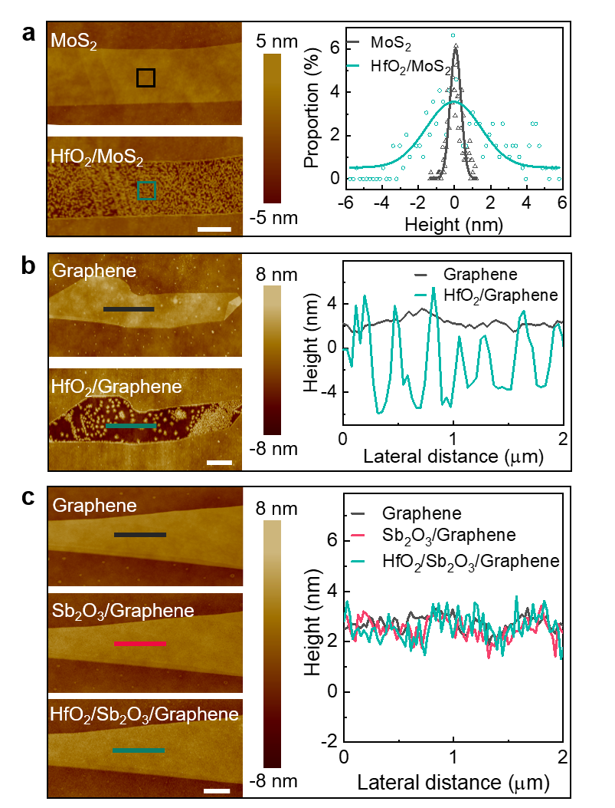
Supplementary Fig. 1∣Morphological characterizations of deposited dielectric layers. a, AFM images of exfoliated MoS₂ and after the direct ALD of HfO₂. Scale bar, 1 μm. Right, the surface flatness measurements from the indicated area in AFM images. b, c, AFM images of exfoliated graphene and after ALD of 4 nm HfO₂ for samples without and with 1 nm Sb₂O₃. Scale bar, 1 μm. Right, the height profile from the indicated areas in AFM images.

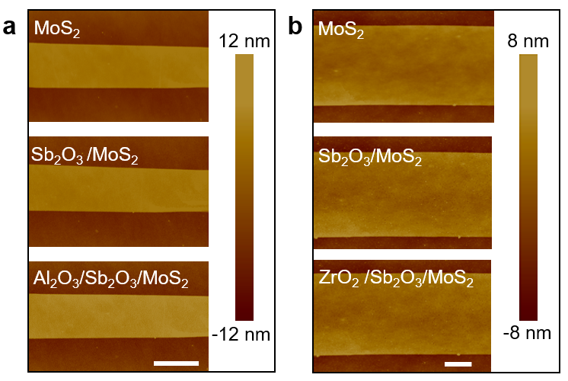
Supplementary Fig. 2∣Morphological characterizations of deposited dielectric layers. a, b, AFM images of exfoliated MoS₂, after 1 nm Sb₂O₃ deposition and after 4 nm Al₂O₃ (a) and ZrO₂ (b) deposition. Scale bar, 1 μm.

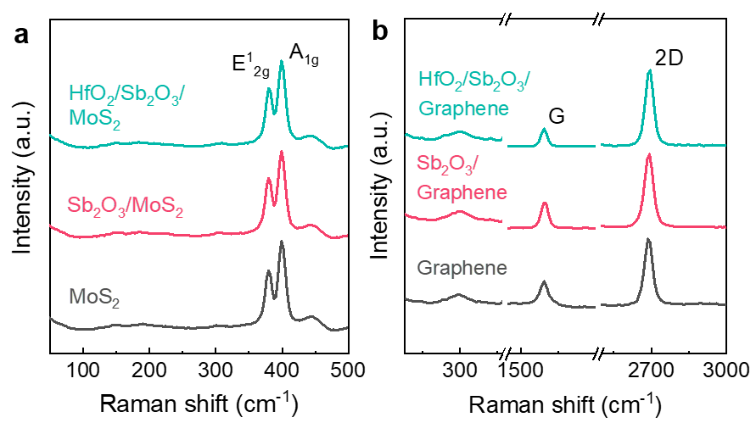
Supplementary Fig. 3∣The sequential Raman spectra of MoS₂ and graphene following the dielectric layers deposition. a, The Raman spectra of exfoliated MoS₂ and after the deposition of Sb₂O₃ and HfO₂. b, The Raman spectra of few-layer graphene and after the deposition of Sb₂O₃ and HfO₂. The unchanged Raman spectra indicate that our processes of dielectrics integration are non-destructive to the underlying 2D materials.

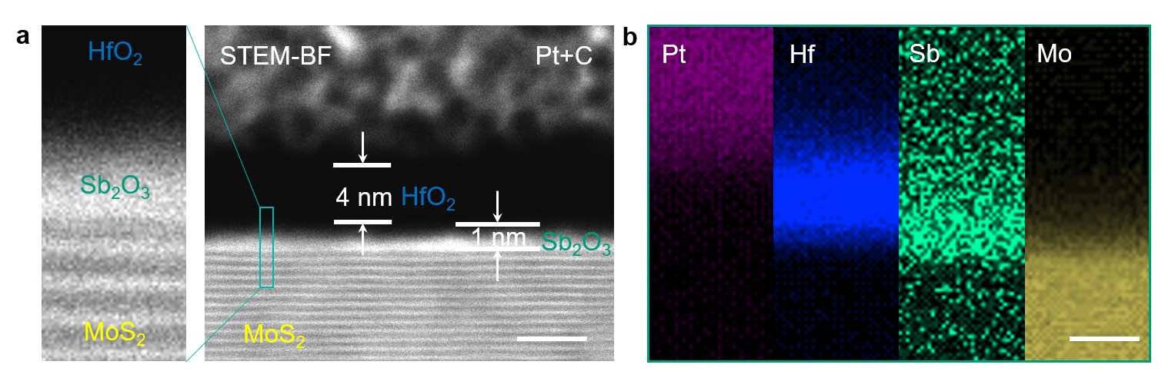
Supplementary Fig. 4∣Cross-sectional STEM characterizations of dielectrics with 4 nm HfO₂ integrated. a, Bright-field (BF) cross-sectional STEM image of HfO₂/Sb₂O₃ on MoS₂. Scale bars, 5 nm. The thicknesses of the HfO₂ and Sb₂O₃ layers are marked. b, STEM-EDS mapping. From left to right, elemental mapping of Pt, Hf, Sb and Mo, respectively. Scale bar, 5 nm.

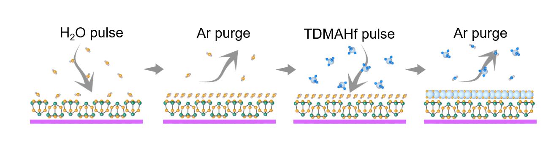
Supplementary Fig. 5∣Schematic illustration of a typical ALD process of HfO₂ on Sb₂O₃ surface.

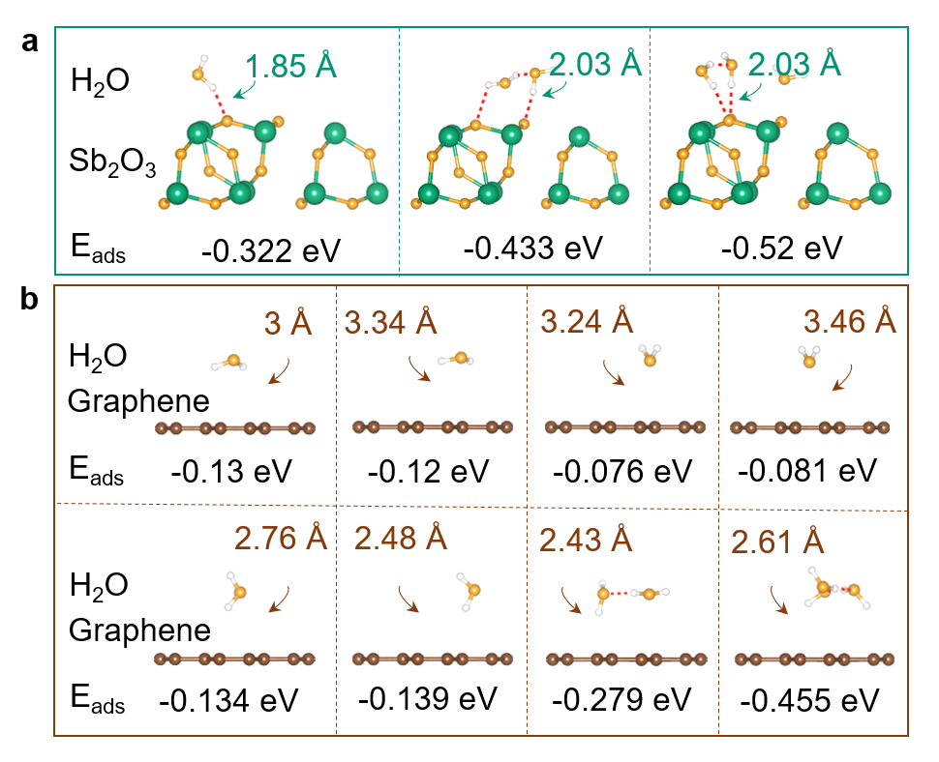
Supplementary Fig. 6∣Theoretical calculations of the adsorption behaviors of ALD precursor H₂O molecules on different materials and the experimental evidence. a, b, Calculated interatomic distance and adsorption energy of different adsorption configurations of H₂O molecules on the Sb₂O₃ surface (a) and graphene (b).

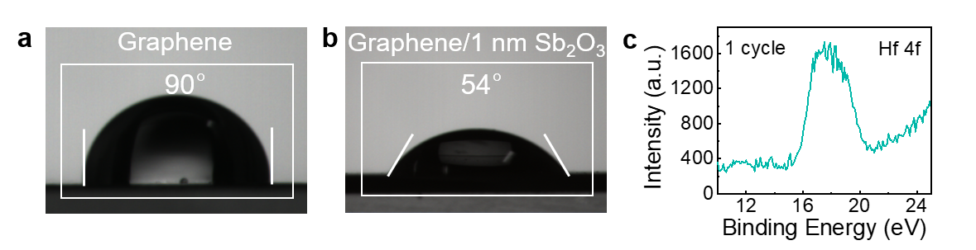
Supplementary Fig. 7∣The experimental evidence of ALD precursor H₂O molecules on different materials. a, b, The water contact angle of CVD graphene on Cu foil before and after deposition of 1 nm Sb₂O₃. Due to the buffer layer of Sb₂O₃ on the surface, the contact angle decreased from 90º to 54º. c, The XPS spectrum of Hf 4f in one single HfO₂ ALD cycle. We carried out one ALD cycle (H₂O-TDMAHf) on the surface Sb₂O₃ layer, and used XPS to detect the formation of HfO₂. The XPS signal of Hf element indicates the sufficient adsorption of H₂O molecules on Sb₂O₃ layer.

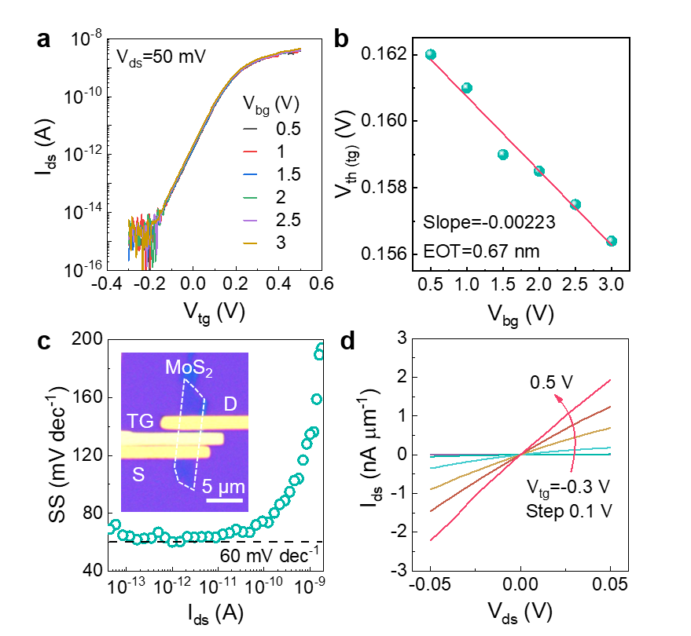
Supplementary Fig. 8∣Electrical characteristics of FETs based on monolayer MoS₂ prepared by mechanical exfoliation with thicknesses t_{d} of 3 nm as gate dielectrics. a, Transfer characteristics of the FET with dielectric layer thickness t_{d} of 3 nm under different V_{bg} from 0.5-3 V with 0.5 V step. b, The threshold voltage V_{th} as a function of V_{bg} extracted from a. Given EOT=300 nm of back gate, from the linear fitting, we can estimate the EOT of top-gate dielectric layer to be 0.67 nm. c, SS versus I_{ds} characteristics of the device in a, showing constant SS across over 4 orders of I_{ds} with minimum SS of ~60 mV dec⁻¹. Inset: the image of the FET with dielectric layer thickness t_{d} of 3 nm as top-gate dielectrics. d, Output curves of the FET in a. The device exhibits linear curves at V_{tg} from -0.3 to 0.5 V with a 0.1 V step.

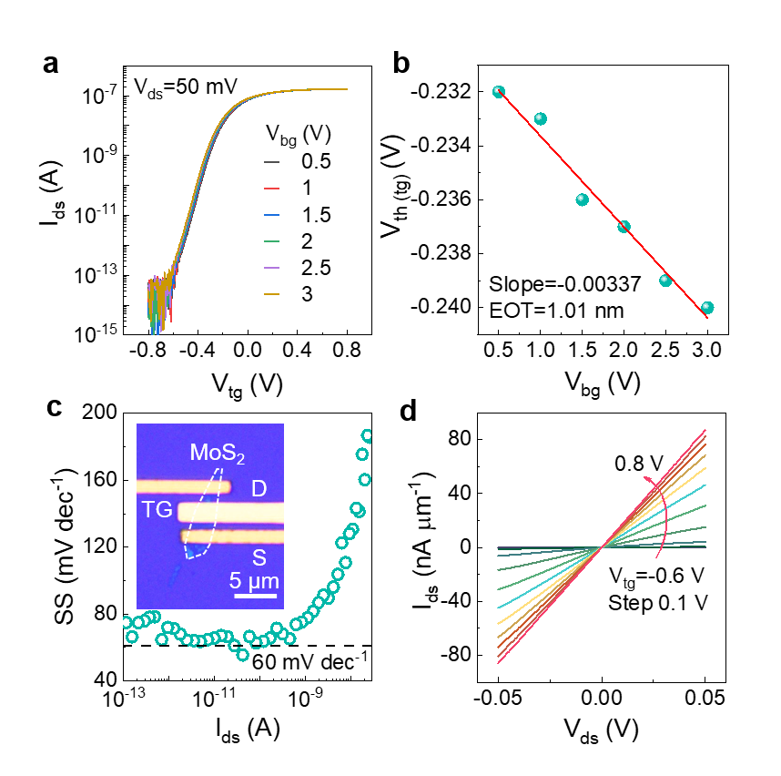
Supplementary Fig. 9∣Electrical characteristics of FETs based on monolayer MoS₂ prepared by mechanical exfoliation with thicknesses t_{d} of 5 nm as gate dielectrics. a, Transfer characteristics of the FET with dielectric layer thickness t_{d} of 5 nm under different V_{bg} from 0.5-3 V with 0.5 V step. b, The threshold voltage V_{th} as a function of V_{bg} extracted from a. Given EOT=300 nm of back gate, from the linear fitting, we can estimate the EOT of top-gate dielectric layer to be 1.01 nm. c, SS versus I_{ds} characteristics of the device in a, showing constant SS across over 4 orders of I_{ds} with minimum SS of ~60 mV dec⁻¹. Inset: the image of the FET with dielectric layer thickness t_{d} of 5 nm as top-gate dielectrics. d, Output curves of the FET in a. The device exhibits linear curves at V_{tg} from -0.6 to 0.8 V with a 0.1 V step.

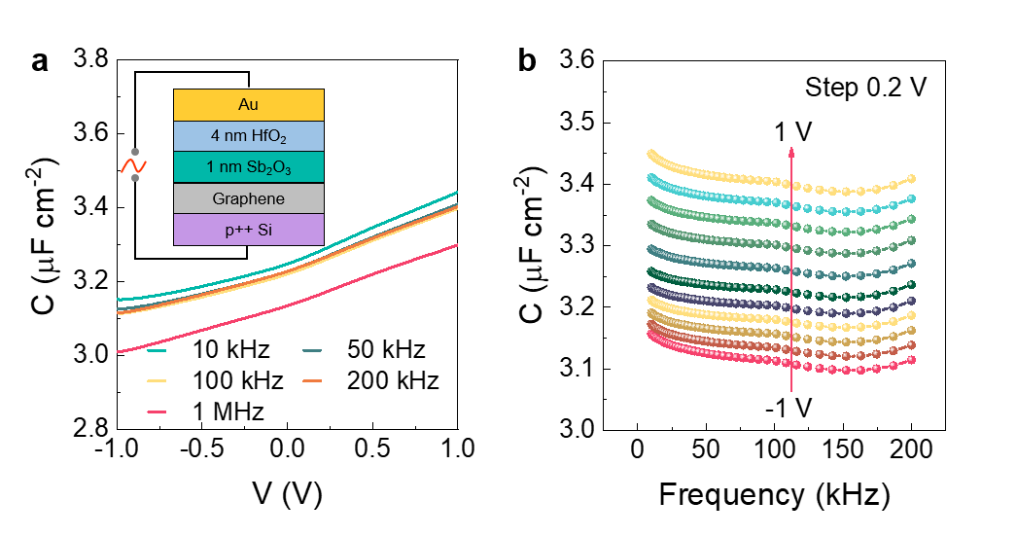
Supplementary Fig. 10∣Capacitance-voltage (C-V) and capacitance-frequency (C-f) measurements of the hybrid 1-nm Sb₂O₃/ 4-nm HfO₂ dielectric layer in a capacitor at various bias voltage and frequency. a, C-V characteristics at different frequency. b, C-f characteristics under different voltage with the same device in a. The capacitance remains stable at high frequency and electric field thanks to the all-inorganic oxides of our dielectric layer.

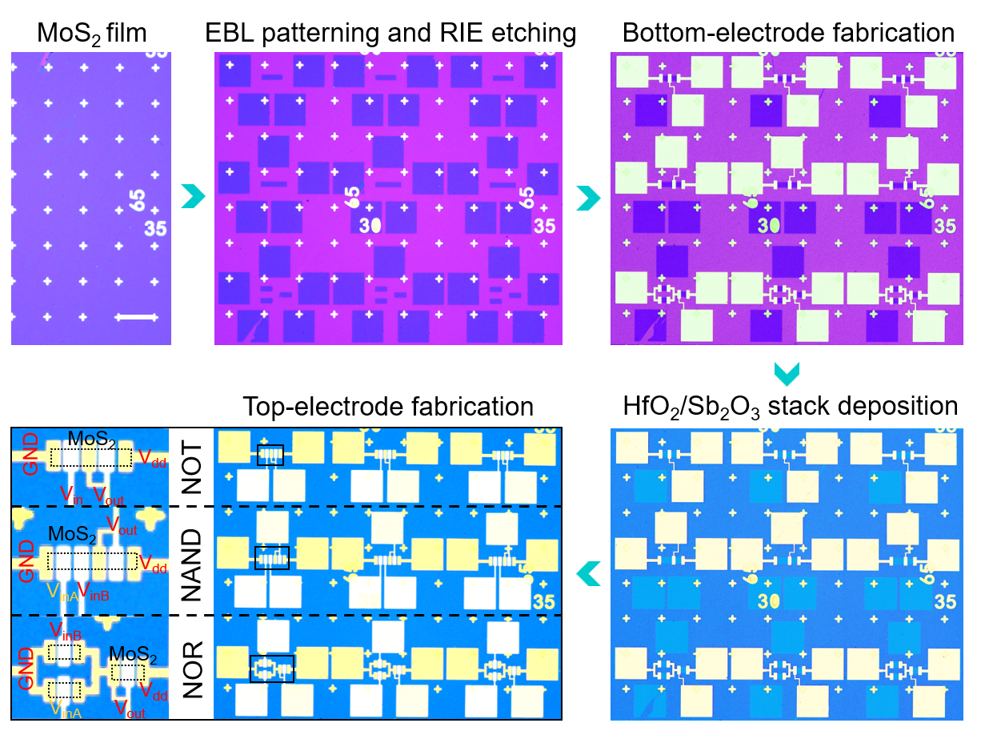
Supplementary Fig. 11∣Fabrication process of logic gates based on large-scale monolayer MoS₂ by CVD. First, we transfer the MoS₂ film grown on sapphire substrate onto SiO₂/Si substrate, then pattern the channel regions on MoS₂ film by electron beam lithography (EBL) and reaction ion etching (RIE). Then, we pattern the bottom-electrodes region by EBL and deposit 10-nm Bi/90-nm Au as electrodes. Afterwards, we deposit 1 nm Sb₂O₃ and 4 nm HfO₂ with thermal evaporation and ALD as the gate dielectrics. Finally, we pattern the top-electrode with a second EBL process and deposit 10-nm Bi/90-nm Au. Scale bars, 100 μm.

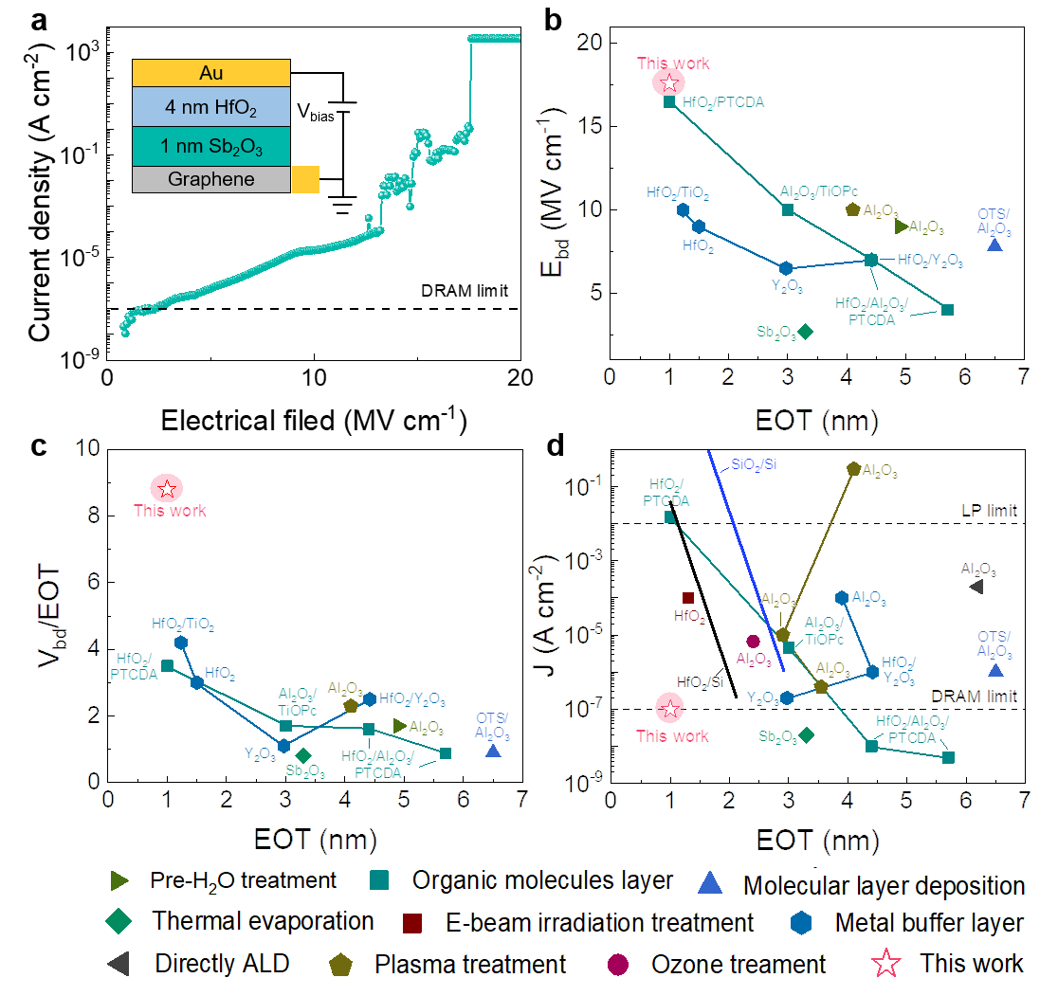
Supplementary Fig. 12∣Breakdown characteristics of the hybrid HfO₂/Sb₂O₃ dielectric layer and benchmark of FET with HfO₂/Sb₂O₃ dielectric layer. a, Current density as a function of electric field measured on a metal-insulator-metal capacitor with 1 nm Sb₂O₃ and 4 nm HfO₂. b and c, Statistics of breakdown electrical filed (E_{bd}), breakdown voltage (V_{bd})/EOT for the state-of-the-art dielectrics integrated on 2D materials. d, The leakage current (under V_{tg}=1 V) as a function of EOT measured from top-gate MoS₂ FETs, in comparison with 2D data and Si from the literature. The black and blue lines are the leakage currents of HfO₂/Si and SiO₂/Si. The two horizontal lines mark the limits of leakage current for low-power (LP) integrated circuit and DRAM applications.

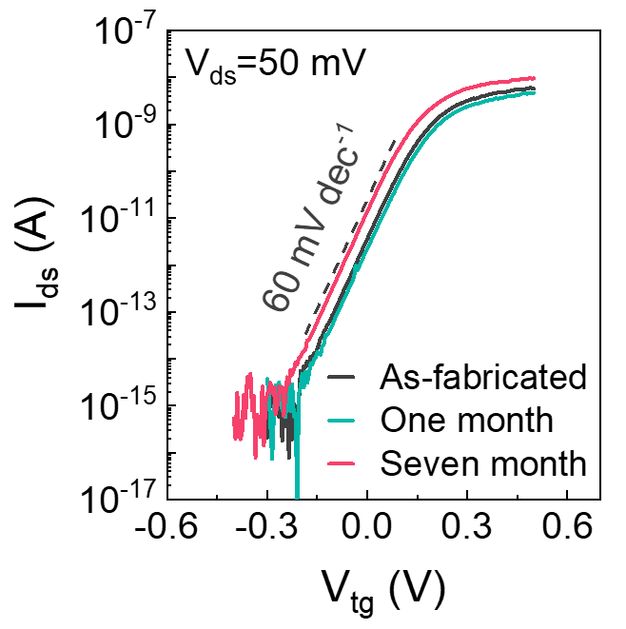
Supplementary Fig. 13∣Environmental stability of the FETs. Transfer characteristic curves of top-gate MoS₂ transistor with gate dielectric t_{d} of 3 nm that are respectively obtained after an increasing exposure time in ambient condition, indicating an excellent stability of our device.

Supplementary Table 1∣The summary of dielectric properties and device performance of the state-of-the-art dielectrics integrated on 2D semiconductors.
