Supporting information
Pressure-induced phase separation for microstructural formation control in supercritical polymer solution: A promising solution enhancing mechanical properties of flash-spun filament
Jae-Hyung Wee ^{1†}, Younghwan Bae¹, Nam Pil Cho^{1,2}, Moo Sung Kim³, Won Jun Lee², Sang Young Yeo^{1*}
¹ Advanced Textile R&D Department, Korea Institute of Industrial Technology, 143 Hanggaulro, Sangnok-gu, Ansan-si, Gyeonggi- do, 15588, Republic of Korea
²Department of Fiber System Engineering, Dankook University, 152 Jukjeon-ro, Suji-gu, Yongin-si, Gyeonggi-do, 16890, Republic of Korea
³Department of Polymer Engineering, Graduate School, School of Polymer Science and Engineering & Alan G. MacDiarmid Energy Research Institute, Chonnam National University, 77 Yongbong-ro, Buk-gu, Gwangju 61186, Republic of Korea

* Corresponding author: miracle@kitech.re.kr (S. Y. Yeo)

Table S1. Thermal property parameters obtained by DSC curve at 20 ºC/min.
Samples | T_{m} ^{a)}  (°C) | T_{c} ^{b)}  (°C) | ∆H_{c} ^{c)}  (J/g) | Crystallinity ^{d)}  (%)
FSF-134 | 131.3 | 114.1 | 165.2 | 57.5%
FSF-113 | 133.2 | 115.1 | 173.7 | 60.5%
FSF-87 | 133.5 | 114.4 | 178.5 | 62.2%
FSF-76 | 133.3 | 115.2 | 189 | 65.8%
FSF-69 | 131.3 | 114.0 | 170.9 | 59.5%
FSF-65 | 130.7 | 113.4 | 167.5 | 58.3%
*a) T_{m}: Melting temperature, b) T_{c}: crystallization temperature, c) ∆H_{c}: crystallization enthalpy, d) crystallinity calculated based on 100 % crystallization of HDPE (287.2 J/g).

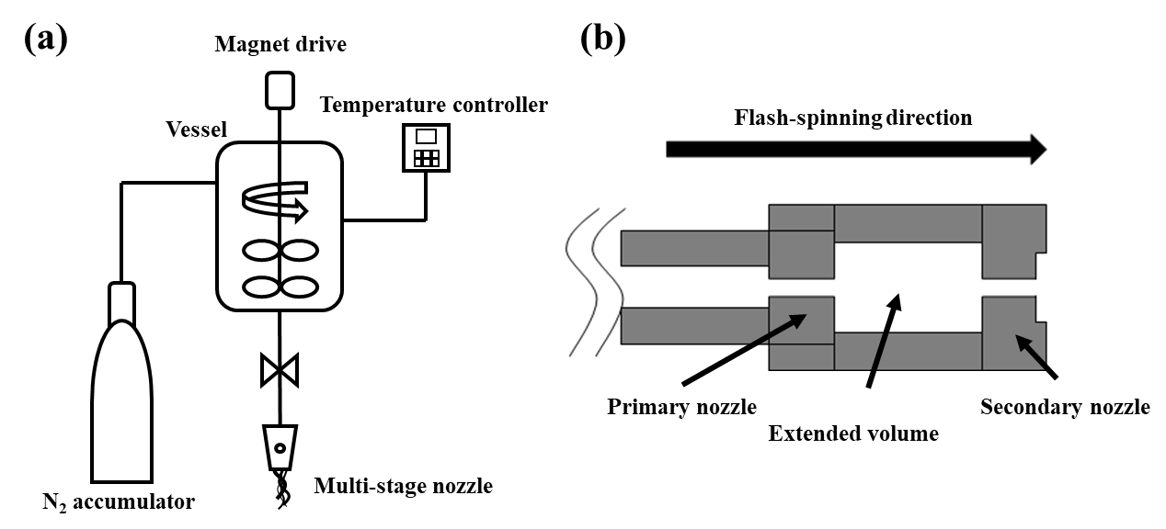
Figure S1. Schematics of (a) lab-scale flash-spinning apparatus and (b) multi-stage nozzle with extended volume for pressure-induced phase separation (orifice diameter is 0.7 μm).

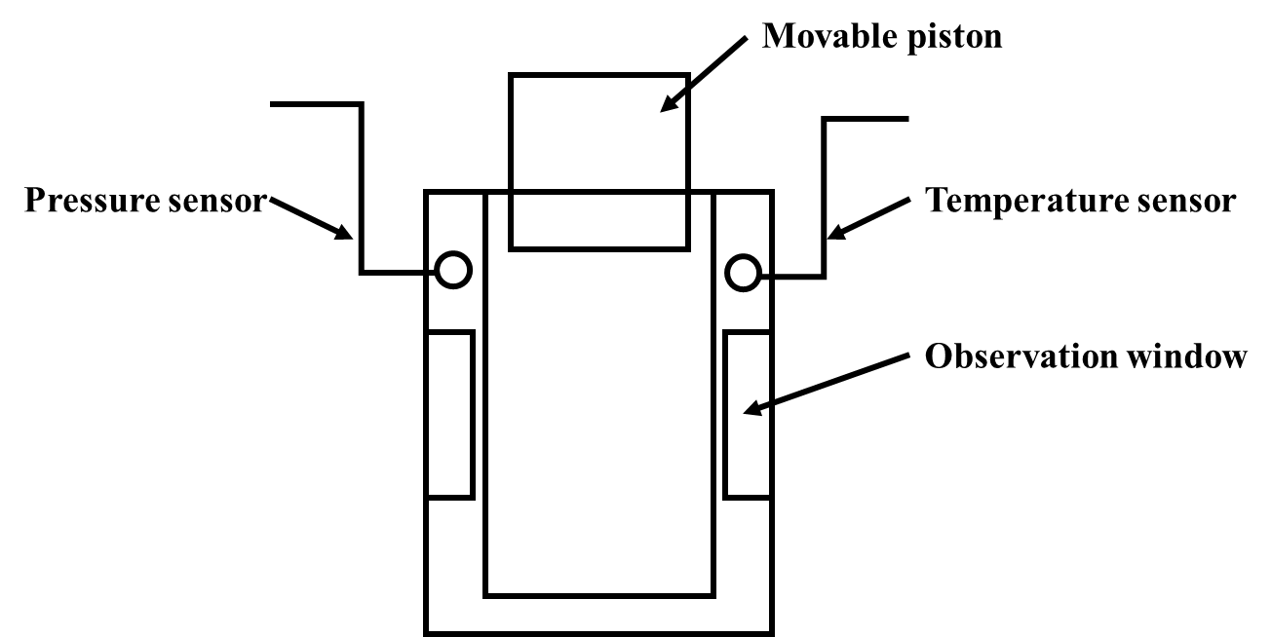
Fig. S2. Schematic of the high-pressure view cell system.

