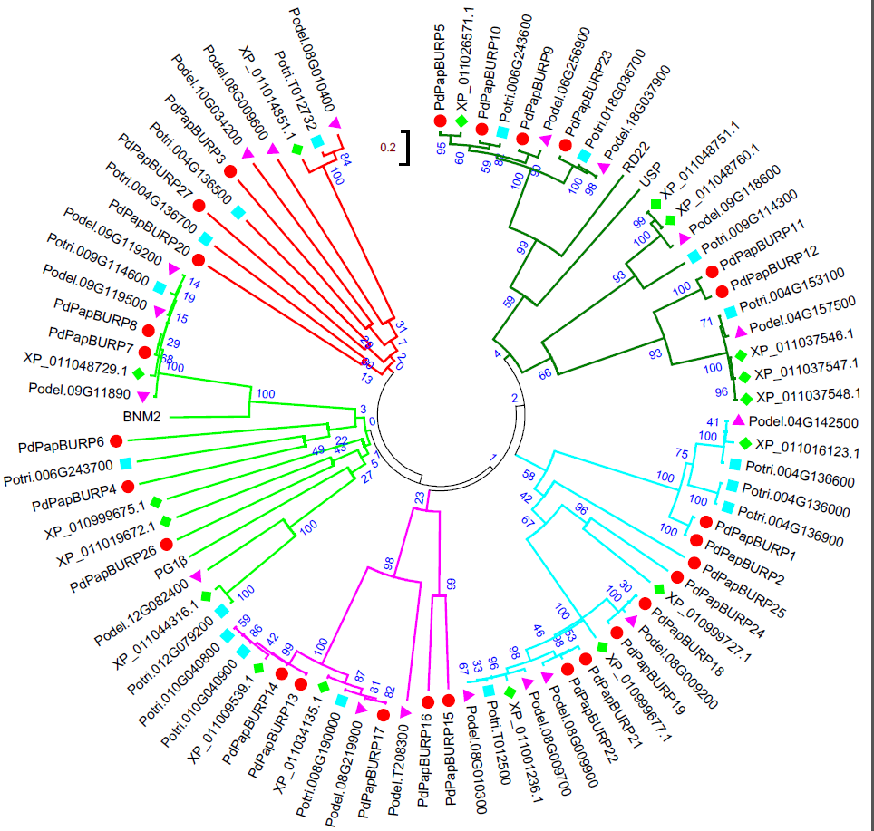
Fig. S1 phylogenic tree of all the BURP proteins in P. davidiana × P. alba var. pyramidalis, P. trichocarpa, P. deltoids and P. euphratica
The unrooted N-J tree of 27 PdPapBURP proteins (marked with red circle), 17 BURP proteins in P. trichocarpa (blue square), 18 in P. deltoids (pink triangle) and 17 in P. euphratica (green diamond). The bootstrap values are shown at the branches. Different subclasses are represented by different branch colors.

