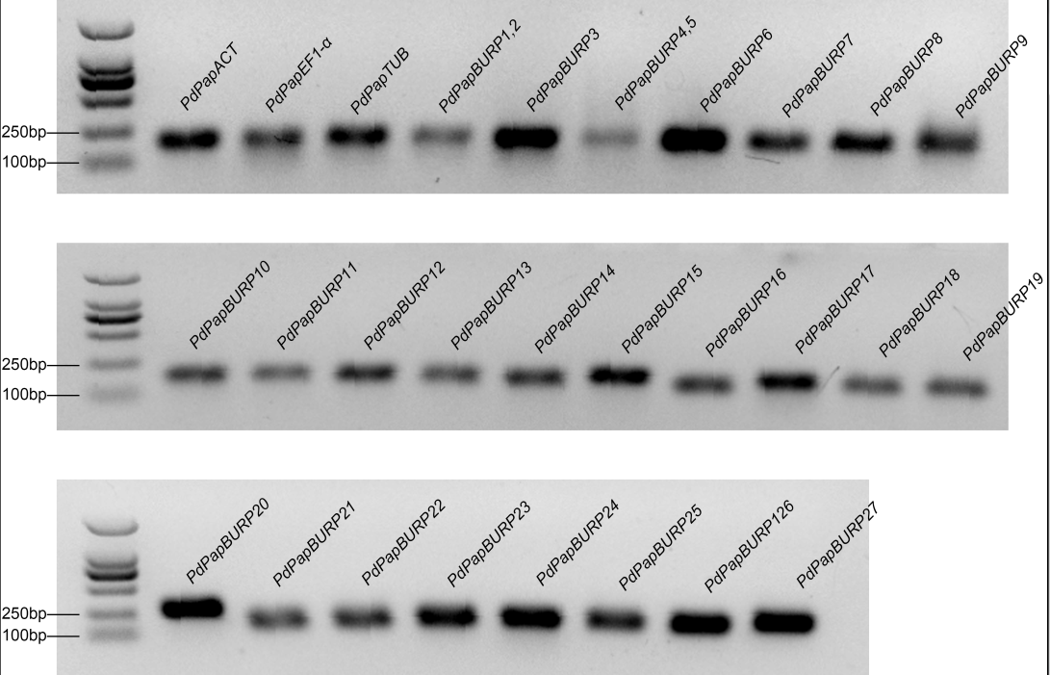
Fig. S2 Amplification products of the primers used in the quantitative RT-PCR assays
Specific amplification products acquired using each quantitative primer pair of the PdPapBURP genes and mixed cDNA template are shown in agarose gel electrophoresis image. Ladder is DL2000. The bands of 100 and 250 base-pair (bp) size are marked.

